- Hardware Layout
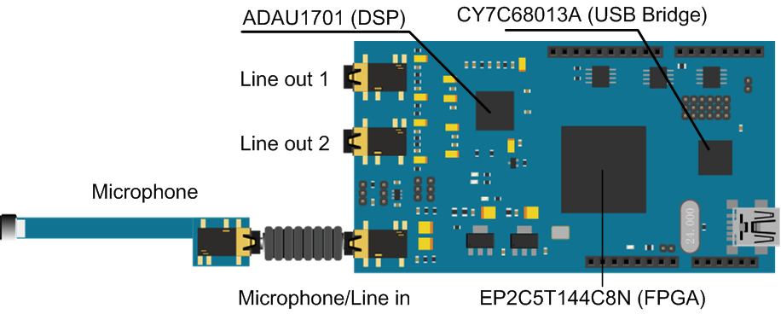
- Jumper
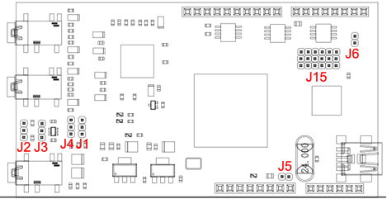
  - Microphone/Audio Input Jumper (J1,J2,J3,J4)
Function | J1 | J2 | J3 | J4
Mic in (+20 dB) | 2-3 | 2-3 | 2-3 | 2-3
Mic in | 2-3 | 2-3 | 1-2 | 1-2
Line in (2 channel) | 1-2 | 1-2 | - | -
  - Archo Firmware Download Jumper (J15，J6)
J15:
Function | J15
Download FPGA&DSP’s Firmware | B-C
Communicate between USB and FPGA | A-B

J6:
Function | J6
CY7C68013 Boot From E2PROM | Jump
CY7C68013 Boot Not From E2PROM | Remove

  - Power Supplier Jumper (J5): USB Power-up
  - Software Installation
Please download and install Python (x,y)
http://www.softpedia.com/get/Programming/Other-Programming-Files/Python-x-y.shtml

- Firmware Download
Based on the different applications, user may need to download the firmware of DSP/FPGA and cy7c68013a into Archo

  - cy7c68013a Firmware Download
- Disconnect the USB, insert the jumper of J6
- Connect the USB to the computer. You may be required to install the driver of ‘Cypress_EZ-USB_FX2LP_-_EEPROM_missing’.
- Remove jumper of J6 when D6 is lighted.
- Under the download_firmware directory, right click and choose ‘Open IPython console here’. Type in ‘run download_firmware_68013a_archo.py’, Wait until the installation is completed.
- Disconnect the USB.

  - DSP/FPGA Firmware Download
- Disconnect the USB, insert the 6 jumpers of J15 into location A-B, and also insert J6.
- Connect the USB with computer. You may be required to install the driver of ‘Cypress_EZ-USB_FX2LP_-_EEPROM_missing’.
- Under the download_programe directory, right click and choose ‘Open IPython console here’. Type in ‘run download_firmware_DSP_FPGA.py’. You may be required to install the driver of ‘Archo_Boot’ as well. Install the driver and restart from the very beginning of 3.2.
- Disconnect the USB, insert the 6 jumpers into location B-C, and remove J6.

