Application: Archo Sound Pressure Level Meter V1.0
- The connection between Archo and Arduino
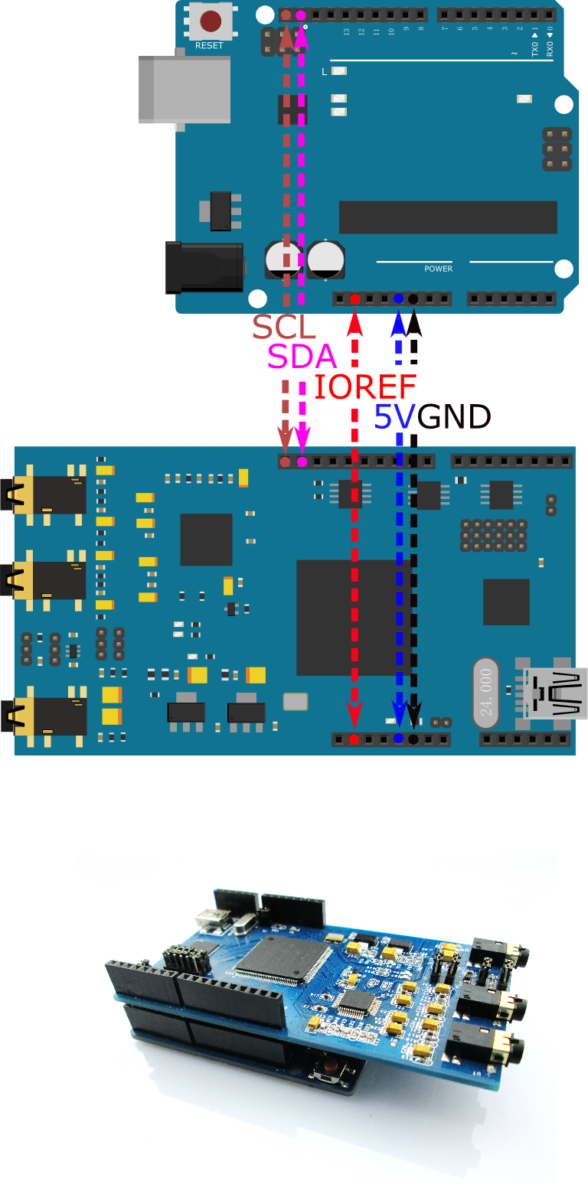

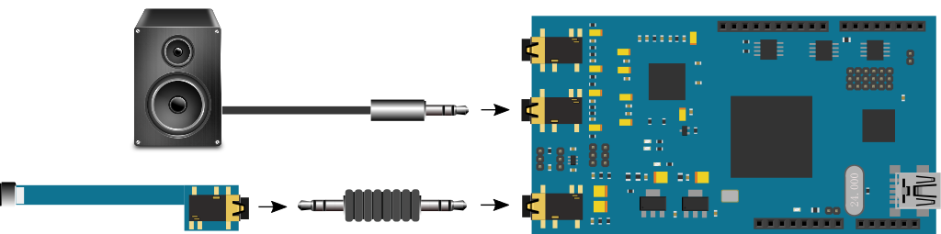
2. Installation of the software
Copy Archo_SPLM to Arduino\libraries

3. Function List

3.1 Archo (int addr)
Create an Archo object, default address of i2c is 77
3.2 void begin()
Initiate Archo
3.3 void outVolume(unsigned long volume)
Modify output volume
Parameter (unsigned long volume):
DB_0 0 dBFS
DB_N3 -3 dBFS
DB_N6 -6 dBFS
DB_N9 -9 dBFS
DB_N12 -12 dBFS
DB_N15 -15 dBFS
DB_N18 -18 dBFS
DB_N20 -20 dBFS
DB_N21 -21 dBFS
Custom the value：
0x00147AE -40dB (see 5.1 and 5.2)

3.4 void outMode (unsigned long signal_type)
Modify the output pattern of sound
Parameter (unsigned long signal_type):
TONE
WHITE_NOISE
PINK_NOISE

3.5 void outFreq (unsigned long freq)
Modify the frequency of the sound when the output sound is TONE.
Parameter (unsigned long freq):
e.g. 1000, out put the sin wave of 1000Hz.

3.6 float getspl (float cal_data)
Set calibration value of the microphone, then read and return the sound-level reading,
Parameter (float cal_data):
e.g. 36.3 without +20dB gain jumper
16.3 with +20dB gain jumper

3.7 void spl_switch (byte fast_or_slow)
Set the time average for sound-measuring to Fast (125ms) or Slow (1s)
Parameters (byte fast_or_slow):
LEVEL_FAST
LEVEL_SLOW

3.8 void spl_filter (byte filter_type)
Set the frequency weight for sound-level measurement
Parameter (byte filter_type):
Z_WEIGHT Linear weighting
A_WEIGHT A weighting
C_WEIGHT C weighting

3.9 void spl_filter_custom (unsigned long fir_coef[],int length)
Set the frequency weight of sound-level measuring as user-defined filter
(1~128 order Fir Filter)
Parameters (unsigned long fir_coef[],int length):
e.g. int length = 10
unsigned long fir_coef[] = {
0xccccc, 0.1
0xccccc, 0.1
0xccccc, 0.1
0x200000, 0.25
0x200000, 0.25
0x200000, 0.25
0x200000, 0.25
0x200000, 0.25
0x200000, 0.25
0x200000 0.25
};
The frequency response of the filter is:
INCLUDEPICTURE "mk:@MSITStore:C:\\PROGRA~1\\ANALOG~1\\SIGMAS~1.9\\Help\\SIGMAS~1.CHM::/Toolbox/Filters/../../Images/image148.jpg" \* MERGEFORMAT 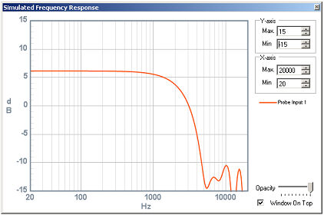
3.10 void spl_in_mute(unsigned long onoff)
Microphone input mute
Parameter (byte filter_type):
ON Mute OFF, default
OFF Mute ON

4. Demo

See demo folder

5. Appendix
5.1 Archo floating number conversion

Numerical Format: 5.23
Range: -16.0 to (+16.0 - 1 LSB)

Examples
1000 0000 0000 0000 0000 0000 0000 = -16.0
1110 0000 0000 0000 0000 0000 0000 = -4.0
1111 1000 0000 0000 0000 0000 0000 = -1.0
1111 1110 0000 0000 0000 0000 0000 = -0.25
0000 0000 0000 0000 0000 0000 0000 = 0.0
0000 0010 0000 0000 0000 0000 0000 = 0.25
0000 1000 0000 0000 0000 0000 0000 = 1.0
0010 0000 0000 0000 0000 0000 0000 = 4.0
0111 1111 1111 1111 1111 1111 1111 = 16.0

5.2 dB value conversion

Examples：convert -40dB to Hex format

20*log10(x/1) = -40dB => x = 0.01
0.01*2^23 = 83886.08
Hex value = 83886 = 0x00147AE

