

**VINCINITI**

**APT3065-A**

**SUPERVISOR: FREDRICK OGORE**

By

**CHELSY MWIKALI MUTUA**

**664631**

Clear Timelines

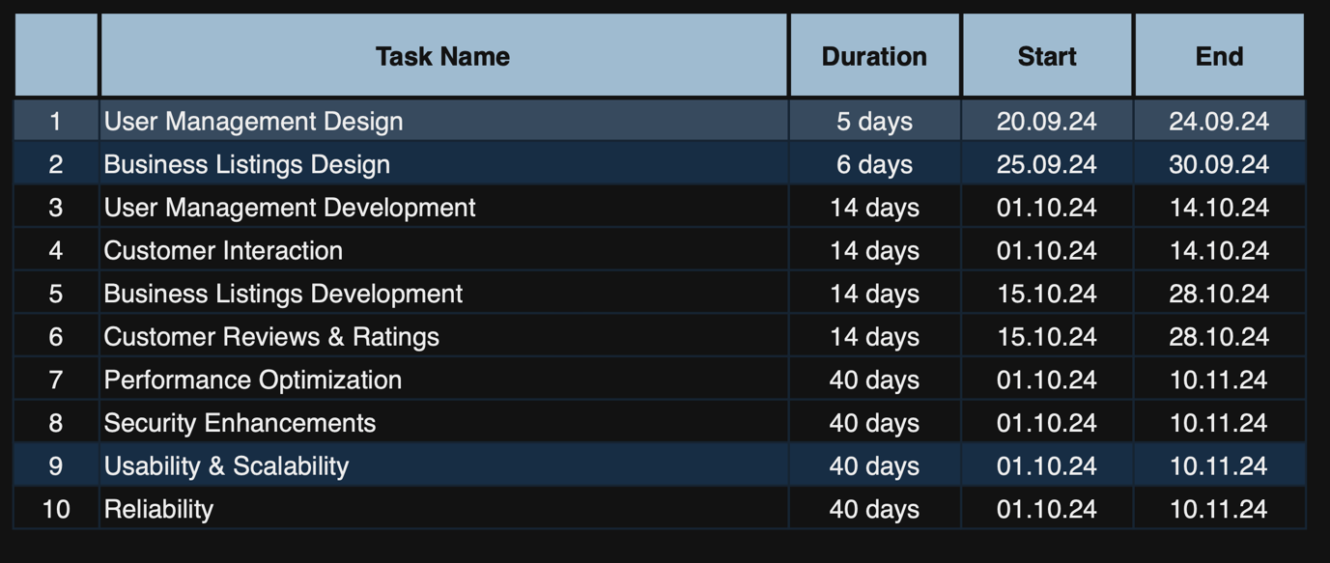

UI

