Chemistry Add-in for Word   
User’s Guide

Version 2.0 – Wednesday, July 6, 2016

Abstract

This document describes how to use the Chemistry Add-in for Word, an add-in for Microsoft Word that provides a simple and flexible way to include chemical information in a Word document.

**Note:**

* Most resources discussed in this paper are provided with the Chemistry Add-in package. For a complete list of documents and software discussed, see “Resources” at the end of this document.
* For Chemistry Add-in updates and software availability news, see   
  <http://chem4word.codeplex.com> or  
  <http://research.microsoft.com/chem4word/>
* For general news and discussion about the Chemistry Add-in for Word, please join our FaceBook page at  
  <http://www.facebook.com/home.php?sk=group_186300551397797>

***Disclaimer****: This document is provided “as-is”. Information and views expressed in this document, including URL and other Internet Web site references, may change without notice. You bear the risk of using it.*

*This document does not provide you with any legal rights to any intellectual property in any Microsoft product. You may copy and use this document for your internal, reference purposes.*

*© 2016 Outercurve Foundation. All rights reserved.*

*Microsoft and Windows are trademarks of the Microsoft group of companies.  Chemdoodle Web is a trademark of iChemLabs, LLC. All other trademarks are property of their respective owners.*

Contents

Introduction 3

Getting Started 4

Prerequisites 4

System Requirements 4

Installation 4

Auto Update 5

UI Overview 6

How to Create and Manage Chemistry Zones 7

Specify a Chemistry Zone’s Representation 8

Change a Zone’s Labels 9

Insert a Zone from the Chemistry Gallery 10

Insert a Chemistry Zone from the Web 12

Manage the Zones in the Chemistry Gallery 13

How to Manage Chemistry Zones with the ChemistryNavigator 14

Display Options 15

Import 16

Auto 16

Prompt 16

Strict (fail) 16

Depiction 17

Preferred Depiction 17

Navigator Box 17

Rendering 17

Render Atom Labels in Colour 17

Show Implicit Hydrogen labels 17

How to edit 2-D Structures 18

Basic ChemDoodle Functions 18

Group Buttons 19

Editor Shortcuts 19

When Atoms are Hovered 20

When Bonds are Hovered 20

Creating a New Structure 21

Editing an Existing Structure 22

Updating the Labels 22

Hydrogen Display 23

Loading and Saving from the Editor 24

Flipping and mirroring structures. 25

Bond Lengths 25

Error reporting 25

Resources 26

Appendix 1: CML Basics 28

CML Data Storage 28

Appendix 2: How CML Data is Stored in a Document 29

# Introduction

The Chemistry Add-in provides a simple and flexible way to include chemical information in a Word document.

With the Chemistry Add-in, you can:

* **Create inline "chemistry zones" to represent chemical data.**

Chemistry zones are controls that contain information about a molecule and display the information in a variety of ways. The underlying data is stored as Chemical Markup Language (CML), a widely used XML schema for representing chemical data. The data typically includes trivial and International Union of Pure and Applied Chemistry (IUPAC) names, the concise formula, and data for a 2-D structure.

* **Display chemical information in a variety of ways.**

A chemistry zone can display any representation that is supported by the underlying CML data. With a few clicks, you can switch from the molecule’s trivial name to its concise formula to its 2-D representation.

* **Draw and edit your own chemistry.**

The Chemistry Add-in supports ChemDoodle web, a fully featured structure editor. Draw your own structures from scratch or edit downloaded chemical structures. Export and import chemical strctures from MDL Mofile format.

* **Display print-quality 2-D chemical structures.**

Chemistry zones can represent molecules by displaying a 2-D structure diagram using publication-quality, resolution-independent graphics. The Chemistry Add-in also includes an editor that enables you to modify the structure. The diagram is inserted into the document as a DrawingML image, so that others can view it, whether or not they have installed the Chemistry Add-in on their system[1]. You can also publish a document authored using the Chemistry Add-in as a PDF file.

* **Accept chemical data in a variety of formats.**

You can create a “chemistry zone” by typing a simple common name such as “water”, and then using the Chemistry Add-in to convert it to your preferred representation.

* **Import CML files from online web services**

Using the **Load From** option in the ribbon, you can look up existing molecular structures from the NCBI’s PubChem (<http://pubchem.ncbi.nlm.nih.gov/>) or the Unilever Centre’s OPSIN (<http://opsin.ch.cam.ac.uk/>) databases.

* **Handle most molecules.**

The Chemistry Add-in can handle any molecule that has appropriate CML data. The Chemistry Add-in includes CML data for several hundred common molecules. For additional molecules, you simply create or obtain a CML file and import it into a document.

* **Store and expose chemical information in a semantically rich manner.**

The Chemistry Add-in supports publishing and data-mining scenarios for authors, readers, publishers, and other vendors across the chemical information community.

This paper describes how to use the Chemistry Add-in to include chemical information in a Word document.

# Getting Started

This section describes how to get started with the Chemistry Add-in.

## Prerequisites

You should have a basic understanding of:

* Microsoft Word
* Chemical nomenclature and diagrams

An understanding of CML is helpful but not required.

## System Requirements

Hardware Requirements

Any computer that can run Office 2007, Office 2010, Office 2013 or Office 2016.

Software Requirements

Your computer must have the following software:

Any version of Windows that can run Office 2007, Office 2010, Office 2013 or Office 2016, and Internet Explorer 9, which includes Windows Vista and later versions of Windows.

Word 2007 through to Word 2016.

For details on Office requirements, see the Resources section at the end of this document.

## Installation

The Chemistry Add-in is packaged in a file that contains the following files:

* Chem4Word.Setup.msi

Depending upon your computer’s configuration, you may need to install the primary Interop Assemblies for your current version of Office, and/or the Office Open XML Software Development Kit.

Installing Prerequisites

The Chemistry Add In requires these prerequisites

* Primary Interop Assemblies for Microsoft office
* OOXML Software development kit

Your computer may have these components installed already. The Installer will install these components if they are not already present.

To Install the Chemistry Add-in

1. Close all Word documents.

2. Copy the Chemistry Add-in .zip file to your hard drive.

3. Extract the contents of the .zip file to a folder.

4. Navigate to that folder and run Chem4Word.Setup.msi

5. Use the installation wizard to install the Chemistry Add-in.

To verify the installation, launch Word. The ribbon should now include a Chemistry tab, as shown in Figure 1.

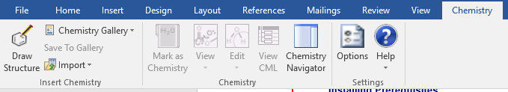

Figure 1. Word ribbon with Chemistry tab

**Tip:** The rest of the document will be easier to follow if you first install the Chemistry Add-in.

## Auto Update

If we have published a new version of Chemistry Add-In for Word since your last installation, the program will prompt you to install it. You can accept or decline this prompt without affecting your current installation. The auto-update will inform you of the new version available and their features:  
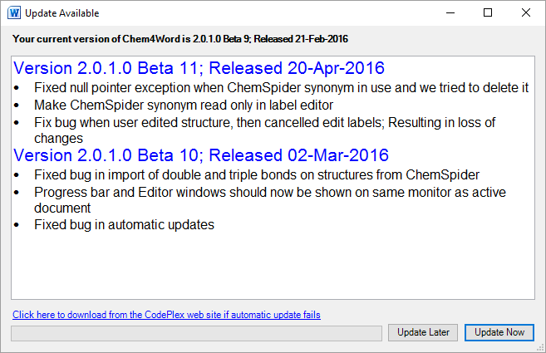

You can either opto to Update Now or Update Later. Update Now will shut down the add-in and install the new version.

# UI Overview

The Chemistry tab contains the primary user interface for the Chemistry Add-in, as shown in Figure 2.



Figure 2. Chemistry tab

The tab has three command groups:

Import

Import and save chemical data:

**Draw Structure** draws a completely new structure.

**Chemistry Gallery** displays a gallery of chemistry zones that can be inserted into a document.

**Save To Gallery** saves a chemistry zone to the Chemistry Gallery for easy re-use in later documents.

**Load From** imports a CML data file and adds it to the document

Chemistry

Manage chemistry zones:

**Mark as Chemistry** marks selected text as a chemistry zone.

* **View** enables you to select which representation of a molecule to display.

**Edit** displays the **Edit 2D** and **Edit Labels** options in order to modify the 2-D structure or the text associated with a zone.

**Chemistry Navigator** displays a panel that contains all the chemistry zones in the current document.

Settings

Manage the chemistry-related aspects of the document:

**Options** enables you to configure the Chemistry Add-in defaults.

**Help** displays the **Help** and **Check for updates** commands.

# How to Create and Manage Chemistry Zones

A chemistry zone displays data for a particular molecule, based on the molecule’s CML data. There are two kinds of chemistry zones: *textual* and *2D*. Textual chemistry zones are based on equation zones and have a similar UI. The 2D zones use a picture content control. This section shows how to use the commands from the **Chemistry** group to create and manage chemistry zones.

At its most basic level, a chemistry zone is simply a control that contains a selected block of text.

To create a chemistry zone from text

2. Click the **Mark as Chemistry** button and the corresponding text on the fly-out menu to create a chemistry zone for the selected text, as shown in Figure 3.

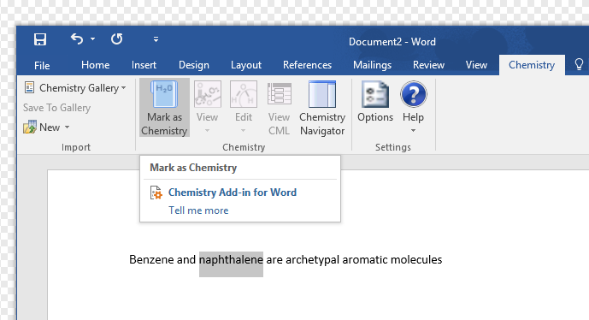

Figure 3. Creating a chemistry zone.

If you hover over a chemistry zone, Word highlights it. If you click the highlighted text, Word displays the zone UI, with a Chemistry label to identify it as a chemistry zone. Unlike Math equation zones, the chemistry zone UI does not display a dropdown menu. It simply indicates the zone’s type and extent.

Each chemistry zone is based on CML data that is included in the document. Marking text as a chemistry zone automatically creates a CML data region which only contains the selected text as a chemical name of unknown type.

## Specify a Chemistry Zone’s Representation

When you click **Mark as Chemistry**, the add-in adds the molecule’s CML data to the document, which includes:

* One or more text labels (a molecule’s CML data usually includes the IUPAC name and usually one or more trivial names).
* The concise formula (e.g. C6H6).
* 2-D structural data.

The benzene CML data contains two labels—the IUPAC name (benzene) and a trivial name (phenyl hydride)—the concise formula, and a set of 2-D data.

The CML infrastructure recognizes all of benzene’s names and its concise formula, so you can use any of them to enter benzene into your document and convert it to a chemistry zone. After you have converted an instance of “benzene”—or one of its equivalents—into a chemistry zone, you can easily change the representation.

To change a chemistry zone’s representation

1. Click the zone to select it.

2. Click the **Chemistry** group’s **View** command, which will display a drop-down list of the possible display options supported by add-in based on the molecule’s CML data. Figure 4 shows the dialog box for benzene.

3. Select the preferred representation from the list.

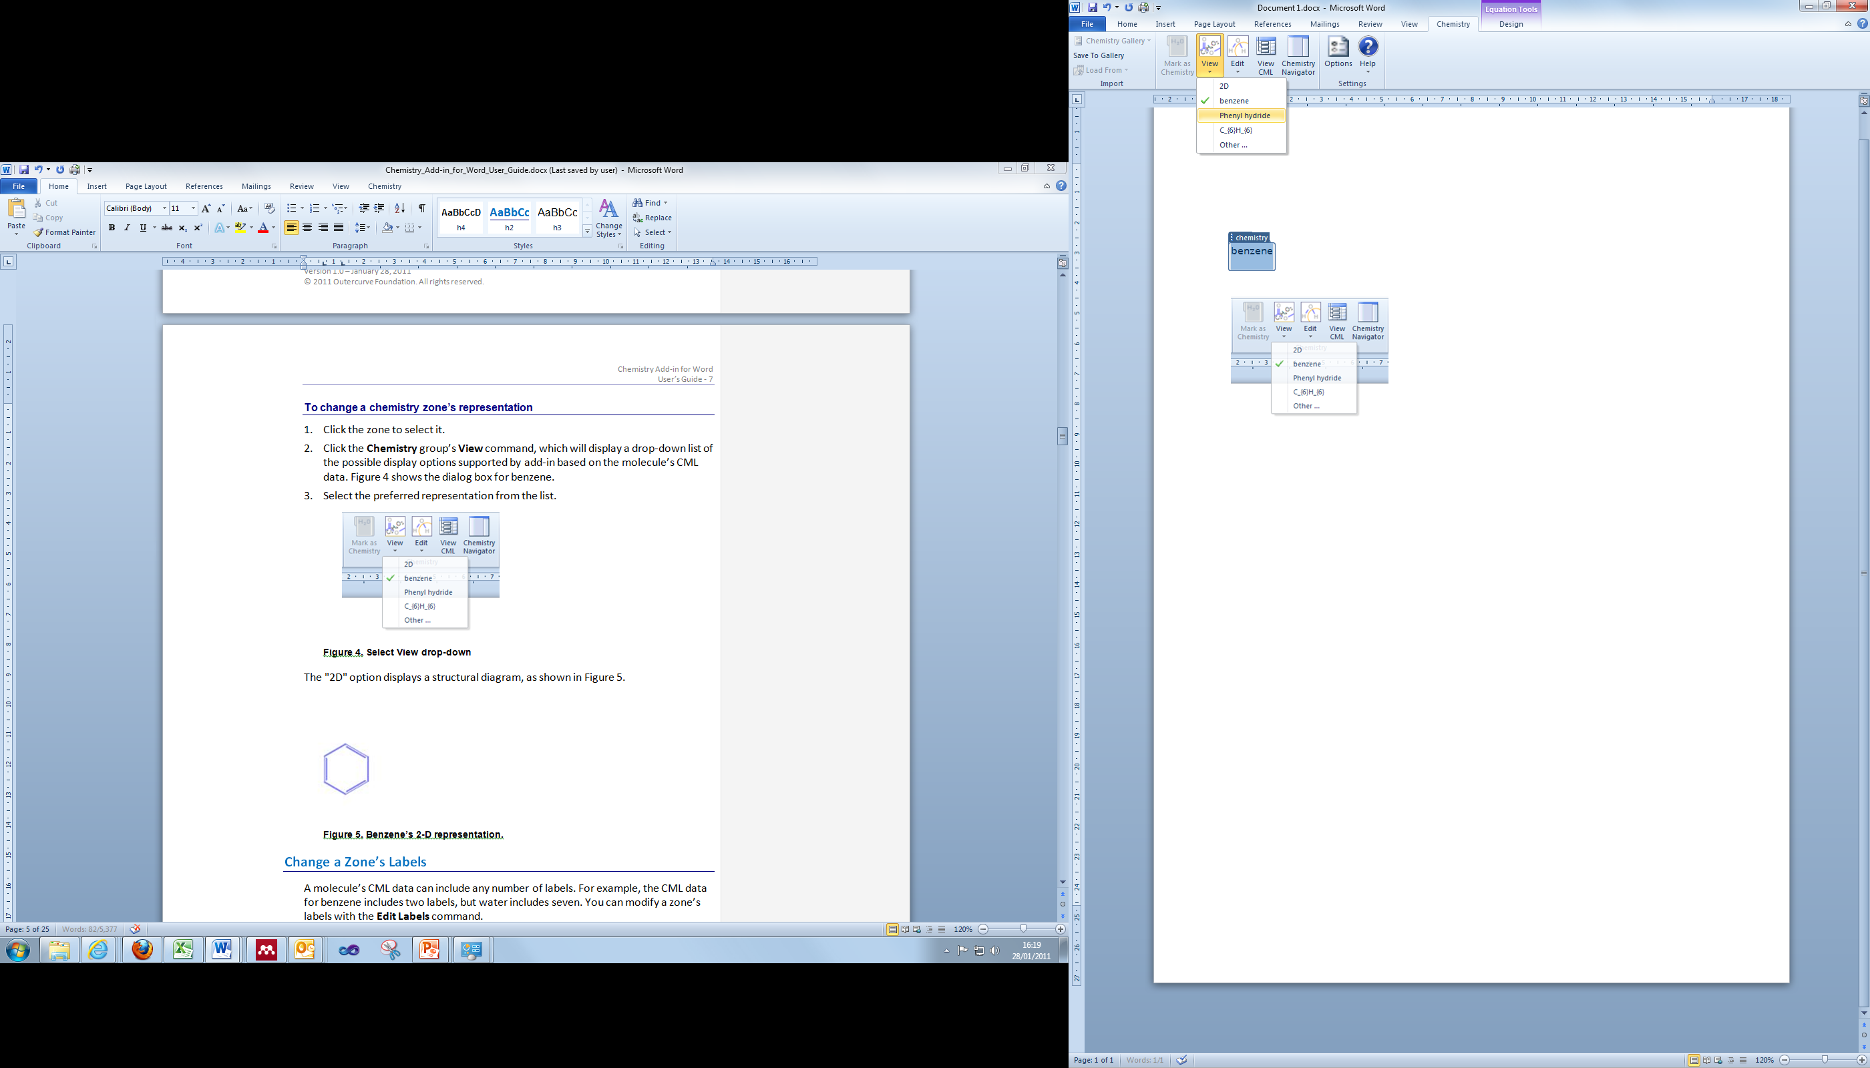

Figure 4. Select View drop-down

The "2D" option displays a structural diagram, as shown in Figure 5.

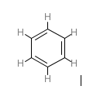

Figure 5. Benzene’s 2-D representation.

## Change a Zone’s Labels

A molecule’s CML data can include any number of labels. For example, the CML data for benzene includes two labels, but water includes seven. You can modify a zone’s labels with the **Edit Labels** command.

To modify a zone’s labels

1. Select the zone.

2. Click **Edit**, and then **Edit Labels**.

Figure 6 shows the **Edit Labels** dialog box for water.

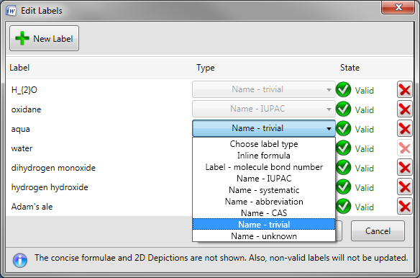

Figure 6. Edit Labels dialog box.

The Chemistry Add-in enables you to add or remove labels (if they are not being used in the document), or modify their properties.

To add a label

1. Click **New Label**, which displays an empty label field below the last label on the current list.

2. Type the new label’s name in the empty box.

3. Select the label type from the **Choose label type** dropdown to the right of the name. A label can have one of the types shown in Figure 6.

4. Click **OK** to add the new label to the zone’s CML.

You can remove labels or modify their properties.

* To remove a label, click the X at the label’s right edge.
* To modify a label’s text, click the text box and edit the text.
* To change the label type, select a new type from the dropdown.

When you are finished, click **OK** to accept the changes.

The changes apply only to the selected zone’s CML data—which is stored in the document—and to any linked zones. It does not change the CML file used to create the zone. If you use the procedure in the preceding section to create a new water zone, it will have a default set of labels. Linked zones are discussed later in this paper.

## Insert a Zone from the Chemistry Gallery

An alternative way to add chemistry zones to a document is the **Chemistry Gallery**, which contains a collection of zones that can be inserted directly into a document.

Figure 7 shows the first few items in the **Chemistry Gallery** that is included with the the Chemistry Add-in package.

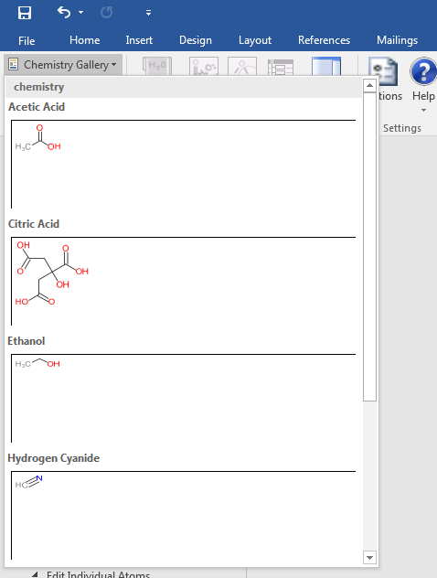

Figure 7. Chemistry Gallery

To insert a chemistry zone into a document from the Chemistry Gallery

1. Place the cursor at the appropriate place in the document.

2. Click **Chemistry Gallery** to display the gallery.

3. Click the appropriate molecule to insert the associated chemistry zone into the document.

4. Change the zone’s representation to the appropriate representation.

## Insert a Chemistry Zone from the Web

Although the add-in ships with several hundred CML files, you can also search the following online databases and import chemical structures directly:

* PubChem
  + <http://pubchem.ncbi.nlm.nih.gov/>
  + PubChem is a chemical structures database provided by the National Center for Biotechnology Information (NCBI), part of the U.S. National Library of Medicine
* OPSIN
  + <http://opsin.ch.cam.ac.uk/>
  + OPSIN is a database maintained by the University of Cambridge whch converts IUPAC compound names to semantic chemical information including a connection table.

To insert a chemistry zone from the web

1. Place the cursor at the appropriate place in the document.
2. Click **Load From** in the Import section of the ribbon
3. Select **PubChem**

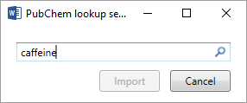

1. Type in your search term, and click the magnifying glass icon 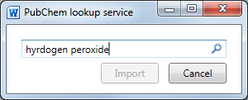
2. Select the desired search result from the list, and click Import.  
   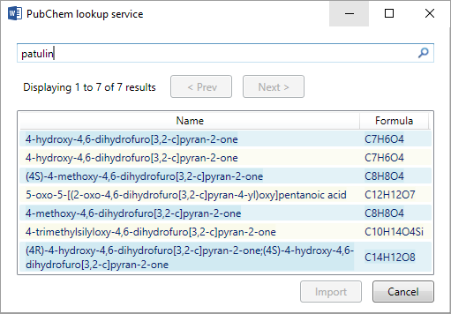

## Manage the Zones in the Chemistry Gallery

You can customize the **Chemistry Gallery** for your particular project or group by adding new zones in either of two ways:

* Insert a zone from your document.
* Import a CML file, to add zones that are not already included with the Chemistry Add-in.

This option is discussed in “How to Import Chemical Data,” later in this document.

To add a zone

1. Select the appropriate 2D chemistry zone.

2. Click **Save to Gallery**.

3. Specify a name for the zone and click **OK** to add the zone to the gallery.

It is only possible to add 2D zones to the gallery

Each item in the **Chemistry Gallery** represents a particular chemical zone, not necessarily a unique molecule. For example, if you modify a benzene zone by adding a new label or changing the 2-D representation, you can add that zone to the gallery as a separate item.

To move or delete a zone

1. Open the **Chemistry Gallery** and right click a zone to display the **Chemistry Gallery** popup.

2. Click **Organize** **and** **Delete** to display the **Building Blocks Organizer** dialog box.

3. Use the dialog box to modify the zone order, or delete zones.

The **Chemistry Gallery** zones are in the **Custom 5** gallery.

# How to Manage Chemistry Zones with the ChemistryNavigator

The **Chemistry Navigator** helps you manage a document’s chemistry zones. To open the manager, click the **Chemistry Navigator** command, which opens the **Chemistry Navigator** panel on the right side of the document.

The **Chemistry Navigator** panel shows every chemistry zone in the document in document order: left to right, top to bottom, as shown in Figure 8.

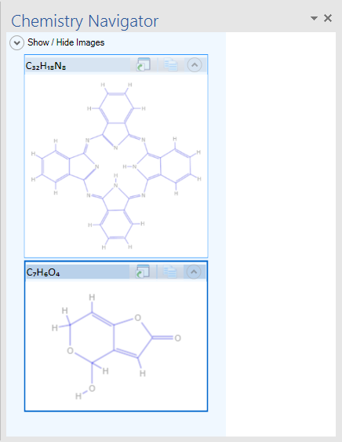

Figure 8. Chemistry Navigator panel

The items are represented in the panel by the preferred navigator depiction, followed by the 2-D representation[2] where possible. The images size with the molecule to make them easy to read.

There are two zone types:

* ***Unlinked zones***: independent entities that have their own CML data.

You can change an unlinked zone’s representation or modify its labels or 2-D structure without affecting any other zone, even those that represent the same molecule.

* ***Linked zones***: a collection of zones that are based on the same stored CML data.

If, for example, you change a particular linked zone’s representation or modify its 2-D structure, you also change every other zone in the collection.

You can use **Chemistry Navigator** to insert linked or unlinked zones by using the buttons to the right of the appropriate concise formula, as shown in the second instance of C6H6 in Figure 8.

To insert a linked zone

1. Place the cursor at the appropriate place in the document.

2. Click the link icon (left) to insert the zone.

3. Specify the preferred representation in the document from the drop-down.

The new linked zone appears in the **Chemistry Navigator** in the appropriate document position.

**Note:** You must create the first instance of a linked zone by using the techniques discussed earlier in this paper. Then you can use Chemistry Navigator to insert additional instances.

To insert an unlinked zone

1. Place the cursor at the appropriate place in the document.

2. Click the unlinked icon (right) to insert the zone.

3. Specify the preferred representation in the document from the drop-down.

The new unlinked zone appears in the **Chemistry Navigator** in the appropriate document position.

# Display Options

The add-in allows you to customize the display of chemical structures. Click the Options button on the toolbar to bring up the dialog:



The dialog contains three tabs:

## Import

This option allows you to specify what happens when the CML you are importing is broken:  
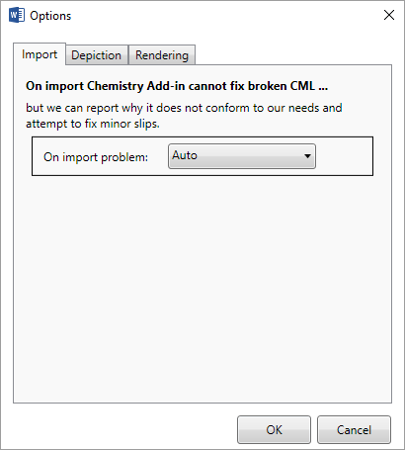

### Auto

Skips over CML errors and imports what it can.

### Prompt

Alerts you to the presence of errors and asks you if you want to continue importing

### Strict (fail)

Alerts you to the presence of errors and fails to import any chemistry.

## Depiction

This tab controls how the add in displays imported CML:  
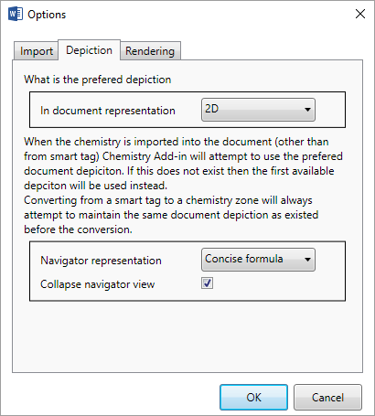

### Preferred Depiction

Choses a depiction option for the imported CML. The default is 2-D.

### Navigator Box

This allows you to choose how the Navigator displays structures.

## Rendering

Controls how structures are displayed in Word 2010 and better.

### Render Atom Labels in Colour

Heteroatoms are rendered using specific colours. If unchecked, this option will render them in black only.

### Show Implicit Hydrogen labels

Implicit hydrogen atoms will be shown by default. Unchecking this option will hide them.

# How to edit 2-D Structures

The add-in uses the ChemDoodle Web™ editor. You can activate the editor by creating a new structure or opening an existing one. When you have finished editing you can save the changes back to the document.

After an editing operation, the add-in check the new structure and allows you to revise any of its labels.

## Basic ChemDoodle Functions

The buttons presented on top of the sketcher provide the following functionality It should also be noted, that in all states, the user can use the mouse wheel to scale the sketcher rendering. Users can also click and drag on the background, with nothing hovered, to move the entire molecule. If the shift key is held while dragging the background, the entire molecule will be rotated. Double-clicking on the background will centre the molecule

 **Move** – Puts the sketcher into move mode. Highlighting an atom or bond and then pressing the mouse down and dragging will translate those objects. This tool is only available in the Single Molecule Sketcher.

 **Clear** – Clears the sketcher. In the Single Molecule Sketcher, this leaves a single carbon atom.

 **Erase** – Puts the sketcher into erase mode. In the Full Sketcher, deleting a bond will remove that bond and deleting an atom will remove that atom and any attached bonds. In the Single Molecule Sketcher, highlighting an atom and clicking will remove that atom and any small disconnected fragments, leaving the largest fragment remaining. Highlighting a bond and clicking will only have an effect if that bond is part of a ring, and in that case it will remove that bond.

 **Undo** – Undoes the last performed action.

 **Redo** – Redoes the last undone action.

 **Zoom in** – Increases the rendering scale of the sketcher.

 **Zoom Out** – Decreases the rendering scale of the sketcher.



**Labels** – After an element has been selected, hover an atom and click to change that atom’s label to the selected element symbol. If you press the mouse down and drag to the edge of the optimize zone, a new bond will sprout from that atom to the label in an optimal position. Drag out of the optimize zone and/or use the *shift*/*alt* keys to place a bond to this label anywhere.

 **Periodic Table** – Pops up a periodic table to select a symbol. After a symbol has been selected, hover an atom and click to change that atom’s label to the selected element symbol. Press the **Close** button to close it.

 **Bonds** – After a bond type has been selected, hover an atom and press the mouse down to begin drawing a new bond of that type. Drag and place the preview to the preferred position and then release the mouse to place the bond. The optimize zone (blue circle) is provided to help place the bond in the optimal position when the mouse pointer is within the bounds of the circle. Hover a bond and click to change that bond’s type to the selected type. The single bond tool is special and will add to bond orders instead of overriding them. Hold down the *shift* key to modify standard lengths and hold down the *alt* key to modify standard angles.

 **Rings** – After a ring type has been selected, hover an atom and press the mouse down to begin drawing a new ring of that type. Drag and place the preview to the preferred position and then release the mouse to place the ring. The optimize zone (blue circle) is provided to help place the ring in the optimal position when the mouse pointer is within the bounds of the circle. Hover a bond and press the mouse down to begin drawing a ring from that bond. Drag the preview to either side of the bond and then release the mouse to place the ring. Hold down the *shift* key to modify standard lengths and hold down the *alt* key to modify standard angles.

** Charges** – After a charge sign has been selected, hover an atom and click the mouse to add or subtract from that atom’s charge amount.

 **Lone Pairs** – After a lone pair icon has been selected, hover an atom and click the mouse to add or remove a lone pair from that atom.

 **Radicals** – After a lone pair icon has been selected, hover an atom and click the mouse to add or remove a lone pair from that atom.

### Group Buttons

 At the end of some button groups, there is a small button with a downwards facing arrow. This means that there are more options available for this button set. Just click on this downwards facing arrow and select an option. The button adjacent to the downwards facing arrow will pick up this option and will be automatically selected for use.

## Editor Shortcuts

Editor shortcuts are executed by holding down the Control key and pressing one of the following keys:

|  |  |
| --- | --- |
| **a** | Selects all content in the Full Sketcher. |
| **n** | Clears the sketcher, leaving a lone carbon atom. |
| **o** | Pops up a window to load a chemical file. |
| **s** | Pops up a window to save the structure in the sketcher in a chemical format. |
| **y** | Redoes the last undone action. |
| **z** | Undoes the last performed action. |
| **+** | Zooms in. |
| **-** | Zooms out. |

### When Atoms are Hovered

When an atom is hovered, the following shortcuts will be active. An atom is hovered if the mouse is close enough to the atom such that the atom is surrounded by an amber circle.

|  |  |
| --- | --- |
| **Alphabet** | Cycles the hovered atom’s label through the element symbols that begin with that letter of the alphabet. |
| **Digits** | Adds a carbon chain with length equal to the digit pressed in the most optimal orientation. The 0 key will add a chain of length 10. |
| **Shift+Digits** | Adds a ring with number of sides equal to the digit pressed (3+) in the most optimal orientation. |
| **Delete/Backspace** | Removes the hovered atom and any attached bonds and any small attached bonds. Leaves the largest fragment remaining in the Single Molecule Sketcher. |
| **+/-** | Increase/Decrease the charge amount of the atom. |

### When Bonds are Hovered

When a bond is hovered, the following shortcuts will be active. A bond is hovered if the mouse is close enough to the center of the bond such that the bond is encapsulated by two amber semicircles.

|  |  |
| --- | --- |
| **Digits** | Changes the bond’s order to the digit. Only 1-3 work. 7 will change the bond to a protruding bond and 8 will change it to a recessed bond. |
| **Shift+Digits** | Adds a ring with number of sides equal to the digit pressed (3+) in the most optimal orientation. |
| **Delete/Backspace** | Removes the hovered bond. In the Single Molecule Sketcher, the bond is removed if and only if that bond is a member of a ring. |
| **f** | Flip the bond orientation. |

## Creating a New Structure

To create a new structure, click the **Draw Structure** button:

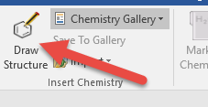

The add in-inserts a single carbon atom as a placeholder and then opens the ChemDoodle™ Web editor.   
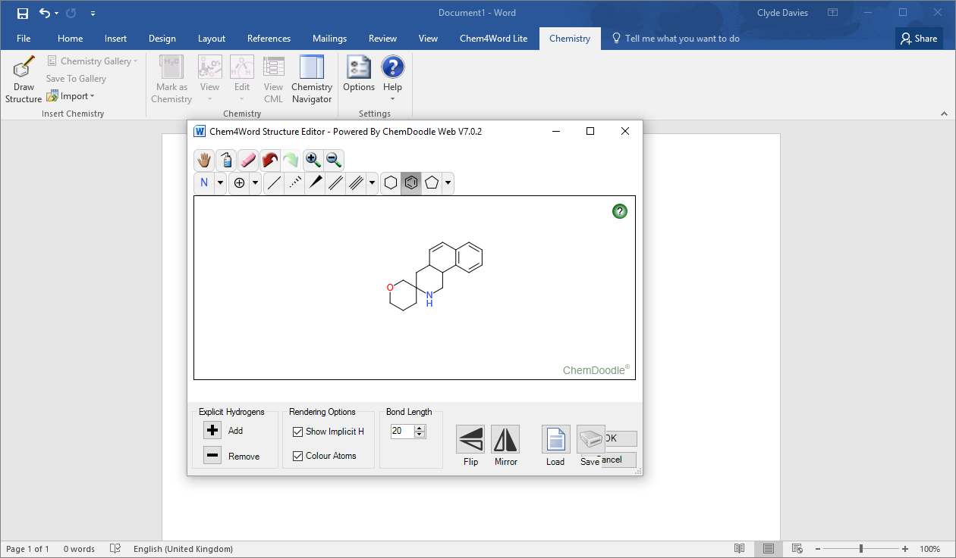

Click the OK button when you have finished editing the structure.

## Editing an Existing Structure

Editing an existing structure is straightforward. Double click the structure to open the ChemDoodle editor:  
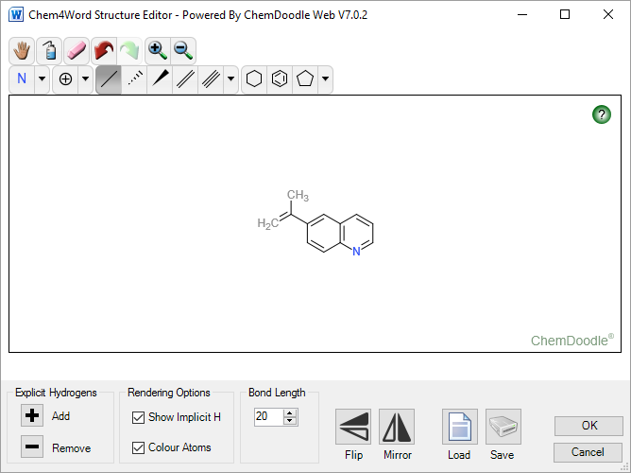

You can make changes and then save them back to the document by clicking the **OK** button.

### Updating the Labels

Any changes you make will cause the add-in to prompt you to review the labels for the structure. You can remove labels or change them. Click the red X button next to a label to remove it from the structure, and the new Label button to create a new label:  
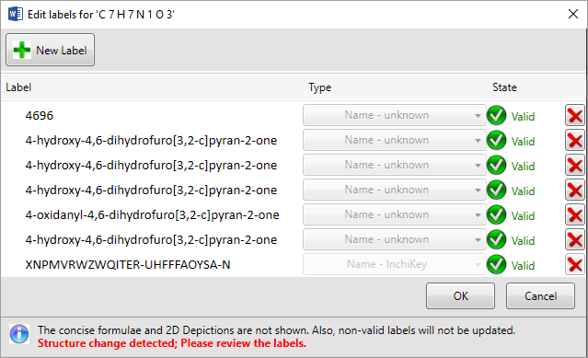

The add-in generates an INChIKey for the structure an uses this to compare it agianst its orginal representation. If the two do not match, then it will ask you to review existing labels.

### Hydrogen Display

The editor allows you to manage display of hydrogen atoms. There are two kinds of hydrogens that can be displayed: explicit and implicit.

**NB: Using the Explicit hydrogen + or - buttons actually modifies the structure by adding hydrogen atoms to it or removing them. Implicit hydrogen display simply shows the presence of inferred hydrogens and does not modify the structure.**

#### Explicit Hydrogens

These may be added or removed to unused valences by clicking the + and – buttons under the Explicit Hydrogen group box.

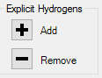

#### Rendering Options

The add-in infers the existence of these by counting unused valences. Click the checkbox for Implicit Hydrogens to toggle display:  
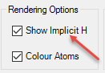

Here you can also toggle rendering of atom labels on colour or black.

This table shows the effect of these actions on structural display for a typical organic molecule (patulin):

|  |  |  |
| --- | --- | --- |
| **Implicit Hydrogen** | **Explicit Hydrogen** | **Structure** |
| Off or On | Added |  |
| Off | Removed |  |
| On | Removed |  |

### Loading and Saving from the Editor

The Editor allows you to import and export to CML and MDL Molfile™ formats directly.

#### Importing

Click the Import File Button to import directly into the Editor:  
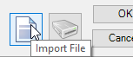

The Import function supports CML and MDL Molfile™ formats.

#### Exporting

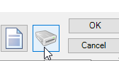

Click the Export file button to export the current drawing to CML or MDL Molfile™ formats.

### Flipping and mirroring structures.

The Flip and Mirror buttons reflect the structure in the vertical and horizontal planes:  
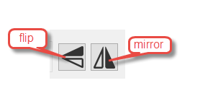

### Bond Lengths

The bond length control specifies the length in pixels of a bond. The default is 20, but you can change this in increments of 5 using the spinner buttons (or type a value in directly).

Changing the bond length affects existing as well as new bonds.   
You can use this to change the size of the rendered image in Microsoft Word.

# Error reporting

If a serious error occurs while you are using the add-in, you will see the following dialog. Please describe what you were doing whern the error occurred. The program will record the error and the circumstances under which it happened. This will help us to fix any bugs.

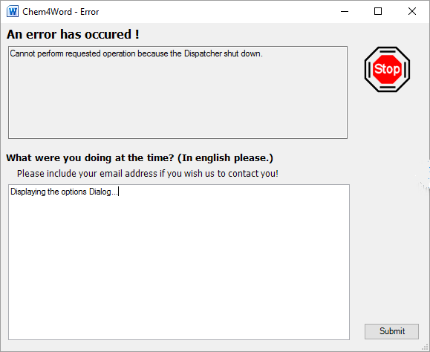

# Resources

This section provides links to additional information about the Chemistry Add-in.

2007 Microsoft Office system requirements

<http://office.microsoft.com/en-us/products/HA101668651033.aspx>

2010 Microsoft Office system requirements

http://technet.microsoft.com/en-us/library/ee624351(office.14).aspx

cml.sourceforge.net - OpenSource Site for CML

<http://cml.sourceforge.net/>

Ecma Office Open XML File Formats overview

<http://office.microsoft.com/en-us/products/HA102058151033.aspx>

ISO Standard

http://www.iso.org/iso/iso_catalogue.htm

Open XML Formats

<http://www.openxmldeveloper.org>

JUMBO FAQ

<http://www.ch.ic.ac.uk/omf/cml/doc/jumbo/faq.html>

Office Development with Visual Studio Developer Center

<http://msdn.microsoft.com/en-us/vsto/default.aspx>

PubChem

<http://pubchem.ncbi.nlm.nih.gov/>

# Appendix 1: CML Basics

CML is an XML-based format for representing a wide range of chemical data. The Chemistry Add-in uses a subset of CML, the molecular convention, which includes support for:

* IUPAC and other names
* Chemical structure
* Formulae

The following example shows the CML data for water.

<?xml version="1.0" ?>

<cml convention="conventions:molecular"

xmlns="http://www.xml-cml.org/schema"

xmlns:conventions="http://www.xml-cml.org/convention/"

xmlns:nameDict="http://www.xml-cml.org/dictionary/cml/name/">

<molecule id="m1">

<name dictRef="nameDict:trivial">H_{2}O</name>

<name dictRef="nameDict:iupac">oxidane</name>

<name dictRef="nameDict:trivial">aqua</name>

<name dictRef="nameDict:trivial">water</name>

<name dictRef="nameDict:systematic">dihydrogen monoxide</name>

<name dictRef="nameDict:systematic">hydrogen hydroxide</name>

<name dictRef="nameDict:trivial">Adam's ale</name>

<formula concise="H 2 O 1" />

<atomArray>

<atom id="a1" elementType="O"

x2="-1.5950000286102295" y2="1.1549999713897705" />

<atom id="a2" elementType="H"

x2="-0.05500002861022946" y2="1.1549999713897705" />

<atom id="a3" elementType="H"

x2="-2.3650000286102295" y2="2.4886790932178062" />

</atomArray>

<bondArray>

<bond id="b1" atomRefs2="a1 a2" order="1" />

<bond id="b2" atomRefs2="a1 a3" order="1" />

</bondArray>

</molecule>

</cml>

The data is typical for the Chemistry Add-in molecules, and includes:

* The IUPAC name
* Several trivial and systematic names
* 2-D structural data, including atom positions and bonding details

For a summary of the commonly used CML elements in the molecular convention, see <http://www.xml-cml.org/convention/>. For details on CML, including the current schema and related tools, see <http://www.xml-cml.org/> and “cml.sourceforge.net - OpenSource Site for CML.”

## CML Data Storage

The Chemistry Add-in stores CML data in the following ways

* The Chemistry Add-in Smart Tag folder contains CML data for several hundred common molecules.

To simplify chemistry zone creation, many molecules are represented by smart tags, as discussed in the next section. The associated data for each molecule is in a .cml file in the add-in’s Smart Tag folder, which is typically C:\Program Files \Chem4Word\Smart Tag.

* The Chemistry Gallery is a Word gallery that contains a collection of chemistry zones.

The gallery typically enables users to quickly find and insert a zone into a document. It usually contains a small collection of commonly used molecules and users can customize the collection, as appropriate. The Chemistry Gallery has its own backing data; a set of .cml files in the add-in’s C:\Program Files\Chem4Word\data folder.

* When a user inserts a chemistry zone into a document, the associated CML data is stored in the document.

Some commands modify the embedded CML data in various ways, such as adding trivial names or modifying the 2-D structure. However, these commands affect only the data that is stored in the document.

# Appendix 2: How CML Data is Stored in a Document

A Word document is basically a structured collection of files, stored a ZIP-compatible Open Package Convention (OPC) format. The document has a .docx extension, but you can use Windows Explorer to examine the contents of a Word document by simply changing the extension to .zip.

**Tip:** Although you can see the contents of a .zip file in Windows Explorer, the contents are easier to work if you first extract them to a folder.

Figure 4 shows the contents of a document named Chem4Word_Example, which was saved after creating a “benzene” chemistry zone.

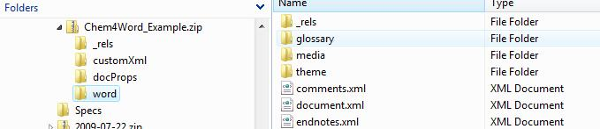

Figure 4. Word document structure

The document is primarily a collection of XML files. Figure 3 shows the Word folder, which contains the document’s primary files. In particular, document.xml contains the body of the document in Office Open XML (OOXML) format. For more information on OOXML, see “Ecma Office Open XML File Formats overview.”

Chemistry zones are represented in document.xml by a structured document element (<w:sdt>). The Chemistry Add-in identifies the associated XML block as a chemistry zone by setting the **alias** element's **val** attribute to “chemistry”. The following example shows the chemistry zone XML for benzene:

<w:sdt>

<w:sdtPr>

<w:alias w:val="chemistry"/>

<w:id w:val="23589811"/>

<w:placeholder>

<w:docPart w:val="DefaultPlaceholder_22675703"/>

</w:placeholder>

</w:sdtPr>

<w:sdtContent>

<m:oMath>

<m:r>

<m:rPr>

<m:sty m:val="p"/>

</m:rPr>

<w:rPr>

<w:rFonts w:ascii="MS ChemSans" w:hAnsi="MS ChemSans "/>

</w:rPr>

<m:t>benzene</m:t>

</m:r>

</m:oMath>

</w:sdtContent>

</w:sdt>

The zone’s CML data is stored separately, in the document’s customXml folder. The zone’s **id** element links the zone to the associated CML data file. Figure 5 shows a portion of the Chem4Word_Example’s customXml folder. The itemN.xml files contain various types of custom XML data, including the CML data. The numbering scheme is not related to the contents of the file. For this example, the benzene CML data is in item8.xml.

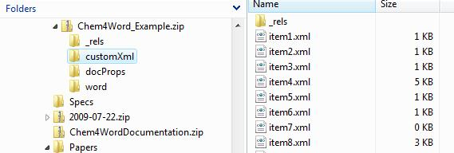

Figure 5. The customXml folder

The benzene chemistry zone was created with a smart tag, so item8.xml contains the CML-formatted data from benzene’s CML file in the Smart Tag folder, 241.cml.

<cml xmlns="http://www.xml-cml.org/schema"

xmlns:nameDict="http://www.xml-cml.org/dictionary/cml/name/"

xmlns:cmlDict="http://www.xml-cml.org/dictionary/cml/"

xmlns:conventions="http://www.xml-cml.org/convention/"

convention="conventions:molecular">

<molecule id="m1" formalCharge="0" spinMultiplicity="1">

<name dictRef="nameDict:iupac">benzene</name>

<name dictRef="nameDict:trivial">Phenyl hydride</name>

<formula concise="C 6 H 6"/>

<atomArray>

<atom id="a1" elementType="C" x2="-1.924" y2="-5.774"/>

<atom id="a2" elementType="C" x2="-3.258" y2="-6.544"/>

<atom id="a3" elementType="C" x2="-3.258" y2="-8.085"/>

<atom id="a4" elementType="C" x2="-1.924" y2="-8.855"/>

<atom id="a5" elementType="C" x2="-0.591" y2="-8.085"/>

<atom id="a6" elementType="C" x2="-0.591" y2="-6.544"/>

<atom id="a7" elementType="H" x2="-1.924" y2="-4.234"/>

<atom id="a8" elementType="H" x2="-4.592" y2="-5.774"/>

<atom id="a9" elementType="H" x2="-4.592" y2="-8.855"/>

<atom id="a10" elementType="H" x2="-1.924" y2="-10.395"/>

<atom id="a11" elementType="H" x2="0.742" y2="-8.855"/>

<atom id="a12" elementType="H" x2="0.742" y2="-5.774"/>

</atomArray>

<bondArray>

<bond id="b1" atomRefs2="a1 a2" order="S" />

<bond id="b2" atomRefs2="a2 a3" order="D" />

<bond id="b3" atomRefs2="a3 a4" order="S" />

<bond id="b4" atomRefs2="a4 a5" order="D" />

<bond id="b5" atomRefs2="a5 a6" order="S" />

<bond id="b6" atomRefs2="a1 a6" order="D" />

<bond id="b7" atomRefs2="a1 a7" order="S" />

<bond id="b8" atomRefs2="a2 a8" order="S" />

<bond id="b9" atomRefs2="a3 a9" order="S" />

<bond id="b10" atomRefs2="a4 a10" order="S"/>

<bond id="b11" atomRefs2="a5 a11" order="S"/>

<bond id="b12" atomRefs2="a6 a12" order="S"/>

</bondArray>

</molecule>

</cml>

This data set contains the following benzene-related data:

* The IUPAC name (benzene).
* A trivial name (phenyl hydride).
* The concise formula (C6H6).
* Data that can be used to create a 2-D structural diagram.

1. Only available in Word 2010 or later versions. Earlier versions display structures as PNG graphics.
2. The Navigator displays structures using a bitmap rendering, instead of the more modern vector-based rendering used in the main document.