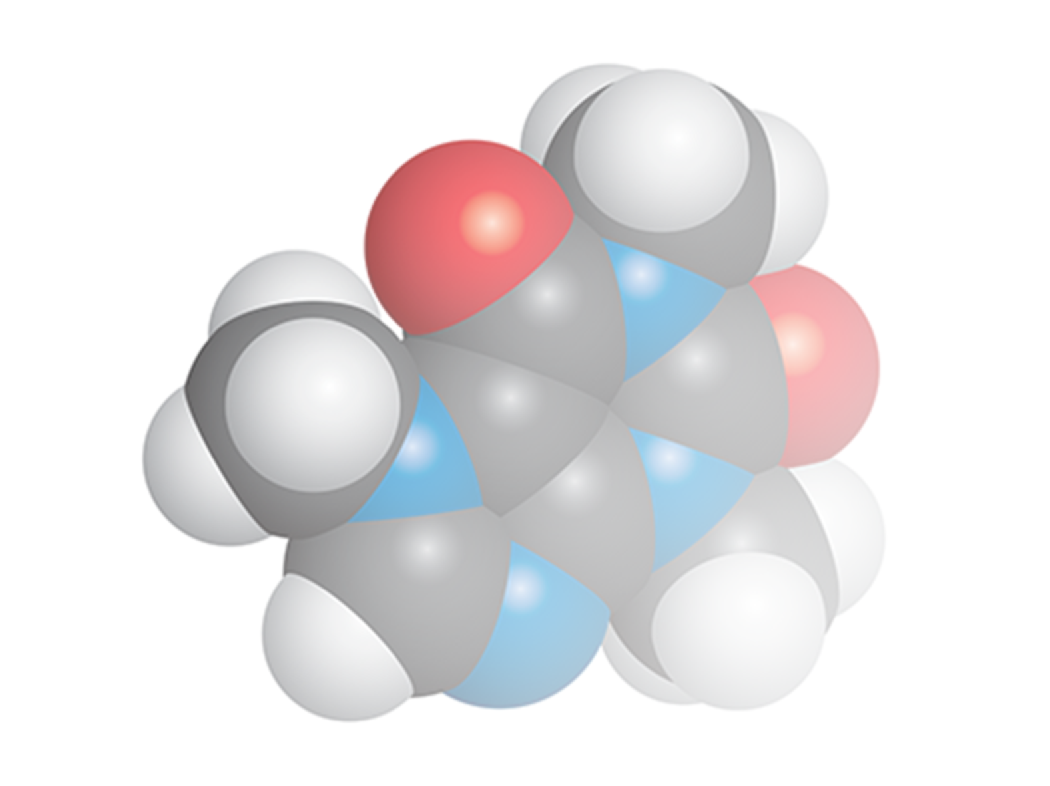**Chemistry Add-in for**

**Microsoft Word**

**User Guide**

**Version 2020**

Table of Contents

Introduction 5

Prerequisites 6

System Requirements 6

Installation 6

To Install Chem4Word 6

Auto Update 7

Legacy documents 9

How to add a chemical structure to a document 9

Import a structure from a file 9

Add a structure from a web-search 9

PubChem search 10

ChEBI Search 11

How to edit an existing chemical structure 11

Convert text to Chemistry 12

Display options for Chemistry 13

The Library 13

The Navigator 15

Exporting chemistry files 16

Chem4Word Options 17

Plug-Ins Tab 17

Editor Options 18

Renderer Options 18

Searcher Options 19

General Tab 20

Privacy Tab 21

Library Tab 22

Maintenance Tab 23

What is ACME? 23

‘Advanced’ 23

‘CML-Based’ 24

‘Molecule Editor’ 24

What functions does ACME support? 24

What functions *doesn’t* ACME support? 24

ACME User Interface 24

Toolbar 26

Highlighting Active Atoms and Bonds 26

Element Selector and Periodic Table Picker 26

Bond Dropdown 27

Draw Button 28

Select Button 32

Ring Button 39

Chain Button 41

Erase Button 41

Cut, Copy and Paste Buttons 42

Undo and Redo Buttons 44

Mirror Buttons 44

Add/Remove Explicit Hydrogens 45

Group and Ungroup Buttons 47

Bond Length Dropdown 49

Settings Button 49

Atom properties 49

Setting Elements or Functional groups 50

Setting a Functional Group 51

Setting Charges 51

Setting Isotopes 51

Togging explicit carbon display 52

Bond Properties 52

Setting Bond Order 53

Setting placement 53

Molecule properties 55

Setting radicals and charges 55

Multiplicity 55

Bracketing 55

ChemDoodle Web Sketcher 56

Draw a structure 56

Hydrogen Display 57

Flipping and mirroring structures. 58

Bond Lengths 58

ChemDoodle Web Commands 59

# Introduction

The Chemistry Add-in, or Chem4Word for short, provides a simple and flexible way to include chemical information in a Word document.

With the Chem4Word, you can:

* **Create inline "chemistry zones" to represent chemical data.**

Chemistry zones are controls that contain information about a molecule and display the information in a variety of ways. We store the underlying data as Chemical Markup Language (CML). This is a widely used XML dialect for representing chemical data. It typically includes trivial and International Union of Pure and Applied Chemistry (IUPAC) names, the concise formula, and the structural formula.

* **Display chemical information in a variety of ways.**

A chemistry zone can display any representation that is supported by the underlying CML data. With a few clicks, you can switch from the molecule’s trivial name, to its concise formula or then to its 2-D representation.

* **Draw and edit your own chemistry.**

New to this version of Chem4Word is ACME, a molecule editor. We wrote this to work specifically with the add-in. ACME is an intuitive chemistry sketcher that enables us to further develop the add-in and add more features. More information about ACME can be found on on page 18 of this guide.

Chem4Word also supports ChemDoodle web, the molecule editor used with the previous version of the add-in. Whichever sketcher you use is up to you!

* **Display print-quality 2-D chemical structures.**

Chemistry zones can represent molecules with a 2-D structure diagram using publication-quality, resolution-independent graphics. We insert the diagram as a DrawingML image, so that others can view it. They do not need Chem4Word installed on their system[1]. You can also publish a document authored using Chem4Word as a PDF file.

* **Accept chemical data in a variety of formats.**

You can create a chemistry zone by typing a simple common name such as ‘pinene’, and then using Chem4Word to convert it to your preferred representation, if the name you type exists in your library.

* **Import CML files from online web services**

Using the **Load From** option in the ribbon, you can look up existing molecular structures from the NCBI’s PubChem (<http://pubchem.ncbi.nlm.nih.gov/>), the Unilever Centre’s OPSIN (<http://opsin.ch.cam.ac.uk/>) or the European Bioinformatics Institute’s ChEBI (<https://www.ebi.ac.uk/chebi/>) databases.

* **Handle most molecules.**

Chem4Word can handle any molecule that has appropriate CML data.

* **Store and expose chemical information in a semantically rich manner.**

Chem4Word supports publishing and data-mining scenarios for authors, readers, publishers, and other vendors across the chemical information community.

This manual describes how to use Chem4Word to include chemical information in a Word document.

## Prerequisites

You should have a basic understanding of:

* Microsoft Word
* Chemical nomenclature and diagrams

An understanding of CML is helpful but not required.

## System Requirements

Hardware Requirements

Any Windows-based computer that can run Office 2010, Office 2013 or Office 2016/O365/2019.

Software Requirements

Your computer must have the following software:

Windows 7 or later, including Internet Explorer 11. Your operating system must have the latest Windows updates installed.

Word 2010, 2013, 2016/O365/2019.

.NET Framework 4.6.2 or greater.

Installation will be halted if Word is detected as running.

Chem 4Word needs an internet connection to function properly. Access to <https://www.chem4word.co.uk> is required during installation and for automatic checking for updates thus should not be blocked by a firewall.

NB: Chem4Word does not work with Word for Macintosh, or online versions of Word. These programs do not work in the same way as the Windows versions of Word.

## Installation

Installation is straightforward. Depending upon your computer’s configuration, it may need to install the Visual Studio Tools for Office for your current version of Office.

### To Install Chem4Word

1. Close all Word documents.
2. Download the file **Chem4Word-Setup.exe** to your hard drive from our releases area on GitHub via <https://www.chem4word.co.uk/download> This will always point you to the latest version.
3. Navigate to your Downloads folder, then run **Chem4Word-Setup.exe**
4. The setup programme will download and install any missing system components.
5. Once you have these pre-requisites, the installer will be downloaded and will be started to install Chem4Word.

To verify the installation, launch Word. The ribbon should now include a Chemistry tab:

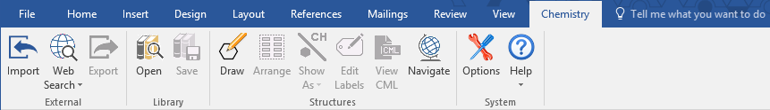

The Ribbon has four command groups

* **External**
  + **Import** – This allows importing files in CML, SDFile or MOLFile format.
  + **Web Search** – This allows you to search the web for structures
  + **Export** – This allows you to export your structures to cml or MOLFile format for sharing
* **Library**
  + **Open** – This shows the library in the left-hand pane
  + **Save** – This saves the currently selected structure into your library
* **Structures**
  + **Draw / Edit**
  + **Arrange** – This will re-arrange multiple molecules in a single structure so that they do not overlap.
  + **Show As** – This allows you to change how this structure is displayed
  + **Edit Labels** – This allows you to change the 1D labels for a structure
  + **View CML** – This allows you to view the CML for the selected structure
  + **Navigate** – This shows the chemistry navigator
* **System**
  + **Options** – This allows you to set your preferences
  + **Help**
    - **About**
    - **Chem4Word Home** – View the Chem4Word home page
    - **System Information** – View system information which we may ask you for if you report a bug
    - **Check for Updates**
    - **User Manual** – View this user manual
    - **You Tube Videos** – View our YouTube tutorials
    - **Buttons Disabled** … - If the buttons are disable this will tell you why

# Auto Update

Chem4Word checks for newer versions every 7 days during normal use and will prompt you to download updates. If an error occurs, it performs an immediate check for updates.

Please do not ignore updates: the shield is either amber or red depending on how many versions you are behind.

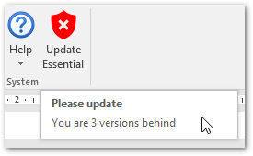

This screen is shown when updates have been detected. It can also be shown by clicking on the Update shield button.

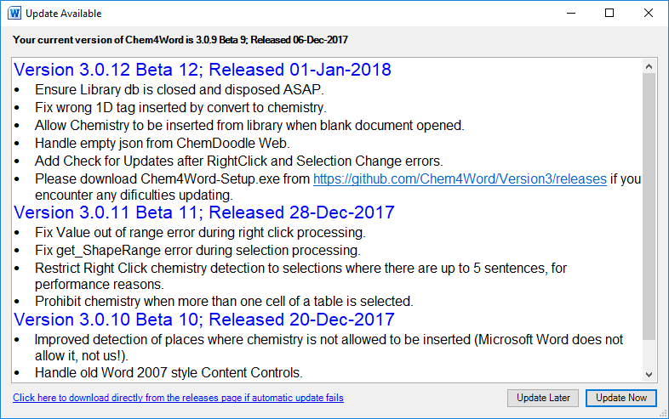

If you think you have missed an update you can check by using “Help” 🡪 “Check for Updates” from the Chemistry Ribbon

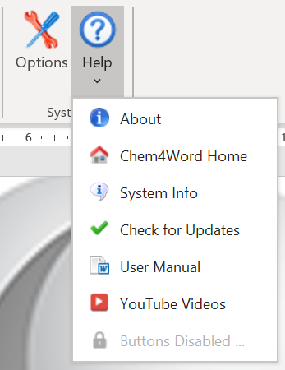

Clicking on “Update Now” will start the update downloading. If this fails, you may need to visit our [download page](https://www.chem4word.co.uk/download/) to download the latest setup executable.

The image below shows the updater in action. It downloads the updated version of Chem4Word, then waits until you have closed all instances of Word [WINWORD] then installs the update.

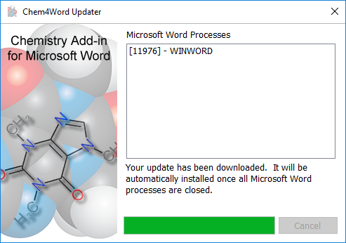

# Legacy documents

When a document is opened it is scanned for any chemistry zones which have been stored in earlier formats. We *highly* recommend you allow these to be converted to the new format when a document is opened!

An automatic backup of the original document will be saved in the Backups folder inside the folder where your user settings are stored. Once this conversion has completed, the old version of Chem4Word will not be able to read the new document format.

# How to add a chemical structure to a document

You can add chemistry to a Microsoft Word document in many ways. You can draw them with ACME or ChemDoodle Web. You can also search PubChem[2] and ChEBI (Chemical Entities of Biological Interest[3],[4]) or use the name-to-structure tool, OPSIN (Open Parser for Systematic IUPAC Nomenclature[5],[6])

## Import a structure from a file

Chem4Word for Microsoft Word supports importing chemistry from three file formats: CML, MOLFile and SDFile.

The Import button browses to a folder containing supported file formats. You then select a file and then import that file as a chemical structure into the current document. The structure will be displayed exactly as it was stored in the imported file.

## Add a structure from a web-search

There are three options for importing a structure from web searches:

|  |  |
| --- | --- |
| PubChem Logo | PubChem is a public repository of chemical structures and biological data maintained by National Center for Biotechnology Information (NCBI). |
| ChEBI logo ChEBI | Chemical Entities of Biological Interest (ChEBI) is a freely available dictionary of molecular entities focused on ‘small’ chemical compounds maintained by the European Molecular Biology Laboratory (EMBL). |
| University of CambridgeOPSIN | OPSIN is a tool developed at the University of Cambridge that converts chemical names into chemical structures |

### PubChem search

The PubChem search allows you to search by name or formula for structures in the PubChem database. You can retrieve multiple structures. Chem4Word sorts these by relevance.

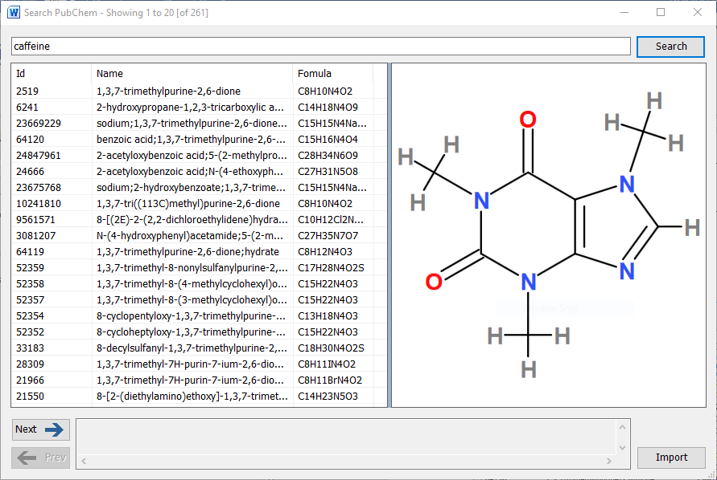

Selecting an entry in the returned results displays a structure, as stored in the PubChem database. You can move forwards and backwards through all the results. he selected result can be added to the document at the current position by clicking the Import button.

### ChEBI Search

The ChEBI search allows you to search by name for structures in the ChEBI database. Fewer results are returned by this search tool than the PubChem search, as a scoring algorithm limits the number of possible structures returned.

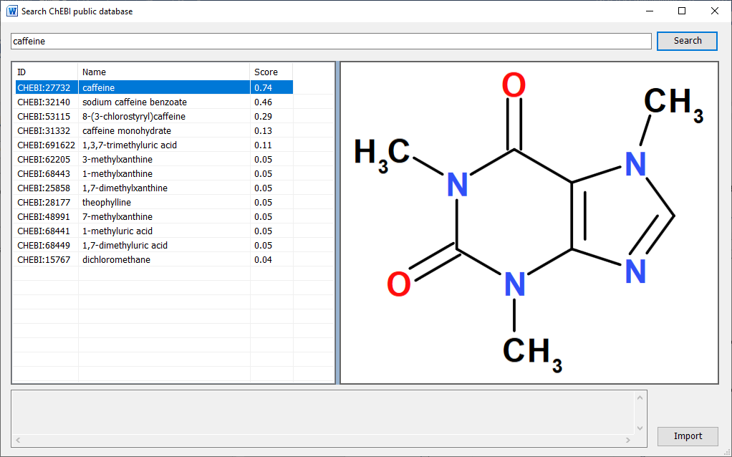

It is possible that there are entries in this database where no chemical structure is available. A message indicating this will be shown at the bottom of this window.

Clicking the Import button adds the displayed structure to the current document.

## How to edit an existing chemical structure

When you select a chemistry object in a document, you can edit the contents by clicking the edit button. Double-clicking a chemistry object edits the structure.

If you change the chemistry, the add-in automatically runs a PubChem search to see if the new structure is known. You will be given the opportunity to add/change/delete labels associated with the new structure.

When you attempt to edit a structure, the add-in performs some checks to see if the structure being edited has features which can only be edited in ACME. If you encounter this message, please set ACME as the default editor in the Options window.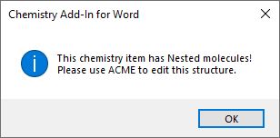

## Convert text to Chemistry

When you right click on a selection (which contains up to 5 sentences of plain text) it is analysed to see if it contains the names of any structures within your library.

This text contains alpha-pinene: when you right click, the context menu will show a button for converting this to a chemistry object.

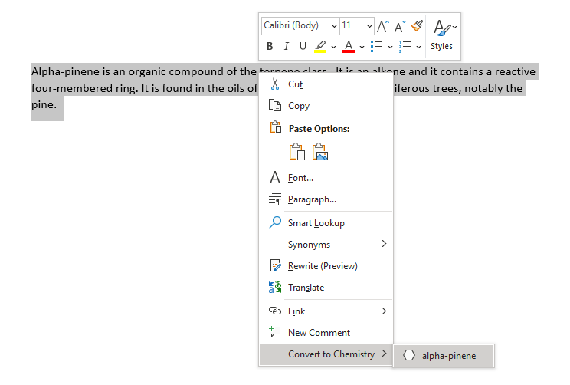

The converted object is shown below.

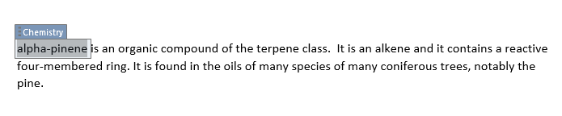

# Display options for Chemistry

Chem4Word for Microsoft Word displays chemistry in multiple formats. For structures imported from files and web sources, chemistry objects may have associated names and synonyms as well as formulae. 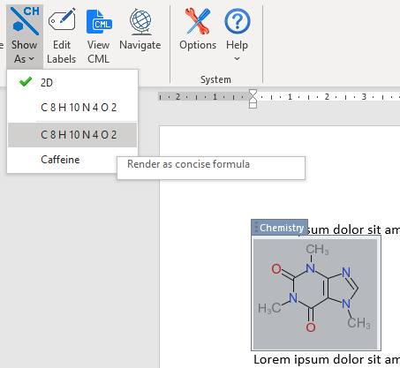You can switch the display to these alternatives if you wish.

When you draw a structure in a document, the add-in searches PubChem to see if the structure is known, and any known names and synonyms are retrieved.

You can also add your own synonyms and formulae to any structure using the Edit Labels button.

The example on the right shows all the depiction options for caffeine that available when this chemistry object is inserted from ChEBI. The currently displayed chemistry object can be changed to show any one of these alternative depictions.

Adding other chemistry objects to the document that are linked to another chemistry object updates to the formula label automatically It also updates those imported from PubChem. The Edit Labels button also allows you to delete labels and create your own labels to use as identifiers in your document.

# The Library

The Library is a store of re-usable chemical structures. Chem4Word provides approximately 2000 library entries. You can easily store your own structures in the Library for use in other documents by clicking the Save button in the Library section of the ribbon.

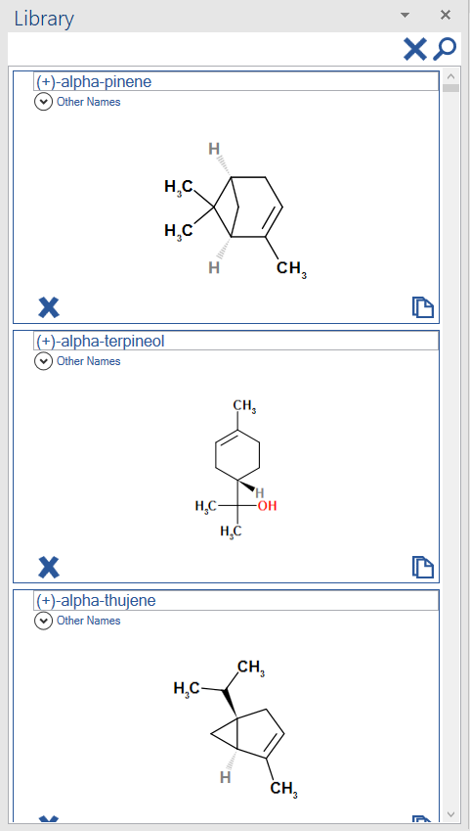The Library can be opened and closed using buttons on the ribbon.

There is a search button at the top of the Library panel, to help you to find structures by name. Type the name to search and click the magnifying glass. To show all molecules in the Library, click the cross next to the magnifying glass.

To insert a copy of a structure from the Library into the document at the current cursor position, simply click the paste icon  at the bottom right of the structure you want to add.

You can also delete structures from your Library by clicking the cross at the bottom left of the structure. Deleting a structure from the Library cannot be undone!

# The Navigator

The Navigator resembles the Library, as it enables the quick addition of chemistry to a Word document. The Navigator, however, only shows chemistry that has already been added to the current document. This includes chemistry that may not be in the current library, such as structures that you have drawn yourself.

The Navigator contains one panel for each unique structure in the current document. Each panel in the Navigator shows the chemical structure and formula of each molecule. The buttons at the bottom of the panel add structures to the document, either by creating a linked copy or pasting a new copy of an existing structure at the current position in the document.

The arrow buttons find individual and linked structures in the document by moving backwards or forwards through the current document.

Selecting structures in the document will also automatically select them in the Navigator.

|  |  |
| --- | --- |
|  | Duplicate the structure and add it to the document at the currently selected position. |
|  | Add a linked copy of the structure to the document at the currently selected position. |
|  | Move to the previous linked structure in the document. |
|  | Move to the next linked structure in the document. |

The Navigator automatically updates when structures are added to the document. It may show structures that are not visible in the document. These are still stored in the document as CML, but not linked to any visible content. This means you can easily restore a structure after deleting it. Saving the document purges any unused chemistry.

# Exporting chemistry files

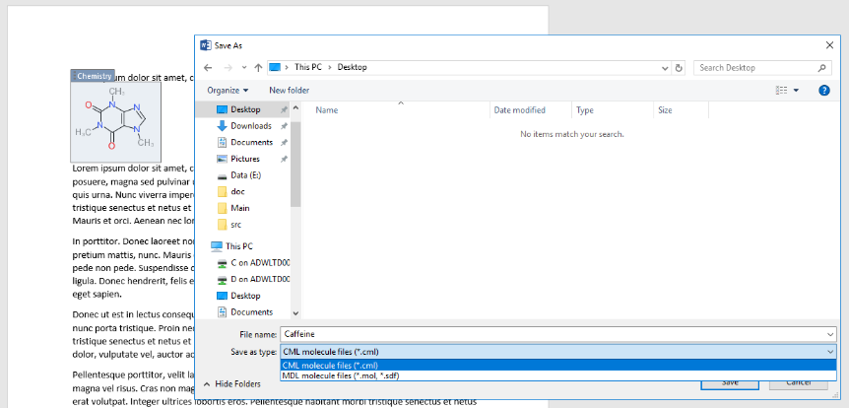Chem4Word allows you to export chemical structures as both CML files and MDL MOLFiles.

To export a structure, simply select the chemistry object in the document and click the Export button in the ribbon.

Choose a folder and type a file name, select the appropriate file type, and click the Save button.

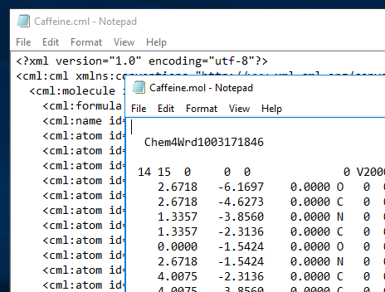The figure to the left shows example content of CML and MOLFile files for caffeine exported from a Chem4Word document.

Both file formats are based on recognised standards and should be suitable for import into other chemical-aware applications.[7]

# Chem4Word Options

## Plug-Ins Tab

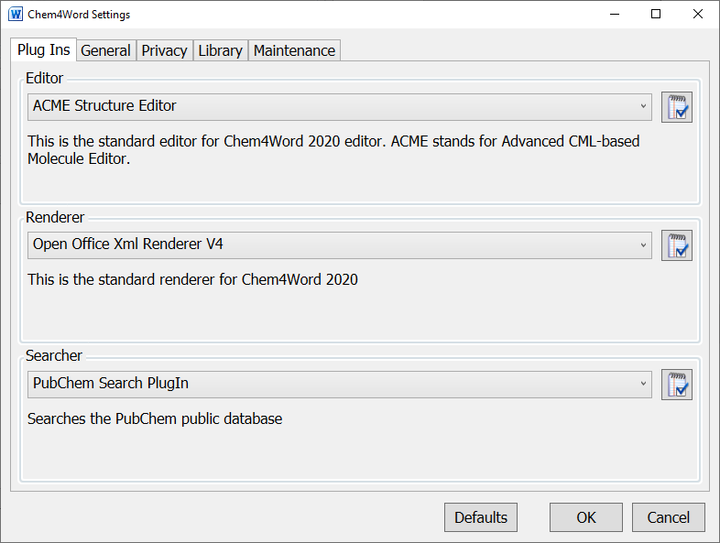

Here you can change the default editor and renderer or set the options for the selected editor, renderer or searcher.

### Editor Options

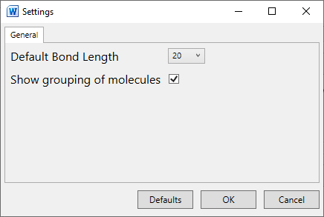

Here you can select your preferred bond length for new drawings and if you require grouping of molecules to be shown. These options do not affect existing structures in a document.

### Renderer Options

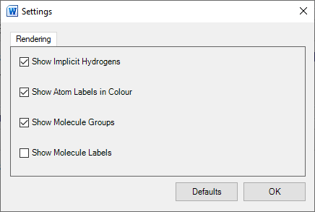

Here you can set the options for your selected renderer. These options do not affect existing structures in a document.

### Searcher Options

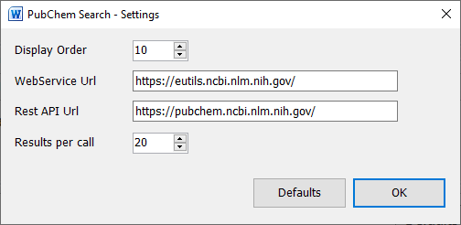

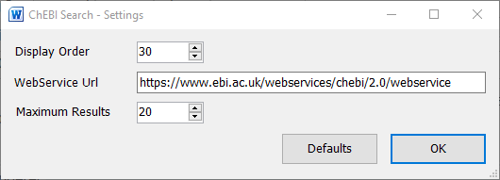

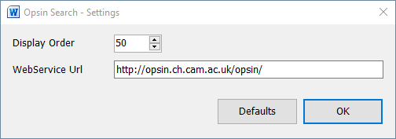

Here you can set the display order and the URLs for our preferred molecule search services. You should not need to change these URLs.

## General Tab

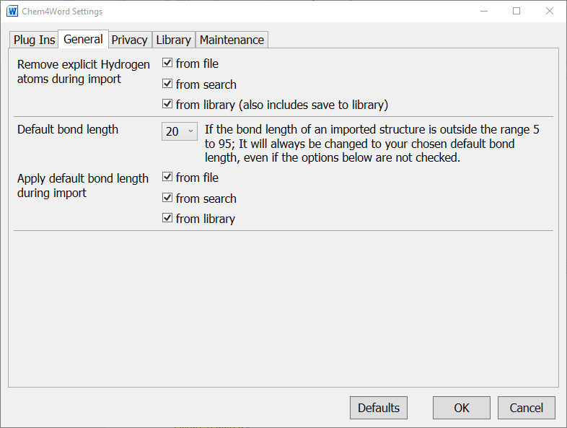

Here you can set what happens to explicit hydrogens and bond size when a structure is inserted into your document. These options do not affect existing structures in a document.

## Privacy Tab

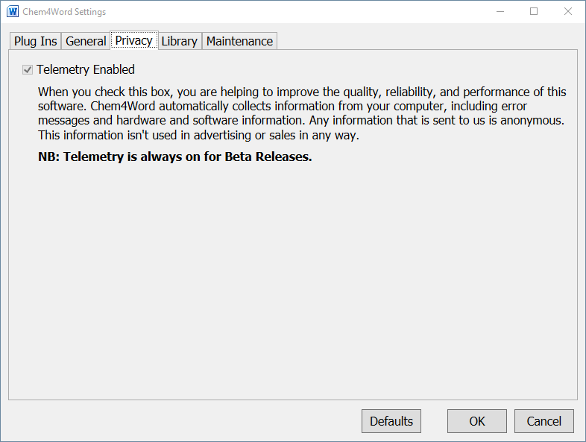

Here you can select whether you wish us to have access to application usage data. For beta releases it is always set. For production releases it is recommended that this be left set.

## Library Tab

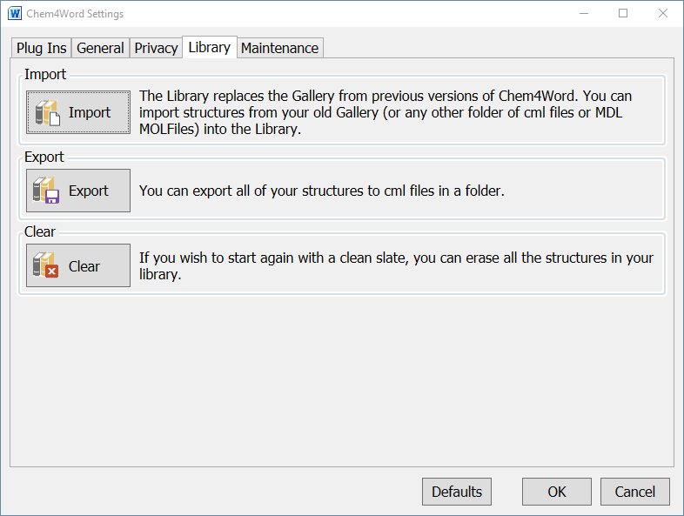

Here you can import and export a set of structures from your library to or from a folder on your hard disk. (The Clear button is mainly for internal use during development, but as we believe it may be of use for production it has been retained.)

## Maintenance Tab

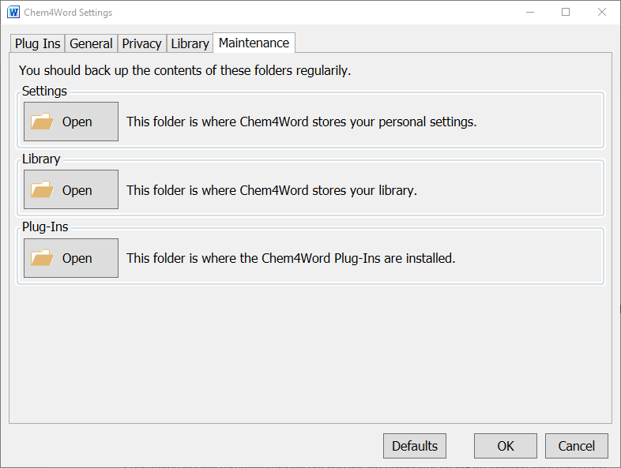

Here you can get quick access to the folders on your system where Chem4Word stores data.

# What is ACME?

Chem4Word now contains a brand-new editor, ACME. ACME Stands for Advanced CML-Based Molecule Editor

ACME has been written by us from scratch to enable the further development and enhancement of the add-in.

The default editor is ACME, but if you prefer, you can still use the ChemDoodle Web editor from version 3.0 of the add-in. This can be changed from the Plug-Ins tab of the Options window.

### ‘Advanced’

Many popular chemical editors do not harness recent developments in Windows Desktop graphics. ACME exploits them fully. It displays structures rapidly and with very high fidelity. ACME’s graphics are resolution-independent and render well under all display settings. ACME is also open-source and highly extensible[8].

### ‘CML-Based’

The editor is designed to work directly with the underlying CML: the same format that stores the chemistry in your Word document. It transfers information seamlessly between the editor and the document.

### ‘Molecule Editor’

There are now many molecule editors or ‘sketchers’ for drawing chemical structures. ACME works the same way as these. If you are used to using other tools, you will find ACME’s user interface very familiar. If not, you should find it easy to use and learn. ACME puts productivity and ease-of-use above features.

## What functions does ACME support?

ACME allows you to carry out common chemistry sketching tasks, such as:

* Freehand drawing
* Ring and chain drawing
* Editing of existing atoms and bonds
* Cut, copy and paste
* Resizing and rotation
* Repositioning of molecule fragments
* Parent-child relationships between molecules (‘groups’)
* Drawing functional groups

ACME supports unlimited undo and redo of all editing operations.

## What functions *doesn’t* ACME support?

Currently ACME does not support:

* Functional group expansion
* Reaction drawing
* ‘Smoothing’ of structures

# ACME User Interface

The ACME interface has three main elements. From top to bottom:

1. The toolbar allows the selection of drawing, manipulation tools and settings.
2. The drawing canvas. This is where you draw your chemistry. The drawing canvas includes a zoom box, which allows you to zoom out of very large structures.
3. Below the canvas is a status bar. This shows what the currently selected tool is used for.

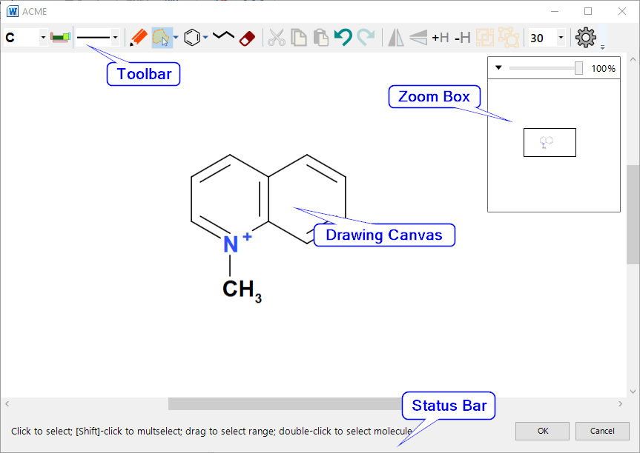

## Toolbar

The toolbar has five control groups: 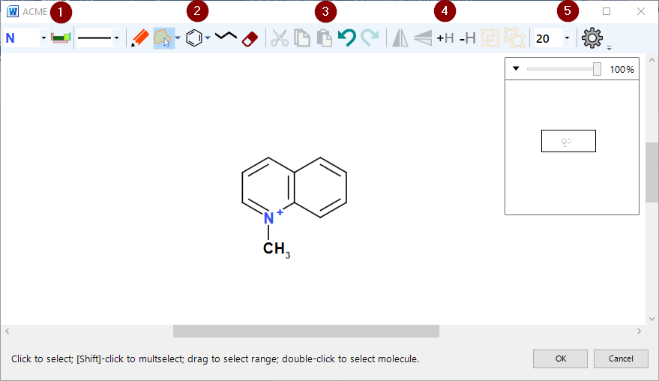

Figure 1: ACME layout

1. Element and bond type selectors
2. Mode buttons – these make dragging and clicking in the editor do different things
3. Common editing commands such as cut, copy, paste & undo/redo
4. Manipulation commands – flip, add/remove hydrogens and group/ungroup
5. Editor settings

The editor can only operate in one mode at one time, but all modes are available at any time. The commands can only be invoked according to context, *e.g.* flipping a molecule is only possible if it is selected.

If a command cannot be carried out, ACME disables the associated button.

### Highlighting Active Atoms and Bonds

ACME highlights the currently active atom or bond with orange brackets **[ ]**. Any operation resulting from mouse clicks will affect the active object.

### Element Selector and Periodic Table Picker



The element selector is the first control. When ACME starts, it populates this with common elements and functional groups, plus any other elements and functional groups present in the structure being edited. The adjacent periodic table picker works with the element selector.

The element selector is a simple dropdown. It works in two ways:

* With no selection active, the selector sets the current element for all draw operations.
* With a selection active, the selector changes all selected atoms to the selected element.

#### Periodic Table Picker

The element selector contains a standard list of atoms, plus any non-standard atoms used in the current chemistry. The periodic table picker button allows selection of additional elements.

Click the periodic table picker button to display the periodic table popup. Clicking an element in the popup adds extra atoms to the standard list and sets the currently selected element. If you have a selection active in the editor, then it will set the selected atom’s element to your choice.

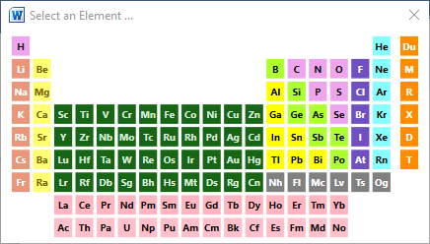

Figure 2: The periodic table popup

Click the Close box or press [Esc] to dismiss the picker without choosing an atom.

You can set generic atom types: R, M, X using this popup. Other functional groups must be set by right clicking on the atom.

### Bond Dropdown



The bond selector lists all bond types available in ACME. As with the element selector:

* With no selection active, the selector sets the current bond for all subsequent draw operations
* With a selection active, the selector changes all selected bonds to the selected type

Selecting an option sets both the bond order and the bond stereo:

| Option | Bond Order | Bond Stereo |
| --- | --- | --- |
|  | Single | None |
|  | Double | None |
|  | Triple | None |
|  | Single | Wedge (out of paper) |
|  | Single | Hatch (into paper) |
|  | Half | None |
|  | 1.5 (resonance bond) | None |
|  | Zero (hydrogen bond/agostic association) | None |
|  | 2.5 | None |
|  | Single | Indeterminate |
|  | Double | Indeterminate |

All these properties (and more) can be set from the Bond Options dialogue.

### Draw Button



This puts ACME into Draw Mode. This is the default when ACME starts*.*  What happens depends upon where you click:

* Clicking on empty space will drop an atom at the current cursor position:  
  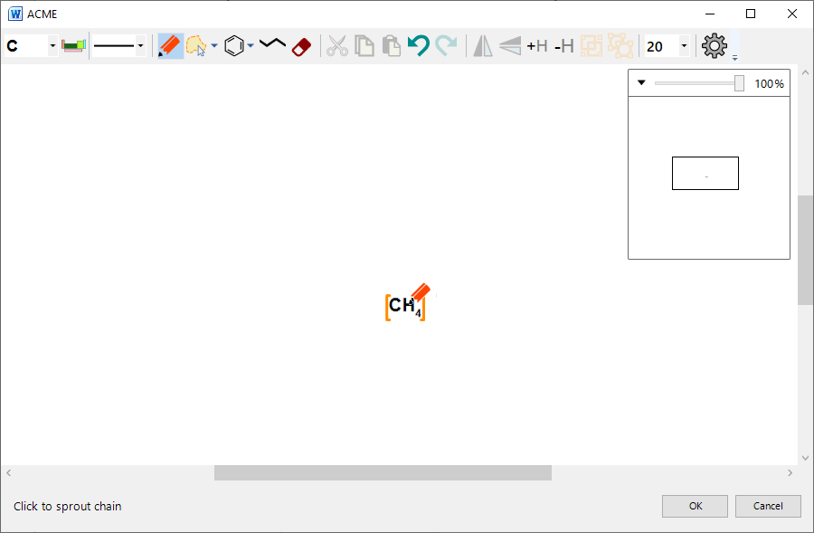

Figure 3: Dropping a single atom

* Clicking on an existing atom will either:
  + Change the atom’s element to the currently selected element – if the atom has a different element to the current element:  
    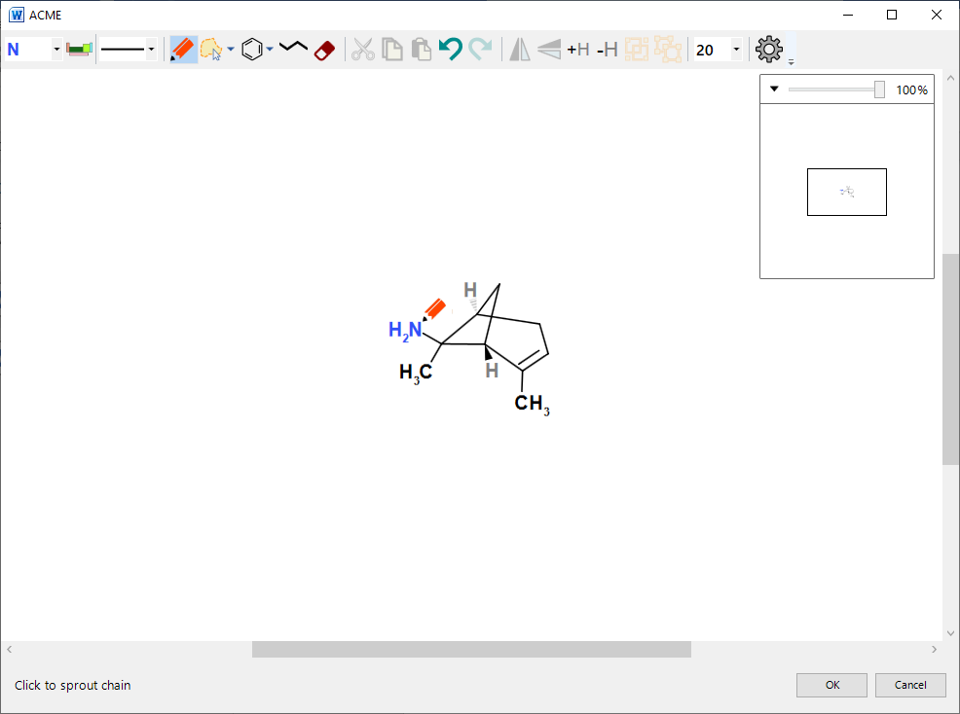
  + Sprout a single atom chain ending in the currently selected element – if the clicked atom is the same as the selected element:  
    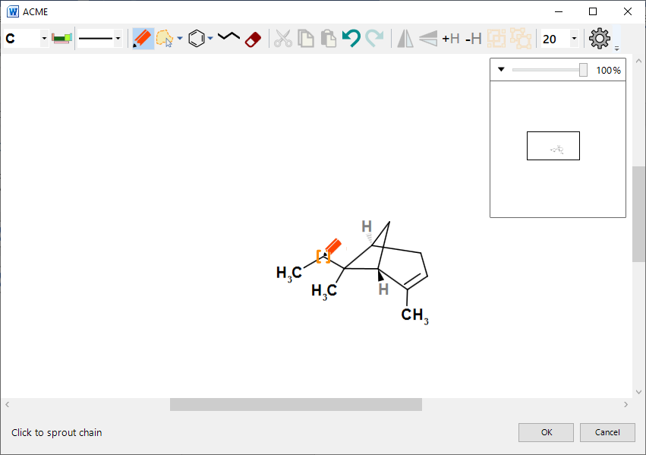
* Clicking on a bond in draw mode changes the bond to the currently selected bond type:  
  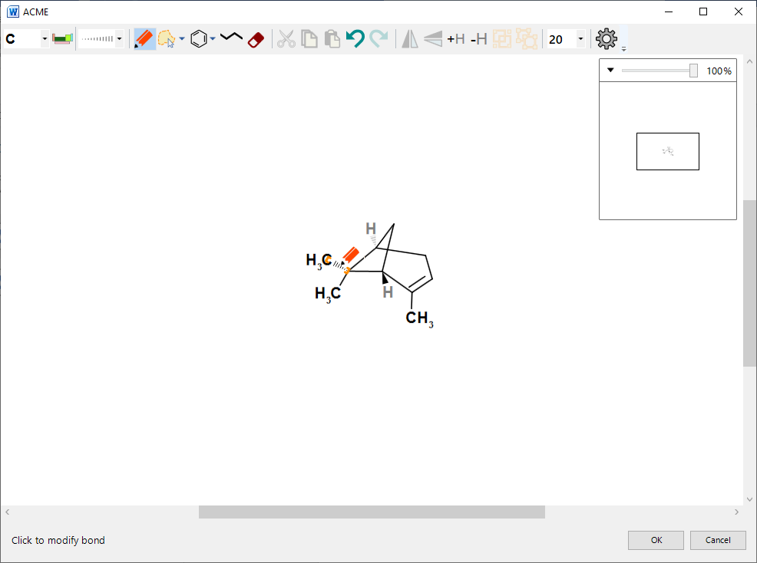

Figure 4: Setting a hatch bond by clicking

* + Clicking on a wedge or hatch stereo bond with the same stereo selected will invert the direction of the bond:  
    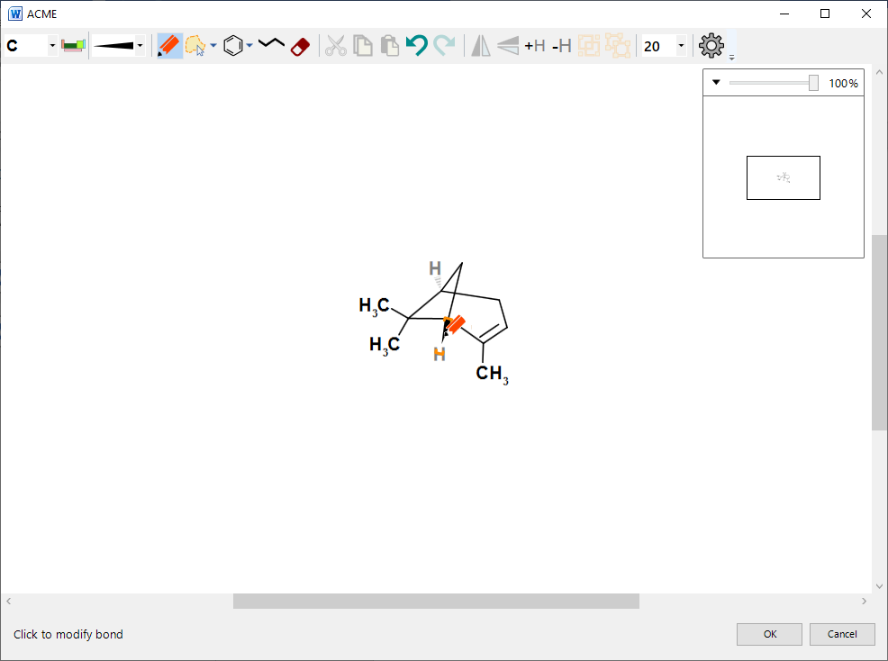

Figure 5: Inverting a stereobond

Draw mode also allows you to ‘draw freehand’:

* Click and drag on an atom: the editor draws a ‘ghost bond’ to show you where the new atom will be placed;
* Release to draw the new atom.

#### Locking

By default, ACME locks both the bond length and angles when drawing:

* Pressing [Shift] unlocks the bond length – this snaps to multiples of the currently selected bond length;
* Pressing [Ctrl] unlocks the bond angle – this snaps to increments of 15 degrees.

You can unlock both snapping by pressing both [Shift] and [Ctrl] at the same time.

#### Drawing multiple bonds

You can also increase the order of a bond by ‘stroking’ over it: click on the bond’s first atom, drag, and then release over the second. A single bond will become a double, and a double bond a triple.

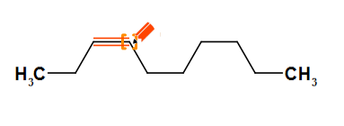

Figure 6: Stroking over a single bond

### Select Button

This puts ACME into select mode. You can select individual atoms and bonds, or entire molecules.

Selections are important for making bulk changes to molecules. You can select atoms and bonds before:

* Deleting them
* Changing either atom element or bond order
* Moving fragments of molecules
* Cutting or copying atoms and bonds

#### Selecting individual atoms and bonds

Click on an atom or bond to select it. To clear the selection, click on a blank area of the canvas.

[Shift]-clicking will add atoms or bonds to the selection. Selecting additional atoms implies that ACME adds all connecting bonds between selected atoms too.

#### Range selection

Clicking and dragging on empty space in select mode either draws a lasso or rectangle selection. Releasing the mouse button will select all objects in the catchment area.

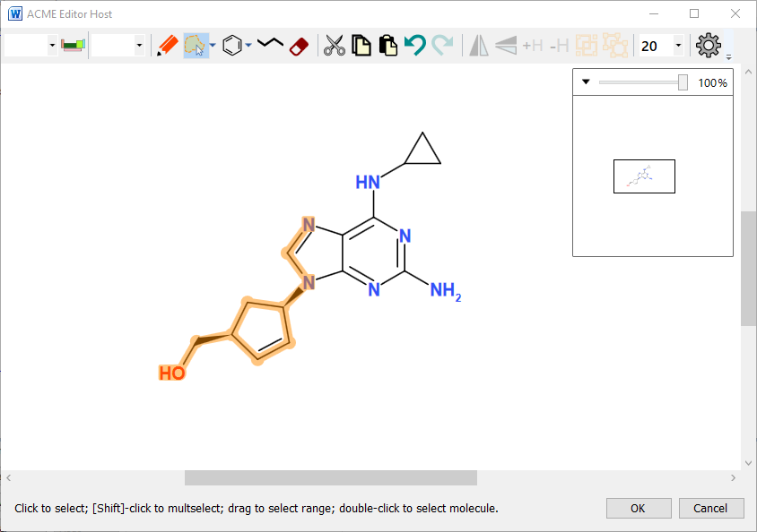

Figure 7:selecting a range of atoms and bonds

#### Types of selection

To switch between lasso and rect mode, click the small arrow next to the Select button, then click on the corresponding option in the popup:  
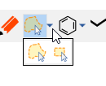

#### Lasso Mode

Lasso mode allows you to draw around part of or all a chemical object by clicking and dragging. The selection area is outlined in orange as you do this.

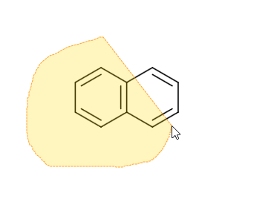

Figure 8: Lasso select

#### Rectangle Mode

Rectangle mode works like lasso mode, except that the selection area is rectangular:  
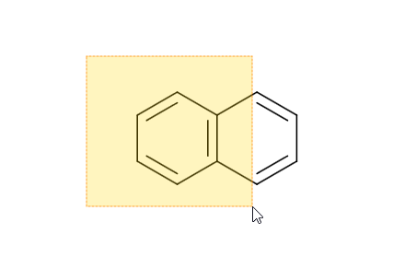

Figure 9: Rectangle selection

When you release the mouse button, anything in the selection area is highlighted in orange as selected.

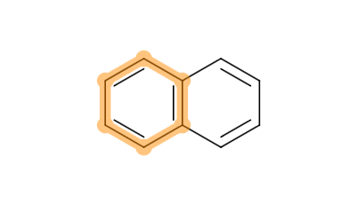

Figure 10: The result of the previous rectangle selection

Selecting *all* atoms and bonds makes ACME display a *molecule selector*:

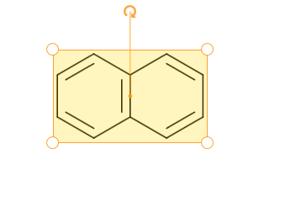

Figure 11: Molecule Selection Highlighting

Double-clicking any atom or bond will select its parent molecule. This is a convenient alternative to lassoing all atoms.

NB: Grouped molecules can be selected by single clicking.

#### Editing the selection

Pressing the Delete key when there is a selection active will remove the selection from the editor. This applies to atoms, bonds and molecules.  
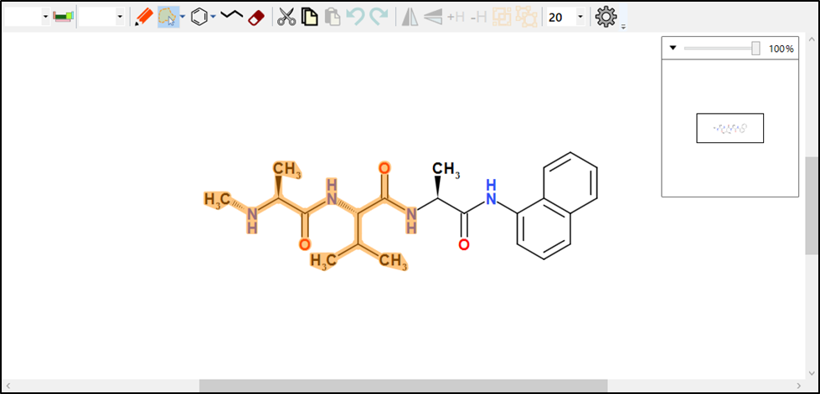

Figure 12: selecting atoms prior to deletion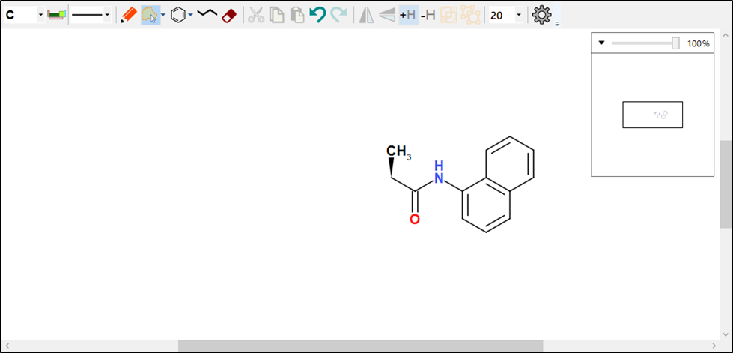

Figure 13: Pressing [Delete] removes the selected objects

If atoms and bonds are selected, then changing either the current atom or bond using the selector controls will modify the selected objects. If you select multiple elements, then ACME will show a blank element selector value:  
  
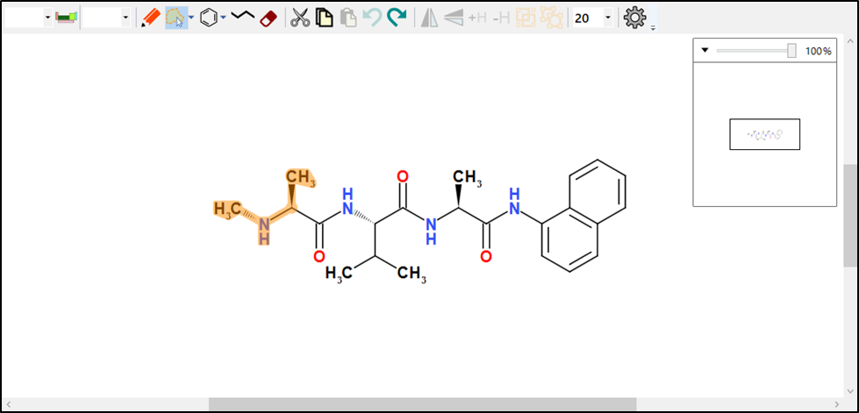

Figure 14: Select the atoms, then select an element

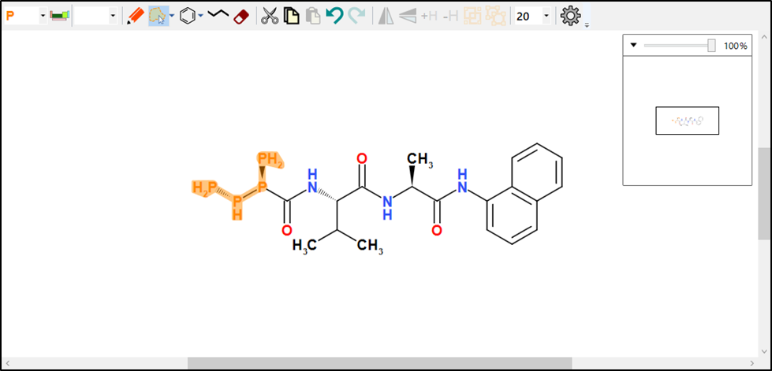

Figure 15: ACME changes the selected atoms to the chosen element

* Select a range of atoms and bonds. Then click and drag to move them. ACME ‘rubber-bands’ the molecule while you do this:  
  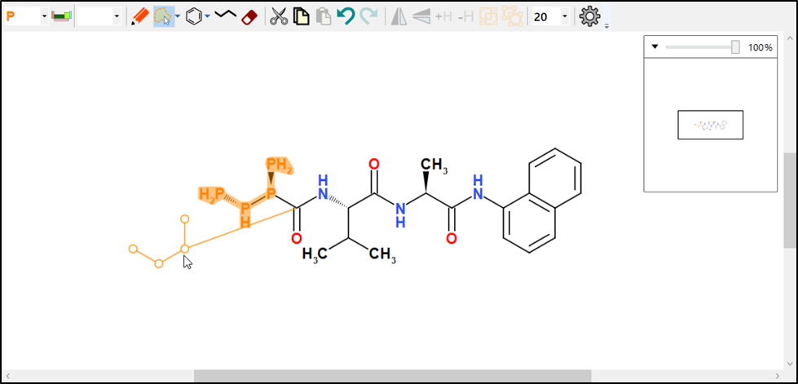  
    
  Hold down [Shift] or [Ctrl] to unlock bond lengths or angles while dragging a fragment. Holding [Alt] pivots the fragment about the unselected neighbouring atom.
* If you selected a molecule, you can either
  + Rotate the molecule by dragging the small curved arrow around in a circle. Rotating increments in multiples of 15 degrees. Hold [Ctrl] to unlock the angle snapping: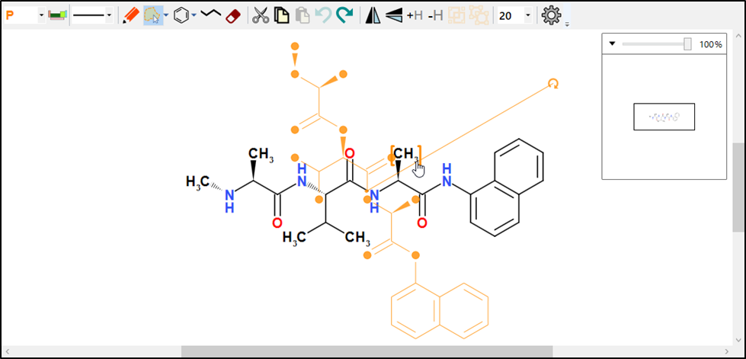
  + Resize the molecule by dragging one of the corner handles:  
    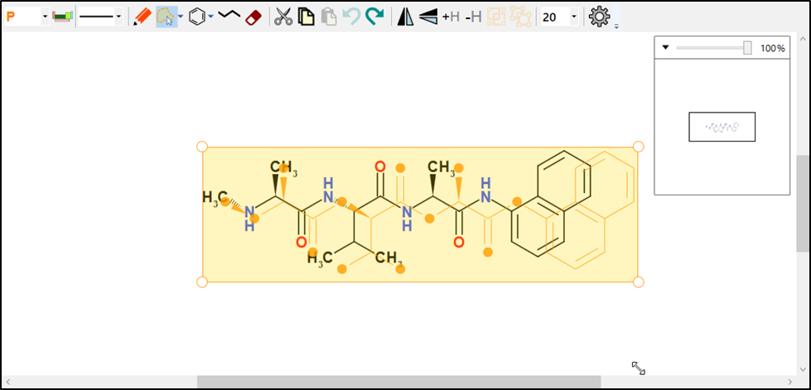
  + Move the molecule by clicking in the selector area and dragging:  
    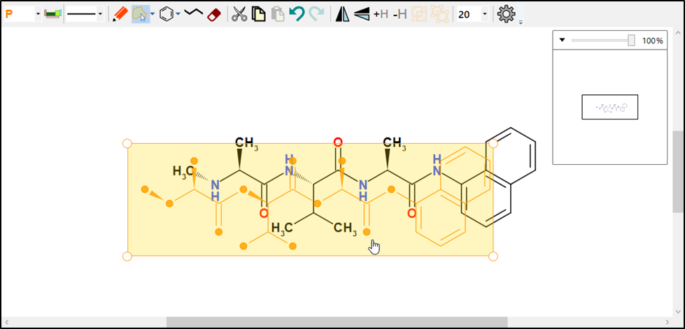

### Ring Button

The ring button puts ACME into ring mode*.* This allows you to draw a ring on the canvas. Rings can be drawn in free space, or on top of other bonds and atoms.

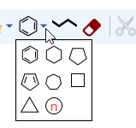

ACME can draw either fixed or variable rings. The ring button shows the currently selected fixed ring. You can choose the ring type by clicking the small dropdown arrow next to it and then clicking a ring in the panel.

#### Fixed rings

Click on a ring type to draw a ring. Then either click on a blank area of the canvas, an atom or a bond to place the ring. ACME will show a placeholder if it can draw a ring:

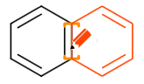

Figure 16: Placeholder showing new ring placement

NB: If there is no placeholder visible, then this means ACME cannot draw the ring in the desired position, usually through visual congestion.

#### Variable Ring

Click this icon to draw a variable ring:  
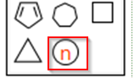

Click and drag on a bond, atom or free space. Then drag in the direction of the arrow to change the placeholder size. The number gives the current ring size:

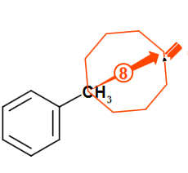

Figure 17: Drag to change ring size.

Release the mouse button when the ring is the correct size:  
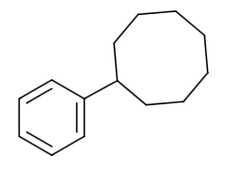

Figure 18: New ring drawn in place

### Chain Button

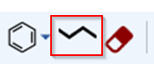

Clicking this puts ACME into chain drawing mode. Chain drawing mode works like variable ring drawing mode:

* Click on free space and drag to draw a free-standing chain:
* Click on an atom and drag to attach a chain. 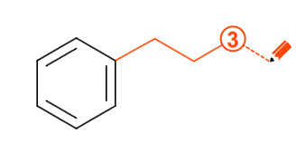

Figure 19: Attaching a chain

Chains are variable length: the chain placeholder shows how many atoms it will have in it. You don’t need to draw a chain following a straight path: you can alter the path as you go.

You can cancel chain drawing at any time by pressing [Esc].

### Erase Button



The erase button puts ACME into erase mode. This is an alternative to selecting atoms or bonds and then deleting by pressing [Del]. Erase mode is useful for making small, precise deletions in a structure.

Clicking the Erase button shows a cursor like a small eraser. Hover over a bond or atom and click it to delete it:  
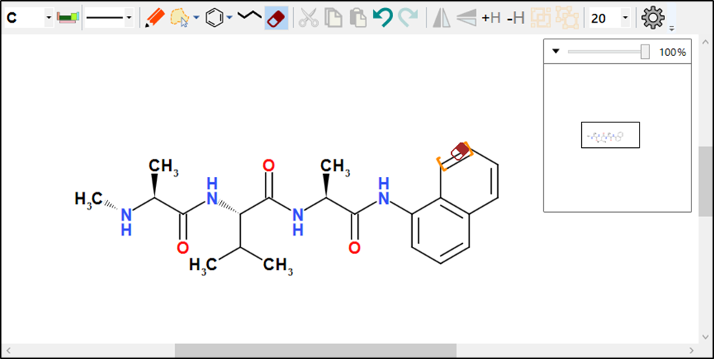

Figure 20: Click to delete a bond

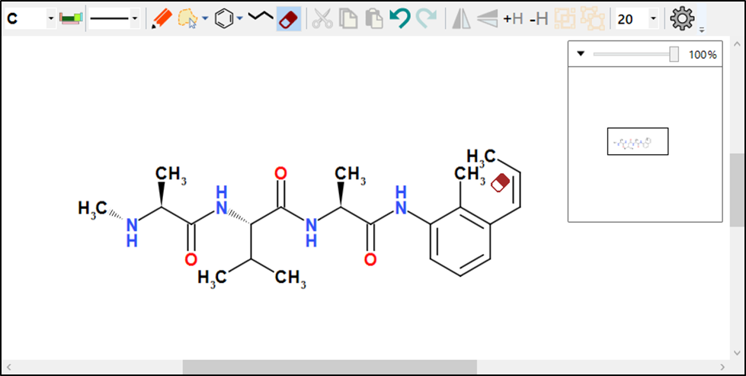

Figure 21: After deleting bond

### Cut, Copy and Paste Buttons



The cut, copy and paste buttons allow you to transfer chemistry into or out of ACME, and to remove or add to it. Both operations use the Windows Clipboard. ACME also supports pasting from the Windows Clipboard History (⊞ - V)

When ACME copies the selection, it does so as entire molecules, regardless of whether a molecule is selected. Copying a range of atoms then pasting causes ACME to create one or more new molecules to hold the copied objects.

ACME does *not* allow individual bonds to be copied and pasted. ACME copies selected atoms and includes the connecting bonds automatically.

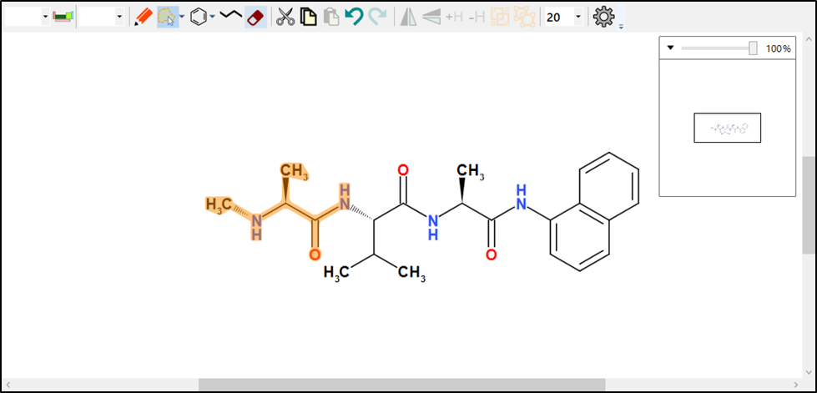

Figure 22: Selecting a range of atoms prior to copying

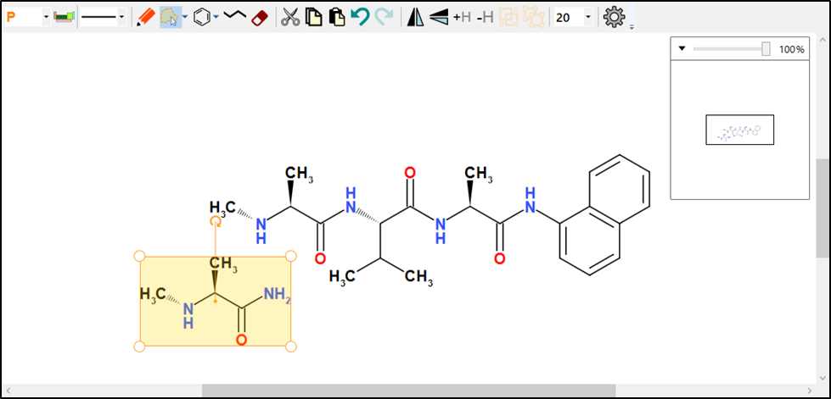

Figure 23: The result of copying and pasting the previous selection

#### Data Transfer Format

ACME’s primary data transfer format is CML. ACME converts CML on the Clipboard to chemistry, and *vice versa.* ACME also converts SDFile formats on pasting into the editor.

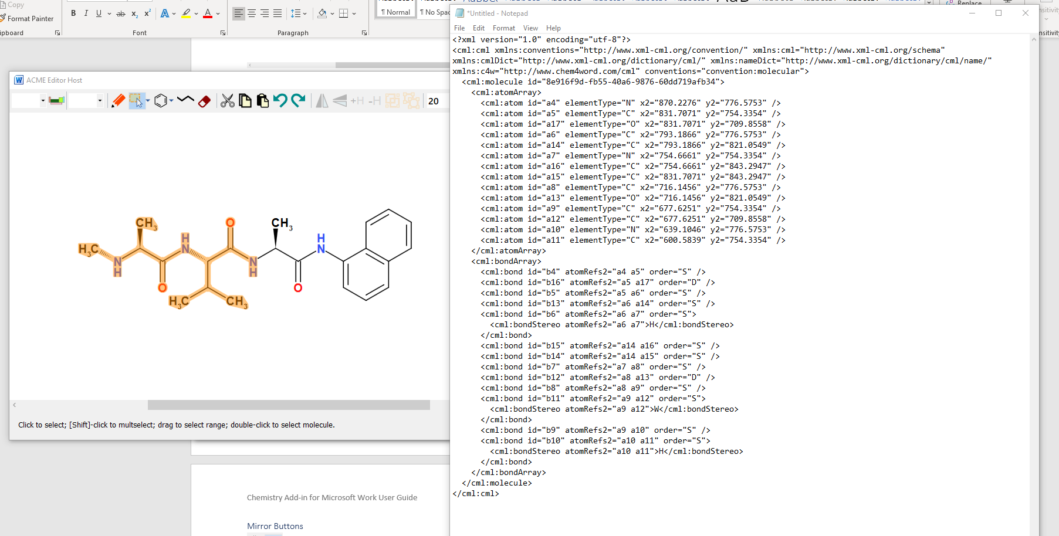

Figure 24: CML pasted into Notepad from a copy operation. ACME encapsulates the selection as a molecule.

### Undo and Redo Buttons



The Undo button restores the state of the chemistry before the previous drawing or editing operation. The Redo button allows you to replay the action after undoing it. Any subsequent editing operations after Undo will clear the Redo buffer.

### Mirror Buttons



The Mirror buttons allow you to invert a selected molecule, either horizontally or vertically. Mirroring does not preserve absolute stereochemistry by default.

To preserve absolute stereochemistry, hold down [Shift] *before* clicking the button.

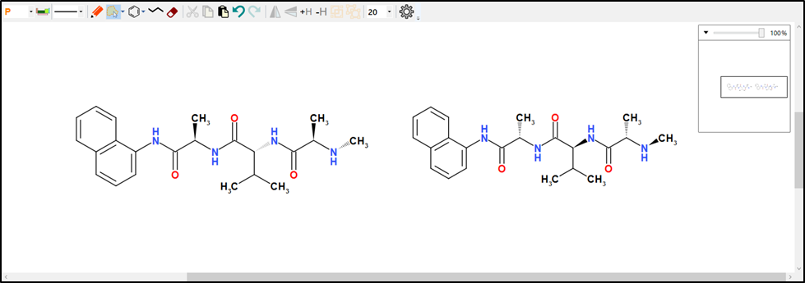

Figure 25 Mirrored versus flipped molecule. ACME inverts stereochemistry only when flipping

### Add/Remove Explicit Hydrogens



Adds or removes explicit hydrogen atoms to the model. The +H button converts implicit hydrogen atoms into explicit hydrogens. The -H button reverses this operation.

Adding or removing hydrogens does not change the fundamental chemistry of the molecule.

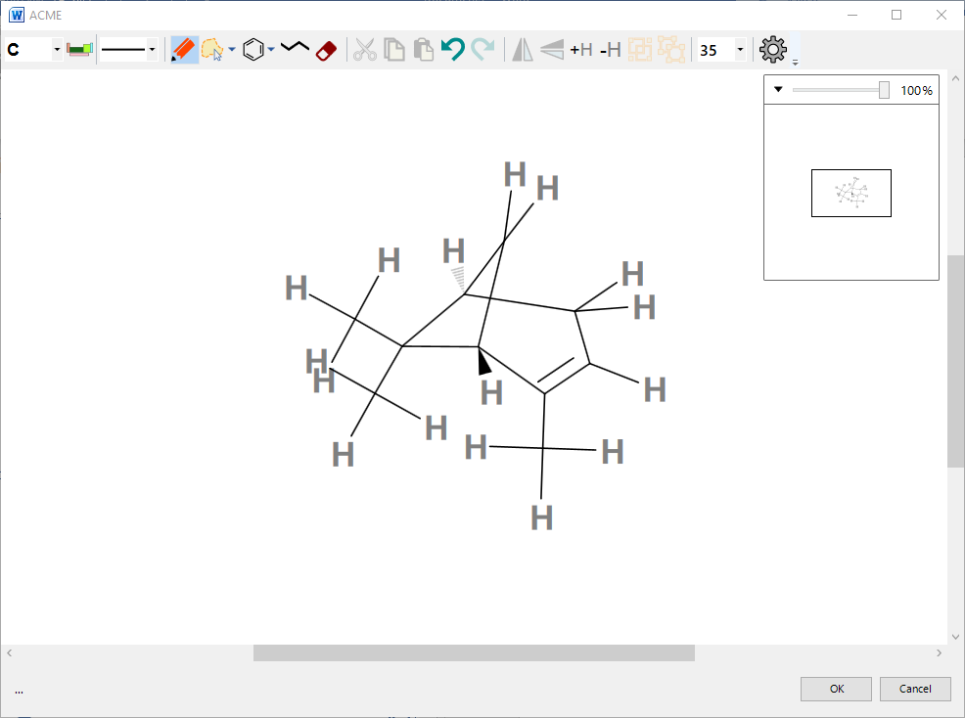

Figure 26: Explicit hydrogens added

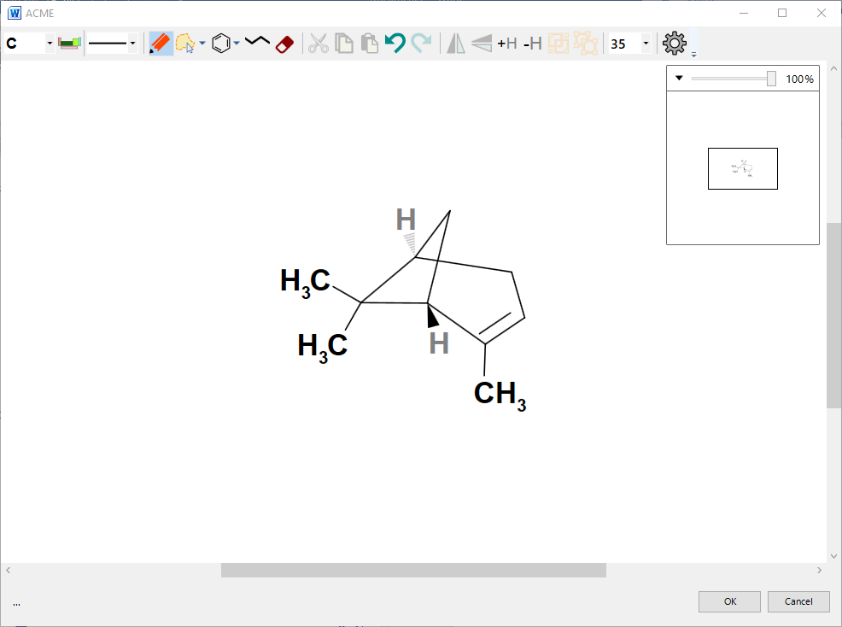

Figure 27:Explicit hydrogens removed.

This affects only hydrogen atoms that would be connected by single, non-stereo bonds.

### Group and Ungroup Buttons



Grouping and ungrouping are special features of ACME. CML allows definition of ‘nested’ molecules, which are contained in other molecules. ACME calls the containing molecule a ’group’. A group contains no chemistry of its own. It is simply a container for other molecules.

Grouping is particularly useful to set molecule-level properties on multiple molecules, using the Molecule Properties dialogue.

#### Grouping Molecules

Select two or more molecules and click the Group button.

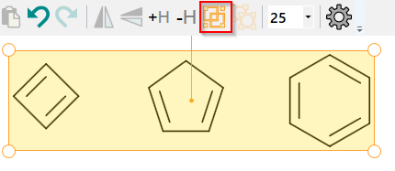

ACME now displays the molecule as a group:

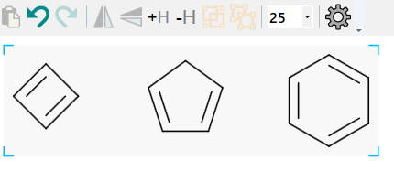

Figure 28: Grouped molecules: note the shading and corner brackets

ACME draws grouped molecules against a shaded background, with blue ‘group brackets’ at the corners. Group brackets and shading are not rendered in the document by default. They are purely a visual cue to indicate the presence of a grouped molecule.

Molecules may be grouped indefinitely. You can select a group by single-clicking on the shaded area. The group selector has square handles at the corners to distinguish it from an ungrouped molecule:  
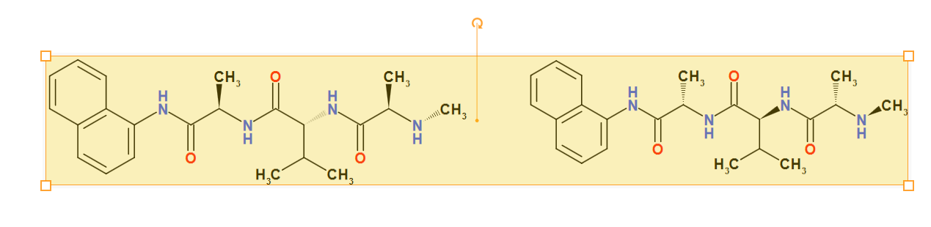

Figure 29: Selecting a group

Grouped molecules can be flipped, resized and rotated like ungrouped molecules.

#### Ungrouping

To ungroup a grouped molecule, select it and click the Ungroup button:  


ACME now displays two or more separate molecules.

### Bond Length Dropdown



The bond length dropdown allows you to select an average bond length for the sketch. Changing this will change the size of the bonds in *all* existing molecules.

### Settings Button



The Settings button displays ACME’s settings dialog. This allows you to choose defaults for the editor’s behaviour:  
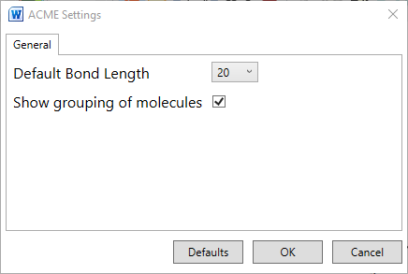

#### Default Bond Length

Use this to choose the default length of bonds drawn when ACME edits a new structure.

#### Show grouping of molecules

Setting this will cause ACME to display groups with grouping brackets. Turning off displays grouped and ungrouped molecules identically, with no shading or brackets.

# Atom properties

You can edit the properties of atoms, bonds and molecules directly by right-clicking an atom, bond or selected molecule, when ACME is in select or draw mode.

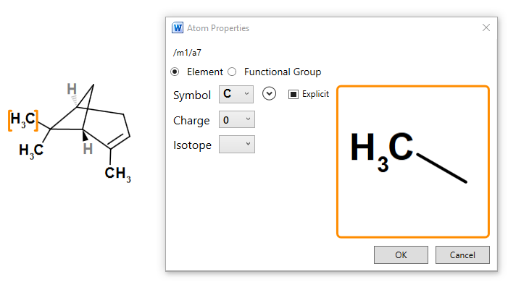

Figure 30: Right-clicking on an atom shows the property dialogue

## Setting Elements or Functional groups

Select an element from the dropdown. If the element you want is not shown, then click the small down-arrow to expand the periodic table picker:

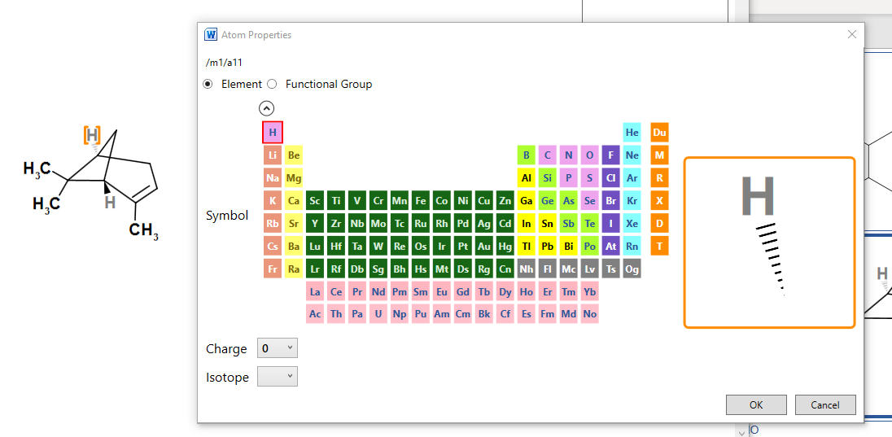  
Clicking the arrow again hides the periodic table picker.

### Setting a Functional Group

Clicking on the Functional Group option button allows you to select from a range of predefined functional groups:  
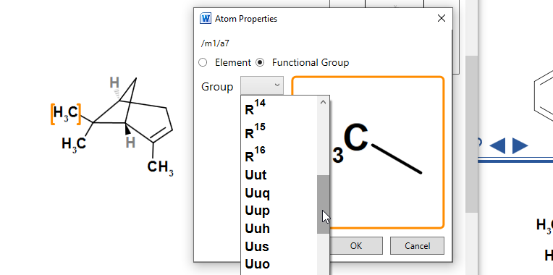

R, X and M groups can be set using this method. We included the legacy symbols of Elements 113 to 118 as functional groups so that you can use them interchangeably.

## Setting Charges

Choose a charge from the Charge dropdown. The atom preview display will update in response:  
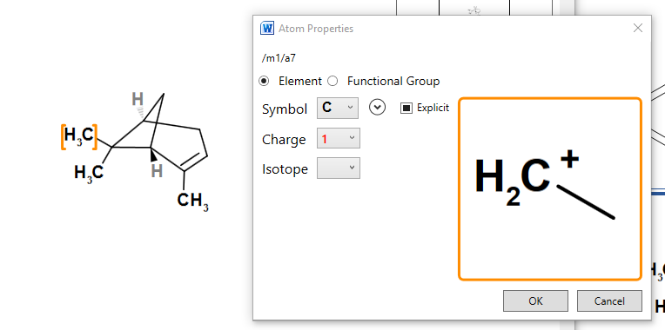

## Setting Isotopes

Allowed isotopes for the atom can be selected from the Isotope dropdown picker. Setting it to blank means the isotope is unknown.

## Togging explicit carbon display

The Explicit checkbox applies only to carbon atoms. It has three settings. Click repeatedly to cycle through these settings.

|  |  |
| --- | --- |
|  | Atom labels are set automatically by ACME. Terminal carbons are shown explicitly, as are allenic carbons. |
|  | Acme hides atoms labels |
|  | ACME shows atom labels regardless of context. |

# Bond Properties

Right click on a bond to display the Bond Properties dialogue:

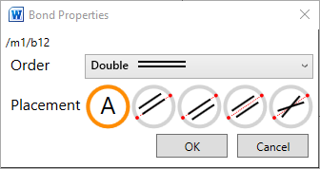

## Setting Bond Order

You can click the Order dropdown to set the order of the current bond. This is useful for more specialised bond types:  
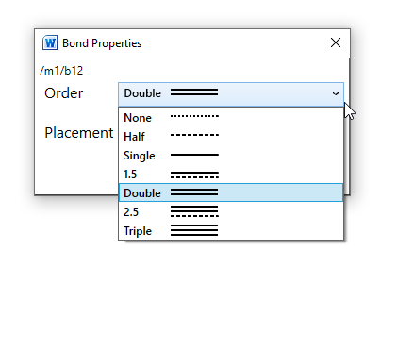

## Setting placement

Placement for double bonds governs which side of the primary bond axis the subsidiary bond is drawn.

* Click **A** to set the placement automatically: ACME will attempt to explicitly set an aesthetically pleasing bond placement.
* Click one of the other placements to explicitly set the bond placement.

Placement can be set on bonds of orders 1.5, double and 2.5. You can also set the stereo of single bonds using this dialog, including the direction of wedge and hatch bonds:

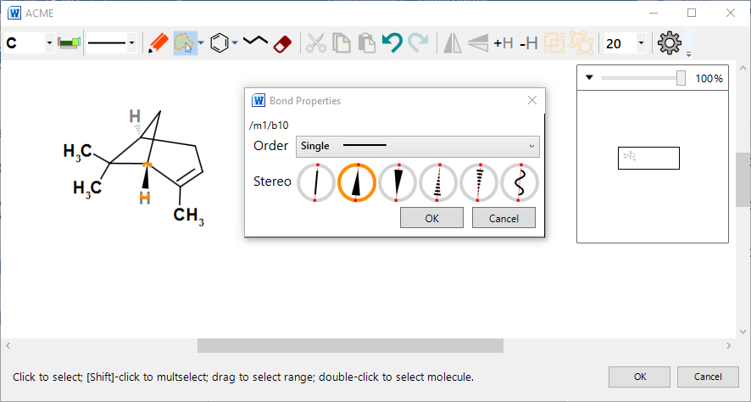

Figure 31: Setting the direction of a stereobond

# Molecule properties

You can set molecule properties by first selecting the entire molecule (either by lassoing or double clicking) and then right clicking the selection. This displays the Molecule properties dialogue:  
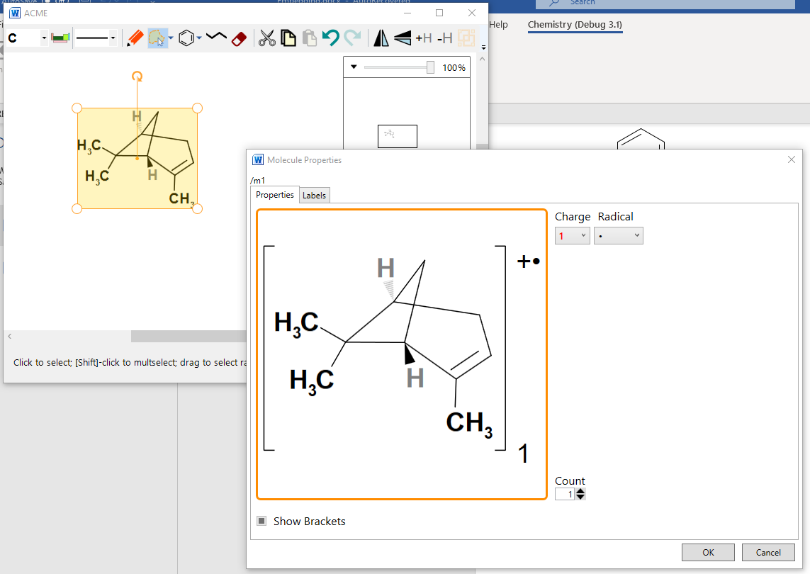

Figure 32: Molecule properties dialogue. The charge and radical labels have been added. ACME automatically adds brackets.

## Setting radicals and charges

You can set a radical and/or charge label using the dropdowns at the top right. If either of these are set, ACME brackets the molecule. Chem4Word will subsequently display these labels in the document.

## Multiplicity

The spinner on the bottom right allows you to set the multiplicity. Again, setting this will display the molecule brackets.

## Bracketing

The Show Brackets checkbox allows you to display brackets for a molecule independently of charge, radical or multiplicity. If any of the former labels are set, then brackets display automatically and cannot be turned off.

NB: To apply these properties to a set of molecules, group them first. ACME can only bracket or label a single selected molecule.

# ChemDoodle Web Sketcher

Chem4Word also supports the ChemDoodle for Web sketcher[9].

## Draw a structure

To draw a structure in a document, click the Draw button on the Chemistry Ribbon. This will activate the Chem4Word Editor tool.

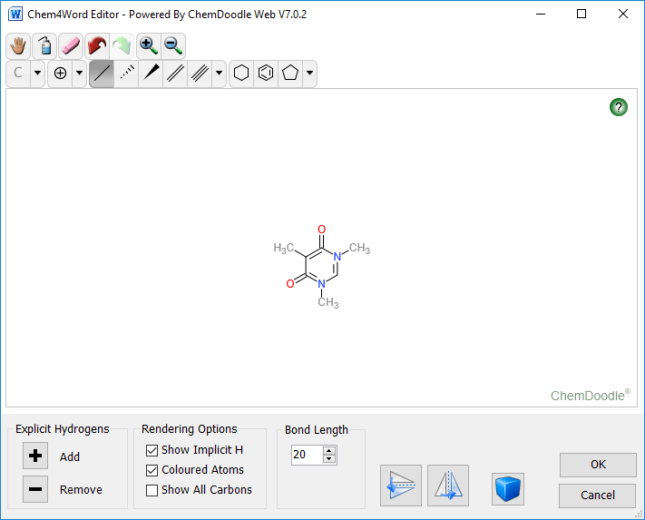

Use the bonds, rings and atoms tools to create a structure; at present, radicals and lone pairs are not supported in Chem4Word.

It is possible to change the default bond length in the drawing tool. Explicit hydrogen atoms can be added or removed from a structure by clicking the + and – buttons in this tool. There are also buttons to flip the structure horizontally or vertically.

|  |  |
| --- | --- |
|  | With the drawing tool, it is also possible to draw multiple structures in the same window. Clicking this button changes the drawing mode to multiple molecules. |

The final option in the drawing tool allows the drawing of explicit atoms with specific colours. Checking the “Coloured atoms” box will show atoms with coloured labels; without this option, all bonds and atoms will be drawn in black.

On clicking the OK button, the add-in runs a PubChem search to see if this chemistry is known. Labels such as names and synonyms will be returned. At this point, you have the option to add/edit/delete labels as you may need.

### Hydrogen Display

The editor allows you to manage display of hydrogen atoms. There are two kinds of hydrogens that can be displayed: explicit and implicit.

NB: Using the Explicit hydrogen + or - buttons modifies the structure by adding hydrogen atoms to it or removing them. Implicit hydrogen display simply shows the presence of inferred hydrogens and does not modify the structure.

#### Explicit Hydrogens

These may be added or removed to unused valences by clicking the + and – buttons under the Explicit Hydrogen group box.

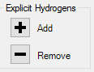

#### Rendering Options

The add-in infers the existence of these by counting unused valences. Click the checkbox for Implicit Hydrogens to toggle display:

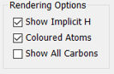

Here you can also toggle rendering of atom labels on colour or black.

This table shows the effect of these actions on structural display for a typical organic molecule (patulin):

| **Implicit Hydrogen** | **Explicit Hydroge**  **n** | **Structure** |
| --- | --- | --- |
| Off or On | Added |  |
| Off | Removed |  |
| On | Removed |  |

### Flipping and mirroring structures.

The Flip and Mirror buttons reflect the structure in the vertical and horizontal planes:  
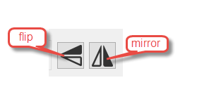

### Bond Lengths

The bond length control specifies the length in pixels of a bond. The default is 20, but you can change this in increments of 5 using the spinner buttons (or type a value in directly).

Changing the bond length affects existing as well as new bonds. You can use this to change the size of the rendered image in Microsoft Word

See section ChemDoodle Web Commands for keyboard shortcuts and explanation of ChemDoodle Web buttons.

After editing a structure, the following dialogue is shown if we detect a change in the concise formula.

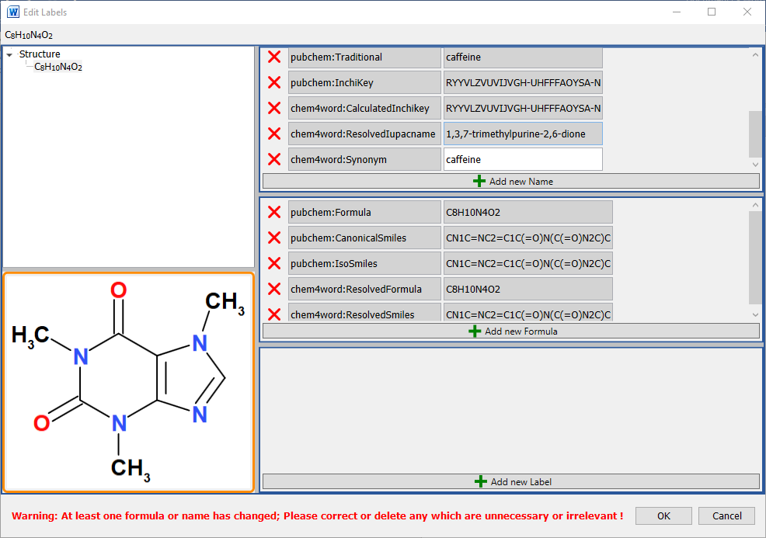

The image above shows the information retrieved when caffeine is drawn using the Chem4Word Editor. the retrieved information, an additional synonym, caffeine, has been added.

# ChemDoodle Web Commands

The buttons presented on top of the sketcher provide the following functionality. It should also be noted, that in all states, the user can use the mouse wheel to scale the sketcher rendering. Users can also click and drag on the background, with nothing hovered, to move the entire molecule. If the shift key is held while dragging the background, the entire molecule will be rotated. Double-clicking on the background will centre the molecule

 **Move** – Puts the sketcher into move mode. Highlighting an atom or bond and then pressing the mouse down and dragging will translate those objects. This tool is only available in the Single Molecule Sketcher.

 **Clear** – Clears the sketcher. In the Single Molecule Sketcher, this leaves a single carbon atom.

 **Erase** – Puts the sketcher into erase mode. In the Full Sketcher, deleting a bond will remove that bond and deleting an atom will remove that atom and any attached bonds. In the Single Molecule Sketcher, highlighting an atom and clicking will remove that atom and any small disconnected fragments, leaving the largest fragment remaining. Highlighting a bond and clicking will only have an effect if that bond is part of a ring, and in that case it will remove that bond.

 **Undo** – Undoes the last performed action.

 **Redo** – Redoes the last undone action.

 **Zoom in** – Increases the rendering scale of the sketcher.

 **Zoom Out** – Decreases the rendering scale of the sketcher.



**Labels** – After an element has been selected, hover an atom and click to change that atom’s label to the selected element symbol. If you press the mouse down and drag to the edge of the optimize zone, a new bond will sprout from that atom to the label in an optimal position. Drag out of the optimize zone and/or use the *shift*/*alt* keys to place a bond to this label anywhere.

 **Periodic Table** – Pops up a periodic table to select a symbol. After a symbol has been selected, hover an atom and click to change that atom’s label to the selected element symbol. Press the **Close** button to close it.

 **Bonds** – After a bond type has been selected, hover an atom and press the mouse down to begin drawing a new bond of that type. Drag and place the preview to the preferred position and then release the mouse to place the bond. The optimize zone (blue circle) is provided to help place the bond in the optimal position when the mouse pointer is within the bounds of the circle. Hover a bond and click to change that bond’s type to the selected type. The single bond tool is special and will add to bond orders instead of overriding them. Hold down the *shift* key to modify standard lengths and hold down the *alt* key to modify standard angles.

 **Rings** – After a ring type has been selected, hover an atom and press the mouse down to begin drawing a new ring of that type. Drag and place the preview to the preferred position and then release the mouse to place the ring. The optimize zone (blue circle) is provided to help place the ring in the optimal position when the mouse pointer is within the bounds of the circle. Hover a bond and press the mouse down to begin drawing a ring from that bond. Drag the preview to either side of the bond and then release the mouse to place the ring. Hold down the *shift* key to modify standard lengths and hold down the *alt* key to modify standard angles.

** Charges** – After a charge sign has been selected, hover an atom and click the mouse to add or subtract from that atom’s charge amount.

 **Lone Pairs** – After a lone pair icon has been selected, hover an atom and click the mouse to add or remove a lone pair from that atom.

 **Radicals** – After a lone pair icon has been selected, hover an atom and click the mouse to add or remove a lone pair from that atom.

Group Buttons

 At the end of some button groups, there is a small button with a downwards facing arrow. This means that there are more options available for this button set. Just click on this downwards facing arrow and select an option. The button adjacent to the downwards facing arrow will pick up this option and will be automatically selected for use.

1. Only available in Word 2010 or later versions. Earlier versions display structures as PNG graphics.
2. Details about the PubChem search tool is available at <https://pubchem.ncbi.nlm.nih.gov/search/>.
3. Further information about ChEBI searching is can be found here <https://www.ebi.ac.uk/chebi/>.
4. Hastings, J., de Matos, P., Dekker, A., Ennis, M., Harsha, B., Kale, N., Muthukrishnan, V., Owen, G., Turner, S., Williams, M., and Steinbeck, C. (2013) The ChEBI reference database and ontology for biologically relevant chemistry: enhancements for 2013. [Nucleic Acids Res.](http://dx.doi.org/10.1093/nar/gks1146)
5. More information about OPSIN available from <http://opsin.ch.cam.ac.uk/>.
6. [Daniel M. Lowe](http://pubs.acs.org/author/Lowe%2C+Daniel+M), [Peter T. Corbett](http://pubs.acs.org/author/Corbett%2C+Peter+T), [Peter Murray-Rust](http://pubs.acs.org/author/Murray-Rust%2C+Peter), and [Robert C. Glen](http://pubs.acs.org/author/Glen%2C+Robert+C), J. Chem. Inf. Model., 2011, 51 (3), pp 739–753
7. For more information on the cml format, see <http://www.xml-cml.org/>. Accelrys have a document that describes several chemical file formats, including the MOLFILE file format used by Chem4Word. A copy of this document can be obtained from the Accelrys website: <http://download.accelrys.com/freeware/ctfile-formats/ctfile-formats.zip>.
8. ACME is the *only* molecule editor component written in C#, and which exploits the *full* power of the .NET Framework. .NET developers can easily incorporate it into their own Windows Desktop programming projects. ACME is licensed under Apache 2.0. [Please feel free to contact us](mailto:info@chem4word.co.uk) for help if you want to use ACME in your own projects.
9. Whether you use ACME instead is entirely your preference and can be configured from the Options dialog. Updates to existing installation for Chem4Word will default to the already selected editor. New installations default to ACME.