# Pre-requisites

Windows 7 (x64) PC or newer

Word 2010 or newer

Turn this windows feature on “.NET Framework 3.5” (this is for the WiX Toolset)

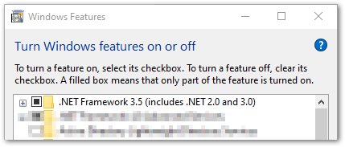

Install Visual Studio 2022

Ensure that the following workloads are installed.

* Azure development
* .NET desktop development
* Office/SharePoint development

Ensure that the following individual components are installed.

* .NET Framework 4.5.2 targeting pack
* .NET Framework 4.6.2 targeting pack

# Additional Software

Git for Windows <https://git-scm.com/download/win>

Clone the repository from <https://github.com/Chem4Word/Version3-2.git>

WiX installer 3.11.1 <http://wixtoolset.org/releases/>

Also install WiX Extension for Visual Studio 2022

# Setting up Chem4Word VSTO Signing.

In order to ease swapping between developers we have created a Self-Signed certificate for the Add-In

Browse to $/src/Scripts/

Run PowerShell file “Install-Dev-Certificate.ps1”

# Running inside Visual Studio

The main project which can be run and debugged in Visual studio is:

* **Chem4Word.V3**
  + In Project Properties, set debug start action to start external program
    - C:\Program Files (x86)\Microsoft Office\Office15\WINWORD.EXE

There are some other useful programs developed during the testing phase, they are:

* **WinForms.TestHarness** – This fires up a test environment for chemistry which is not integrated with word.
* **Wpf.UI.Sandbox** – Play pen for developing new WPF bits and bobs.
* **LibraryTransformer** – Allows the conversion of a library structures from (Google) protocol buffer to cml and vice versa.
* **Wpf.FunctionalGroupEditor** – Experimental Functional Group Editor.

The XUnit tests which are run as part of our dev build pipeline are defined in **Chem4WordTests**.