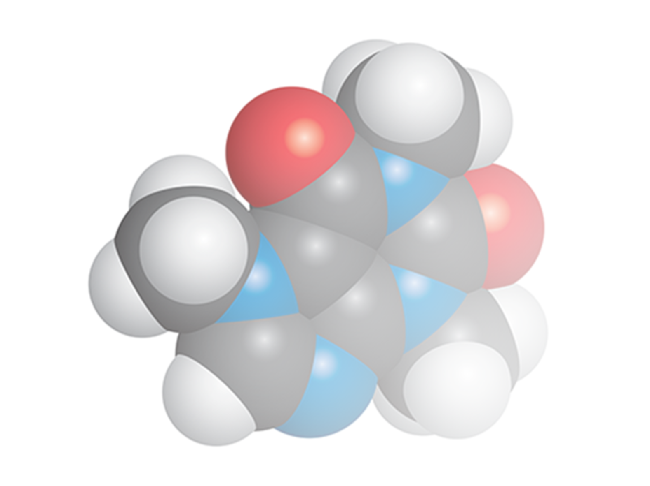**Chemistry Add-in for**

**Microsoft Word**

**User Guide**

**Version 3.3 (2023)**

Table of Contents

Introduction 5

Prerequisites 6

System Requirements 6

Installation 6

To Install Chem4Word 6

Auto Update 8

Legacy documents 10

How to add a chemical structure to a document 10

Import a structure from a file 10

Add a structure from a web-search 10

PubChem search 11

ChEBI Search 12

How to edit an existing chemical structure 12

Convert text to Chemistry 13

Display options for Chemistry 14

Libraries 15

The Navigator 16

Exporting chemistry files 17

Chem4Word Options 18

Plug-Ins Tab 18

Editor Options 18

Renderer Options 19

Searcher Options 19

General Tab 20

Privacy Tab 21

Libraries Tab 22

“Select Folder” 22

“Add Library” 22

“New Library” 22

“Download a Library” 23

“Remove Library” 23

“Edit Library” 24

Maintenance Tab 25

Rendering of characters 26

What is ACME? 27

‘Advanced’ 27

‘CML-Based’ 27

‘Molecule Editor’ 27

What functions does ACME support? 27

What functions *doesn’t* ACME support? 28

ACME User Interface 28

Toolbar 29

Highlighting Active Atoms and Bonds 29

Element Selector and Periodic Table Picker 29

Periodic Table Picker 30

Bond Dropdown 30

Draw Button 31

Locking 34

Drawing multiple bonds 34

Select Button 35

Selecting individual atoms and bonds 35

Range selection 35

Types of selection 36

Lasso Mode 36

Rectangle Mode 37

Editing the selection 39

Ring Button 43

Fixed rings 43

Variable Ring 44

Chain Button 45

Erase Button 45

Reaction button 47

Repositioning Reactions 48

Cut, Copy and Paste Buttons 49

Data Transfer Format 50

Undo and Redo Buttons 51

Mirror Buttons 51

Add/Remove Explicit Hydrogens 52

Group and Ungroup Buttons 53

Grouping Molecules 54

Ungrouping 55

Bond Length Dropdown 55

Settings Button 55

Default Bond Length 55

Show grouping of molecules 55

Reaction Toolbar 56

Choosing a reaction type 56

Editing Reagents and Conditions 57

Assigning reactants and products 58

Initial Assignment 58

Deassigning 59

Plus Tool 60

Aligning objects 61

Atom properties 63

Setting Elements or Functional groups 63

Setting a Functional Group 64

Setting Charges 65

Setting Isotopes 65

Togging explicit carbon display 65

Bond Properties 66

Setting Bond Order 67

Setting placement 67

Molecule properties 69

Setting radicals and charges 69

Multiplicity 69

Bracketing 69

# Introduction

The Chemistry Add-in, or Chem4Word for short, provides a simple and flexible way to include chemical information in a Word document.

With the Chem4Word, you can:

* **Create inline "chemistry zones" to represent chemical data.**

Chemistry zones are controls that contain information about a molecule and display the information in a variety of ways. We store the underlying data as Chemical Markup Language (CML). This is a widely used XML dialect for representing chemical data. It typically includes trivial and International Union of Pure and Applied Chemistry (IUPAC) names, the concise formula, and the structural formula.

* **Display chemical information in a variety of ways.**

A chemistry zone can display any representation that is supported by the underlying CML data. With a few clicks, you can switch from the molecule’s trivial name, to its concise formula or then to its 2-D representation.

* **Draw and edit your own chemistry.**

New to this version of Chem4Word is ACME, a molecule editor. We wrote this to work specifically with the add-in. ACME is an intuitive chemistry sketcher that enables us to further develop the add-in and add more features. More information about ACME can be found on on page 18 of this guide.

Chem4Word also supports ChemDoodle web, the molecule editor used with the previous version of the add-in. Whichever sketcher you use is up to you!

* **Display print-quality 2-D chemical structures.**

Chemistry zones can represent molecules with a 2-D structure diagram using publication-quality, resolution-independent graphics. We insert the diagram as a DrawingML image, so that others can view it. They do not need Chem4Word installed on their system[1]. You can also publish a document authored using Chem4Word as a PDF file.

* **Accept chemical data in a variety of formats.**

You can create a chemistry zone by typing a simple common name such as ‘pinene’, and then using Chem4Word to convert it to your preferred representation, if the name you type exists in your library.

* **Import CML files from online web services**

Using the **Load From** option in the ribbon, you can look up existing molecular structures from the NCBI’s PubChem (<http://pubchem.ncbi.nlm.nih.gov/>), the Unilever Centre’s OPSIN (<http://opsin.ch.cam.ac.uk/>) or the European Bioinformatics Institute’s ChEBI (<https://www.ebi.ac.uk/chebi/>) databases.

* **Handle most molecules.**

Chem4Word can handle any molecule that has appropriate CML data.

* **Store and expose chemical information in a semantically rich manner.**

Chem4Word supports publishing and data-mining scenarios for authors, readers, publishers, and other vendors across the chemical information community.

This manual describes how to use Chem4Word to include chemical information in a Word document.

## Prerequisites

You should have a basic understanding of:

* Microsoft Word
* Chemical nomenclature and diagrams

An understanding of CML is helpful but not required.

## System Requirements

Hardware Requirements

* Any Windows-based computer that can run Microsoft Office.

Recommended screen resolution 1920x1080 (minimum 1366x768)

Software Requirements

Your computer must have the following software:

Windows 7 or later, including Internet Explorer 11.  
Your operating system must have the latest Windows updates installed.

Word 2010, 2013, 2016, 2019, 2021, 365

.NET Framework 4.6.2 or greater.

Chem4Word needs an internet connection to function properly. Access to <https://www.chem4word.co.uk> is required during installation and for automatic checking for updates thus should not be blocked by a firewall.

NB: Chem4Word does not work with Word for Macintosh, or online versions of Word. These programs do not work in the same way as the Windows versions of Word.

## Installation

Installation is straightforward. Depending upon your computer’s configuration, it may need to install the Visual Studio Tools for Office for your current version of Office.

### To Install Chem4Word

1. Close all Word documents.
2. Download the file **Chem4Word-Setup.exe** to your hard drive from our releases area on GitHub via <https://www.chem4word.co.uk/download> this will always point you to the latest version.
3. Navigate to your Downloads folder, then run **Chem4Word-Setup.exe**
4. The setup programme will download and install any missing system components.
5. Once you have these pre-requisites, the installer will be downloaded and will be started to install Chem4Word.

To verify the installation, launch Word. The ribbon should now include a Chemistry tab:

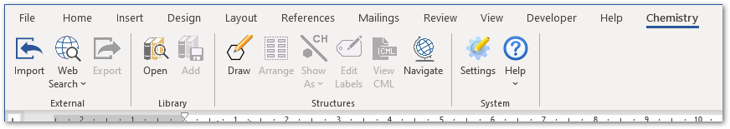

The Ribbon has four command groups

* **External**
  + **Import** – This allows importing files in CML, SDFile or MOLFile format.
  + **Web Search** – This allows you to search the web for structures
  + **Export** – This allows you to export your structures to cml or MOLFile format for sharing
* **Library**
  + **Open** – This shows the library in the left-hand pane
  + **Save** – This saves the currently selected structure into your library, the button is disabled if the currently selected library is a system library.
* **Structures**
  + **Draw / Edit**
  + **Arrange** – This will re-arrange multiple molecules in a single structure so that they do not overlap.
  + **Show As** – This allows you to change how this structure is displayed
  + **Edit Labels** – This allows you to change the 1D labels for a structure
  + **View CML** – This allows you to view the CML for the selected structure
  + **Navigate** – This shows the chemistry navigator
* **System**
  + **Settings** – This allows you to set your settings / preferences
  + **Help**
    - **About**
    - **Chem4Word Home** – View the Chem4Word home page
    - **System Information** – View system information which we may ask you for if you report a bug
    - **Check for Updates**
    - **User Manual** – View this user manual
    - **You Tube Videos** – View our YouTube tutorials
    - **Buttons Disabled** … – If the buttons are disable this will tell you why

# Auto Update

Chem4Word checks for newer versions every 7 days during normal use and will prompt you to download updates. If an error occurs, it performs an immediate check for updates.

Please do not ignore updates: the shield is either amber or red depending on how many versions you are behind.

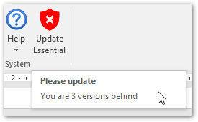

This screen is shown when updates have been detected. It can also be shown by clicking on the Update shield button.

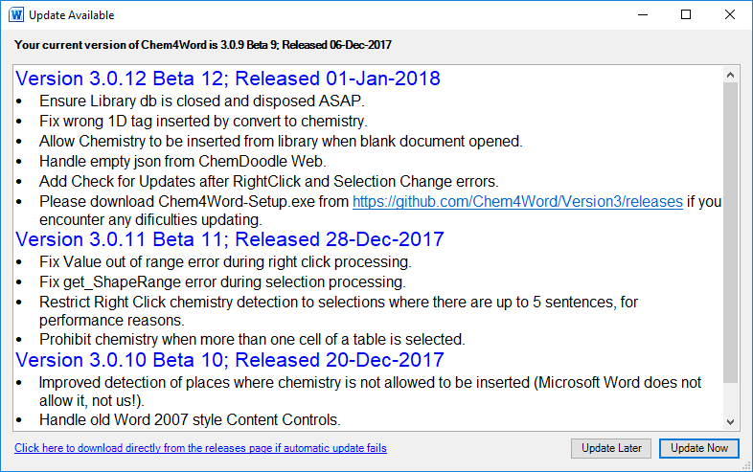

If you think you have missed an update you can check by using “Help” 🡪 “Check for Updates” from the Chemistry Ribbon

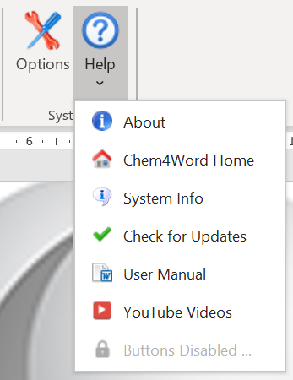

Clicking on “Update Now” will start the update downloading. If this fails, you may need to visit our [download page](https://www.chem4word.co.uk/download/) to download the latest setup executable.

The image below shows the updater in action. It downloads the updated version of Chem4Word, then waits until you have closed all instances of Word [WINWORD] then installs the update.

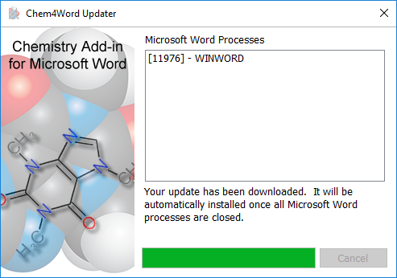

We have been informed that some Anti-Virus systems are falsely detecting our updater as a virus.

You may see “Access denied” or similar message.

If so, please temporarily disable your AV system and try to update again.

# Legacy documents

When a document is opened it is scanned for any chemistry zones which have been stored in earlier formats. We *highly* recommend you allow these to be converted to the new format when a document is opened!

An automatic backup of the original document will be saved in the Backups folder inside the folder where your user settings are stored. Once this conversion has completed, the old version of Chem4Word will not be able to read the new document format.

# How to add a chemical structure to a document

You can add chemistry to a Microsoft Word document in many ways. You can draw them with ACME or ChemDoodle Web. You can also search PubChem[2] and ChEBI (Chemical Entities of Biological Interest[3],[4]) or use the name-to-structure tool, OPSIN (Open Parser for Systematic IUPAC Nomenclature[5],[6])

## Import a structure from a file

Chem4Word for Microsoft Word supports importing chemistry from three file formats: CML, MOLFile and SDFile.

The Import button browses to a folder containing supported file formats. You then select a file and then import that file as a chemical structure into the current document. The structure will be displayed exactly as it was stored in the imported file.

## Add a structure from a web-search

There are three options for importing a structure from web searches:

|  |  |
| --- | --- |
| PubChem Logo | PubChem is a public repository of chemical structures and biological data maintained by National Center for Biotechnology Information (NCBI). |
| ChEBI logo ChEBI | Chemical Entities of Biological Interest (ChEBI) is a freely available dictionary of molecular entities focused on ‘small’ chemical compounds maintained by the European Molecular Biology Laboratory (EMBL). |
| University of CambridgeOPSIN | OPSIN is a tool developed at the University of Cambridge that converts chemical names into chemical structures. |

### PubChem search

The PubChem search allows you to search by name or formula for structures in the PubChem database. You can retrieve multiple structures. Chem4Word sorts these by relevance.

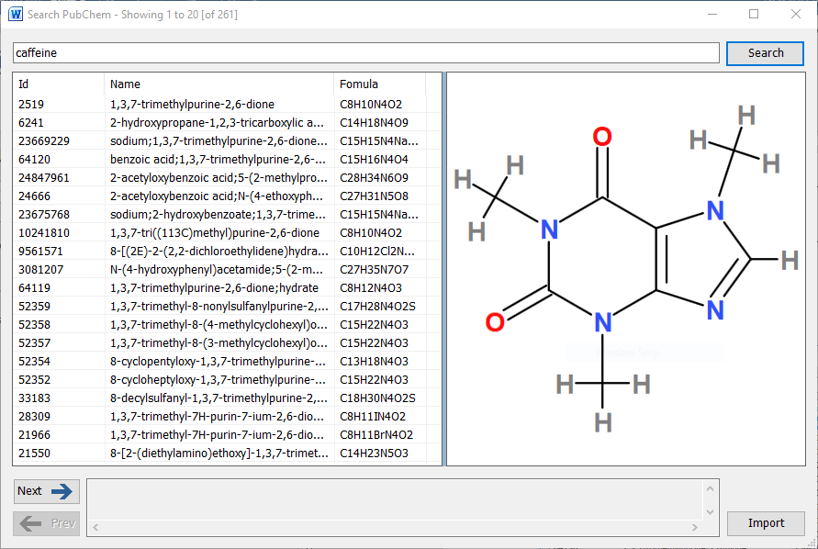

Selecting an entry in the returned results displays a structure, as stored in the PubChem database. You can move forwards and backwards through all the results. the selected result can be added to the document at the current position by clicking the Import button.

### ChEBI Search

The ChEBI search allows you to search by name for structures in the ChEBI database. Fewer results are returned by this search tool than the PubChem search, as a scoring algorithm limits the number of possible structures returned.

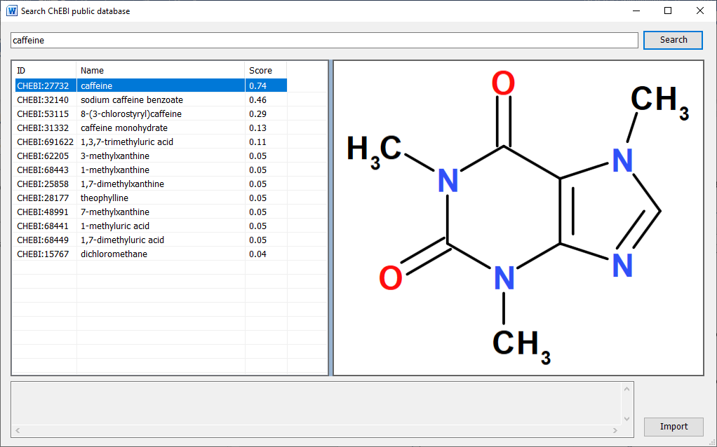

It is possible that there are entries in this database where no chemical structure is available. A message indicating this will be shown at the bottom of this window.

Clicking the Import button adds the displayed structure to the current document.

## How to edit an existing chemical structure

When you select a chemistry object in a document, you can edit the contents by clicking the edit button. Double-clicking a chemistry object edits the structure.

If you change the chemistry, the add-in automatically runs a PubChem search to see if the new structure is known. You will be given the opportunity to add/change/delete labels associated with the new structure.

When you attempt to edit a structure, the add-in performs some checks to see if the structure being edited has features which can only be edited in ACME. If you encounter this message, please set ACME as the default editor in the Options window.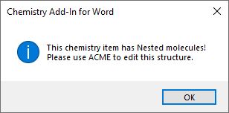

## Convert text to Chemistry

When you right click on a selection (which contains plain text and does not include a line ending) it is analysed to see if it contains the names of any structures within your library.

This text contains the string alpha-pinene when you right click, the context menu will show a button for converting this to a chemistry object.

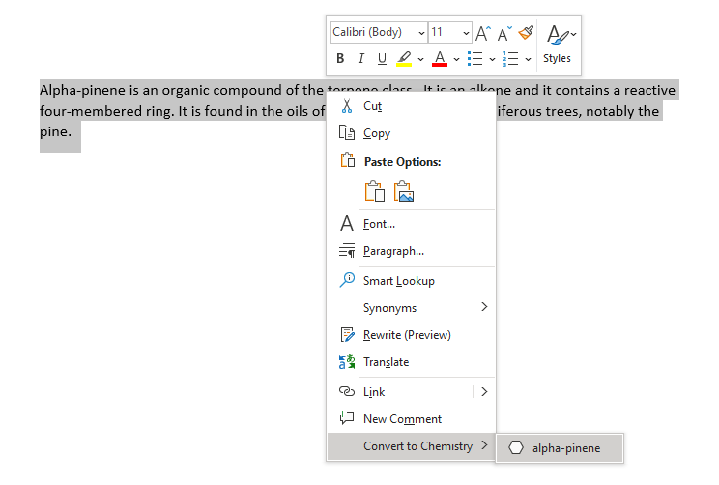

The converted object is shown below.

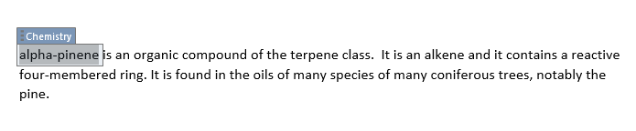

# Display options for Chemistry

Chem4Word for Microsoft Word displays chemistry in multiple formats. For structures imported from files and web sources, chemistry objects may have associated names and synonyms as well as formulae. You can switch the display to these alternatives if you wish.

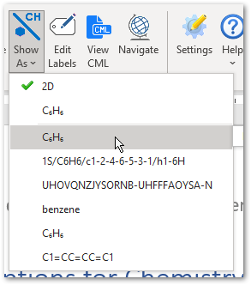

When you draw a structure in a document, the add-in searches PubChem to see if the structure is known, and any known names and synonyms are retrieved.

You can also add your own synonyms and formulae to any structure using the Edit Labels button.

The example on the right shows all the depiction options for benzene that are available when this chemistry object is drawn using ACME. The currently displayed chemistry object can be changed to show any one of these alternative depictions.

The Edit Labels button opens the form shown below to allow you to create update and edit the structure’s labels. NB: You are prevented from deleting any labels that are in use.

# Libraries

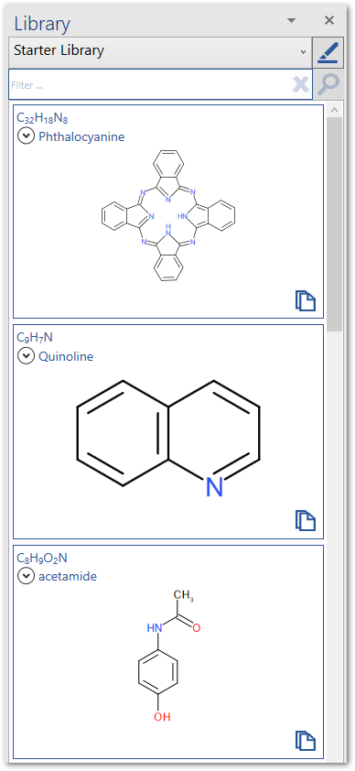In Chem4word you can select from multiple libraries.

A library is a store of re-usable chemical structures.

Chem4Word is delivered with a starter library, which can be edited, and a system library which contains approximately 2000 structures of plant essential oils.

You can easily store your own structures in the starter library for use in other documents by clicking the Save button in the library section of the ribbon.

The library can be opened and closed using buttons on the ribbon.

The drop down at the top allows you to select the current library.

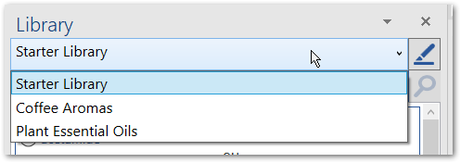

There is also a search box at the top of the library panel, to help you to find structures by name. Type the name to search for then click the magnifying glass. To show all molecules in the library, click the cross next to the magnifying glass.

To insert a copy of a structure from the library into the document at the current cursor position, simply click the paste icon  at the bottom right of the structure you want to add.

# The Navigator

The Navigator resembles the library, as it enables the quick addition of chemistry to a Word document. The Navigator, however, only shows chemistry that has already been added to the current document. This includes chemistry that may not be in the current library, such as structures that you have drawn yourself.

The Navigator contains one panel for each unique structure in the current document. Each panel in the Navigator shows the chemical structure and formula of each molecule. The buttons at the bottom of the panel add structures to the document, either by creating a linked copy or pasting a new copy of an existing structure at the current position in the document.

The arrow buttons find individual and linked structures in the document by moving backwards or forwards through the current document.

Selecting structures in the document will also automatically select them in the Navigator.

|  |  |
| --- | --- |
|  | Duplicate the structure and add it to the document at the currently selected position. |
|  | Add a linked copy of the structure to the document at the currently selected position. |
|  | Move to the previous linked structure in the document. |
|  | Move to the next linked structure in the document. |

The Navigator automatically updates when structures are added to the document. It may show structures that are not visible in the document. These are still stored in the document as CML, but not linked to any visible content. This means you can easily restore a structure after deleting it. Saving the document purges any unused chemistry.

# Exporting chemistry files

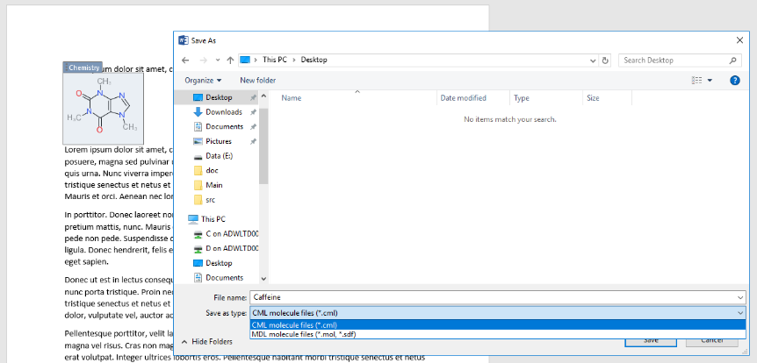Chem4Word allows you to export chemical structures as both CML files and MDL MOLFiles.

To export a structure, simply select the chemistry object in the document and click the Export button in the ribbon.

Choose a folder and type a file name, select the appropriate file type, and click the Save button.

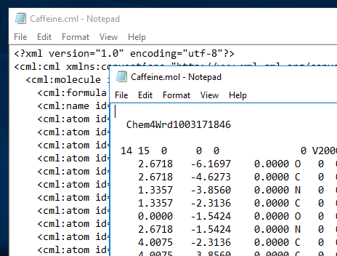The figure to the left shows example content of CML and MOLFile files for caffeine exported from a Chem4Word document.

Both file formats are based on recognised standards and should be suitable for import into other chemical-aware applications.[7]

# Chem4Word Settings

## Plug-Ins Tab

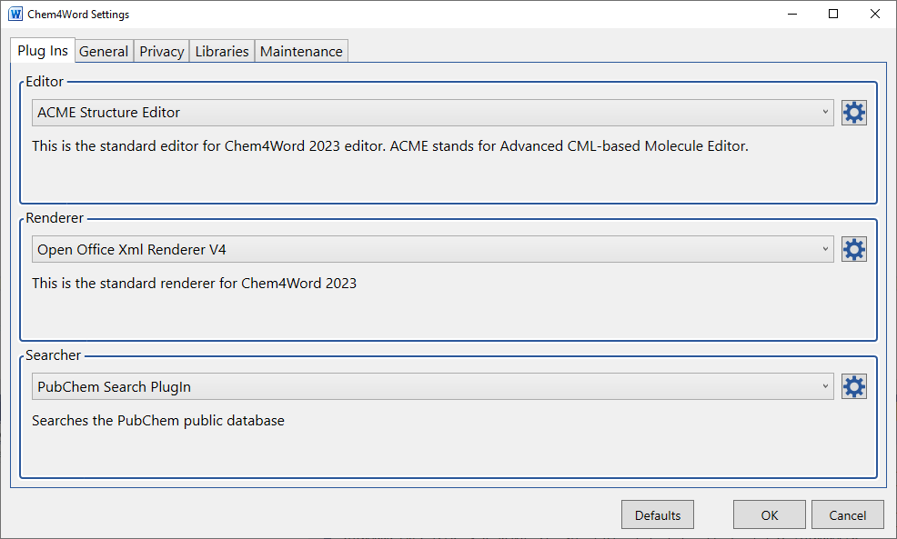

Here you can change the default editor and renderer or set the options for the selected editor, renderer or searcher.

### Editor Options

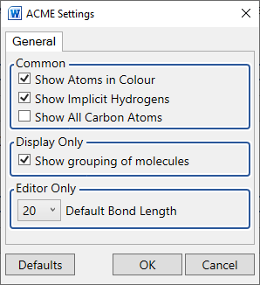

Here you can select your preferred bond length for new drawings and other visual elements. These options do not affect existing structures in a document.

### Renderer Options

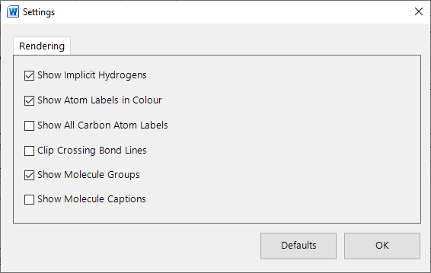

Here you can set the options for your selected renderer. These options do not affect existing structures in a document.

### Searcher Options

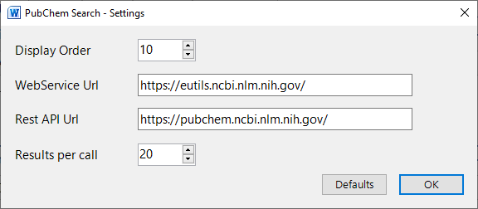

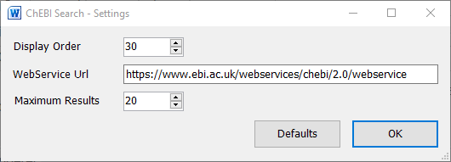

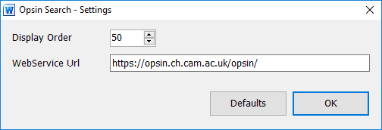

Here you can set the display order and the URLs for our preferred molecule search services. You should not need to change these URLs.

## General Tab

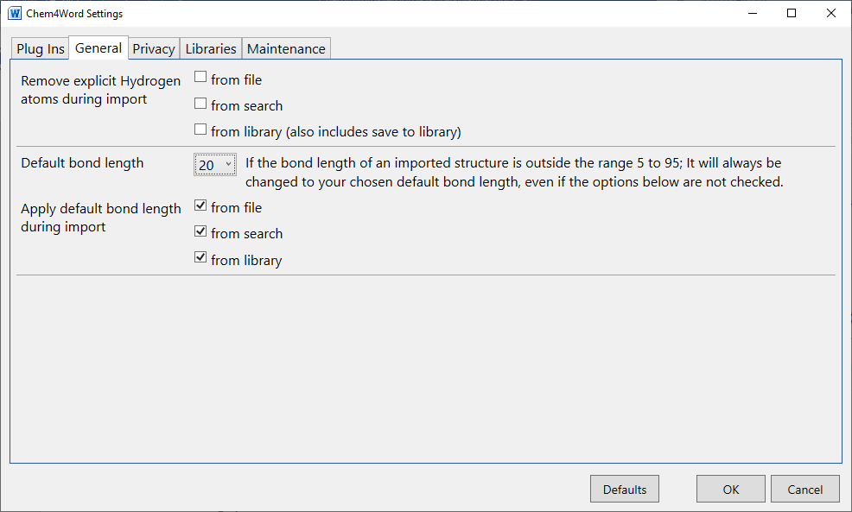

Here you can set what happens to explicit hydrogens and bond size when a structure is inserted into your document. These options do not affect existing structures in a document.

## Privacy Tab

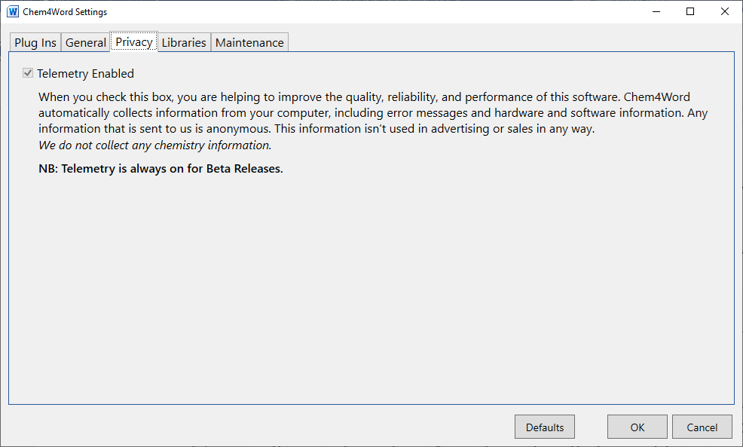

Here you can select whether you wish us to have access to application usage data. For beta releases it is always set. For production releases it is recommended that this be left set.

## Libraries Tab

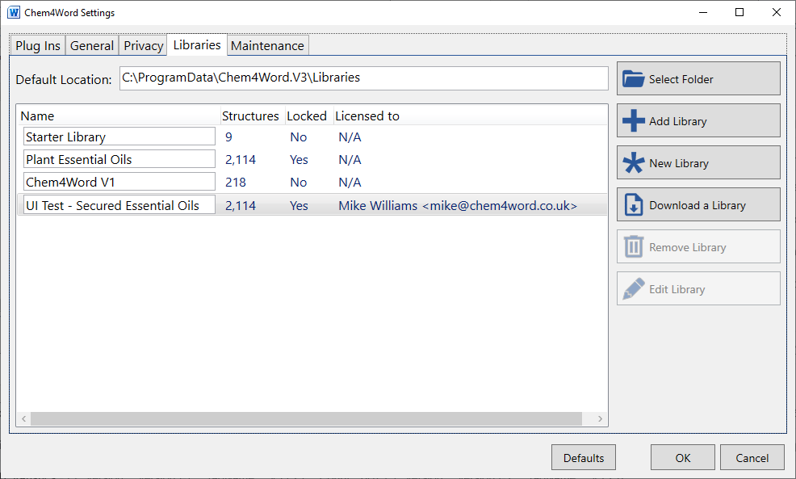

You can edit the contents of any library which is not locked.

Columns seen

|  |  |
| --- | --- |
| Name | The name of the library. This can be edited but must be unique. |
| Structures | How many structures are present in the library |
| Locked | “No” means that you can freely edit the library |
| Licenced to | This shows who the library is licensed to |

You can’t remove the currently selected library; selection of active library is done via a selector on the Library Task Pane.

The buttons on the right perform the following functions:

### “Select Folder”

This allows you to set the default folder where Chem4Word stores any libraries you may wish to create.

### “Add Library”

This allows you to add a pre-created library.

### “New Library”

This allows you to create a fresh library for you to add structures to.

### “Download a Library”

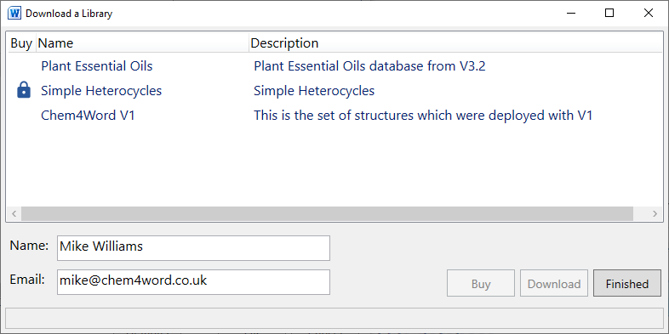

This form allows you to download a library which we have created.

If an entry in the list shows a padlock next to it, then this library needs to be purchased, click the Buy button to take you to our ecommerce site. Once a library is bought you will need to close this form and open it again.

When you select a library then click on the download button it will be downloaded and automatically installed.

### “Remove Library”

This allows you to remove a library from the list available. Note the library database file is NOT deleted, so can easily be added back later.

### “Edit Library”

This form allows you to edit the contents of any library which you have write access to.

The following controls are available in the library editor.

| Control | Use |
| --- | --- |
|  | This allows you to create a new structure using ACME |
|  | This allows you to edit the structure’s meta data |
|  | This allows you to bulk import structures from CML or SDFile files |
|  | This allows you to export all the structures to CML or SDFile files |
|  | This allows you to run our property calculator web service for all structures |
|  | This allows you to delete the checked structures |
|  | This allows you to zoom the structures grid |
|  | This allows you to change the sort order in the grid |
|  | This allows you to filter the structures which are displayed   |  |  | | --- | --- | | Filter … | Type your filter string here | |  | This will clear the filter | |  | This will apply the filter | |  | This toggle shows only checked structures | |
|  | Here you can change the display name or add and remove tags for the selected structure |

## Maintenance Tab

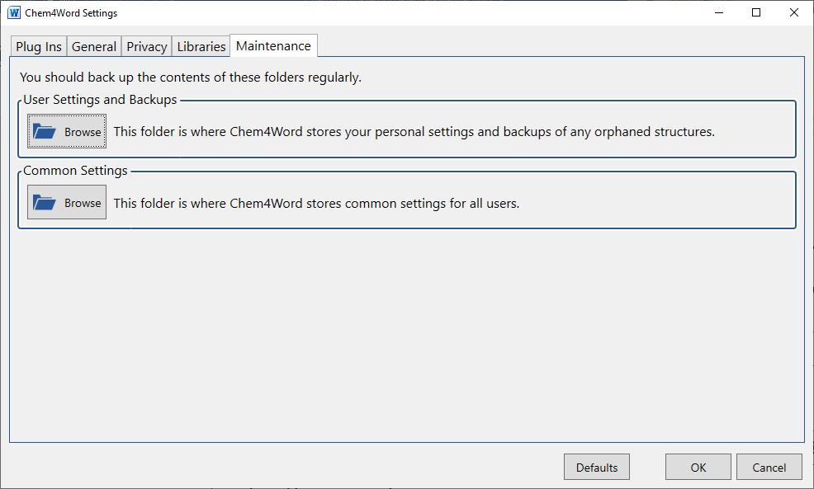

Here you can get quick access to the main folders on your system where Chem4Word stores data.

The following folders are written to while using Chem4Word …

|  |  |
| --- | --- |
| C:\Users\Owner\AppData\Local\Chem4Word.V3 | User settings |
| C:\Users\Owner\AppData\Local\Chem4Word.V3\Backups | Backups of structures which have become orphaned |
| C:\Users\Owner\AppData\Local\Chem4Word.V3\Telemetry | Copy of the telemetry sent to us |
| C:\ProgramData\Chem4Word.V3 | Machine wide settings |
| C:\ProgramData\Chem4Word.V3\Libraries | Default location for our libraries |
| C:\ProgramData\Chem4Word.V3\Libraries\Backups | Backup of a library before the database schema is patched. |
| C:\ProgramData\Chem4Word.V3\Plugins | Plug ins not part of the standard distribution, these will be installed when downloading a library |
| C:\ProgramData\Chem4Word.V3\Plugins\Updates | Updates for plug ins (they will be applied next time word is started) |

# Rendering of characters

To precisely position the label characters and clip the bond lines to not overlap them we use a subset of the Arial true type font which has been converted to curves.

When the Chem4Word bond size is set to 20 the rendered characters will be set to 10 point (the ACS recommended size).

The allowable characters are

* -+=.,*#/?!%&[](){}<>:;@~
* 1234567890
* ABCDEFGHIJKLMNOPQRSTUVWXYZ
* abcdefghijklmnopqrstuvwxyz
* Special characters
  + ' // single quote
  + " // double quote
  + // space
  + ° // degrees
  + – // en dash U+2013
  + — // em dash U+2014
  + ✱ // heavy asterisk U+2731
  + ′ // prime U+2032
  + ″ // double prime U+2033
  + • // bullet U+2022
  + α // alpha U+03B1
  + β // beta U+03B2
  + γ // gamma U+03B3
  + μ // mu U+03BC
  + δ // delta U+03B4
  + " // capital delta U+0394
  + ℃ // degrees Celsius U+2103
  + ⇒ // rightwards double arrow U+21D2
  + ⊠ // squared times U+22A0

Any characters not within this set are rendered as ⊠ (squared times Unicode 22A0)

# What is ACME?

Chem4Word now contains a brand-new editor, ACME. ACME Stands for **A**dvanced **C**ML-Based **M**olecule **E**ditor.

ACME has been written by us from scratch to enable the further development and enhancement of the add-in.

The default editor is ACME, but if you prefer, you can still use the ChemDoodle Web editor from version 3.0 of the add-in. This can be changed from the Plug-Ins tab of the Options window.

### ‘Advanced’

Many popular chemical editors do not harness recent developments in Windows Desktop graphics. ACME exploits them fully. It displays structures rapidly and with very high fidelity. ACME’s graphics are resolution-independent and render well under all display settings. ACME is also open-source and highly extensible[8].

### ‘CML-Based’

The editor is designed to work directly with the underlying CML: the same format that stores the chemistry in your Word document. It transfers information seamlessly between the editor and the document.

### ‘Molecule Editor’

There are now many molecule editors or ‘sketchers’ for drawing chemical structures. ACME works the same way as these. If you are used to using other tools, you will find ACME’s user interface very familiar. If not, you should find it easy to use and learn. ACME puts productivity and ease-of-use above features.

## What functions does ACME support?

ACME allows you to carry out common chemistry sketching tasks, such as:

* Freehand drawing
* Ring and chain drawing
* Editing of existing atoms and bonds
* Cut, copy and paste
* Resizing and rotation
* Repositioning of molecule fragments
* Parent-child relationships between molecules (‘groups’)
* Drawing functional groups
* Drawing reactions

ACME supports unlimited undo and redo of all editing operations.

## What functions *doesn’t* ACME support?

Currently ACME does not support:

* Functional group expansion
* Organometallics and p-bonds
* ‘Smoothing’ of structures

# ACME User Interface

The ACME interface has three main elements. From top to bottom:

1. The toolbar tray contains the main toolbar. This allows the selection of drawing, manipulation tools and settings. Additional toolbars support reactions and the aligning of elements
2. The drawing canvas. This is where you draw your chemistry. The drawing canvas includes a zoom box, which allows you to zoom out of very large structures.
3. Below the canvas is a status bar. This shows what the currently selected tool is used for.

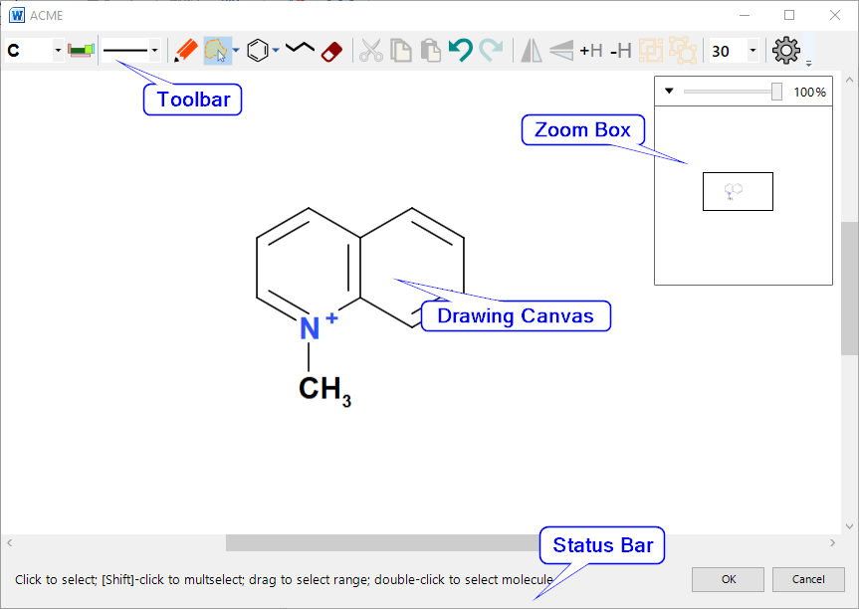

# Toolbar

The toolbar has five control groups: 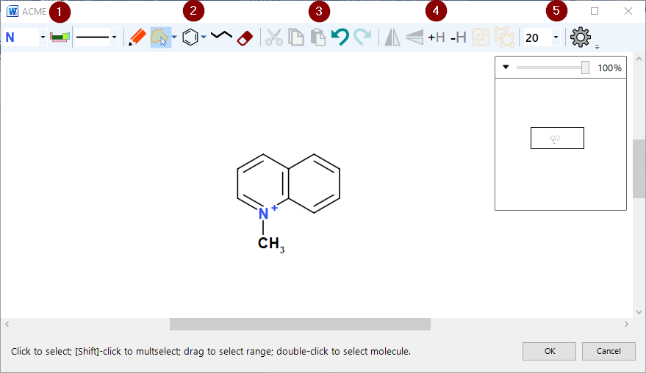

Figure : ACME layout

1. Element and bond type selectors
2. Mode buttons – these make dragging and clicking in the editor do different things
3. Common editing commands such as cut, copy, paste & undo/redo
4. Manipulation commands – flip, add/remove hydrogens and group/ungroup
5. Editor settings

The editor can only operate in one mode at one time, but all modes are available at any time. The commands can only be invoked according to context, *e.g.* flipping a molecule is only possible if it is selected.

If a command cannot be carried out, ACME disables the associated button.

## Highlighting Active Atoms and Bonds

ACME highlights the currently active atom or bond with orange brackets **[ ]**. Any operation resulting from mouse clicks will affect the active object.

## Element Selector and Periodic Table Picker



The element selector is the first control. When ACME starts, it populates this with common elements and functional groups, plus any other elements and functional groups present in the structure being edited. The adjacent periodic table picker works with the element selector.

The element selector is a simple dropdown. It works in two ways:

* With no selection active, the selector sets the current element for all draw operations.
* With a selection active, the selector changes all selected atoms to the selected element.

### Periodic Table Picker

The element selector contains a standard list of atoms, plus any non-standard atoms used in the current chemistry. The periodic table picker button allows selection of additional elements.

Click the periodic table picker button to display the periodic table popup. Clicking an element in the popup adds extra atoms to the standard list and sets the currently selected element. If you have a selection active in the editor, then it will set the selected atom’s element to your choice.

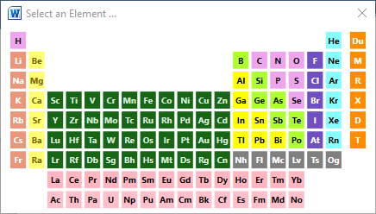

Figure : The periodic table popup

Click the Close box or press [Esc] to dismiss the picker without choosing an atom.

You can set generic atom types: R, M, X using this popup. Other functional groups must be set by right clicking on the atom.

## Bond Dropdown



The bond selector lists all bond types available in ACME. As with the element selector:

* With no selection active, the selector sets the current bond for all subsequent draw operations
* With a selection active, the selector changes all selected bonds to the selected type

Selecting an option sets both the bond order and the bond stereo:

| Option | Bond Order | Bond Stereo |
| --- | --- | --- |
|  | Single | None |
|  | Double | None |
|  | Triple | None |
|  | Single | Wedge (out of paper) |
|  | Single | Hatch (into paper) |
|  | Half | None |
|  | 1.5 (resonance bond) | None |
|  | Zero (hydrogen bond/agostic association) | None |
|  | 2.5 | None |
|  | Single | Indeterminate |
|  | Double | Indeterminate |

All these properties (and more) can be set from the Bond Options dialogue.

## Draw Button



This puts ACME into Draw Mode. This is the default when ACME starts*.*  What happens depends upon where you click:

* Clicking on empty space will drop an atom at the current cursor position:  
  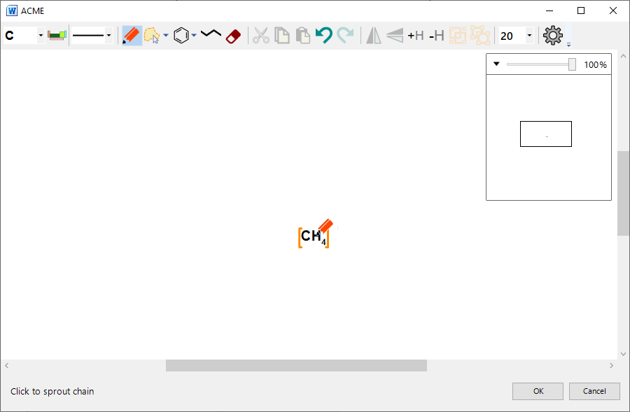

Figure : Dropping a single atom

* Clicking on an existing atom will either:
  + Change the atom’s element to the currently selected element – if the atom has a different element to the current element:  
    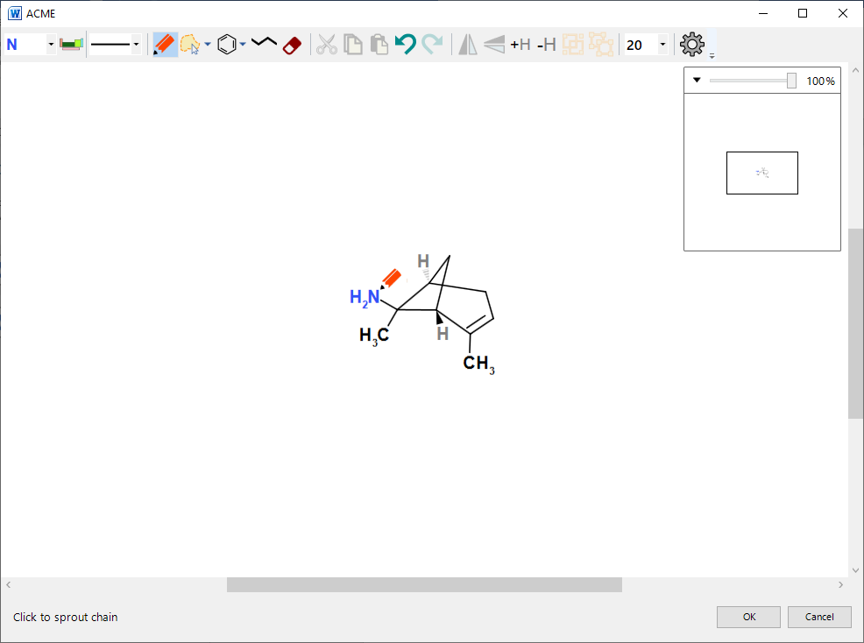
  + Sprout a single atom chain ending in the currently selected element – if the clicked atom is the same as the selected element:  
    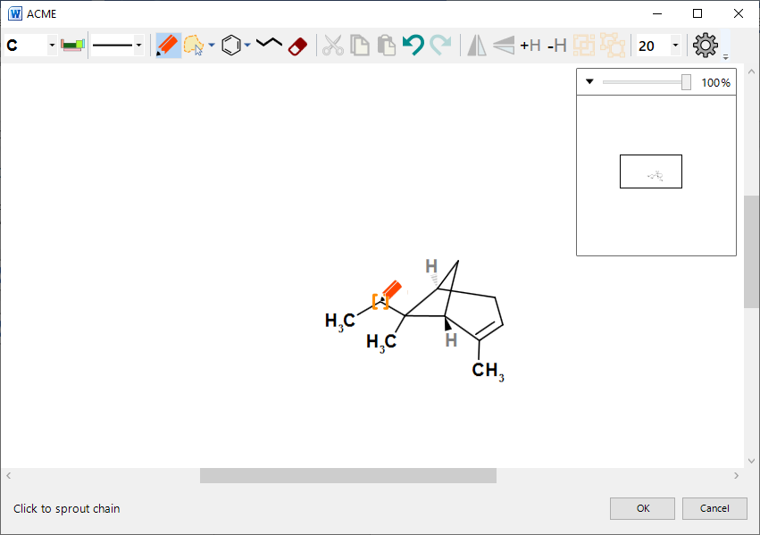
* Clicking on a bond in draw mode changes the bond to the currently selected bond type:  
  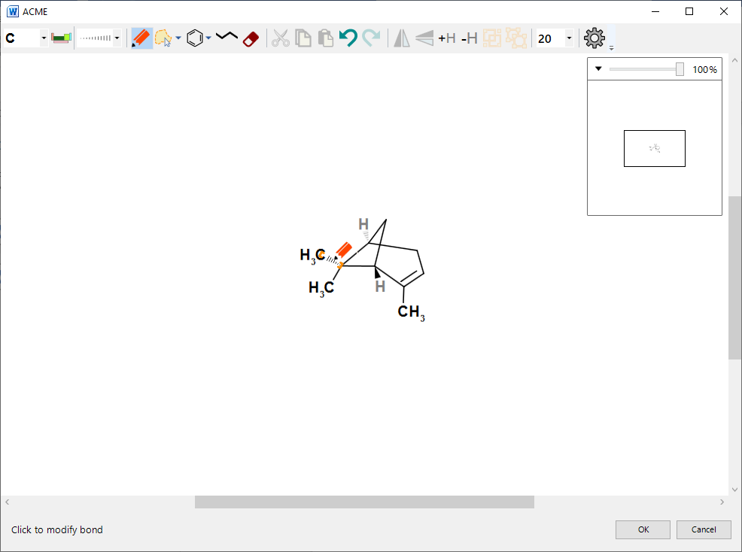

Figure : Setting a hatch bond by clicking

* + Clicking on a wedge or hatch stereo bond with the same stereo selected will invert the direction of the bond:  
    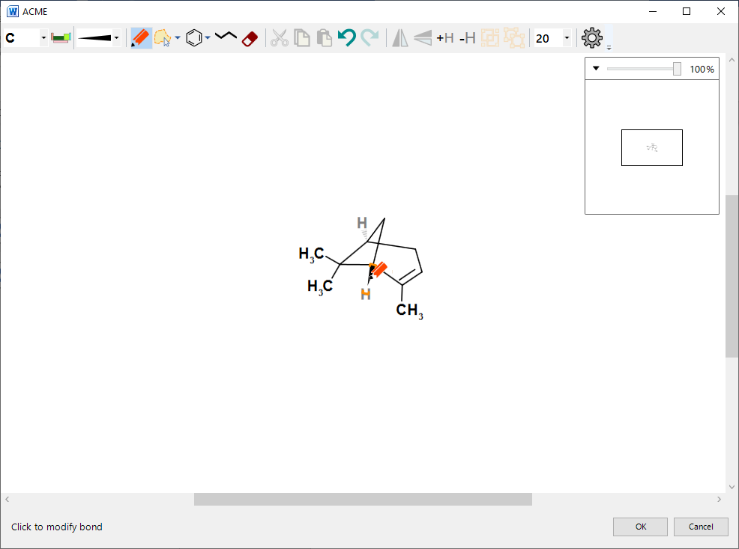

Figure : Inverting a stereobond

Draw mode also allows you to ‘draw freehand’:

* Click and drag on an atom: the editor draws a ‘ghost bond’ to show you where the new atom will be placed;
* Release to draw the new atom.

### Locking

By default, ACME locks both the bond length and angles when drawing:

* Pressing [Shift] unlocks the bond length – this snaps to multiples of the currently selected bond length;
* Pressing [Ctrl] unlocks the bond angle – this snaps to increments of 15 degrees.

You can unlock both snapping by pressing both [Shift] and [Ctrl] at the same time.

### Drawing multiple bonds

You can also increase the order of a bond by ‘stroking’ over it: click on the bond’s first atom, drag, and then release over the second. A single bond will become a double, and a double bond a triple.

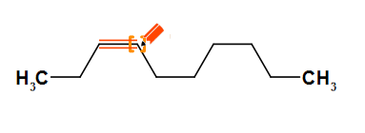

Figure : Stroking over a single bond

If Chem4Word detects an error in the valency count (too many bonds) of an atom then it is highlighted in the editor with a red spot as shown below.

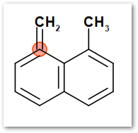

## Select Button

This puts ACME into select mode. You can select individual atoms and bonds, or entire molecules.

Selections are important for making bulk changes to molecules. You can select atoms and bonds before:

* Deleting them
* Changing either atom element or bond order
* Moving fragments of molecules
* Cutting or copying atoms and bonds

### Selecting individual atoms and bonds

Click on an atom or bond to select it. To clear the selection, click on a blank area of the canvas.

[Shift]-clicking will add atoms or bonds to the selection. Selecting additional atoms implies that ACME adds all connecting bonds between selected atoms too.

### Range selection

Clicking and dragging on empty space in select mode either draws a lasso or rectangle selection. Releasing the mouse button will select all objects in the catchment area.

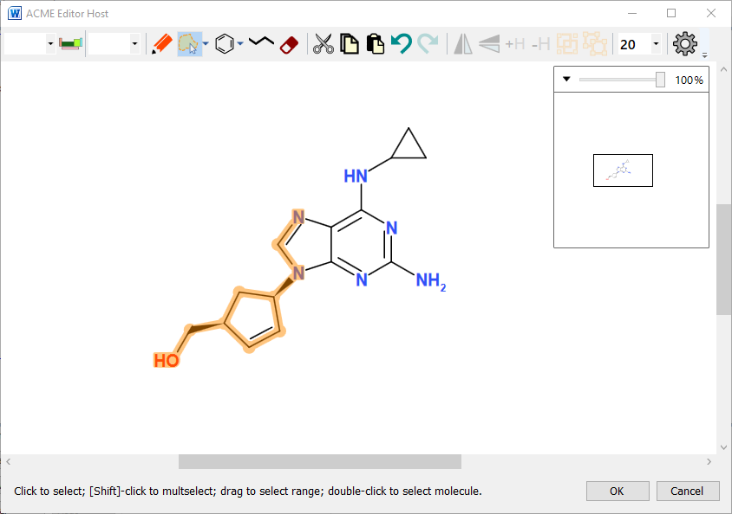

Figure : Selecting a range of atoms and bonds

### Types of selection

To switch between lasso and rectangle mode, click the small arrow next to the Select button, then click on the corresponding option in the popup:  
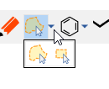

### Lasso Mode

Lasso mode allows you to draw around part of or all a chemical object by clicking and dragging. The selection area is outlined in orange as you do this.

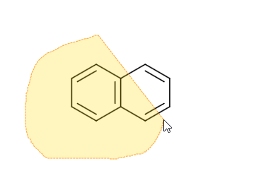

Figure : Lasso select

### Rectangle Mode

Rectangle mode works like lasso mode, except that the selection area is rectangular:  
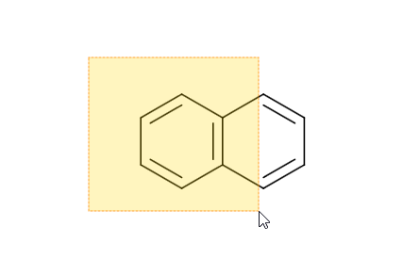

Figure : Rectangle selection

When you release the mouse button, anything in the selection area is highlighted in orange as selected.

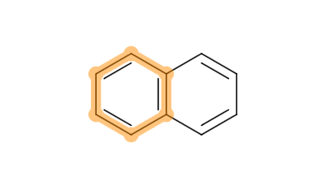

Figure : The result of the previous rectangle selection

Selecting *all* atoms and bonds makes ACME display a *molecule selector*:

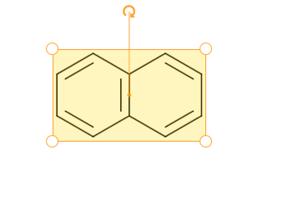

Figure : Molecule Selection Highlighting

Double-clicking any atom or bond will select its parent molecule. This is a convenient alternative to lassoing all atoms.

NB: Grouped molecules can be selected by single clicking.

### Editing the selection

Pressing the Delete key when there is a selection active will remove the selection from the editor. This applies to atoms, bonds and molecules.  
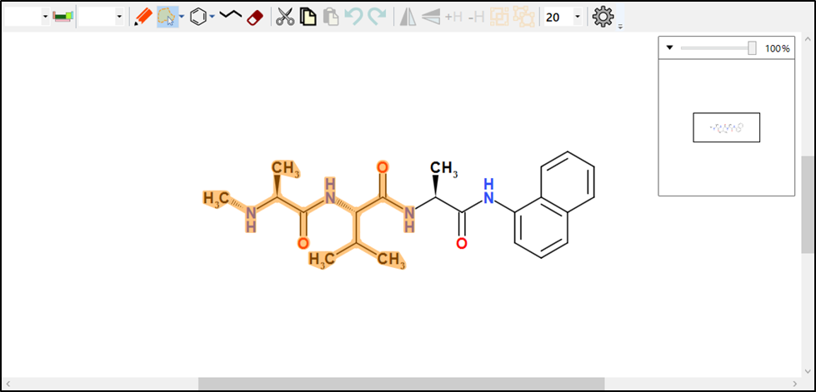

Figure 12: selecting atoms prior to deletion

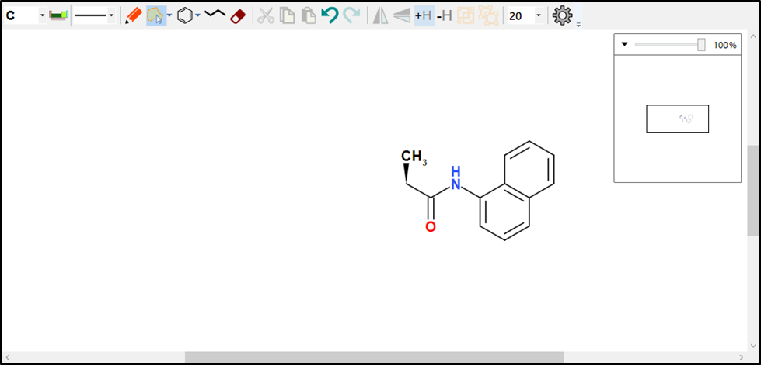

Figure : Pressing [Delete] removes the selected objects

If atoms and bonds are selected, then changing either the current atom or bond using the selector controls will modify the selected objects. If you select multiple elements, then ACME will show a blank element selector value:  
  
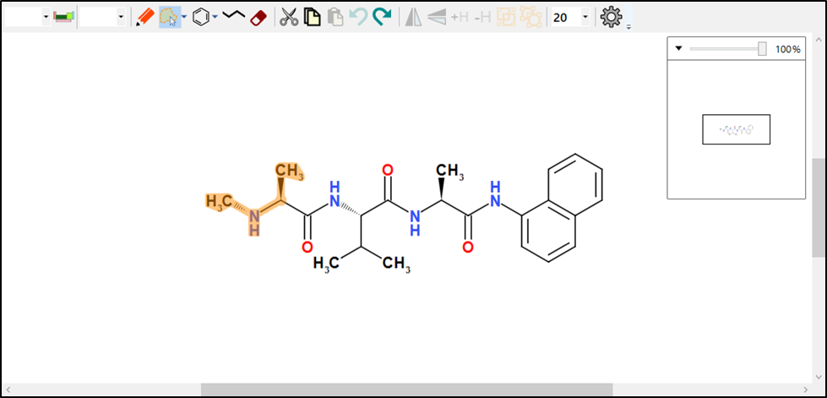

Figure : Select the atoms, then select an element

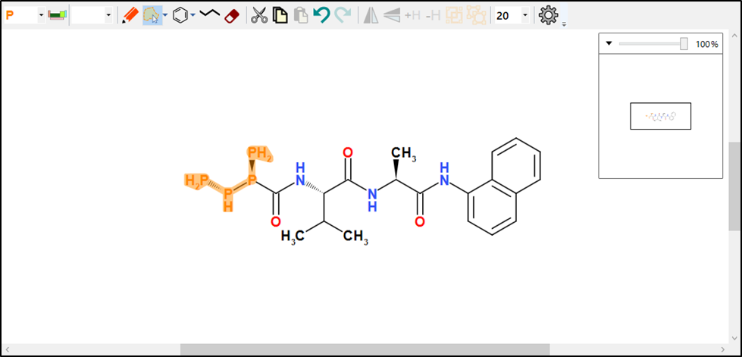

Figure : ACME changes the selected atoms to the chosen element

* Select a range of atoms and bonds. Then click and drag to move them. ACME ‘rubber-bands’ the molecule while you do this:  
  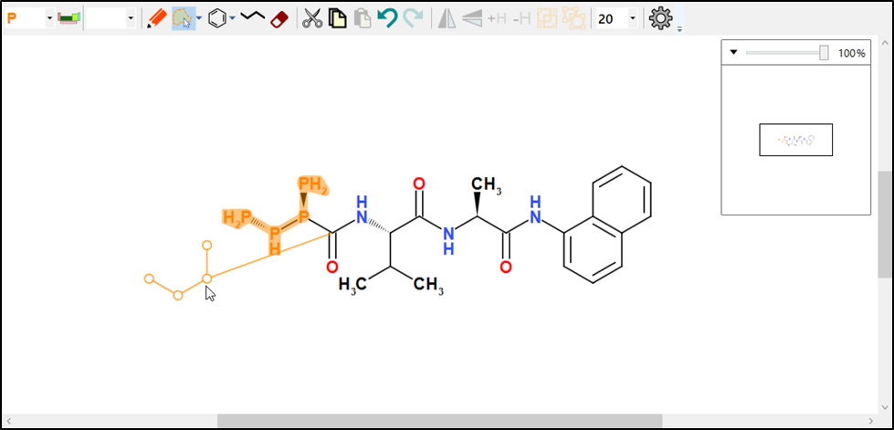  
    
  Hold down [Shift] or [Ctrl] to unlock bond lengths or angles while dragging a fragment. Holding [Alt] pivots the fragment about the unselected neighbouring atom.
* If you selected a molecule, you can either
  + Rotate the molecule by dragging the small curved arrow around in a circle. Rotating increments in multiples of 15 degrees. Hold [Ctrl] to unlock the angle snapping: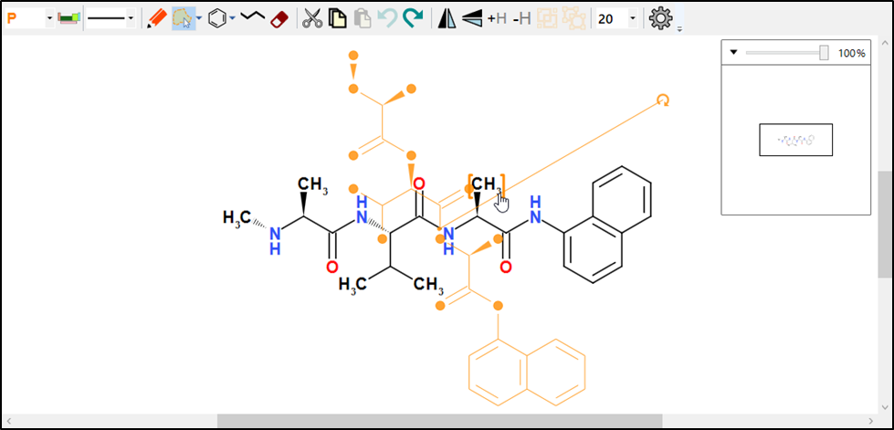
  + Resize the molecule by dragging one of the corner handles:  
    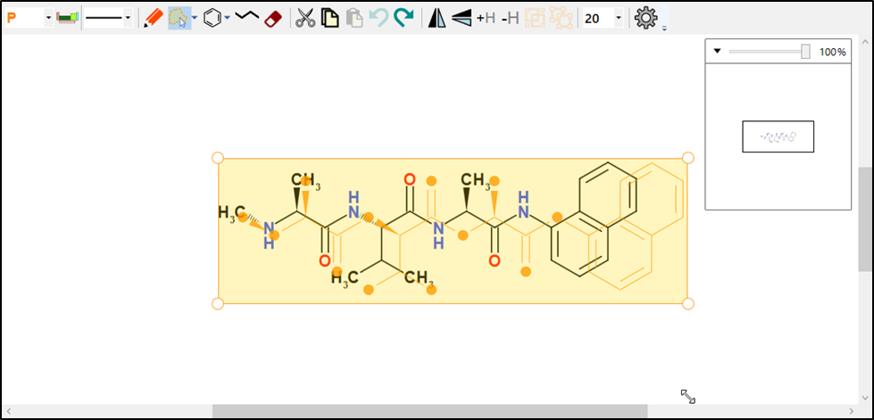
  + Move the molecule by clicking in the selector area and dragging:  
    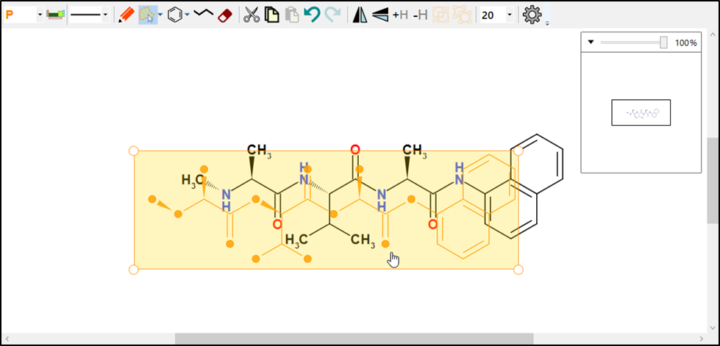

## Ring Button

The ring button puts ACME into ring mode*.* This allows you to draw a ring on the canvas. Rings can be drawn in free space, or on top of other bonds and atoms.

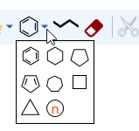

ACME can draw either fixed or variable rings. The ring button shows the currently selected fixed ring. You can choose the ring type by clicking the small dropdown arrow next to it and then clicking a ring in the panel.

### Fixed rings

Click on a ring type to draw a ring. Then either click on a blank area of the canvas, an atom or a bond to place the ring. ACME will show an orange placeholder if it can draw a ring:

|  |  |
| --- | --- |
|  |  |
| Allowed | Not Allowed |

Figure : Placeholder showing new ring placement

NB: If there is no placeholder visible, then this means ACME cannot draw the ring in the desired position, usually through visual congestion.

### Variable Ring

Click this icon to draw a variable ring:  
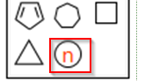

Click and drag on a bond, atom or free space. Then drag in the direction of the arrow to change the placeholder size. The number gives the current ring size:

|  |  |
| --- | --- |
|  |  |
| Allowed | Not Allowed |

Figure : Drag to change ring size.

Release the mouse button when the ring is orange and the correct size:  
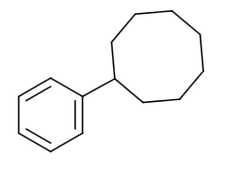

Figure : New ring drawn in place

## Chain Button

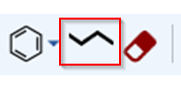

Clicking this puts ACME into chain drawing mode. Chain drawing mode works like variable ring drawing mode:

* Click on free space and drag to draw a free-standing chain:
* Click on an atom and drag to attach a chain.

|  |  |
| --- | --- |
|  |  |
| Allowed | Not Allowed |

Figure : Attaching a chain

Chains are variable length: the chain placeholder shows how many atoms it will have in it. You don’t need to draw a chain following a straight path: you can alter the path as you go.

You can cancel chain drawing at any time by pressing [Esc].

## Erase Button



The erase button puts ACME into erase mode. This is an alternative to selecting atoms or bonds and then deleting by pressing [Del]. Erase mode is useful for making small, precise deletions in a structure.

Clicking the Erase button shows a cursor like a small eraser. Hover over a bond or atom and click it to delete it:  
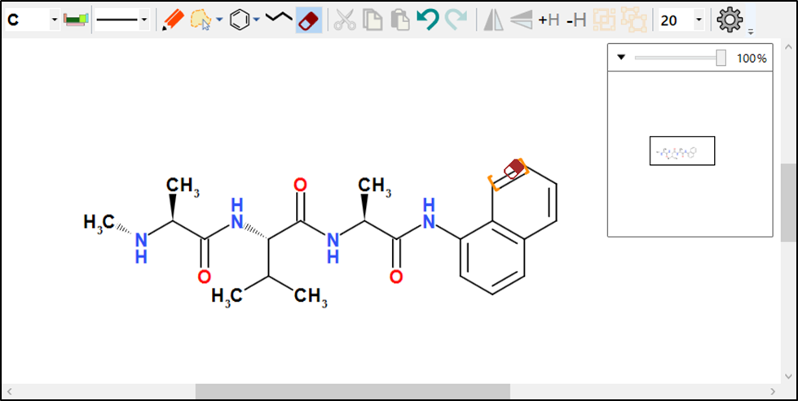

Figure : Click to delete a bond

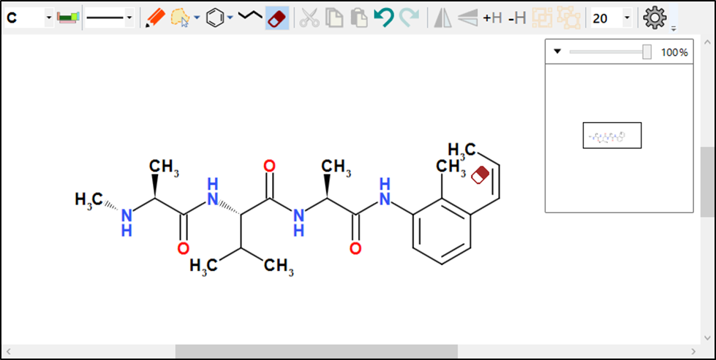

Figure : After deleting bond

## Reaction button

This button draws the arrows for a chemical reaction. Use the Reaction toolbar to modify the reaction afterwards.

The Reaction button looks like this: . Click, then drag in the drawing area to draw a reaction arrow:

You can change the default reaction arrow in the Reaction toolbar:

ACME supports forward, equilibrium, biased equilibrium and blocked reaction-type arrows.

### Repositioning Reactions

To reposition a reaction, simply click and drag the yellow circle at the beginning or end of the selected arrow to move the respective point or click and drag on the arrow body to move it in its entirety. Any associated text will move with the arrow when released.

As with other operations, locking the arrow to fixed lengths and angles can be turned off by holding down [Shift] and/or [Ctrl], respectively.

## Cut, Copy and Paste Buttons



The cut, copy and paste buttons allow you to transfer chemistry into or out of ACME, and to remove or add to it. Both operations use the Windows Clipboard. ACME also supports pasting from the Windows Clipboard History (⊞ - V)

When ACME copies the selection, it does so as entire molecules, regardless of whether a molecule is selected. Copying a range of atoms then pasting causes ACME to create one or more new molecules to hold the copied objects.

ACME does *not* allow individual bonds to be copied and pasted. ACME copies selected atoms and includes the connecting bonds automatically.

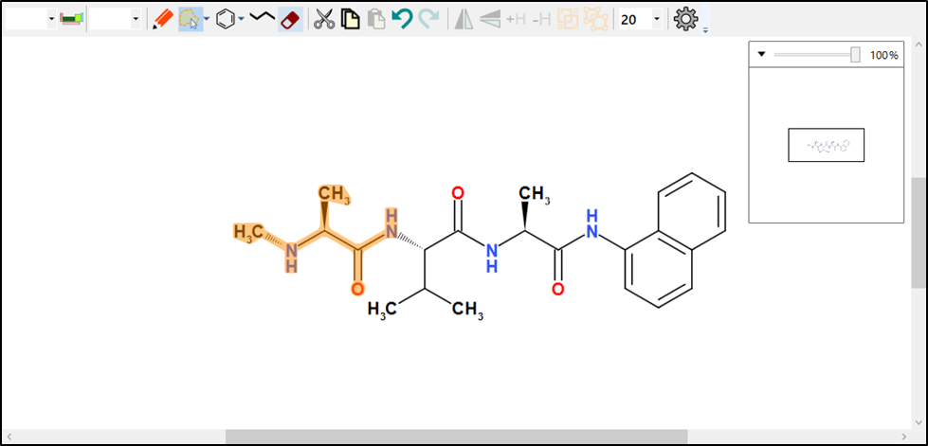

Figure : Selecting a range of atoms prior to copying

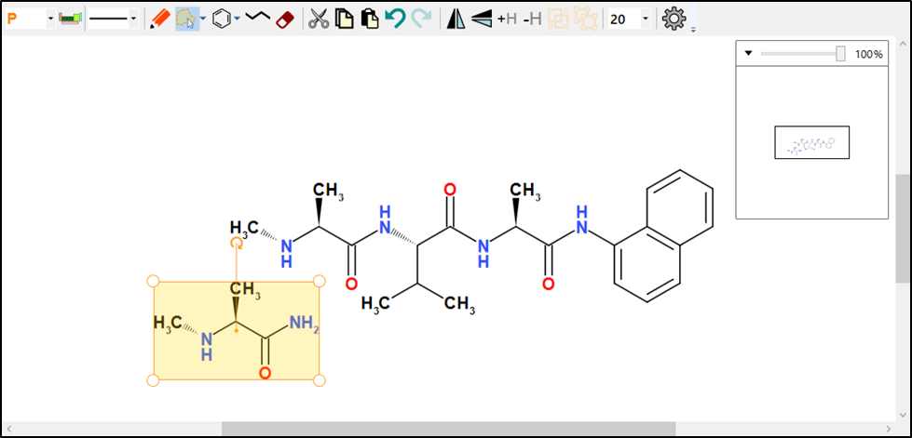

Figure : The result of copying and pasting the previous selection

### Data Transfer Format

ACME’s primary data transfer format is CML. ACME converts CML on the Clipboard to chemistry, and *vice versa.* ACME also converts SDFile formats on pasting into the editor.

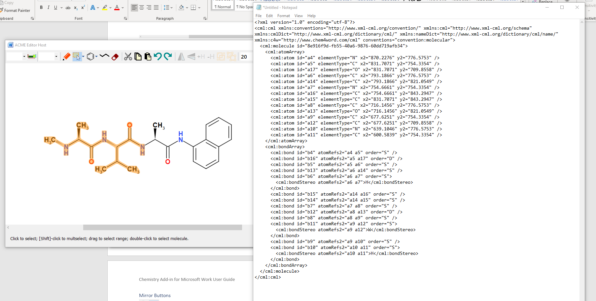

Figure : CML pasted into Notepad from a copy operation. ACME encapsulates the selection as a molecule.

## Undo and Redo Buttons



The Undo button restores the state of the chemistry before the previous drawing or editing operation. The Redo button allows you to replay the action after undoing it. Any subsequent editing operations after Undo will clear the Redo buffer.

## Mirror Buttons



The Mirror buttons allow you to invert a selected molecule, either horizontally or vertically. Mirroring does not preserve absolute stereochemistry by default.

To preserve absolute stereochemistry, hold down [Shift] *before* clicking the button.

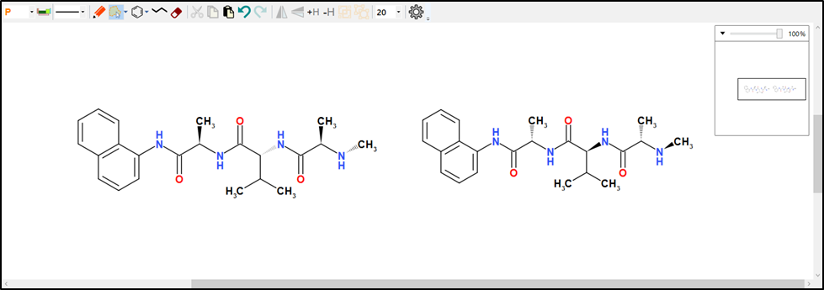

Figure 25 Mirrored versus flipped molecule. ACME inverts stereochemistry only when flipping

## Add/Remove Explicit Hydrogens



Adds or removes explicit hydrogen atoms to the model. The +H button converts implicit hydrogen atoms into explicit hydrogens. The -H button reverses this operation.

Adding or removing hydrogens does not change the fundamental chemistry of the molecule.

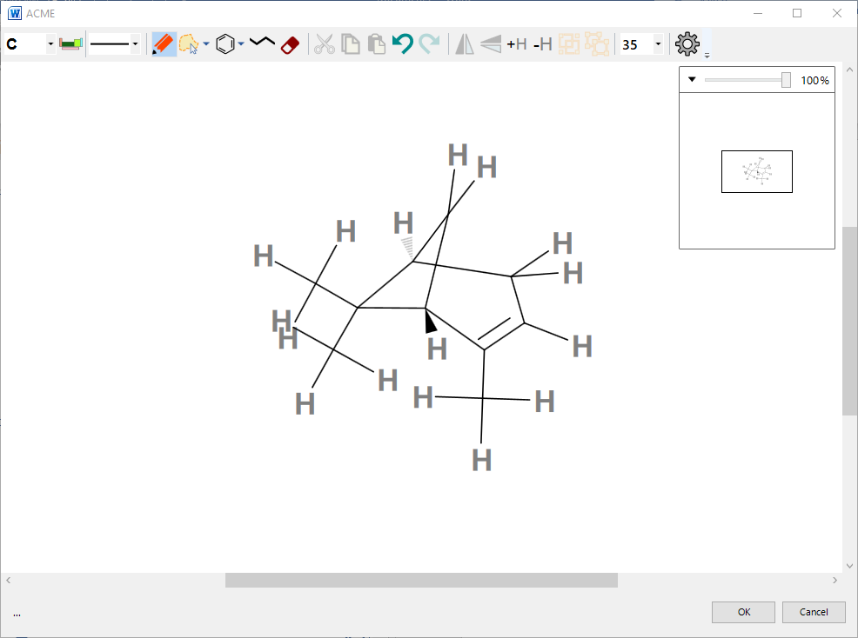

Figure : Explicit hydrogens added

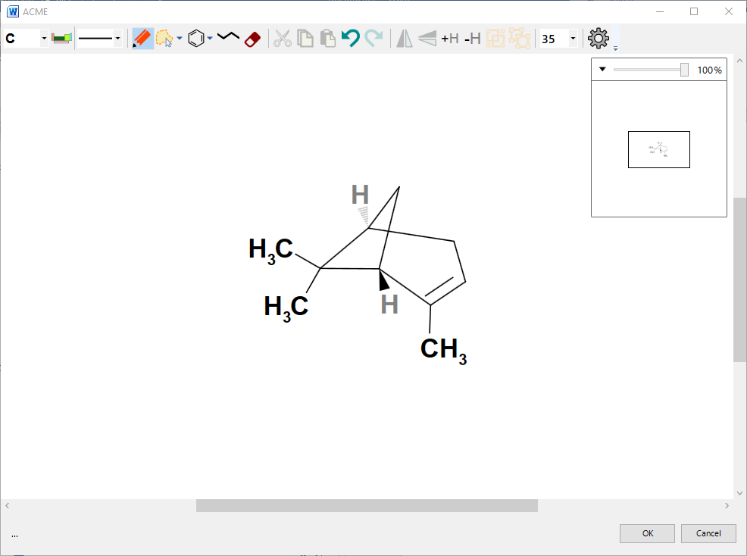

Figure :Explicit hydrogens removed.

This affects only hydrogen atoms that would be connected by single, non-stereo bonds.

## Group and Ungroup Buttons



Grouping and ungrouping are special features of ACME. CML allows definition of ‘nested’ molecules, which are contained in other molecules. ACME calls the containing molecule a ’group’. A group contains no chemistry of its own. It is simply a container for other molecules.

Grouping is particularly useful to set molecule-level properties on multiple molecules, using the Molecule Properties dialogue.

### Grouping Molecules

Select two or more molecules and click the Group button.

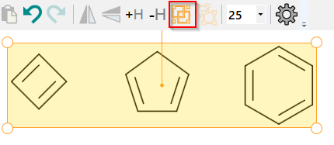

ACME now displays the molecule as a group:

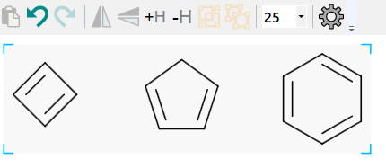

Figure : Grouped molecules: note the shading and corner brackets

ACME draws grouped molecules against a shaded background, with blue ‘group brackets’ at the corners.

**NB: Group brackets and shading are *not* rendered in the document by default. They are purely a visual cue to indicate the presence of a grouped molecule in the editor.**

Molecules may be grouped indefinitely. You can select a group by single-clicking on the shaded area. The group selector has square handles at the corners to distinguish it from an ungrouped molecule:  
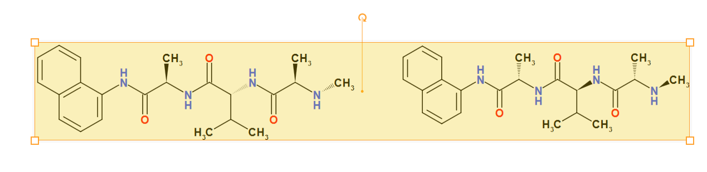

Figure : Selecting a group

Grouped molecules can be flipped, resized and rotated like ungrouped molecules.

### Ungrouping

To ungroup a grouped molecule, select it and click the Ungroup button:  


ACME now displays two or more separate molecules.

## Bond Length Dropdown



The bond length dropdown allows you to select an average bond length for the sketch. Changing this will change the size of the bonds in *all* existing molecules.

## Settings Button



The Settings button displays ACME’s settings dialog. This allows you to choose defaults for the editor’s behaviour:  
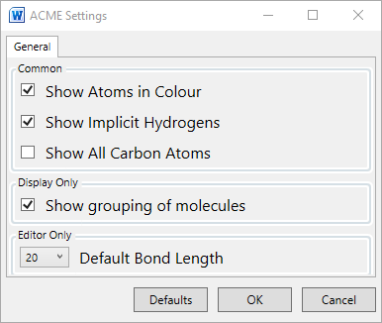

### Default Bond Length

Use this to choose the default length of bonds drawn when ACME edits a new structure.

### Show grouping of molecules

Setting this will cause ACME to display groups with grouping brackets. Turning off displays grouped and ungrouped molecules identically, with no shading or brackets.

# Reaction Toolbar



The Reaction toolbar allows you manipulate reactions. ACME provides basic reaction support: reaction types, reagents and conditions, and roles.

The reaction toolbar functions are enabled according to whether you have reactions or molecules selected. These buttons will be greyed-out when not available.

ACME persists reactions, reagents, conditions, reactants, and products in CML. This allows you to mine documents for chemical transformations or store them in any hosting application.

## Choosing a reaction type

Click the reaction arrow dropdown to select the default reaction type drawn using the Reaction button:  
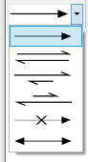

You can select from the following arrow types:

* Forward
* Equilibrium
* Equilibrium biased forward
* Equilibrium biased reverse
* Blocked
* Resonance

## Editing Reagents and Conditions

In Select mode, click the arrow to select it. Then click either the now-enabled Edit Reagents or Edit conditions button:

You can then edit the text by typing in the box. To save the edit, hit [Return] or click off the box. To cancel editing, hit [Esc].

When editing reaction text, the Formatting toolbar appears:  


This sets the selected text to subscript or superscript or inserts special symbols. The dropdown button at the end of the toolbar allows you to select from a pallet of special symbols.

**NB: double clicking on the highlighted reagents or conditions in a selected reaction will also edit them directly.**

## Assigning reactants and products

Assigning reactant or product roles to a molecule is entirely optional. You can use ACME to draw complete reactions without having to do this. However, if you intend to process documents automatically in any way, we highly recommend this step. Reactants and products are then stored as references to existing molecules in the underlying CML.

### Initial Assignment

To assign roles, select reactants, products, and the reaction arrow. The Assign Reaction Roles button is then enabled:

On clicking, ACME selects the reaction and displays role indicators above each molecule. Molecules closer to the tail of the arrow are assigned as reactants (dark red solid circle), those closer to the head as products (dark blue solid circle). This allows you to identify which molecules participate in the reaction:

Deselecting the arrow hides the role indicators.

### Deassigning

Select a reaction and then click the Deassign Reaction Roles button:

ACME clears all role assignments from the reaction.  
Plus Tool



This inserts a plus sign as free-floating text. Use this to visually indicate multiple reactants and/or products:

# Aligning objects

You can align objects with the buttons on the Alignment toolbar:  


The functions are, in order:

* Align Lefts
* Align Centres (horizontal)
* Align Rights
* Align Bottoms
* Align Middles (vertical)
* Align Tops

You must select more than one object on screen (molecule, reaction or plus sign) before aligning.

Before Aligning Middles  
After Alignment

# Atom properties

You can edit the properties of atoms, bonds and molecules directly by right-clicking an atom, bond or selected molecule, when ACME is in select or draw mode.

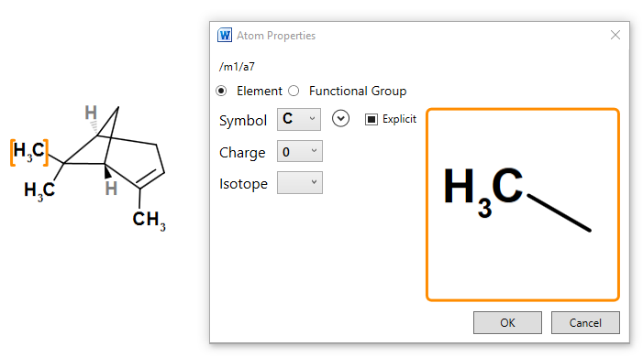

Figure : Right-clicking on an atom shows the property dialogue

## Setting Elements or Functional groups

Select an element from the dropdown. If the element you want is not shown, then click the small down-arrow to expand the periodic table picker:

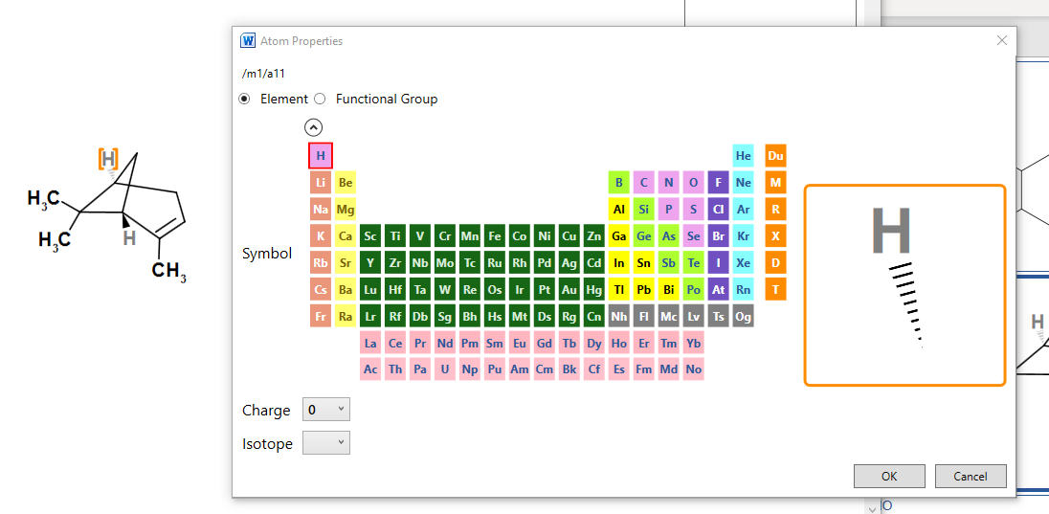  
Clicking the arrow again hides the periodic table picker.

### Setting a Functional Group

N.B.  Functional groups are a new and exploratory feature in Chem4Word.  Currently, they do not resolve along with any changes to the molecule structure, so molecules containing them will not be assigned new names, formulae, or other labels.

We will be addressing this issue in a later release.  For now, please feel free to use them with the above proviso in mind.

Clicking on the Functional Group option button allows you to select from a range of predefined functional groups:  
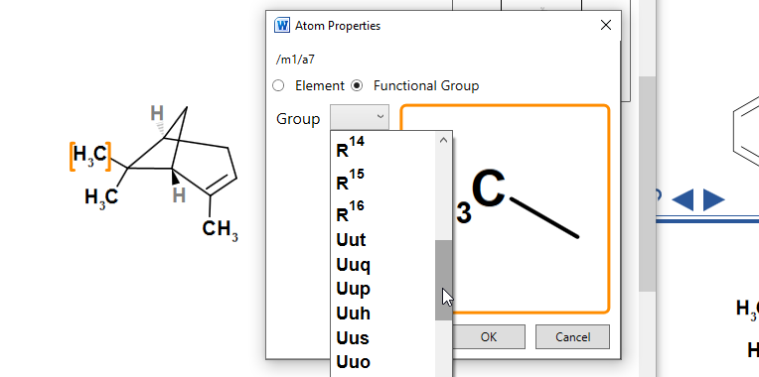

R, X and M groups can be set using this method. We included the legacy symbols of Elements 113 to 118 as functional groups so that you can use them interchangeably.

Each functional group consists of a set of one or more components, which may also be functional groups.

In the case of CH2CH2OH these are

* CH2 [Primary]
* CH2
* O
* H

When a Functional group is displayed a decision is made whether to render it forwards or backwards.

The primary term is first placed such that it is centred about the atom's position (shown with red border) then the rest of the terms (shown with blue border) are either placed to the left (backwards) or right (forwards). Thus you should end up with something like the images below (without the borders).

|  |  |
| --- | --- |
| Forwards | Backwards |
| CH3  CH2  O  H  CH2 | CH3  CH2  O  H  CH2 |

## Setting Charges

Choose a charge from the Charge dropdown. The atom preview display will update in response:  
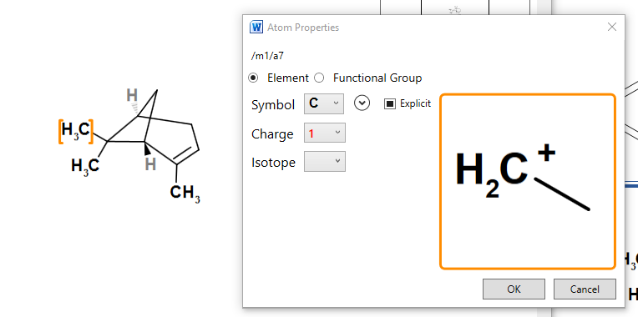

## Setting Isotopes

Allowed isotopes for the atom can be selected from the Isotope dropdown picker. Setting it to blank means the isotope is unknown.

## Togging explicit carbon display

The Explicit checkbox applies only to carbon atoms. It has three settings. Click repeatedly to cycle through these settings.

|  |  |
| --- | --- |
|  | Atom labels are set automatically by ACME. Terminal carbons are shown explicitly, as are allenic carbons (=C=). |
|  | ACME hides atoms labels |
|  | ACME shows atom labels regardless of context. |

# Bond Properties

Right click on a bond to display the Bond Properties dialogue:

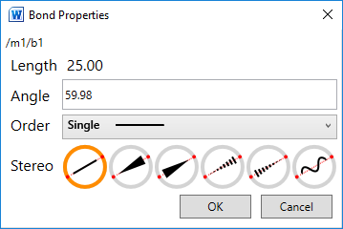

The bond angle is relative to “Screen North”

If you change the angle of a terminal bond only that bond will be changed.

If you change the angle of a non-terminal bond the whole molecule will be rotated.

## Setting Bond Order

You can click the Order dropdown to set the order of the current bond. This is useful for more specialised bond types:  
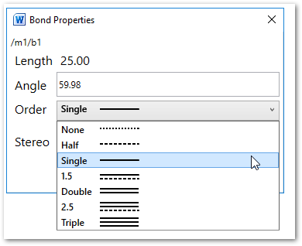

## Setting placement

Placement for double bonds governs which side of the primary bond axis the subsidiary bond is drawn.

* Click **A** to set the placement automatically: ACME will attempt to explicitly set an aesthetically pleasing bond placement.
* Click one of the other placements to explicitly set the bond placement.

Placement can be set on bonds of orders 1.5, double and 2.5. You can also set the stereo of single bonds using this dialog, including the direction of wedge and hatch bonds:

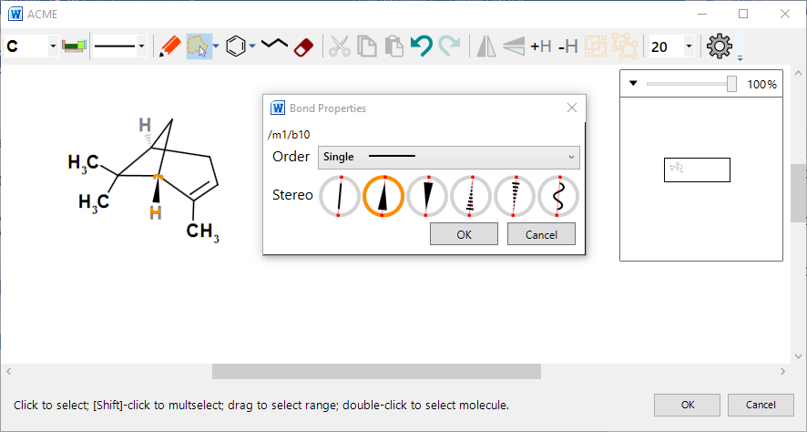

Figure : Setting the direction of a stereobond

# Molecule properties

You can set molecule properties by first selecting the entire molecule (either by lassoing or double clicking) and then right clicking the selection. This displays the Molecule properties dialogue:  
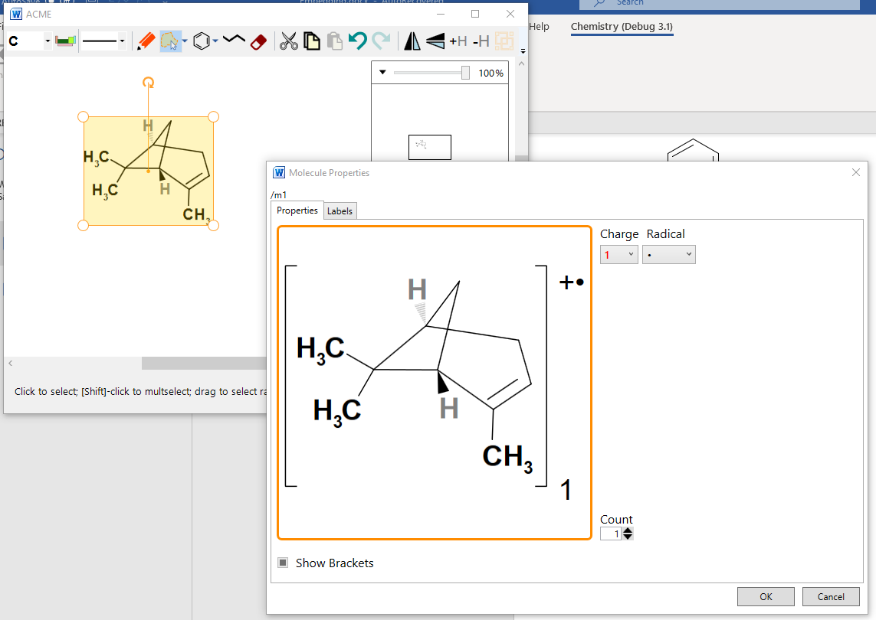

Figure : Molecule properties dialogue. The charge and radical labels have been added. ACME automatically adds brackets.

## Setting radicals and charges

You can set a radical and/or charge label using the dropdowns at the top right. If either of these are set, ACME brackets the molecule. Chem4Word will subsequently display these labels in the document.

## Multiplicity

The spinner on the bottom right allows you to set the multiplicity. Again, setting this will display the molecule brackets.

## Bracketing

The Show Brackets checkbox allows you to display brackets for a molecule independently of charge, radical or multiplicity. If any of the former labels are set, then brackets display automatically and cannot be turned off.

NB: To apply these properties to a set of molecules, group them first. ACME can only bracket or label a single selected molecule.

1. Only available in Word 2010 or later versions. Earlier versions display structures as PNG graphics.
2. Details about the PubChem search tool is available at <https://pubchem.ncbi.nlm.nih.gov/search/>.
3. Further information about ChEBI searching is can be found here <https://www.ebi.ac.uk/chebi/>.
4. Hastings, J., de Matos, P., Dekker, A., Ennis, M., Harsha, B., Kale, N., Muthukrishnan, V., Owen, G., Turner, S., Williams, M., and Steinbeck, C. (2013) The ChEBI reference database and ontology for biologically relevant chemistry: enhancements for 2013. [Nucleic Acids Res.](http://dx.doi.org/10.1093/nar/gks1146)
5. More information about OPSIN available from <http://opsin.ch.cam.ac.uk/>.
6. [Daniel M. Lowe](http://pubs.acs.org/author/Lowe%2C+Daniel+M), [Peter T. Corbett](http://pubs.acs.org/author/Corbett%2C+Peter+T), [Peter Murray-Rust](http://pubs.acs.org/author/Murray-Rust%2C+Peter), and [Robert C. Glen](http://pubs.acs.org/author/Glen%2C+Robert+C), J. Chem. Inf. Model., 2011, 51 (3), pp 739–753
7. For more information on the cml format, see <http://www.xml-cml.org/>. Accelrys have a document that describes several chemical file formats, including the MOLFILE file format used by Chem4Word. A copy of this document can be obtained from the Accelrys website: <http://download.accelrys.com/freeware/ctfile-formats/ctfile-formats.zip>.
8. ACME is the *only* molecule editor component written in C#, and which exploits the *full* power of the .NET Framework. .NET developers can easily incorporate it into their own Windows Desktop programming projects. ACME is licensed under Apache 2.0. [Please feel free to contact us](mailto:info@chem4word.co.uk) for help if you want to use ACME in your own projects.