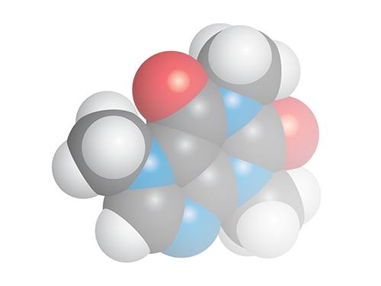

**Chemistry Add-in for**

**Microsoft Word**

**User Guide**

**Version 3.0**

Contents

Introduction 3

Prerequisites 4

System Requirements 4

Installation 4

To Install the Chemistry Add-in 4

Converting documents from the previous version of the Chemistry Add-in for Microsoft Word 4

How to add a chemical structure to a document 5

Draw a structure 5

Import a structure from a file 6

Add a structure from a web-search 6

PubChem search 7

ChEBI Search 7

How to edit a chemical structure 8

Display options for Chemistry 9

The Library 10

The Navigator 10

Exporting chemistry files 11

# Introduction

The Chemistry Add-in provides a simple and flexible way to include chemical information in a Word document.

With the Chemistry Add-in, you can:

* **Create inline "chemistry zones" to represent chemical data.**

Chemistry zones are controls that contain information about a molecule and display the information in a variety of ways. The underlying data is stored as Chemical Markup Language (CML), a widely used XML schema for representing chemical data. The data typically includes trivial and International Union of Pure and Applied Chemistry (IUPAC) names, the concise formula, and data for a 2-D structure.

* **Display chemical information in a variety of ways.**

A chemistry zone can display any representation that is supported by the underlying CML data. With a few clicks, you can switch from the molecule’s trivial name to its concise formula to its 2-D representation.

* **Draw and edit your own chemistry.**

The Chemistry Add-in supports ChemDoodle web, a fully featured structure editor. Draw your own structures from scratch or edit downloaded chemical structures. Export and import chemical structures from MDL Molfile format.

* **Display print-quality 2-D chemical structures.**

Chemistry zones can represent molecules by displaying a 2-D structure diagram using publication-quality, resolution-independent graphics. The Chemistry Add-in also includes an editor that enables you to modify the structure. The diagram is inserted into the document as a DrawingML image, so that others can view it, whether or not they have installed the Chemistry Add-in on their system[1]. You can also publish a document authored using the Chemistry Add-in as a PDF file.

* **Accept chemical data in a variety of formats.**

You can create a “chemistry zone” by typing a simple common name such as “water”, and then using the Chemistry Add-in to convert it to your preferred representation, assuming that the name you type exists in your library.

* **Import CML files from online web services**

Using the **Load From** option in the ribbon, you can look up existing molecular structures from the NCBI’s PubChem (<http://pubchem.ncbi.nlm.nih.gov/>), the Unilever Centre’s OPSIN (<http://opsin.ch.cam.ac.uk/>) or the European Bioinformatics Institute’s ChEBI (<https://www.ebi.ac.uk/chebi/>) databases.

* **Handle most molecules.**

The Chemistry Add-in can handle any molecule that has appropriate CML data.

* **Store and expose chemical information in a semantically rich manner.**

The Chemistry Add-in supports publishing and data-mining scenarios for authors, readers, publishers, and other vendors across the chemical information community.

This paper describes how to use the Chemistry Add-in to include chemical information in a Word document.

## Prerequisites

You should have a basic understanding of:

* Microsoft Word
* Chemical nomenclature and diagrams

An understanding of CML is helpful but not required.

## System Requirements

Hardware Requirements

Any Windows-based computer that can run Office 2010, Office 2013 or Office 2016.

Software Requirements

Your computer must have the following software:

Windows 7 or later, including Internet Explorer 11. All operating systems must have the latest Windows updates installed

Word 2010 through to Word 2016.

.NET Framework 4.5

For Chem4Word to function correctly, an internet connection is required.

Note: Chem4Word does not work with Word for Mac, or online versions of Word because these programs do not work in the same way as the Windows versions of Word.

## Installation

The Chemistry Add-in is packaged in a file that contains the following files:

* Chem4Word-Setup.exe

Depending upon your computer’s configuration, you may need to install the primary Interop Assemblies for your current version of Office, and/or the Office Open XML Software Development Kit.

### To Install the Chemistry Add-in

1. Close all Word documents.

2. Download the file Chem4Word-Setup.exe to your hard drive from our releases area on GitHub at https://github.com/Chem4Word/Version3/releases

3. Navigate to your downloads folder, then run Chem4Word-Setup.exe

4. The setup bootstrapper will download and install any missing system components.

5. Once these the pre-requisites are installed the latest installer will be downloaded and will be started to install the Chemistry Add-in.

To verify the installation, launch Word. The ribbon should now include a Chemistry tab, as shown in the figure, below.



# Converting documents from the previous version of the Chemistry Add-in for Microsoft Word

Documents created with the previous version of the add-in will be automatically converted to the new format. Once this conversion has completed, the old version of the add-in will not function correctly.

# How to add a chemical structure to a document

Chemical structures can be added to a Microsoft Word document in many ways. Structures can be drawn using the Chem4Word Editor tool. Structures can also be added from PubChem[2] and ChEBI (Chemical Entities of Biological Interest[3],[4]) searches as well as using the name-to-structure tool, OPSIN (Open Parser for Systematic IUPAC nomenclature[5],[6])

## Draw a structure

To draw a structure in a document, click the Draw button on the Chemistry Ribbon. This will activate the Chem4Word Editor tool.

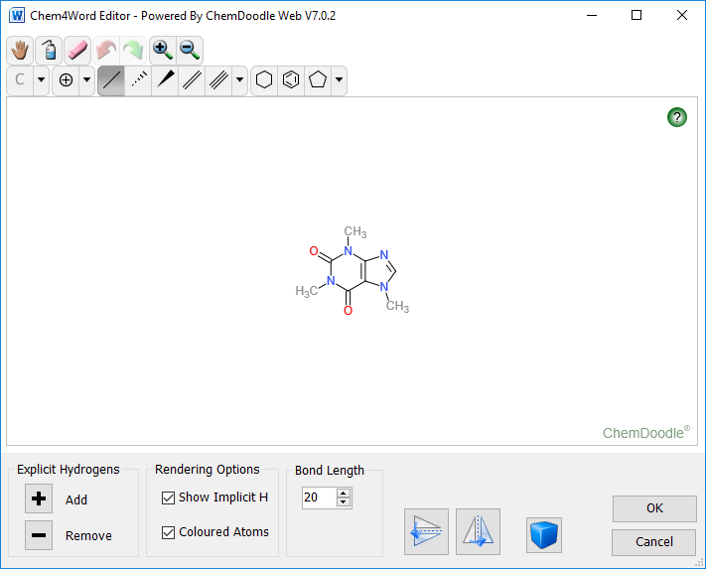

Use the bonds, rings and atoms tools to create a structure; at present, radicals and lone pairs are not supported in Chem4Word.

It is possible to change the default bond length in the drawing tool. Explicit hydrogen atoms can be added or removed from a structure by clicking the + and – buttons in this tool. There are also buttons to flip the structure horizontally or vertically.

|  |  |
| --- | --- |
|  | With the drawing tool, it is also possible to draw multiple structures in the same window. Clicking this button changes the drawing mode to multiple molecules. |

The final option in the drawing tool allows the drawing of explicit atoms with specific colours. Checking the “Coloured atoms” box will show atoms with coloured labels; without this option, all bonds and atoms will be drawn in black.

On clicking the OK button, the add-in runs a ChemSpider search to see if this chemistry is known. Labels such as names and synonyms will be returned. At this point, you have the option to add/edit/delete labels as you may need.

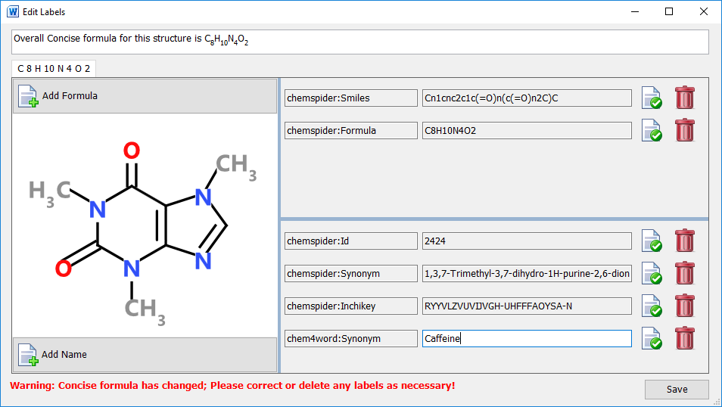

The image above shows the information retrieved when caffeine is drawn using the Chem4Word Editor. In addition to the retrieved information, an additional synonym, Caffeine, has been added.

## Import a structure from a file

The Chemistry Add-in for Microsoft Word supports importing chemistry from three file formats, CML, MolFile and SDFile.

The Import button allows you to browse to a folder containing supported file formats, to select a file and then import that file as a chemical structure into the current document. The structure will be displayed exactly as it was stored in the imported file. Further editing can be done, once the structure is added to the document

## Add a structure from a web-search

There are three options for importing a structure from web searches.

|  |  |
| --- | --- |
| PubChem Logo | PubChem is a public repository of chemical structures and biological data maintained by National Center for Biotechnology Information (NCBI). |
| ChEBI logo ChEBI | Chemical Entities of Biological Interest (ChEBI) is a freely available dictionary of molecular entities focused on ‘small’ chemical compounds maintained by the European Molecular Biology Laboratory (EMBL). |
| University of CambridgeOPSIN | OPSIN is a tool developed at the University of Cambridge that converts chemical names into chemical structures |

## PubChem search

The PubChem search allows you to search by name or formula for structures in the PubChem database. Multiple records can be retrieved by such searches and are sorted by relevance.

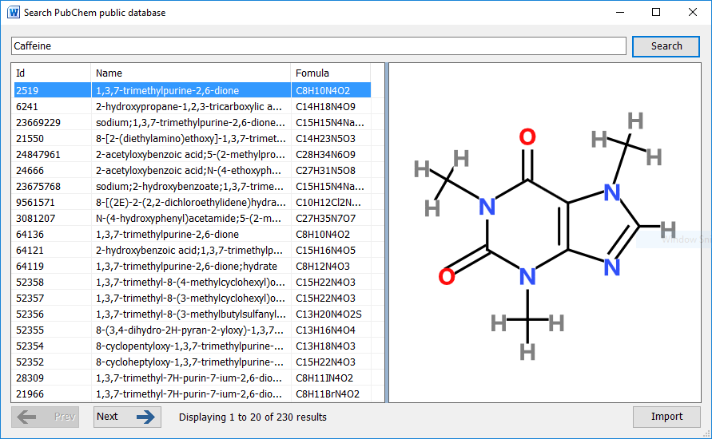

Selecting an entry in the returned results displays a structure as stored in the PubChem database. You can navigate forwards and backwards through all of the results and the selected result can be added to the document at the current position by clicking the Import button.

## ChEBI Search

The ChEBI search allows you to search by name for structures in the ChEBI database. Fewer results are returned by this search tool than the PubChem search as a scoring algorithm limits the number of possible structures returned.

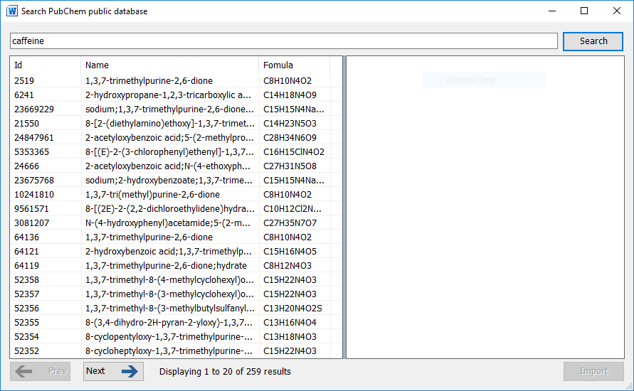

It is possible that there are entries in this database where no chemical structure is available. A message indicating this will be shown at the bottom of this window.

Clicking the Import button adds the displayed structure to the current document.

# How to edit a chemical structure

When you select a chemistry object in a document, you can edit the contents by clicking the edit button. Double-clicking a chemistry object also allows you to edit a structure.

If the chemistry object is changed by your edits, the add-in automatically runs a ChemSpider search to see if the new structure is known. You will be given the opportunity to add/change/delete labels associated with the new structure.

# Display options for Chemistry

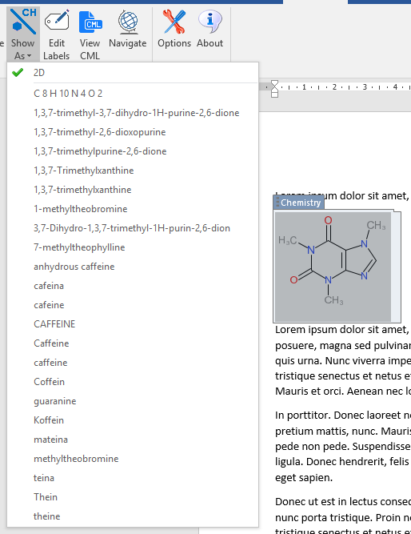The Chemistry Add-in for Microsoft Word allows chemistry to be represented in multiple formats. For structures imported from files and web sources, chemistry objects may have associated names and synonyms as well as formulae.

When you draw a structure in a document, the add-in searched ChemSpider to see if the structure is known, and any known names and synonyms are retrieved.

You can also add your own synonyms and formulae to any structure using the Edit Labels button.

The example on the right shows all of the depiction options for caffeine that available when this chemistry object is inserted from ChEBI. The currently displayed chemistry object can be changed to show any one of these alternative depictions.

By adding other chemistry objects to the document that are linked to another chemistry object will allow the editing of any one of them to be reflected in an automatic change to the automatically created formula label and those imported from ChemSpider. The Edit Labels button also allows you to delete labels and create your own labels to use as identifiers in your document.

# The Library

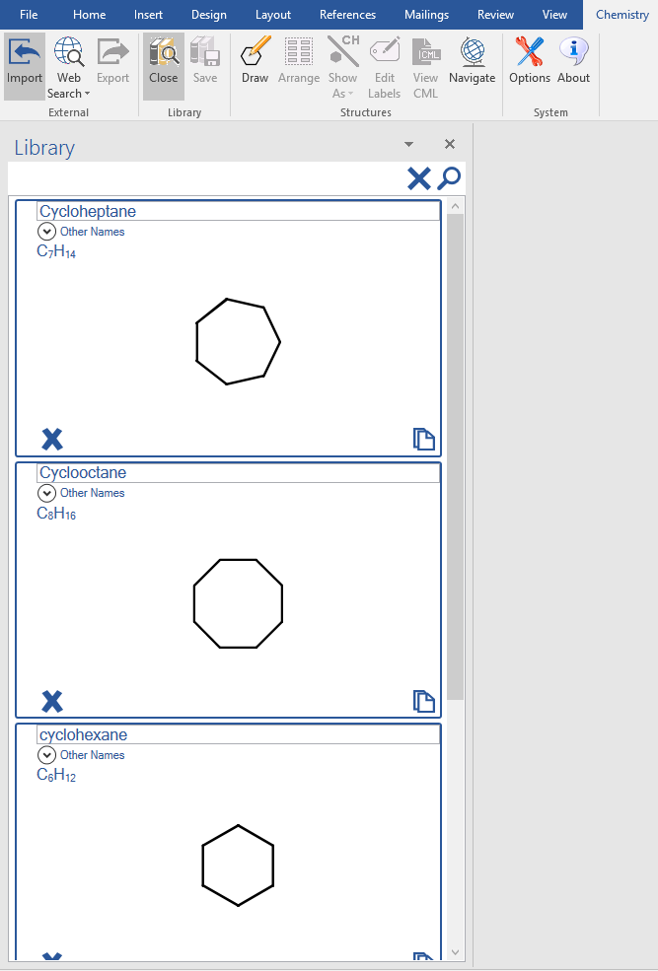The library is a store of re-usable chemical structures. Chem4Word provides only a small number of library entries. You can store your own structures in the Library for use in other documents.

The Library can be opened and closed using buttons on the ribbon.

There is a search button at the top of the Library panel, to help you to find structures by name. Type the name to search and click the magnifying glass. To show all molecules in the Library, click the cross next to the magnifying glass.

To insert a copy of a structure from the Library into the document at the current cursor position, simply click the paste icon  at the bottom right of the structure you want to add.

To add a structure that you’ve drawn in your document to your Library, simply select the structure in the document and click the Save button in the ribbon.

You can also delete structures from your Library by clicking the cross at the bottom left of the structure. Deleting a structure from the Library cannot be undone!

# The Navigator

The Navigator shows all the chemical structures in the document and allows you to find the location of chemistry objects throughout the document.

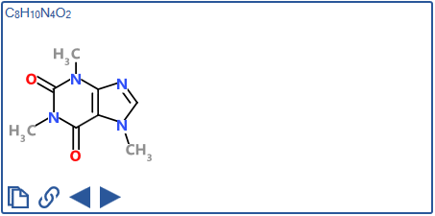The Navigator will contain one window for each unique structure in the current document. Each window in the Navigator shows the chemical structure and formula of each molecule. At the bottom of each window there are four buttons that are used to add structures to the document by either creating a linked copy or pasting a new copy of an existing structure at the current position in the document.

The Navigator buttons allow you to find individual and linked structures in the document by moving backwards or forwards through the current document.

|  |  |
| --- | --- |
|  | Duplicate the structure and add it to the document at the currently selected position. |
|  | Add a linked copy of the structure to the document at the currently selected position. |
|  | Move to the previous linked structure in the document. |
|  | Move to the next linked structure in the document. |

# Exporting chemistry files

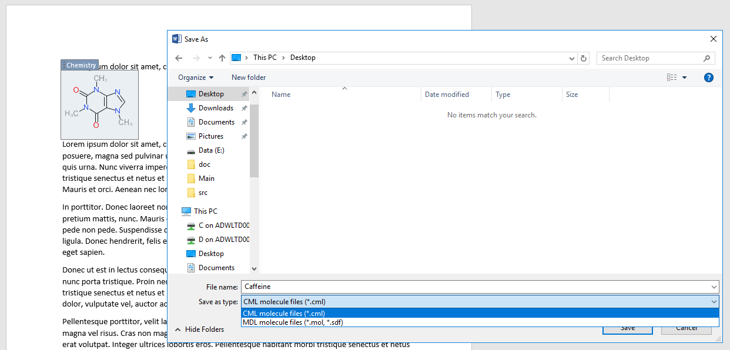Chem4Word allows you to export chemical structures as both CML files and MDL mol files.

To export a structure, simply select the chemistry object in the document and click the Export button in the ribbon.

Choose a folder and type a file name, select the appropriate file type, and click the Save button.

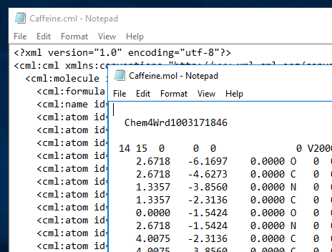The figure to the left shows example content of cml and mol files for caffeine exported from a Chem4Word document.

Both file formats are based on recognised standards, and should be suitable for import into other chemical-aware applications.

For more information on the cml format, see <http://www.xml-cml.org/>. Accelrys have a document that describes a number of chemical file formats, including the mol file format used by Chem4Word. A copy of this document can be obtained from the Accelrys website: <http://download.accelrys.com/freeware/ctfile-formats/ctfile-formats.zip>.

1. Only available in Word 2010 or later versions. Earlier versions display structures as PNG graphics.
2. Details about the PubChem search tool is available at <https://pubchem.ncbi.nlm.nih.gov/search/>.
3. Further information about ChEBI searching is can be found here <https://www.ebi.ac.uk/chebi/>.
4. Hastings, J., de Matos, P., Dekker, A., Ennis, M., Harsha, B., Kale, N., Muthukrishnan, V., Owen, G., Turner, S., Williams, M., and Steinbeck, C. (2013) The ChEBI reference database and ontology for biologically relevant chemistry: enhancements for 2013. [Nucleic Acids Res.](http://dx.doi.org/10.1093/nar/gks1146)
5. More information about OPSIN available from <http://opsin.ch.cam.ac.uk/>.
6. [Daniel M. Lowe](http://pubs.acs.org/author/Lowe%2C+Daniel+M), [Peter T. Corbett](http://pubs.acs.org/author/Corbett%2C+Peter+T), [Peter Murray-Rust](http://pubs.acs.org/author/Murray-Rust%2C+Peter), and [Robert C. Glen](http://pubs.acs.org/author/Glen%2C+Robert+C), J. Chem. Inf. Model., 2011, 51 (3), pp 739–753