Tatiana Hapatsha

Simulated Annealing Questions

Our model system has two local minima, one at approximately 1.9 atomic units and another at approximately 2.4 atomic units.

1. Set the r_init to 1.8 atomic units (i.e. somewhat near the minimum of the energy landscape for the system) and run the simulation a few times.

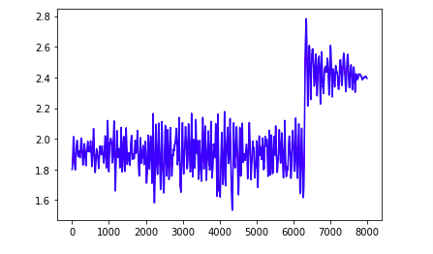

* 1. Does the final value for the position of H always, usually, sometimes or rarely converge to the “equilibrium” value? ….

Yes it usually does

* 1. Does the final value for the position of H ever converge to the other, non-global local minimum in the energy landscape?

Yes,

* 1. How well, in general, does the final value for the potential energy match the minimum of the energy landscape?

They are about the same!

1. Set the r_init to 2.4 atomic units (i.e. very near the other, non-global local minimum in the energy landscape) and run the simulation a few times.

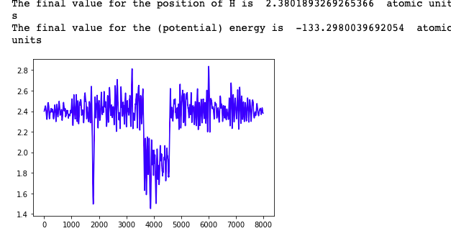

* 1. Does the final value for the position of H always, usually, sometimes or rarely converge to the “equilibrium” value?

**The final value for position H is greater than the equilibrium value and it rarely converges to the equilibrium value.**

* 1. Does the final value for the position of H ever converge to the other, non-global local minimum in the energy landscape (i.e. does the position of H ever end up more or less where it started, even after “exploring” positions with lower energy?)?

Yes It ends up being less than where it started.

* 1. How well, in general, does the final value for the potential energy match the minimum of the energy landscape?

They are just about the same!

1. Note that the value of g used in this week’s exercise is higher than the value of g used in the previous computational exercise (which itself was on the high side for Langevin dynamics).
   1. What effect, if any, does lowering the value of g have? In particular, when you start with r_init being 2.4 atomic units, do you often see the position of H explore values near the global energy minimum in the landscape and then return to the local minimum occurring when the position of H is near 2.4 atomic units?

**The final position for H decreases as I lowered the gamma from 0.02 to 0.01. it seems that the value of H decreases and never really goes back up to the global energy minimum except for one well between 2000 and 4000 . We can assume that the final position of H converges to the global minimum.**

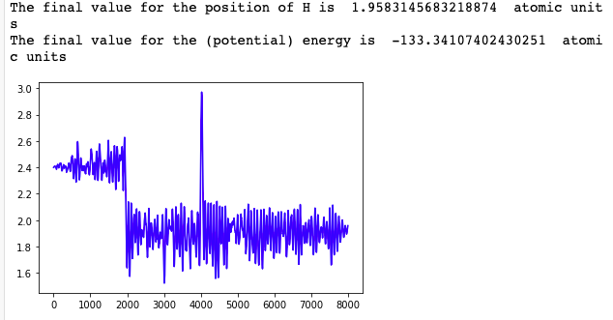

* 1. What does lowering the value of g mean, conceptually speaking? Do your observations of what happens when you lower the value of g make sense in terms of what g means as a “drag” parameter?

**When the gamma was lower (0.01), it lowered the final position of H, but when we kept it higher (0.02), the final position of H was more or less where it started. So the gamma does act as a drag parameter where it can affect the annealing simulation**

1. Convert the initial temperature and hot temperature to kelvin (using the conversion factor ${295 K}/{0.00094 atomic units}$): what would actually happen if you heated an aqueous solution of HF to the hottest temperature used in our simulation?

**We seems to be getting more “wells”. Our position of H seems to be less if the temperature is greater, which can indicate it is converging sometimes to our global minimum.**

1. Change the value of g back to 0.02 and change the initial temperature and hot temperature to 0 (essentially using the drag term in the Langevin equation to minimize energy). How do your answers to the questions in parts 1 & 2 above change? In particular, if you start with r_init = 2.4 atomic units, does the position of H ever converge to the global minimum? You may also want to try using a hotter temperatures than you did with your first

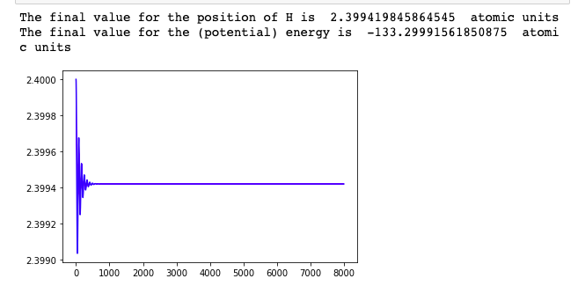

**It appears that position of H never converges to my global minimum. And it just stays pretty constant.**