**Linear Variational Method**

**1.0.1 Questions Part 1:**

1. Work out a general expression for the integrals *Hij*

See attached scan titled “01_LVM”.

1. Write a python function that takes the indices *i* and *j* and returns the value of the integral *Hij*. Skeleton code for this function follows.

This can be found in code titled “LVM_1.py”.

Continue evaluating the energy of different trial wavefunctions by changing the values of the **c** vector and repeating the calculation above. Does increasing the contribution of excited states impact the energy as you expect? Explain.

See attached scan titled “02_LVM”.

1. Show that differentiating the energy functional with respect to all coefficients and setting the derivative to zero results in the following set of equations: *Hikci* = *E*[F(*x*)]*ck*

See attached scans titled “03_LVM_1” and “03_LVM_2”.

**1.0.2 Questions Part 2:**

1. Is the energy you calculated above higher or lower than the ground state energy of the ordi-nary particle in a box system (without the delta function potential)?

**Energy calculated above:** 0.16573541893898724

**Energy of ground state (w/out delta function potential):** 0.04934802200544679

The energy calculated above is higher than the ground state energy of the ordinary particle in a box system.

This can be found in code titled “LVM_2.py”.

1. Why do you think mixing in functions that correspond to excited states in the ordinary particle in a box system actually helped to improve (i.e. lower) your energy in the system with the delta function potential?

The PIB wavefunctions are such that the wavefunctions corresponding to the various excited states will interfere destructively with one another, yielding lower energies of superpositions with the delta function potential.

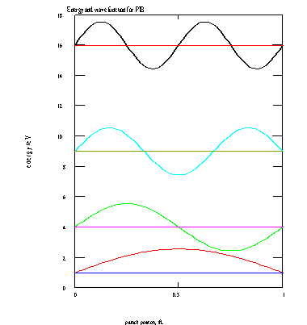

1. Increase the number of basis functions to 6 (so that **H** is a 6x6 matrix and **c** is a vector with 6 entries) and repeat your calculation of the variational estimate of the ground state energy. Does the energy improve (lower) compared to what it was when 3 basis functions were used?

**Results from 3 x 3 matrix:**

Optimized Energy: 0.16573541893898724

Optimized Coefficients: [-9.22618887e-01 3.85712834e-01 -6.61272129e-16]

**Results from 6 x 6 matrix:**

Optimized Energy: 1.52775226519596

Optimized Coefficients: [-1.88514391e-01 -9.34136379e-01 3.03070206e-01 1.16345328e-16 6.62763018e-16 1.10085006e-16]

The energy does not improve and become lower with 6 rather than 3 basis functions.

This can be found in code titled “LVM_3.py”.