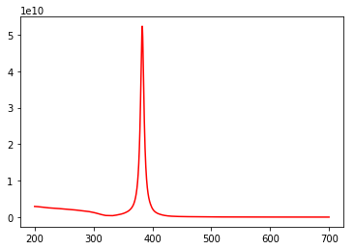

Wavelength (nm)

**Ag in water**

Absorbance

**Question 1: How does the spectrum change as you increase the dielectric constant of the surrounding materials? Try n = 1.45 for glass and n = 1.76 for alumina.**

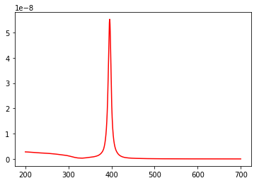

Wavelength (nm)

**Ag in glass**

Absorbance

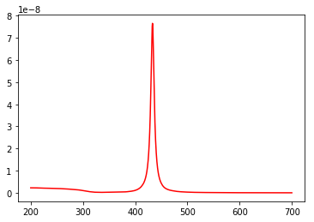

**Ag in alumina**

Wavelength (nm)

Absorbance

The spectra undergo a bathochromic (red) shift to wavelengths of higher frequency and shorter wavelengths.

If we had a dilute solution of nanoparticles, we would get a UV-Vis spectrum that looks like the above.

**Question 2: How does the spectrum change as you decrease the dielectric constant of the surrounding materials? Try n = 1.0 for air.**

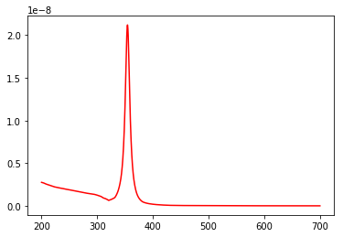

Wavelength (nm)

**Ag in air**

Absorbance

The spectrum undergoes a hypsochromic (blue) shift to wavelengths of lower frequency and longer wavelengths.

**Question 3: How does the spectrum change if you use Au instead of Ag?**

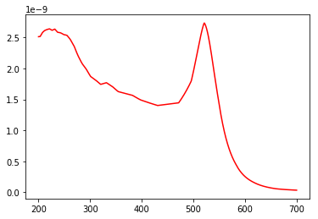

**Au in water**

Wavelength (nm)

Absorbance

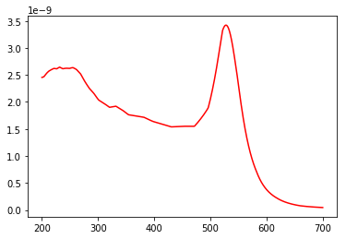

Wavelength (nm)

**Au in glass**

Absorbance

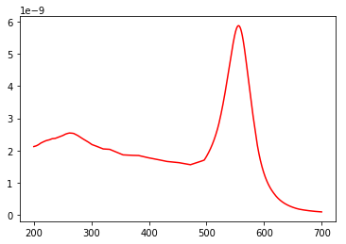

Absorbance

**Au in alumina**

Wavelength (nm)

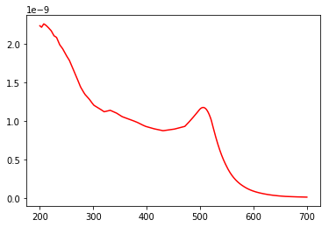

Wavelength (nm)

Absorbance

**Au in air**

The spectra have a different λmax value, now between 500-600nm. It is broader and not as strong, and there is also a significant peak around 200-300nm, whose strength varies on the surrounding materials. The significant peak between 200-300nm may represent (s-d) inter-band transitions of the Au metal.

**Question 4: Plot the real and imaginary parts of the dielectric function of Au and Ag as a function of wavelength; what do you notice about the values in the vicinity of the plasmon resonance (i.e. at wavelengths where the strong absorption peak is observed)?**

The real part of the dielectric function represents how much light slows down when traveling through the material. The imaginary part of the dielectric function represents how much light is attenuated (absorbed) as it travels through the medium.

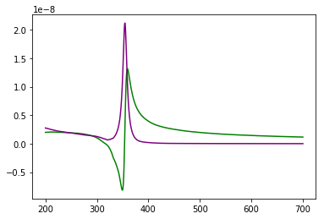

Ag

Real part of dielectric function = green

Imaginary part of dielectric function = purple

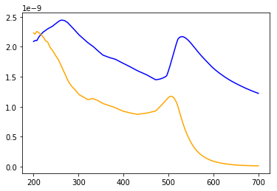

Au

Real part of dielectric function = blue

Imaginary part of dielectric function = orange

The values in the vicinity of the plasmon resonance decrease as the vicinity increases. In silver, the real part has a maximum positive value and a minimum negative value in the area overlapping with the maximum peak of the imaginary part of the dielectric function.

In gold, the values in the vicinity of the plasmon resonance also decrease as the vicinity increases. This applies to the right side of the graph, but not the left side, which both the real and imaginary part have intense peaks around 200-300 nm.