**Questions**

1. How does the total kinetic energy of a collection of ***N*** particles grow with ***N*** assuming each particle has the same average kinetic energy? Compute the total kinetic energy for five different values of ***N*** and plot the results using***pyplot***.

|  |  |
| --- | --- |
| ***N*** | ***T*** |
| 10 | 0 |
| 20 | 0.02 |
| 30 | 0.08 |
| 40 | 0.18 |
| 50 | 0.32 |
| 60 | 0.50 |

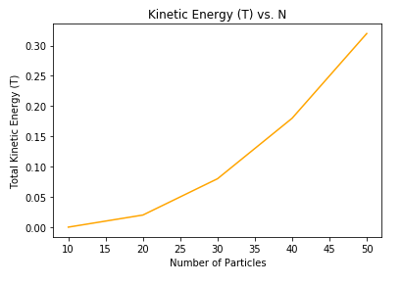

The kinetic energy increases by 0.04 units with increasing ***N***. The graph resembles the shape of a quadratic function.

The exact numbers of x and y values (***N*** and ***T*** values, respectively) above may not be mathematically correct. The author of code suspects that the y values correspond to the following array of x values: [0,1,2,3,4,5]. The scaling is representative of the relationship between ***N*** and kinetic energy (***T***) values.

***Note:*** *The above results may be obtained from the code titled “Not_Following_Dr.Foley’s_Comments”.*

1. How does the total potential energy of a collection of ***N*** equally spaced charged particles grow with ***N***? Compute the total potential energy for five different values of ***N*** and plot the results.

|  |  |
| --- | --- |
| ***N*** | ***T*** |
| 0 | 0 |
| 20 | 1740 |
| 40 | 3480 |
| 60 | 5220 |
| 80 | 6960 |
| 100 | 8700 |

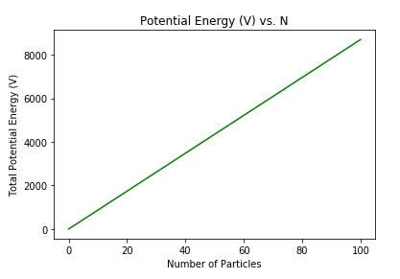

Lack of logical code resulted in a linear graph (shown above) for the relationship between potential energy and ***N***. This was due to the author’s inability to create an array of potential energy values responsive to the number of particles, ***N***.

The graph should be quadratic, since q1 and q2 are equal, making the numerator of the equation of potential energy q2. The denominator represents interparticle distance, which is the same between adjacent particles since the particles simulated were equally spaced. As ***N*** increases, however, the denominator will increase in number, while the numerator will be 1, suggesting that the graph should represent a reciprocal function. The graph should either be quadratic or reciprocal.

***Note:*** *The above results may be obtained from the code titled “Reem_Orientation_Draft1”.*

1. Use the ***time*** library in python to determine how the time required to compute the kinetic and potential energy for the five different values of ***N***; plot the time required vs ***N*** and discuss if the kinetic seems to scale linearly and the potential seems to scale quadratically with ***N***.

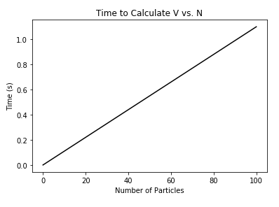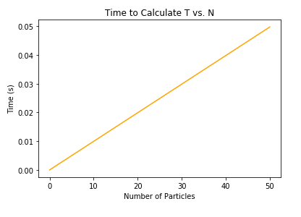

The above graphs are most likely incorrect, due to the author’s inability to generate a time array representative of each of the components of the ***N*** array.

***Note:*** *The above results may be obtained from the code titled “Reem_Orientation_Draft1”.*