**So Much Potential – Langevin Dynamics**

**Question 1:**

* See attached image titled “**LangevinQ1.1.jpg**”.
* These equations account for exchanges of energy between the CO molecule and its surroundings, including other CO molecules. They do not consider the CO molecule in an isolated system, as the velocity Verlet algorithm did. As such, they include a drag term and a random perturbation term, which do not exist in the velocity Verlet algorithm.
* Yes, my equations implementing the BBK algorithm reduce to equations implementing the velocity Verlet algorithm when the drag term is 0 and the random perturbation term is 0. This may be verified by running the code titled, “**LangevinHW_01.py**”.

**Question 2:**

* View code titled “**LangevinHW_02.py**”.

**Question 3:**

* Run code titled “**LangevinHW_02.py**”.
* 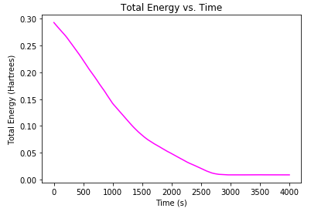The equilibrium bond length from the BBK algorithm of the CO molecule is shorter than that obtained using the velocity Verlet algorithm (1.99 a.u. and 2.12 a.u., respectively).
* The system does reach thermal equilibrium with a well-defined temperature. The energies do seem to converge to a steady state, as indicated by **Figure 1**.
* kBT = (1 a.u.)(0.00026 a.u.) = 0.00026 a.u.
* The energy does not converge exactly to 0.00026 a.u., but converges to values as low as 0.001 Hartrees. This value differs with each run, however.

**Figure 1 –** The total energy vs. time graph of one random run of the code. The wave-like pattern changes with each run.