In the following calculations, interpolation spline order=5 and reduced mass of CO were assumed 13625 atomic units. Vibrational frequency () was calculated 0.011839246473330577 atomic units by taking force factor (k) is 1.9097856898916856 atomic units in the equation  = sqrt (k/mu). Also, accelaration was calculated -2.061446496584389e-05 atomic units when C is separated by O by 3 (r=3) atomic units.

In [**16**]: runfile('/Users/melissasuchanek/Desktop/somuchpotentialtest20.py', wdir='/Users/melissasuchanek/Desktop')

[1.06013853 1.31137316 1.56260779 1.81384242 2.06507705 2.31631168

2.56754631 2.81878094 3.07001557 3.3212502 3.57248484 3.82371947

4.0749541 4.32618873 4.57742336 4.82865799 5.07989262 5.33112725

5.58236188 5.83359651]

[-107.1389493226, -110.8762342308, -112.2035650482, -112.6221628016, -112.6993448642, -112.6532021548, -112.5695515418, -112.4825450847, -112.4093307577, -112.3611216888, -112.3328706063, -112.3154788092, -112.3040496673, -112.0685479896, -112.2907699794, -112.2869226228, -112.0012243902, -111.9483767861, -111.927401279, -112.2798664306]

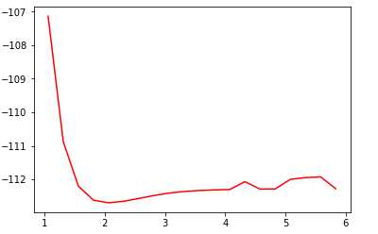

Figure1. r_array versus E_versus

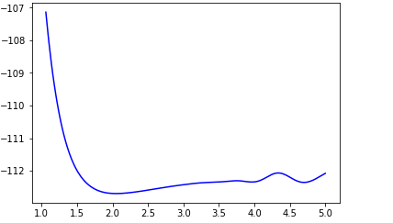

Figure 2. Interpolated r_array vs interpolated E_array

Equilibrium bond length is 2.049949748743719 atomic units

Equilibrium bond length is 1.0844234170854272 Angstroms

Reduced mass is 13625.0 atomic units

Vibrational frequency is 0.011839246473330577 atomic units

Initial separation is 3.1046376746729685 atomic units

Initial velocity is 0.00024661152907471924 atomic units

Force factor is 1.9097856898916856 atomic units

**First derivative of potential**

[ 2.31864633e+01 2.15501028e+01 2.00126017e+01 1.85694463e+01

1.72162364e+01 1.59486848e+01 1.47626176e+01 1.36539743e+01

1.26188075e+01 1.16532832e+01 1.07536807e+01 9.91639225e+00

9.13792376e+00 8.41489419e+00 7.74403578e+00 7.12219409e+00

6.54632789e+00 6.01350924e+00 5.52092346e+00 5.06586914e+00

4.64575812e+00 4.25811551e+00 3.90057969e+00 3.57090230e+00

3.26694823e+00 2.98669566e+00 2.72823601e+00 2.48977398e+00

2.26962753e+00 2.06622788e+00 1.87811951e+00 1.70396017e+00

1.54252088e+00 1.39268590e+00 1.25345279e+00 1.12393235e+00

1.00334865e+00 8.91039005e-01 7.86454027e-01 6.89154377e-01

5.98766861e-01 5.14932721e-01 4.37301811e-01 3.65532605e-01

2.99292189e-01 2.38256266e-01 1.82109155e-01 1.30543789e-01

8.32617175e-02 3.99731059e-02 3.96734478e-04 -3.57400001e-02

-6.87005774e-02 -9.87364295e-02 -1.26085194e-01 -1.50970639e-01

-1.73602663e-01 -1.94177298e-01 -2.12876703e-01 -2.29869171e-01

-2.45309125e-01 -2.59337118e-01 -2.72079835e-01 -2.83650092e-01

-2.94146851e-01 -3.03656175e-01 -3.12253820e-01 -3.20006000e-01

-3.26969400e-01 -3.33191170e-01 -3.38708929e-01 -3.43550764e-01

-3.47735230e-01 -3.51271348e-01 -3.54158610e-01 -3.56386972e-01

-3.57936860e-01 -3.58779731e-01 -3.58887632e-01 -3.58246257e-01

-3.56856715e-01 -3.54735527e-01 -3.51914633e-01 -3.48441386e-01

-3.44378552e-01 -3.39804315e-01 -3.34812273e-01 -3.29511438e-01

-3.24026237e-01 -3.18496512e-01 -3.13073148e-01 -3.07887997e-01

-3.03033036e-01 -2.98559244e-01 -2.94476597e-01 -2.90754073e-01

-2.87319649e-01 -2.84060304e-01 -2.80822013e-01 -2.77409755e-01

-2.73587508e-01 -2.69078248e-01 -2.63564275e-01 -2.56714978e-01

-2.48275072e-01 -2.38095214e-01 -2.26132458e-01 -2.12450250e-01

-1.97218432e-01 -1.80713240e-01 -1.63317305e-01 -1.45519652e-01

-1.27915702e-01 -1.11207269e-01 -9.62025619e-02 -8.38102285e-02

-7.49119802e-02 -7.01609985e-02 -6.99492061e-02 -7.44072371e-02

-8.34044370e-02 -9.65488624e-02 -1.13187282e-01 -1.32405174e-01

-1.53026730e-01 -1.73614852e-01 -1.92471154e-01 -2.07635963e-01

-2.16940746e-01 -2.18442054e-01 -2.10770135e-01 -1.93152362e-01

-1.65413230e-01 -1.27974356e-01 -8.18544821e-02 -2.86694728e-02

2.93676840e-02 8.94468772e-02 1.48160872e-01 2.01505312e-01

2.44880805e-01 2.73372363e-01 2.82791699e-01 2.70099194e-01

2.33412699e-01 1.72007524e-01 8.63164488e-02 -2.20702857e-02

-1.50404972e-01 -2.94782440e-01 -4.50140052e-01 -6.10257708e-01

-7.67757842e-01 -9.14136579e-01 -1.04061649e+00 -1.13971285e+00

-1.20553641e+00 -1.23379408e+00 -1.22178895e+00 -1.16842025e+00

-1.07418338e+00 -9.41169909e-01 -7.73067549e-01 -5.75160189e-01

-3.54327876e-01 -1.19046819e-01 1.20748644e-01 3.55048215e-01

5.75052917e-01 7.73281429e-01 9.43570086e-01 1.08107288e+00

1.18226146e+00 1.24492513e+00 1.26817085e+00 1.25242323e+00

1.19942455e+00 1.11223473e+00 9.95230385e-01 8.53881253e-01

6.93767402e-01 5.20116072e-01 3.37788633e-01 1.51280581e-01

-3.52784597e-02 -2.18124737e-01 -3.93860370e-01 -5.59453353e-01

-7.12237548e-01 -8.49912693e-01 -9.70544397e-01 -1.07256426e+00

-1.15477434e+00 -1.21635663e+00 -1.25687521e+00 -1.27627633e+00

-1.27488832e+00 -1.25342165e+00 -1.21296892e+00 -1.15500484e+00]

**atomik units**

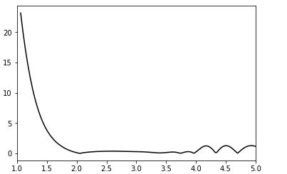

Figure 3. First derivative of potential energy (Force is the negative of the derivative)

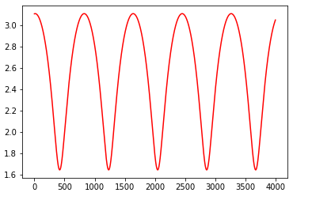

Figure 4. The trajectory of bond length vs time

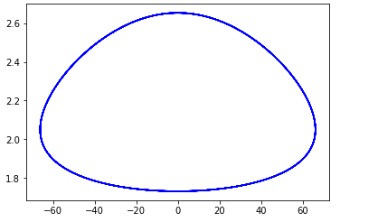

Figure 5. Space trajectory of position vs momentum

**Accelaration is** -2.061446496584389e-05 **atomik units**