# Arduino in Scratch

Scratch requires an extension to be able to communicate with the outside world via hardware (e.g. an Arduino).

The easiest way I have found so far is via ScratchX (<http://scracthx.org>) – online Scratch editor with support for HTML extensions.

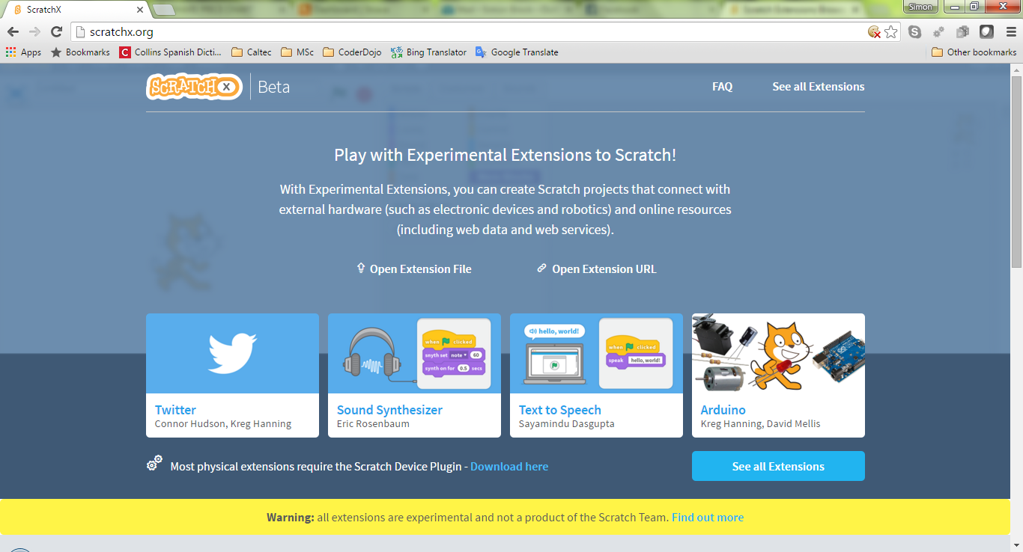

The ScratchX editor needs an extension and helper to be loaded. There are good instructions at <https://scratch.mit.edu/info/ext_download/>. Once installed, the browser will request permission to run the extension. Granted, the (Arduino) commands will appear in the **More Blocks** section of the scripts menu.

There’s a good description of setting up the hardware at <https://khanning.github.io/scratch-arduino-extension/>.

Once loaded (I’ve only got as far as the Scratch screen) there’s a short demo program by clicking on the ‘Arduino’ link in the screen above:

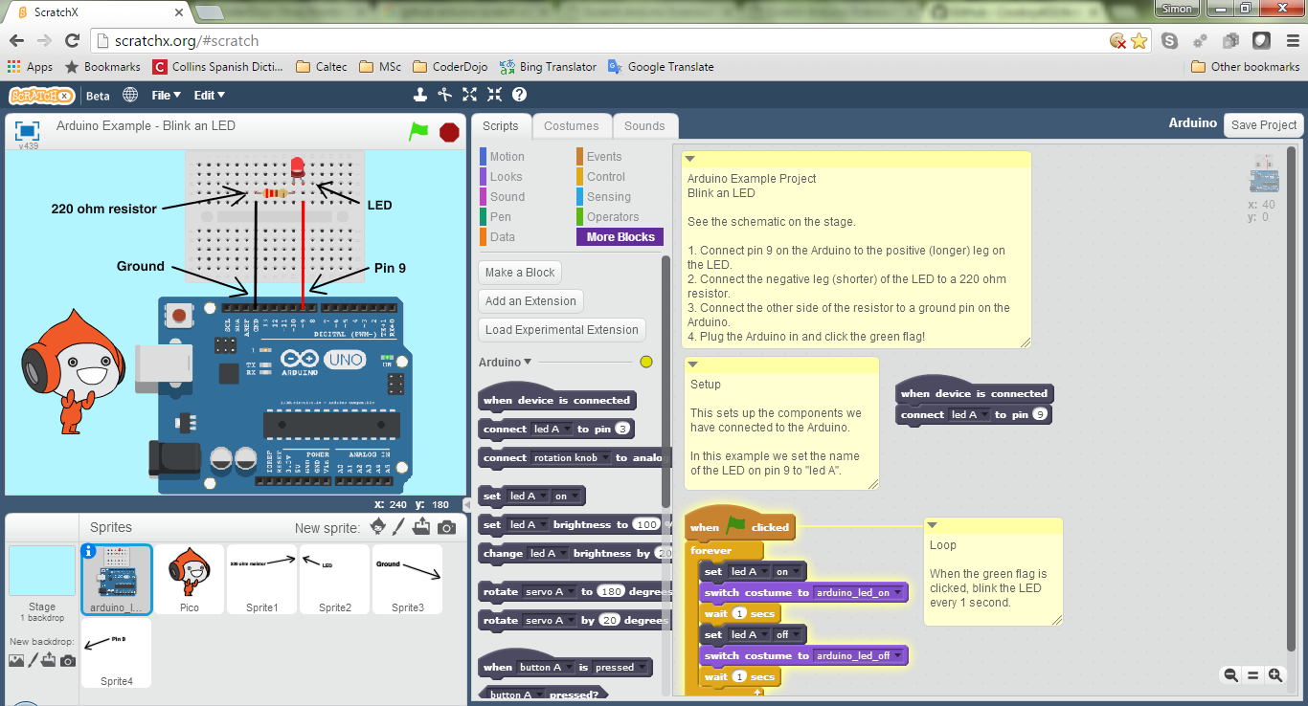

This shows the sprite/s changing costumes but if connected, an LED on the Arduino board changing states also.