LCTF Commander

User Manual

|  |
| --- |
| CHEMIMAGE CORPORATION  LCTF Commander User Manual |
| © ChemImage Corporation  7325 Penn Ave. • Suite 200  Pittsburgh, PA 15208  Phone 412-241-7335 • Fax 412-241-7311 |

Table of Contents

Overview 1

LCTF Commander Interface 1

Information Section 1

Wavelength 2

Sequencing 2

Ordered 2

Arbitrary 2

# Overview

LCTF Commander is a simple program that can be used to operate a ChemImage Liquid Crystal Tunable Filter (LCTF). It enables the user to tune the LCTF manually or with a pre-defined sequence of wavelengths. It also displays basic information and the current status of the LCTF in real-time.

# LCTF Commander Interface

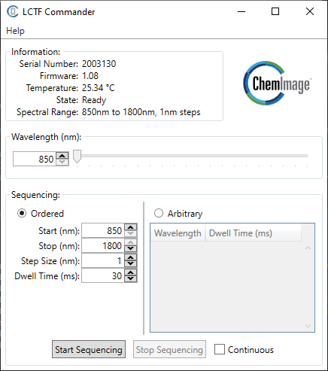

Figure 1: The LCTF Commander interface.

The different areas of the user interface are detailed below.

## Information Section

The information section shows the serial number, firmware version, internal temperature, and current state of the LCTF.

|  |  |
| --- | --- |
| Item | Description |
| Serial Number | A unique identifier for the LCTF. |
| Firmware | The version of firmware on the LCTF. |
| Temperature | The internal temperature of the LCTF. This updates every two seconds. |
| State | The current state of the LCTF firmware. See Table 2 for the possible states and their meaning. |
| Spectral Range | The range of wavelengths that the LCTF can be tuned to. |

Table 1: Descriptions of the fields in the Information section.

If “N/A” is displayed in the information section, the program was not able to connect to the LCTF. This may be due to the LCTF being unplugged from the USB port, another application already connected to the LCTF, or not having drivers installed. Contact support if you are unable to connect to your LCTF.

|  |  |
| --- | --- |
| State Name | Description |
| Ready | The LCTF is tuned to the displayed wavelength and ready for commands. |
| Tuning | The LCTF is currently tuning to the last commanded wavelength. This should take less than 250ms before the LCTF is back to Ready state. |
| Calibrating | The LCTF is calibrating its internal voltages. This can take up to 30 seconds and only occurs when the device is first powered on. |

Table 2: The possible states of the LCTF.

## Wavelength

The wavelength section allows you to manually set the wavelength of the LCTF. Dragging the slider or typing a wavelength into the text box will immediately tune the LCTF to that wavelength.

The lower and upper limits of wavelength are determined by the Spectral Range in the Information section.

## Sequencing

The sequencing section makes the LCTF to cycle through a sequence of wavelengths. There are two modes of sequencing: ordered and arbitrary.

The Start Sequencing button begins a sequencing operation and the Stop Sequencing button stops an already running operation after the next tuned wavelength.

If the Continuous checkbox is checked, the sequence will repeat after it reaches the last wavelength. If it is unchecked, the sequencing operation will automatically end when the sequence has been completed.

### Ordered

Ordered sequencing makes the LCTF step through wavelengths in some set order with a fixed step size. The order can be “forward” if the Stop wavelength is higher than the Start wavelength and the Step Size is positive. Conversely, the order can be “backward” if the Stop wavelength is less than the Start wavelength and the Step Size is negative. The dwell time defines how long to stay at each wavelength after tuning and is limited to between 0 and 10000 milliseconds (10 seconds). Note: Dwell time does NOT include the time it takes the LCTF to tune to the wavelength or latency in the USB communications.

### Arbitrary

Arbitrary sequencing allows you to specify any series of wavelengths and dwell times. Simply enter a wavelength and dwell time in the grid to create a tuning step. To delete a step, select the row by clicking on it and press the delete key. Rows can be inserted by right clicking on existing rows. Note: Dwell time does NOT include the time it takes the LCTF to tune to the wavelength or latency in the USB communications.