Quick start guide for AWATAR_1.0.exe

Magdalena Salzburger, Marc Reimann, Jessica C. Hartmann, Milan Ončák, and Martin K. Beyer
Universität Innsbruck
Institut für Ionenphysik und Angewandte Physik
Technikerstraße 25
6020 Innsbruck, Austria
E-mail: martin.beyer@uibk.ac.at

This quick start guide shows basic functions and explains the GUI (graphical user interface) of the AWATAR program. For explanations or detailed documentation of parameters and options, see the User Manual.
To get started with this example calculation, you need the program AWATAR_1.0.exe and the Gaussian example log-files “co3.h2o.com.log”, “co3.com.log” and “h2o.com.log”:

- Start AWATAR_1.0.exe. The following window opens:
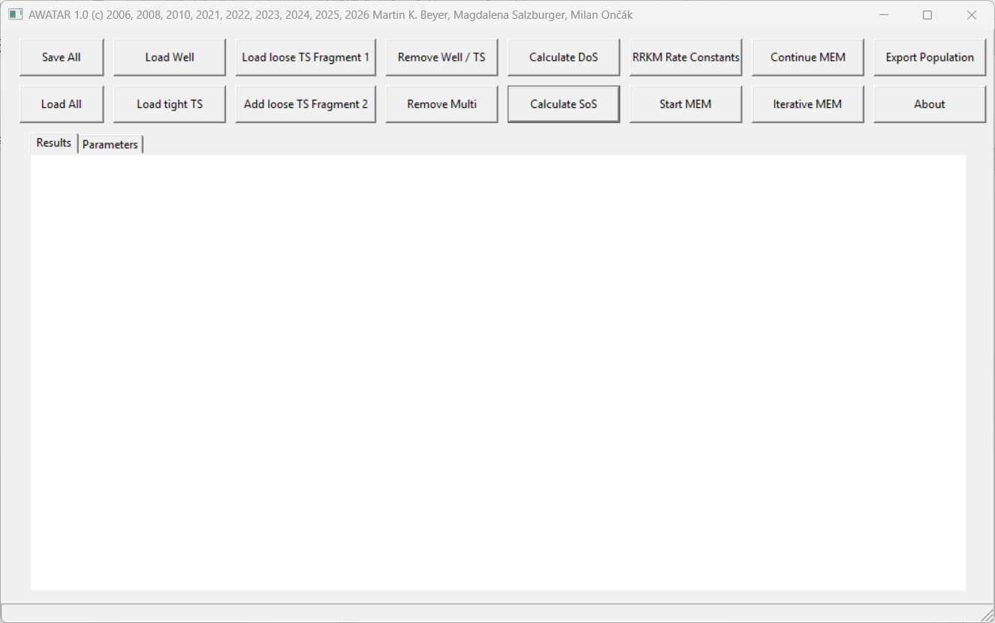
- Go to the panel “Parameters”. In the panel “Parameters”, the user can set all input and control parameters, by changing the numbers after the keywords. All text after a semicolon is treated as a comment. Adapt the “Frequency Scale Factor” to the method and basis set used in the Gaussian calculations. The example log-files are calculated with CCSD/aug-cc-pVDZ, and according to NIST¹, the Frequency Scale Factor should therefore be set to 0.963.
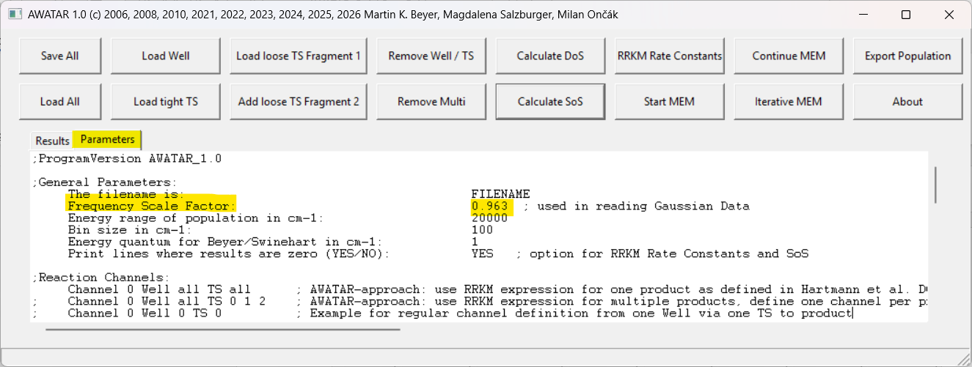
- Next, we load our well, the structure and frequency calculation of the CO₃(H₂O)⁻ molecule. Use the button “Load Well” and select the respective Gaussian log-file (“co3.h2o.com.log”). The well is loaded in a new panel, which looks like this:
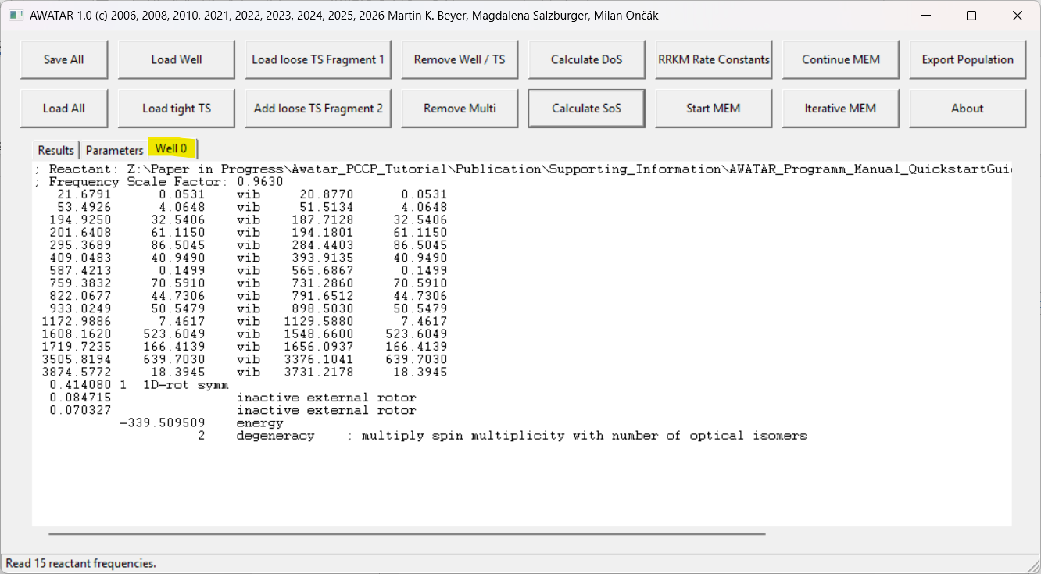
This panel contains all information about the well needed for the calculations, namely the vibrational frequencies and infrared intensities, the rotational constants along with the rotational symmetry number, and the energy and degeneracy of the well.
For documentation purposes, the numbers as calculated appear on the left of the “vib” keyword. The frequencies modified by the scaling factor are shown on the right. One can further modify these values if needed. It is strongly recommended to leave the calculated value as is and only modify the values on the right. This way, one can keep track of all changes. Note that AWATAR uses the modified values on the right, if present.
- Now the density of states can be calculated, using the button “Calculate DoS”. AWATAR reads all required information from the panels “Parameters” and “Well 0” and calculates the density of states as described in Ref 2. The density of states of the well as a function of the total energy appears in the panel “Results”. The results panel works like an editor. Results can be copied for further use, e.g. graphical display, by other programs.
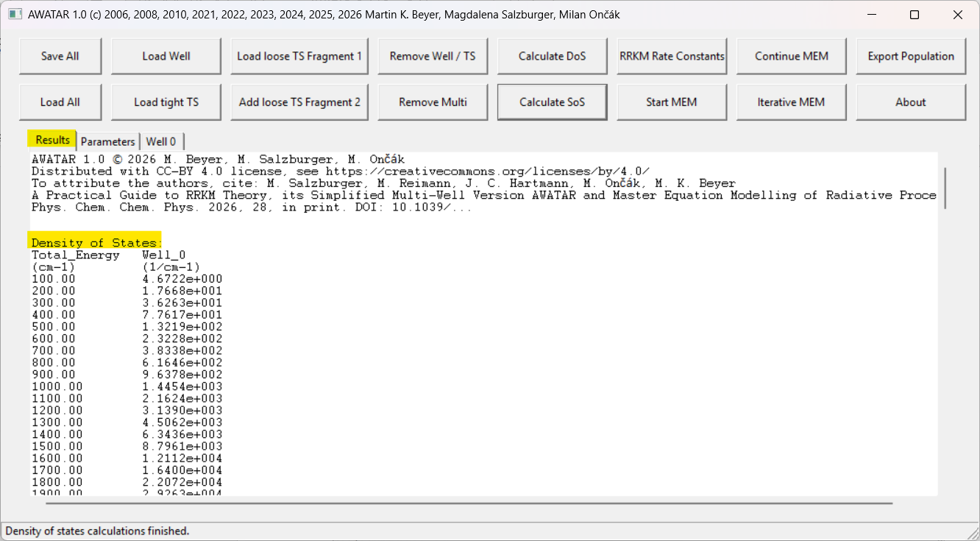
Next, we want to load a loose transition state. Use the button “Load loose TS Fragment 1” and choose the Gaussian log-file of the first fragment, “co3.com.log”. A new panel called “TS 0” appears. Again, this panel contains all information about the first fragment which AWATAR will need for calculations, namely the vibrational frequencies, the rotational constants, the rotational symmetry number, and the energy and degeneracy:
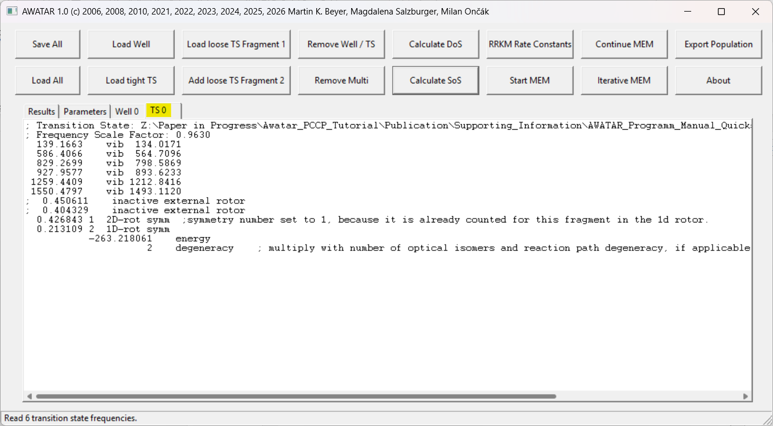
- Next, the second fragment (H₂O) has to be added. Therefore, use the button “Add loose TS Fragment 2”, and choose the Gaussian log-file of the second fragment, “h2o.com.log”. Type “0” in the pop-up panel, as we want to add the second fragment to TS 0.
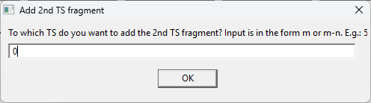
After confirmation with OK, the information regarding the second fragment is added to panel “TS 0”:
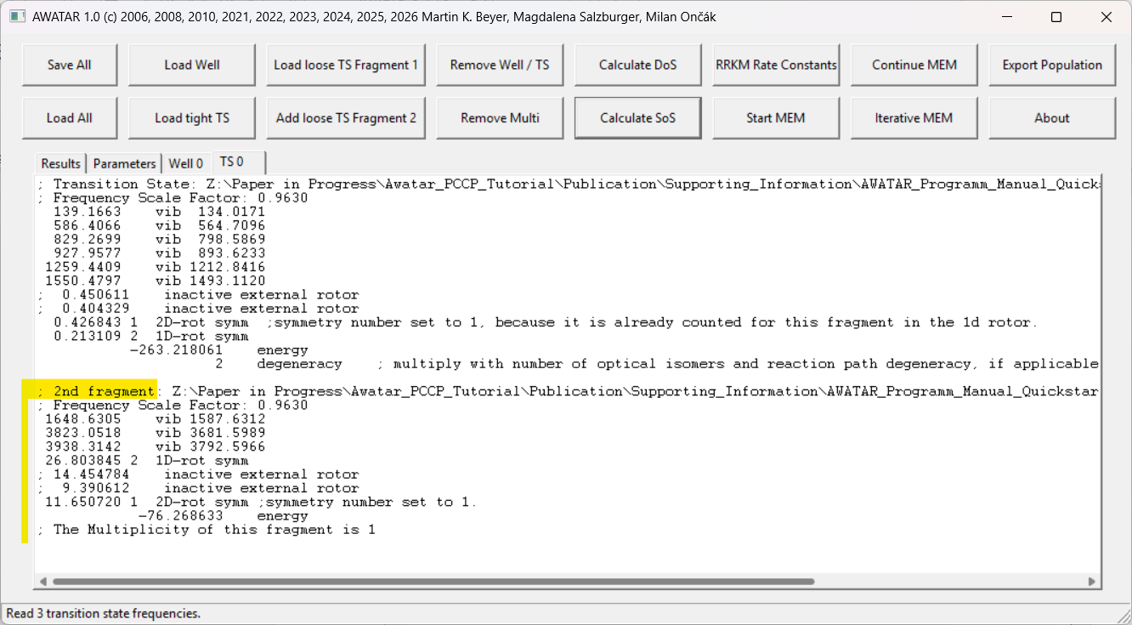
- Now the sum of states of TS 0 can be calculated using the button “Calculate SoS”. AWATAR then reads the information from the panel “Parameters”, “TS 0” and “Well 0”. It calculates the relative energy of the transition state with respect to the global minimum (in this case “Well 0”), and then determines the sum of states as described in Ref 2. The results appear in the panel “Results” in dependence of the energy, whereby the global minimum defines the zero of the energy scale. Note that the sum of states is zero below the energy of the transition state.
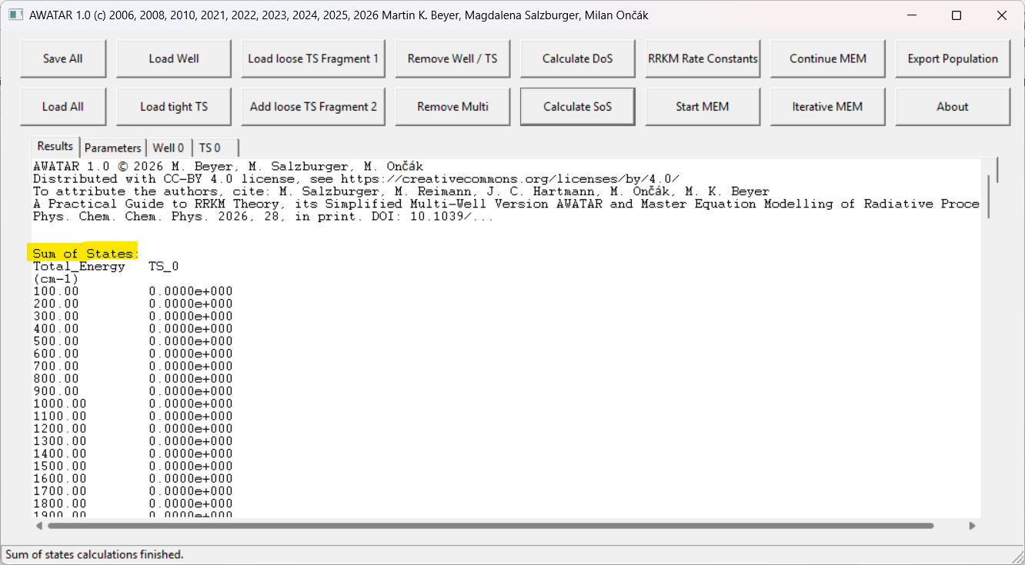
- Next, we want to calculate RRKM rate constants. The required parameters are defined in the section “Reaction channels”:
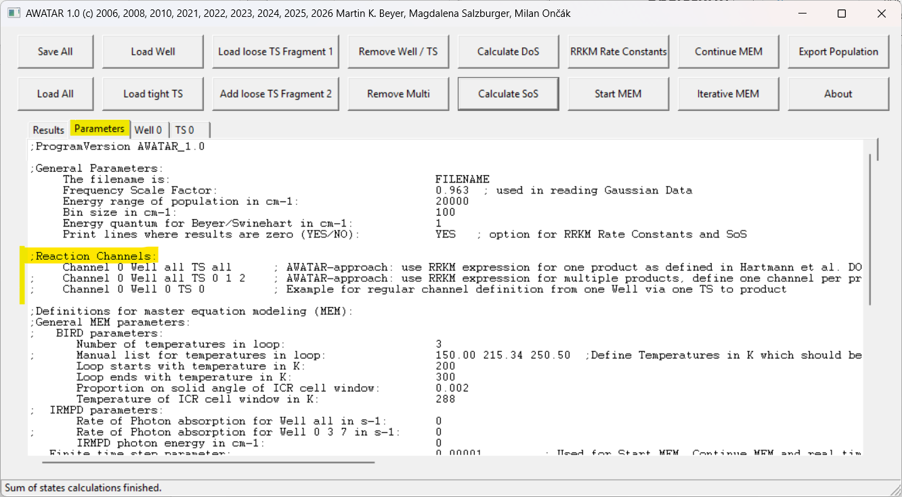
The default channel is “Channel 0 Well all TS all” which means, that the RRKM rate constants are calculated using the density of states of all wells and the sum of states of all transition states.³ Other possible channel definitions are inactive, as the other lines start with a semicolon “;” and all text after semicolons is treated as a comment by the program. For our example calculation, we just use the default settings and do not change the panel “Parameters”. Click on the button “RRKM Rate Constants”, and the results of the calculation are again written to the panel “Results”:
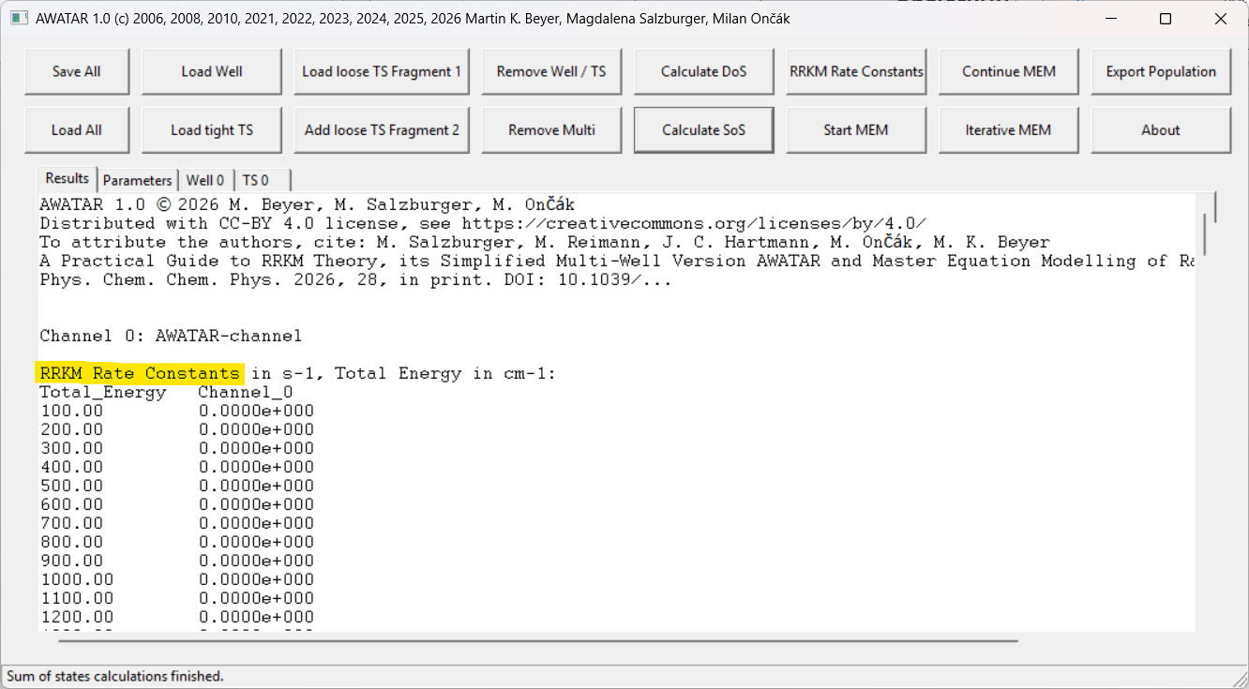
Note, that the RRKM rate constants (second column) are zero for all energies below the activation energy and rise fast above it.
- Finally, we want to perform Master Equation Modeling (MEM). As an example, we calculate real time MEM for BIRD conditions, without IRMPD source. Let’s have a look at the Definitions for master equation modelling (MEM) in the panel “Parameters”: The BIRD parameters define the temperature of the environment. The default is, to perform MEM for 3 different environment-temperatures between 200 K and 300 K. Let’s say, we want to perform MEM just for one temperature of the environment (300 K), so we change the “Number of temperatures in loop” to 1 and activate the line starting with “Manual list for temperatures in loop” by removing the semicolon in front of it. Instead of the three example numbers, write 300, as 300 K is the temperature of our environment. IRMPD is per default inactive, so there is no need to change anything there. In the “Real time MEM parameters”, we can set the initial temperature of the molecules to for example 350 K.
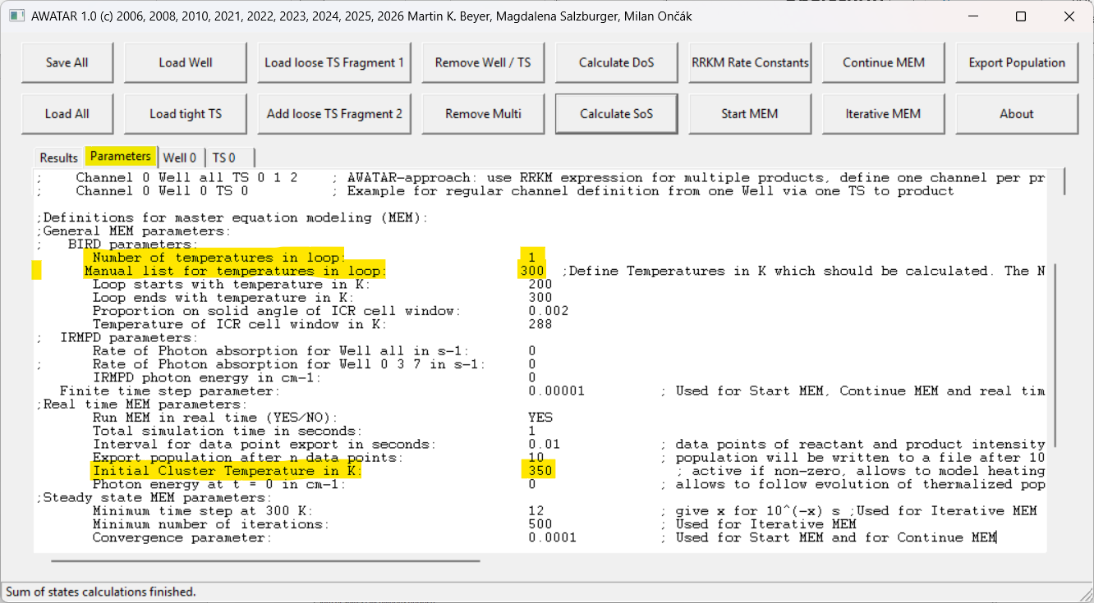
- Now click on the Button “Start MEM” to simulate how a population of molecules with initially 350 K decays in a 300 K environment.
An additional console window opens, showing the progress of the calculation: 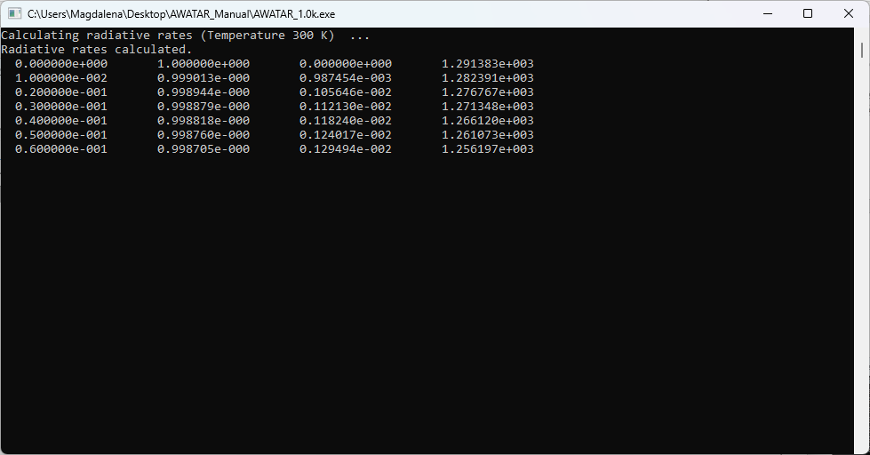
Once the calculation is finished, you find the results again in the panel “Results”:
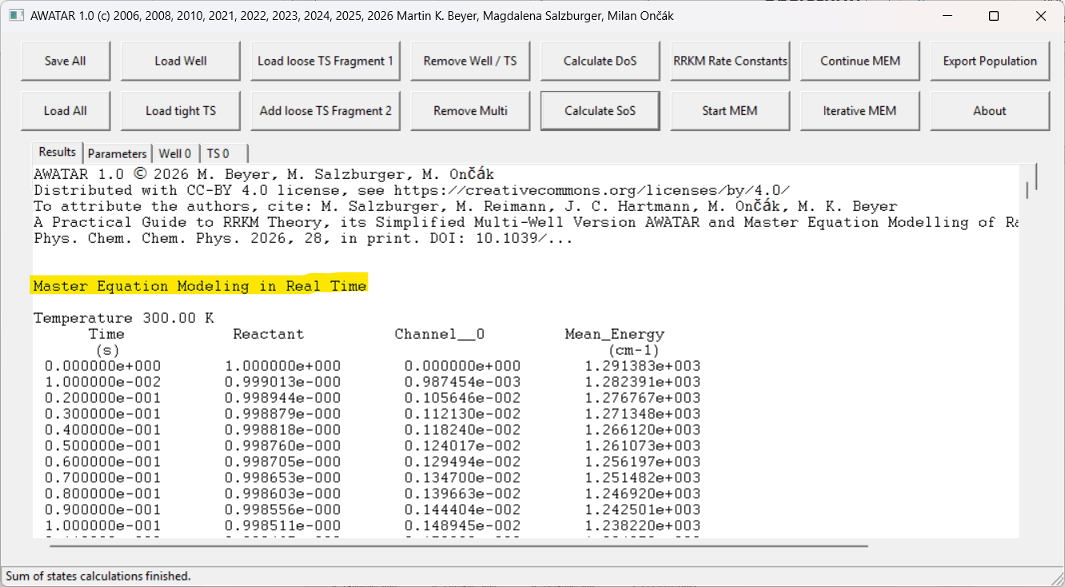
The first row gives the elapsed time in seconds. The second row is the amount of reactant still intact at the given time. The third row is the amount of product formed in the respective channel, and the fourth row is the mean energy of the population. One can see that the mean energy falls. This is due to the cooling to a lower temperature environment and due to the dissociation of the high energy part of the population. Below the results for MEM, also the calculated RRKM rate constants, density of states and sum of states are documented in the panel “Results”.
During MEM the calculated populations are stored to a separate txt-file in the folder of the AWATAR_1.0.exe file. The name of this file is defined by the filename at the top of the panel “Parameters”. As we did not change the default “FILENAME”, you should now find the file “filename_pop.txt” in the folder where you have executed AWATAR_1.0.exe. This file contains the populations of the reactant depending on the simulation time.
Congratulations, you have now performed your first calculations with AWATAR. You can store the current state of all panels and arrays of AWATAR using the button “Save all”.
For other use cases and more detailed information see the User Manual of AWATAR.

References
(1) NIST Standard Reference Database 101. Precomputed vibrational scaling factors. https://​cccbdb.nist.gov​/​vibscalejustx.asp (accessed 2025-04-17).
(2) Gilbert, R. G.; Smith, S. C. Theory of Unimolecular and Recombination Reactions; Physical Chemistry Texts; Blackwell Scientific Publications, 1990.
(3) Hartmann, J. C.; Madlener, S. J.; van der Linde, C.; Ončák, M.; Beyer, M. K. Magic Cluster Sizes of Cationic and Anionic Sodium Chloride Clusters Explained by Statistical Modelling of the Complete Phase Space. Phys. Chem. Chem. Phys. 2024, 26, 10904-10918. DOI: 10.1039/D4CP00357H.

