USER MANUAL FOR AWATAR_1.0.exe
Magdalena Salzburger, Marc Reimann, Jessica C. Hartmann, Milan Ončák, and Martin K. Beyer
Universität Innsbruck
Institut für Ionenphysik und Angewandte Physik
Technikerstraße 25
6020 Innsbruck, Austria
E-mail: martin.beyer@uibk.ac.at
Table of contents
Introduction 2
Citation 2
Using the AWATAR program: general information 3
Definition of wells 4
Definition of transition structures (TS) 5
Adapting the energy of wells and transition structures 10
Adapting the degeneracy of wells and transition structures 11
Calculate density of states (DoS) 12
Calculate sum of states (SoS) 13
Calculate RRKM rate constants 14
Perform Master equation modeling (MEM) 16
Real time MEM 17
Steady state MEM 20
Detailed information: The parameter panel 26
General parameters 26
Reaction channels 27
Definitions for master equation modeling (MEM) 28
Fit parameters 31
Description of generic quantum chemical input file 33
Acknowledgements 34
References 34

Introduction
AWATAR_1.0.exe (in the following also called AWATAR) is a program running on Windows, to perform RRKM, AWATAR and master equation modeling or related calculations on unimolecular reactions in the gas phase, with a focus on problems encountered in gas-phase ion chemistry, ion dissociation and ion spectroscopy. AWATAR is written in PureBasic, see https://www.purebasic.com. It has been used for peer-reviewed research publications by the authors.^{1–4} With AWATAR, you can:
- Calculate the density of states for minimum structures
- Calculate the sum of states for transition structures (both tight and loose transition structures)
- Calculate RRKM rate constants for unimolecular reactions from one well to one transition structure or from multiple wells to multiple transition structures, as described in the AWATAR approach⁴
- Perform master equation modeling, simulating the dissociation of a population of molecules under BIRD conditions, with the option to include an IRMPD source; thereby, the evolution of a population can be modeled in time (real time MEM) or a steady state can be optimized (steady state MEM)
The calculations require:
- The program AWATAR_1.0.exe
- Gaussian log-files containing the optimized structures, energies and frequencies of the molecules of interest (see example files); Output from other quantum chemical calculation programs must be converted as described below, Description of generic quantum chemical input file.

Citation
AWATAR is supplied with a CC-BY license. Any scientific work that uses the AWATAR program must include a reference to our tutorial review in Physical Chemistry Chemical Physics, which made the code publicly available:
M. Salzburger, M. Reimann, J. C. Hartmann, M. Ončák, M. K. Beyer: A Practical Guide to RRKM Theory, its Simplified Multi-Well Version AWATAR and Master Equation Modelling of Radiative Processes. Phys. Chem. Chem. Phys. 2026, 28, in print. DOI: 10.1039/…
Please use the DOI link to retrieve the final page numbers.

Using the AWATAR program: general information
When the file AWATAR_1.0.exe is executed, the following window opens:
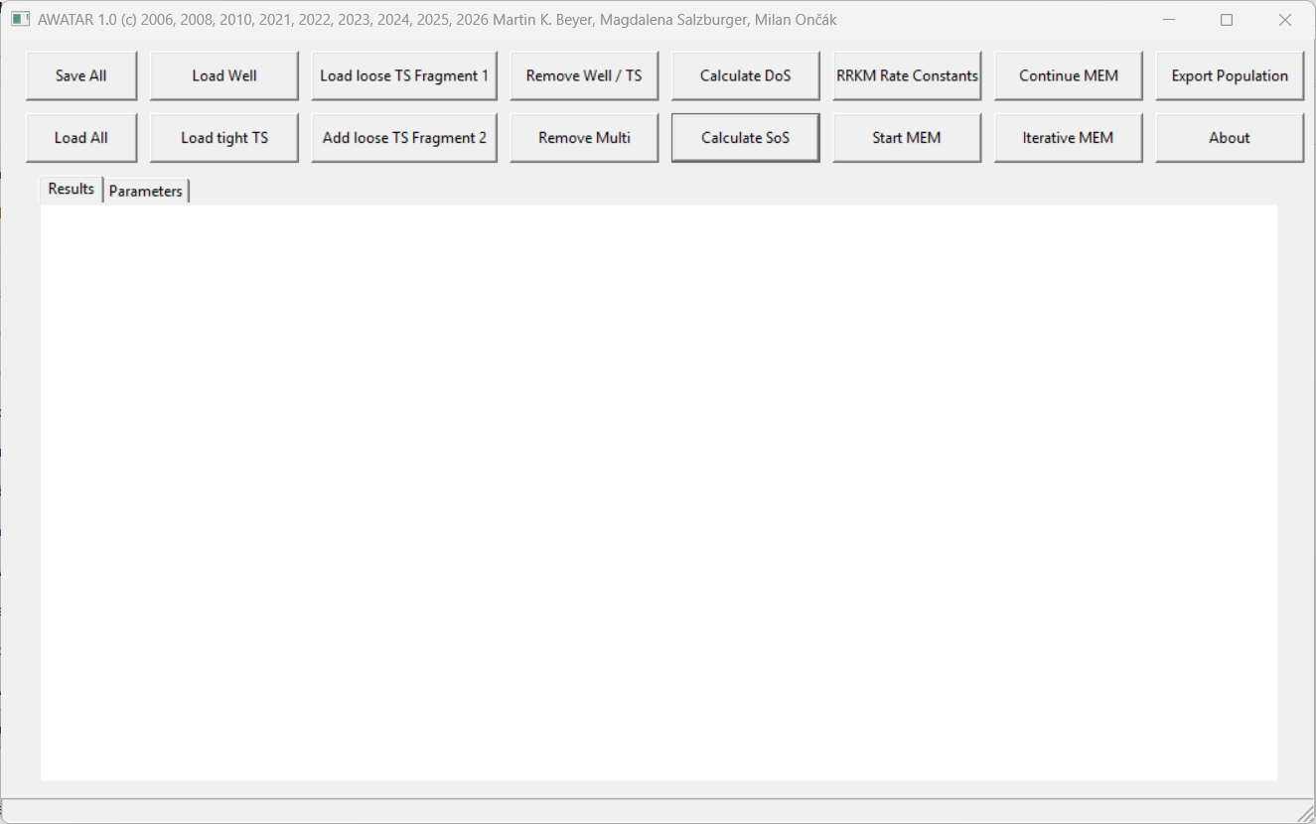
One can switch between the panels “Results” (which will show all relevant results once a calculation is performed) and “Parameters” which defines all necessary settings for the calculations. The user can edit text in all panels, changing for example the input parameters or commenting the results. (Be careful not to modify results.) All text starting with a semicolon “;” is treated as comment, and ignored by AWATAR.
With the button “Save All”, the current state of the program can be saved in the format filename.rrk. Thereby all the text written in any of the panels is saved along with the content of all arrays. Once a MEM calculation is performed (this will be explained in more detail later), an additional console window opens, showing the progress of the calculation. The content of this console window is not stored when using the “Save All” button.
WARNING: Closing the console window immediately terminates AWATAR. All information that has not been saved before will be lost. The reason for the console window is that output into such a window is much faster than output to a panel within AWATAR, which would considerably slow down the calculations.
To open a stored file, click on the button “Load All”. After choosing the respective file filename.rrk, the status of AWATAR, including all relevant variables and arrays, is restored.
For all calculations the program is able to perform, it is necessary to define wells and/or transition structures (TS). This will be explained in the following chapters.

Definition of wells
The definition of a well requires a Gaussian log-file, containing the optimized structure and frequency calculation of the molecule of interest.
Before loading wells, the “Frequency Scale Factor” in the panel “Parameters” should be set. This factor scales the vibrational frequencies. Which factor should be used, depends on the used method and basis set, and can be looked up at NIST.⁵ For example for CCSD/aug-cc-pVDZ:
Frequency Scale Factor: 0.963
Next, the well can be loaded using the button “Load Well” and choosing the respective Gaussian log-file. The well appears then as a new panel (called “Well 0” for the first well, all further wells are enumerated consecutively.) This panel looks for example like this:
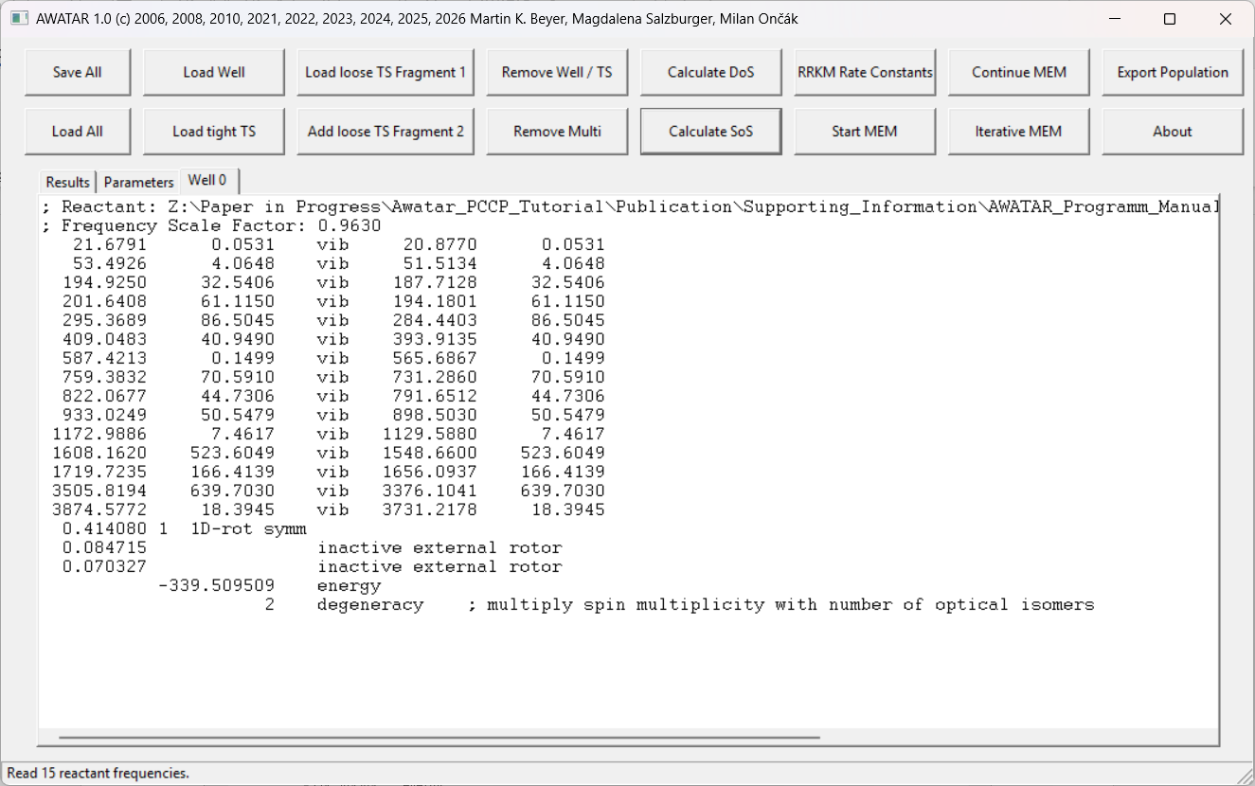
The first line in this panel shows the filename and directory of the loaded file. The used “Frequency Scale Factor ” is documented in the second line.
The following lines containing the word “vib” give the calculated vibrational frequencies in cm⁻¹ of the molecule (first number of each line) along with the infrared intensities in km mol⁻¹ (second and fourth number of each line). The third number is the vibrational frequency in cm⁻¹ scaled by the used Frequency Scale Factor. The idea of this doubling of the frequency output is that the information on the original calculated values is preserved. If no numbers follow after “vib”, the original values are used without change. Otherwise, the modified values are used. Expert users may want to deliberately change those values, e.g. for low-lying vibrational modes.
After the vibrational modes follows information about the rotational modes. Thereby the first number of each line is a rotational constant in cm⁻¹, and in each line, it is also noted whether the corresponding rotational mode is active (counting for the Beyer-Swinehart-Algorithm) or inactive (not counting for the Beyer-Swinehart-Algorithm). In the line with the active rotation, the rotational symmetry number is given after the rotational constant. If the molecule is spherical symmetric with three identical rotational constants, one of the rotational modes is treated as one-dimensional rotor (noted with the text “1D-rot symm”), while the other two are inactive. If the molecule is linear, the rotation does not contribute with any degrees of freedom. Otherwise, the molecule is approximated as prolate or oblate symmetric top, and there is one active rotational mode that can exchange energy with the vibrations, see Gilbert and Smith for detail.⁶
The line containing the word “energy” gives the electronic energy without zero-point correction in Hartree.
The line containing the word “degeneracy” gives the spin degeneracy, which corresponds to the multiplicity. The degeneracy has to be adapted manually for the consideration of other degeneracies. This is explained in more detail in the chapter “Adapting the degeneracy of wells and transition structures”.

Delete wells
To remove a well, go to the respective panel and then use the button “Remove Well/TS”. After confirmation, the well is deleted. Note, that the enumeration of all consecutive wells is adapted, this means that the number of other wells may change due to the removal of a well. The text in the panel “Parameters” however does not change automatically. All prior written references to wells in the panel “Parameters” have to be checked and adapted manually.
There is also the possibility to delete several wells at once with the button “Remove Multi”. The input in the requester has to be in the form “Well m-n” to delete all wells between well m and well n including well m and well n. Again, the enumeration of all consecutive wells is adapted automatically, but all prior references to wells in the panel “Parameters” must be manually adapted.

Definition of transition structures (TS)
Transition structures (TS) can be loaded as loose TS or tight TS. For both options, the Frequency Scale Factor in the panel “Parameters” should be set prior to loading the transition structures. In the following, the definition of loose TS and tight TS is explained separately:

Definition of loose TS
A loose TS consists of two fragments. Two Gaussian log-files are needed, containing the optimized structures and frequencies for both fragments.
The first fragment can be loaded using the button “Load loose TS Fragment 1” and choosing the log-file of the respective fragment. A new panel called “TS 0” appears, further transition structures are enumerated consecutively. The panel “TS 0” looks for example like this:
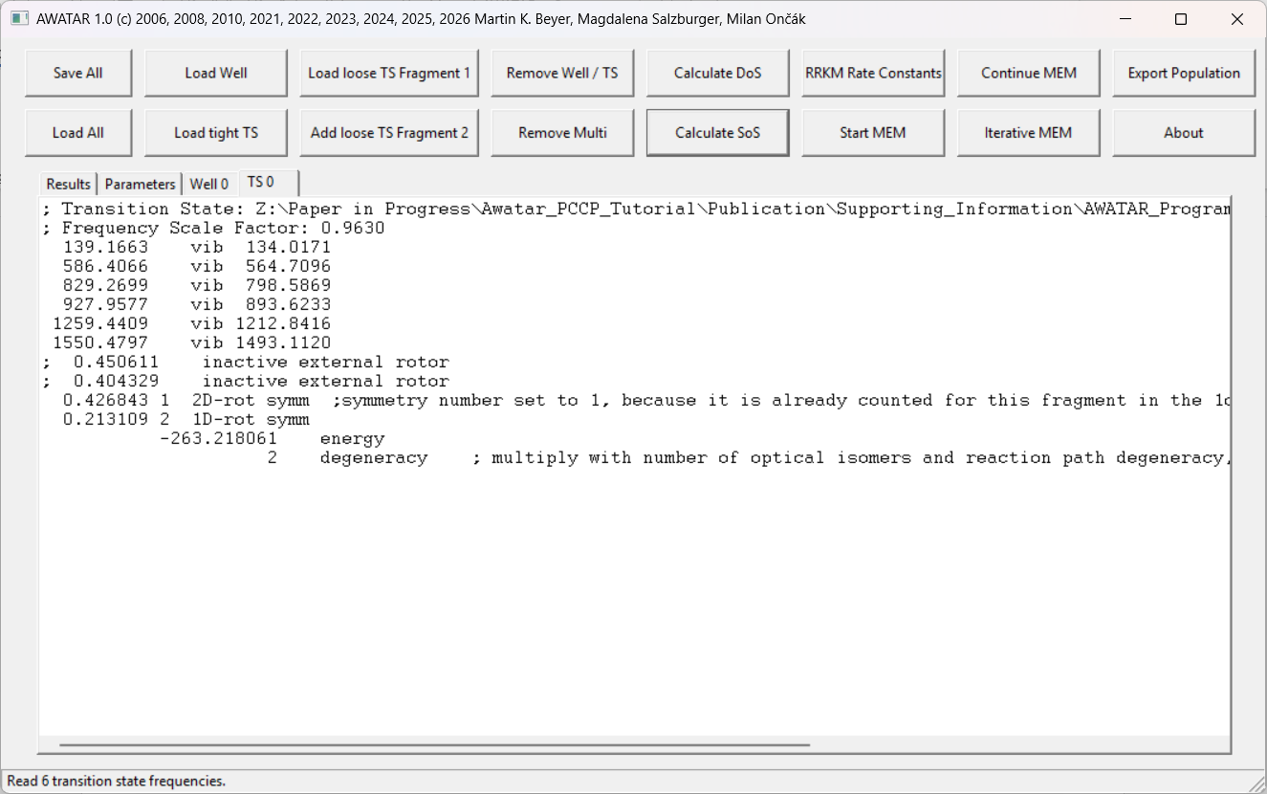
Similar as for a well, the first two lines show the path to the log-file and the Frequency Scale Factor. In the lines containing the word “vib” the vibrational modes are defined, whereby the number before “vib” is the unscaled vibrational frequency in cm⁻¹ and the number after “vib” is the scaled vibrational frequency in cm⁻¹. For transition structures, intensities of vibrational modes are not used in RRKM/AWATAR/MEM calculations/simulations and are therefore not shown.
Next follow the rotational modes. As it is the case for the wells, the rotational constants in cm⁻¹ are given. For loose transition structure fragments, all rotational degrees of freedom contribute to the sum of states calculated by the Beyer-Swinehart algorithm. This is implemented as follows:
- Spherical symmetric molecules (all three rotational constants are the same) are modeled as an active 1D rotor (noted with 1D-rot symm), and an active 2D rotor (noted with 2D-rot symm).
- For linear molecules the rotation contributes with two degrees of freedom, modeled as a two-dimensional rotor.
- All other molecules are approximated as prolate or oblate symmetric top. One of the rotational modes is modeled as a one-dimensional rotor (noted with 1D-rot symm), while the other two rotational modes are modeled as a two-dimensional rotor (noted with 2D-rot symm). Thereby, instead of two inactive external rotors, there is one active 2D rotor, with a rotational constant corresponding to the geometric mean of the rotational constants of the inactive rotors. The rotational constants of the original inactive rotors are noted after a semicolon (and therefore not read by AWATAR), and in the line after that, the active two-dimensional rotor is defined. The symmetry number of this rotor is set to 1, because symmetry is already accounted for this fragment in the 1D rotor.
The line containing the word “energy” gives the electronic energy without zero-point correction in Hartree.
The line containing the word “degeneracy” gives the spin degeneracy, which corresponds to the multiplicity. The degeneracy has to be adapted manually for the consideration of other degeneracies. This is explained in more detail in the chapter “Adapting the degeneracy of wells and transition structures”.
To add the information about the second fragment, use the button “Add loose TS Fragment 2”. After selection of the log-file, a pop-up window requires to enter the number of the TS to which the second fragment should be added. Provide the number in the format “n” to add the fragment to TS n or in the format “m-n” to add the fragments to all TS between TS m and TS n, including TS m and TS n. Confirm with OK, and the information is added. The complete entry for a loose TS can look for example like this:
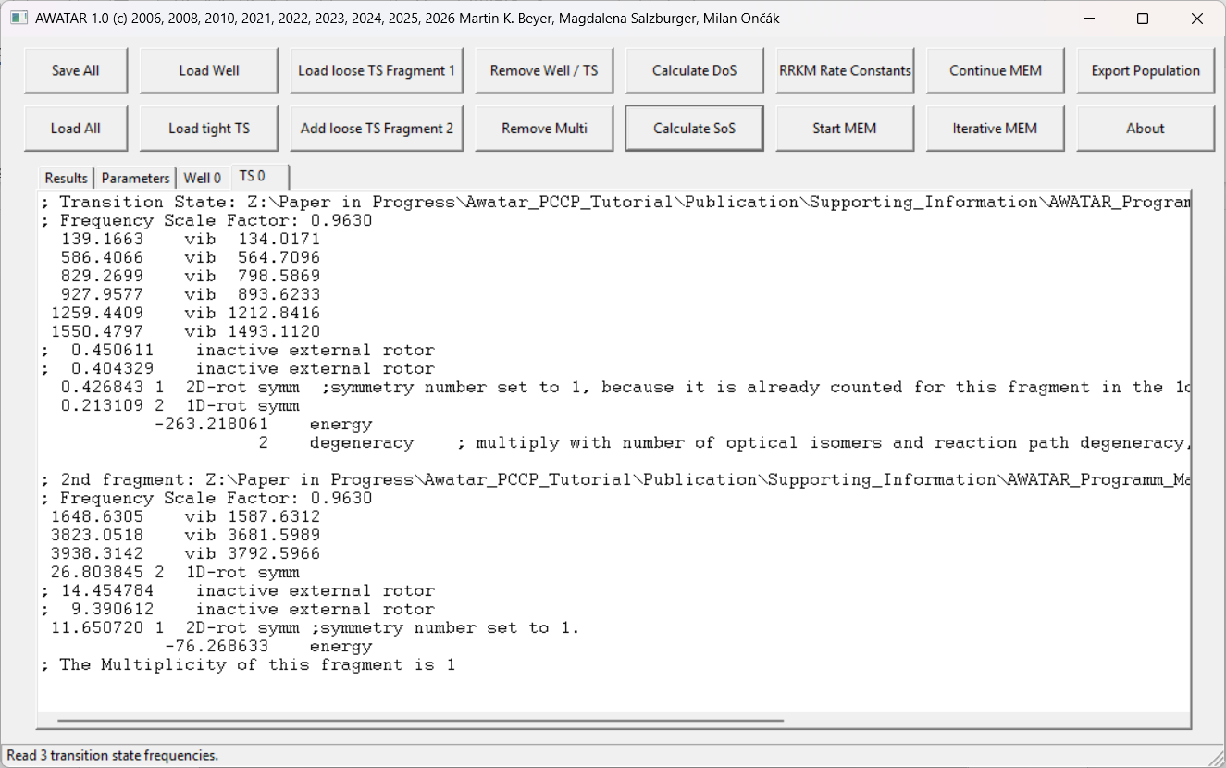
The meaning of the lines is the same as for the first fragment. Note however, that the spin degeneracy is not considered automatically. Instead, the multiplicity is read from the log-file and written to the panel after a semicolon. The degeneracy defined by the first fragment should be adapted such, that the total degeneracy of the transition structure is considered there.
It is also possible to add more than two fragments by using the button “Add loose TS Fragment 2” several times.
Note, that for a correctly loaded TS, the total number of degrees of freedom (counting all vibrational modes and active rotational modes, whereby 2D rotors count twice) is one less than the number of degrees of freedom of a well. When a program routine is executed where this poses a problem, AWATAR gives a warning that the numbers of degrees of freedom are inconsistent.

Definition of tight TS
A tight TS consists of a molecule with one imaginary frequency. This chapter describes how to load a tight TS if a corresponding Gaussian log-file is available (see chapter “Definition of tight TS using the log-file of a well” for a possible alternative).
Set the “Frequency Scale Factor ” in the panel “Parameters”. Then, use the button “Load tight TS” and choose the respective Gaussian log-file. A new panel called “TS 0” appears, (all further transition structures are enumerated consecutively). The new panel looks for example like this:
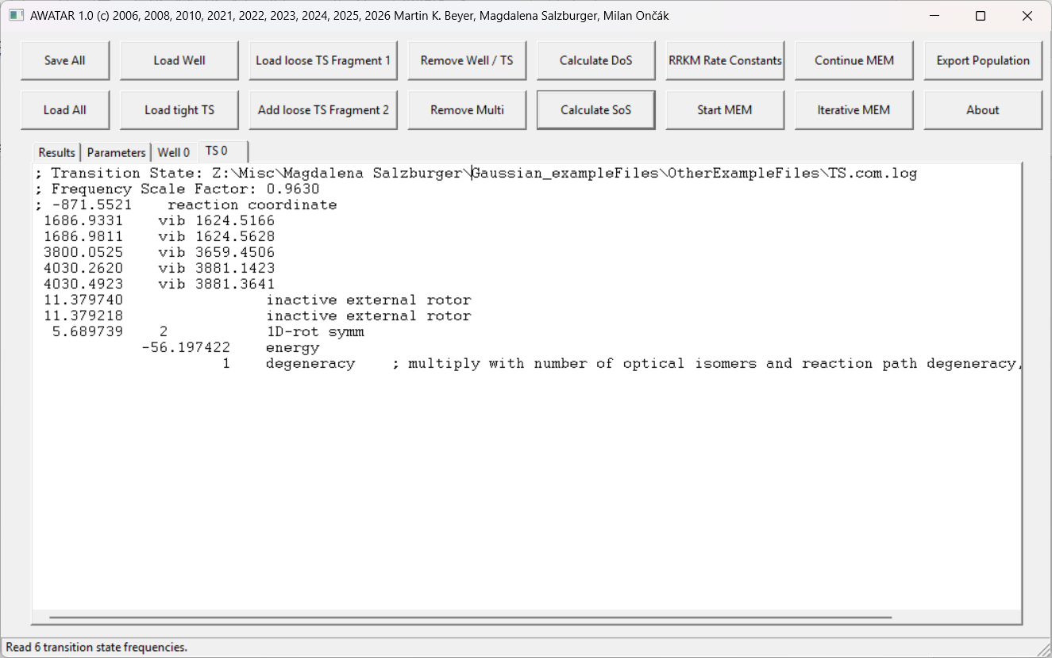
The information is similar to a well, but the infrared intensities are not necessary and therefore missing. The imaginary frequency is noted with the keyword “reaction coordinate” and using the minus sign, as it is done in Gaussian. The respective line is starting with a semicolon, as for the transition structure, the imaginary vibrational mode is not counting for the Beyer-Swinehart-Algorithm and therefore not used for any of the calculations in AWATAR. The total number of degrees of freedom (counting all vibrational modes and active rotational modes, whereby 2D-rotors count twice) is one less than the number of degrees of freedom of a well.
Finally, do not forget to adapt the degeneracy to account e.g. for optical isomers, as only the spin degeneracy is loaded automatically.

Definition of tight TS using the log-file of a well
For modeling dissociation via a tight TS, the log-file of the dissociating well is read. Set the “Frequency Scale Factor ” in the panel “Parameters” prior to loading the TS. Use the button “Load tight TS” and choose the respective log-file. The panel of the TS looks then for example like this:
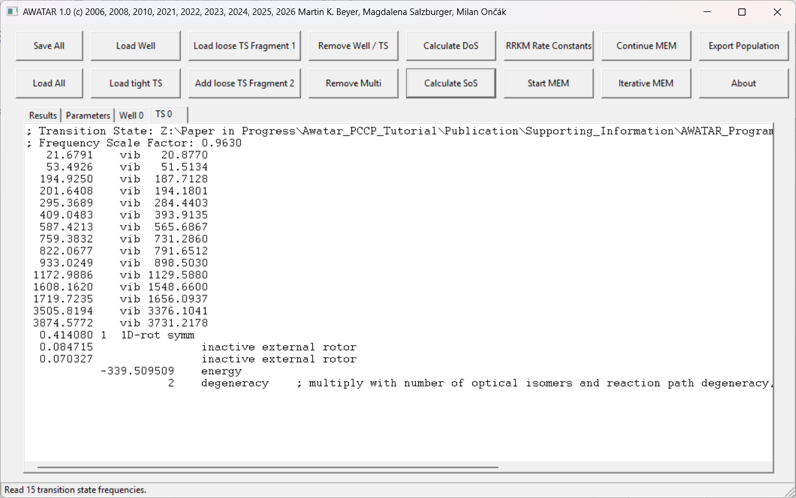
For the transition structure, one vibrational mode (the mode along which the dissociation happens) is not counting for the Beyer-Swinehart-Algorithm. To identify this dissociative mode, you need a program that displays the animated vibrations of a frequency calculation, such as Molden.⁷ The user manually sets a semicolon “;” in front of the frequency of the dissociative mode. Then, the total number of degrees of freedom (counting all vibrational modes and active rotational modes, whereby 2D-rotors count twice) is one less than the number of degrees of freedom of a well.
Also, the transition structure should be higher in energy than the global minimum well. One possibility to add for example an energy of 1000 cm⁻¹ to the energy of the transition structure, is to add the line “offset 1000” in the panel of the transition structure. See chapter “Adapting the energy of wells and transition structures” for further possibilities to change the energy.
Finally, do not forget to adapt the degeneracy manually, as only the spin degeneracy is loaded automatically. In addition to optical isomers, also reaction path degeneracy may be taken into account, as discussed e.g. by Gilbert and Smith.⁶
After those changes the panel of the tight transition structure may look like this:
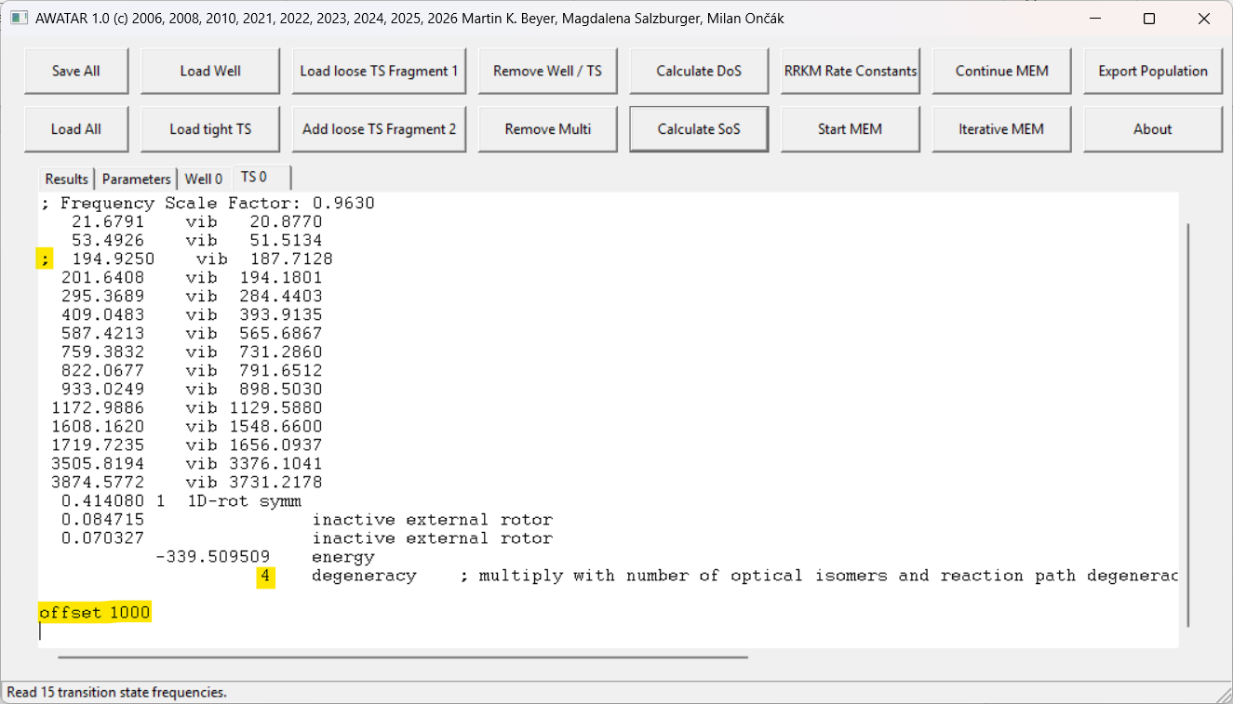

Delete TS:
The deletion of transition structures is possible with the buttons “Remove Well/TS” or “Remove Multi”, as described above for wells (see chapter “Delete wells”). Also, for transition structures, the enumeration of all consecutive TS is adapted automatically, but all prior references to transition structures in the panel “Parameters”, like channel definition, have to be adapted manually.

Adapting the energy of wells and transition structures
When wells or TS are loaded, the sum of electronic energies without zero-point energy is read from the Gaussian file and written in Hartree to the respective panel in a line containing the keyword “energy”. Once a calculation is performed, the zero-point energy is calculated by AWATAR using all active vibrational frequencies (scaled by the Frequency Scale Factor). The total energy consists of the sum of electronic energies and the zero-point energy. The energy of a TS has to be higher than the global minimum well. If this is not the case, AWATAR sets the energy of the TS to the energy of the global minimum well.
There are several possibilities to further change the energy of wells and transition structures. Three options allow to change the energy in the panel of the respective well or TS:
- Change the number before the keyword “energy”. This could look like this:
; -339.509509 energy ; This energy (in au) is from the log-file.
-400.00000 energy ; This energy (in au) is used instead.

- Add a line with a number followed by the word “energy”: This adds the given energy in Hartree to the total energy of the well/TS. For example:
0.50 energy ; This adds 0.5 Hartree to the total energy

- Add a line with the content “offset x” where x is the energy in cm⁻¹ which should be added to the respective well/TS. For example:
offset 1000 ; This adds 1000 cm⁻¹ to the total energy.
The energy of transition structures can additionally also be set or changed in the panel “Parameters” in the section “Fit parameters”. This is explained in chapter “Detailed information: The parameter panel”. When a calculation is performed, the used energies relative to the global minimum well are always noted in the panel “Results”. It is recommended to double check there, that the correct energies are used.

Adapting the degeneracy of wells and transition structures
Prior to perform a calculation, the degeneracies for all wells and transition structures should be determined according to the physics of the system and entered in AWATAR.

Determination of the degeneracy:
Depending on the physics of the system, it may be reasonable to consider the following degeneracies:
- Spin degeneracy: The spin degeneracy is given by the multiplicity of the molecules. When a well or tight TS is loaded, the spin degeneracy is considered automatically, by reading the used multiplicity from the Gaussian log-file. For loose transition structures, the spin degeneracy of the first loaded fragment is as well considered automatically. For the second fragment, the multiplicity is read from the log-file and written to the TS panel as information for the user, but not considered automatically. E.g. for two radical fragments, the spin multiplicity is 2 for each fragment. Together, they yield four spin microstates, so the total spin degeneracy is 4.
- Degeneracy of optical isomers: For chiral molecules, the degeneracy should be multiplied by the factor 2, if both enantiomers are to be considered.
- Path degeneracy: If a transition structure has a higher probability due to several possible pathways, this can also be considered for the total degeneracy. See Gilbert and Smith⁶ for a detailed discussion of reaction path degeneracies.
These degeneracies have to be multiplied to determine the total degeneracy.

Writing the total degeneracy in the AWATAR Program:
The degeneracy can be entered in the panel of the respective well or TS in the following format:
x degeneracy
whereby x is the total degeneracy. After loading a well or TS, the line containing the word degeneracy is already written in the panel, just the number has to be substituted, to consider all degeneracies. For example:
2 degeneracy ;spin multiplicity = 1 , number of optical isomers = 2
If the program finds in one panel of a well or TS several lines containing the word degeneracy, only the last line is considered.
The degeneracy can be further modified in the panel “Parameters” in the section “Fit parameters”. This is explained in chapter “Detailed information: The parameter panel”. When a calculation is performed, the used degeneracies are always noted in the panel “Results”. It is recommended to double check there, if the intended degeneracies are used.

Calculate density of states (DoS)
The DoS reflects the number of possibilities to distribute a given amount of energy over the rovibrational modes of a well. It is used in RRKM and AWATAR calculations of unimolecular rate constants k(E).
Prior to the calculation of DoS, it is necessary to define wells as described in chapter “Definition of wells”. Once one or several wells are defined, the DoS can be calculated with the button “Calculate DoS”. The results appear in the panel “Results”.

The DoS calculation in AWATAR
AWATAR calculates the DoS using the Beyer-Swinehart algorithm COUNT in the version described by Gilbert and Smith.^{6,8} The available energy is always determined relative to the global minimum well. If several wells are loaded, AWATAR determines automatically, which one is the global minimum.

Explanation of the results
The results of a DoS calculation look for example like this:
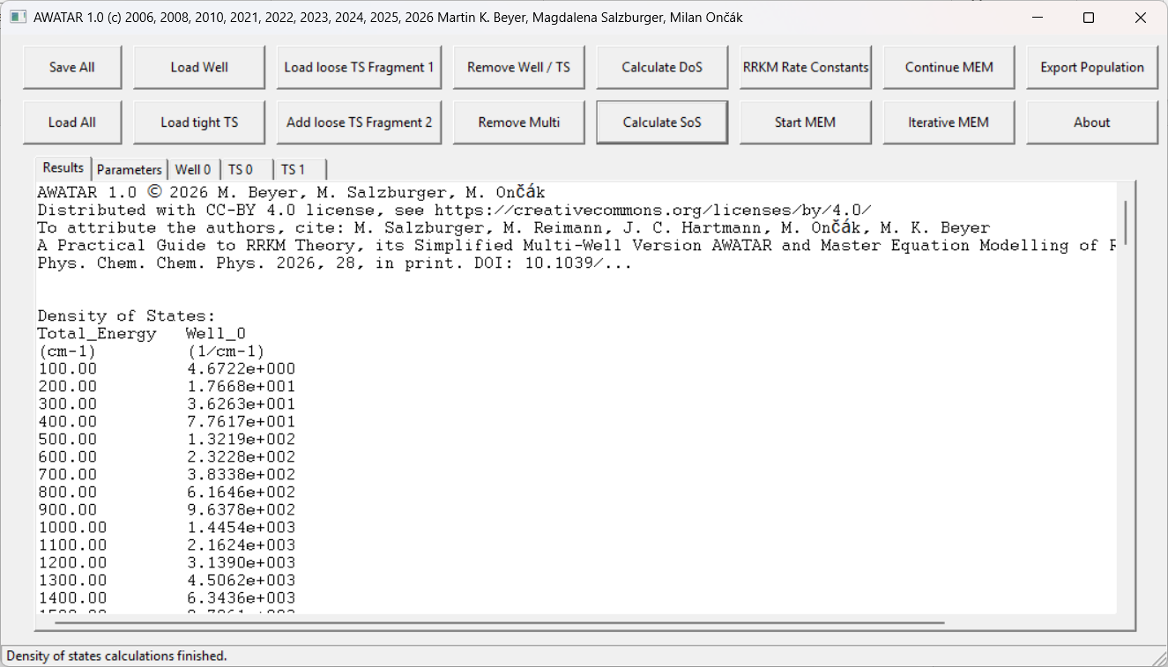
The first row gives the total energy in cm⁻¹ above the global minimum well. The default energies are in steps of 100 cm⁻¹ up to an energy of 20000 cm⁻¹. All further rows give the resulting DoS in 1/cm⁻¹ for each well at the available energy. Note, that the DoS rises fast with increasing energy. For wells which are higher in energy than the global minimum, the DoS is zero for the lowest energies and gets non-zero once the available energy is high enough to populate this well.
At the bottom of the panel “Results”, the degeneracies and relative energies used in the calculation are printed for each well.

Options
Three parameters in the panel “Parameters” in the section “General parameters” (see chapter “General parameters”) determine the output of DoS calculations. The step size for the output is defined by the size of the energy bins used also in MEM calculations (Bin size in cm-1). The range of the total energy (Energy range of population in cm-1 ) and the energy quantum for the Beyer-Swinehart algorithm (Energy quantum for Beyer/Swinehart in cm-1) can be adapted.
The properties of the wells can be adapted as described in chapters “Definition of wells”, “Adapting the energy of wells and transition structures” and “Adapting the degeneracy of wells and transition structures”.

Any changes are reflected in the results window only after the button “Calculate DoS” has been used again to recalculate the DoS with the new parameter settings.

Calculate sum of states (SoS)
The SoS is the number of accessible quantum states of a TS at a given energy (E-E₀), where E₀ is the energy of the TS relative to the minimum energy well. The energy is partitioned over the rovibrational degrees of freedom of the TS and the reaction coordinate. In practice, integer multiples of the Beyer-Swinehart energy quantum are subtracted from (E-E₀), and the remaining energy is distributed over the rovibrational degrees of freedom.
Prior to the calculation of SoS, it is necessary to load the global minimum well, as described in chapter “Definition of wells”, because the global minimum sets the zero of the energy scale. Also, the transition structures of interest need to be loaded, as described in chapter “Definition of transition structures (TS)”. Once the global minimum well and one or several TS are defined, the SoS can be calculated with the button “Calculate SoS”. The results appear in the panel “Results”.

SoS calculation in AWATAR
AWATAR calculates the SoS according to the Beyer-Swinehart algorithm COUNT in the version described by Gilbert and Smith.^{6,8} The available energy is always determined relative to the global minimum well. If several wells are loaded, AWATAR determines automatically, which one is the global minimum.

Explanation of the results
The results of a SoS calculation look for example like this:
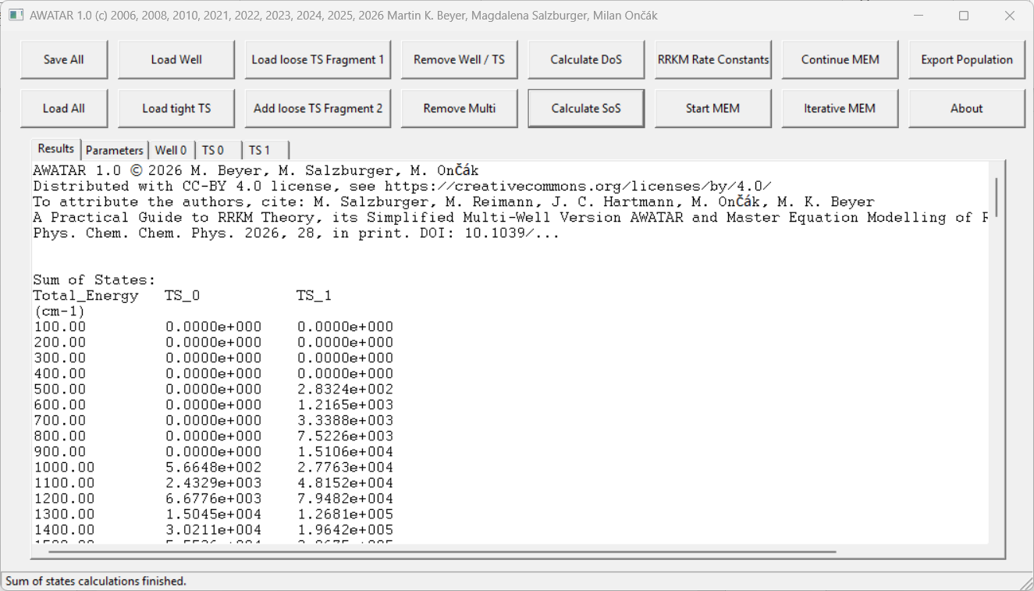
The first row gives the total energy in cm⁻¹ above the global minimum well. All further rows give the resulting SoS (the SoS has no unit) for each transition structure at the available energy. Note, that the SoS rises fast with increasing energy. The SoS is zero for the lowest energies, and gets non-zero once the available energy is high enough to reach the respective transition structure.
At the bottom of the panel “Results”, the degeneracies and relative energies used in the calculation are printed for all wells and TS.

Options
Three parameters in the panel “Parameters” in the section “General parameters” (see chapter “General parameters”) determine the output of DoS calculations. The step size for the output is defined by the size of the energy bins used also in MEM calculations (Bin size in cm-1). The range of the total energy (Energy range of population in cm-1 ) and the energy quantum for the Beyer-Swinehart algorithm (Energy quantum for Beyer/Swinehart in cm-1) can be adapted.
The properties of a TS can be adapted as described in chapters “Definition of transition structures (TS)”, “Adapting the energy of wells and transition structures” and “Adapting the degeneracy of wells and transition structures”.

Any changes are reflected in the results window only after the button “Calculate SoS” has been used again to recalculate the SoS with the new parameter settings.

Calculate RRKM rate constants
RRKM rate constants are unimolecular rate constants calculated according to Rice−Ramsperger−Kassel−Marcus theory using the density of states of one well and the sum of states of one transition structure. In the AWATAR extension of RRKM theory, the sum of the DoS of multiple wells and the sum of the SoS of multiple transition structures are used.
Prior to the calculation of RRKM rate constants, it is necessary to load the wells and transition structures of interest, as described in chapter “Definition of wells”, and “Definition of transition structures (TS)”. The dissociation channels can be defined in the panel “Parameters”, in section “Reaction channels”. The default is, to calculate RRKM rate constants via the AWATAR approach, summing over all wells for the calculation of the density of states, and summing over all transition structures to determine the sum of states. Other options are explained in chapter “Reaction channels”. Once at least one well and one TS are loaded, and the channels of interest are defined, the RRKM rate constants can be calculated with the button “RRKM Rate Constants”. The results appear in the panel “Results”.

The RRKM rate constant calculation in AWATAR
To calculate the RRKM rate, AWATAR determines the density of states for all wells and the sum of states for all TS. Then, the RRKM rate constants are calculated for each channel as defined in the parameter window. Note, that the calculation of RRKM rate constants may not work when very few degrees of freedom are available. It is recommended to use only systems with at least four atoms. Problems arise if DoS or SoS do not increase monotonically with total energy E.

Explanation of the results
The results of the RRKM rate constants calculation look for example like this:
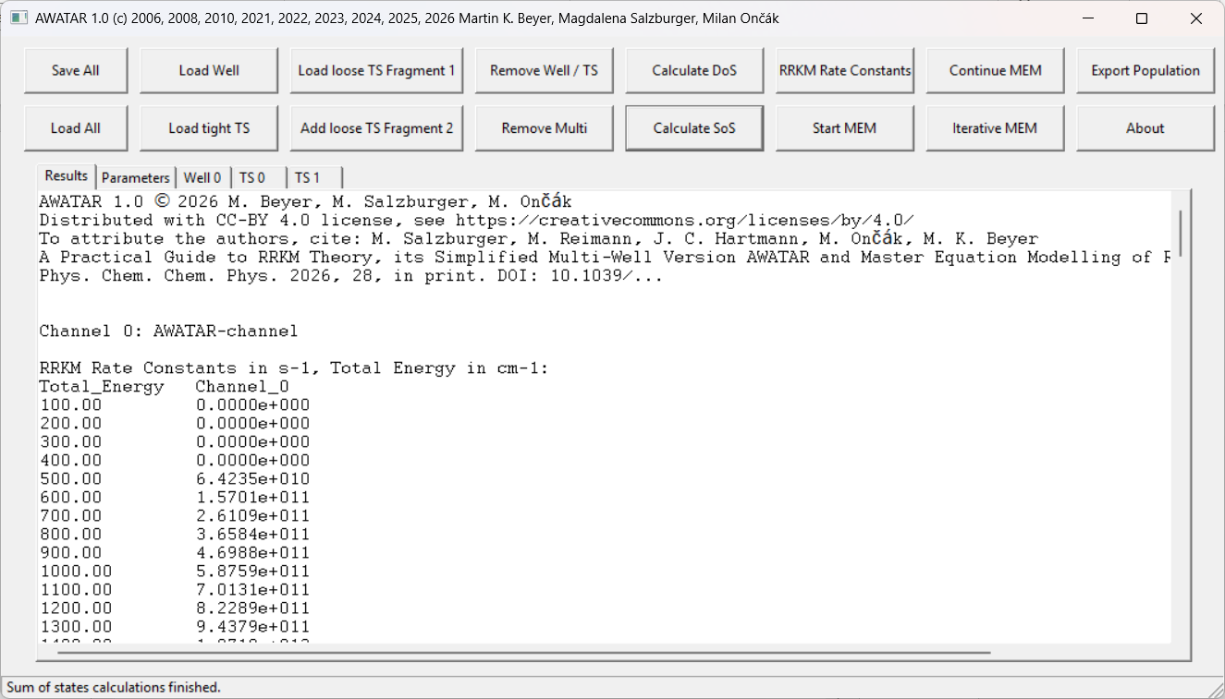
After some general information about program version and license, the defined channels are summarized. In the default case, there is one channel (Channel 0) from all wells to all transition structures, as described within the AWATAR model.⁴ Then, the RRKM rate constants follow: The first row gives the total energy in cm⁻¹ above the global minimum well. All further rows give the resulting RRKM rate constants in s⁻¹ for each defined channel at the available energy. Note, that the RRKM rate constants rise fast with increasing total energy. The RRKM rate constants are zero for the lowest energies (if no transition structure of the respective channel can be reached yet), and get non-zero once the available energy is high enough to reach the lowest transition structure of the channel.
At the bottom of the panel “Results”, the degeneracies and relative energies used in the calculation are printed for all wells and TS.

Options
There are several possibilities to define channels in the panel “Parameters”. Channel definitions are explained in chapter “Reaction channels”.
The steps (Bin size in cm-1) and range of the total energy (Energy range of population in cm-1 ), as well as the energy quantum for the Beyer-Swinehart algorithm (Energy quantum for Beyer/Swinehart in cm-1) can be adapted in the panel “Parameters” in the section “General parameters” (see chapter “General parameters”).
The properties of the wells and TS can be adapted as described in the chapters “Definition of wells”, “Definition of transition structures (TS)”, “Adapting the energy of wells and transition structures” and “Adapting the degeneracy of wells and transition structures”.

Any changes are reflected in the results window only after the button “RRKM Rate Constants” has been used again to recalculate the SoS with the new parameter settings.

Perform Master equation modeling (MEM)
MEM in AWATAR simulates the time evolution of a statistically distributed population of molecules under the influence of environmental black body radiation and a possible additional IRMPD source. It is also possible to simulate the evolution of the population following absorption of a single photon.
The population of the energy levels of all wells is initialized with a Boltzmann distribution at a temperature T defined in the parameter panel. With finite time steps, the change of the population due to photon absorption, photon emission and unimolecular dissociation is modeled. There are two possible options to perform MEM in AWATAR: Real time MEM, to simulate how a population evolves in time, and steady state MEM to determine the steady state population, which is iteratively reached.

Prior to performing MEM it is necessary to:

- define wells and transition structures, following the instructions in chapters “Definition of wells” and “Definition of transition structures (TS)”.

- define reaction channels in the panel “Parameters” (See chapter: “Reaction channels”).

- substitute the word FILENAME in the panel “Parameters” with a name of your choice (See chapter “General parameters”).

- choose the parameters for the MEM simulation in the section “General MEM parameters” in the panel “Parameters” (See chapter: “Definitions for master equation modeling (MEM)”), e.g. the temperature of the environment or the wavelength of an IRMPD source.

- decide, whether you want to perform real time MEM or steady state MEM and follow the instructions in the respective chapter (“Real time MEM” or “Steady state MEM”).

Real time MEM
Following steps 1) to 5) above (see chapter “Perform master equation modeling (MEM)”), a real time MEM simulation is quickly started:

- Define parameters in the section “Real time MEM parameters” in the panel “Parameters”. (See chapter: “Definitions for master equation modeling (MEM)”). E.g. define an initial temperature of the population or an energy input (described as a single photon) at the beginning of the simulation time. Most importantly, write “YES” in the line “Run MEM in real time (YES/NO):”, which is the default.

- It is recommended to save the file prior to starting the calculation using the button “Save all”, since errors in the input panels may cause AWATAR to crash. Another problem is simulation time, which may be excessive. AWATAR currently does not provide an option to interrupt a simulation run, so the only way to stop an excessively long simulation is to kill the program.

- Use the button “Start MEM” to perform real time MEM. An additional console window opens, showing the progress of the calculation. Once the calculation is finished, the results are printed in the panel “Results”. The populations are written to the file filename_pop.txt.

Real time MEM calculation in AWATAR

AWATAR performs MEM as described in our PCCP Tutorial Review.⁹ Note that the MEM calculation relies on RRKM/AWATAR rate constants. These should be calculated before a MEM run and checked for consistency.

Explanation of the information in the console window

The console window looks for example like this:
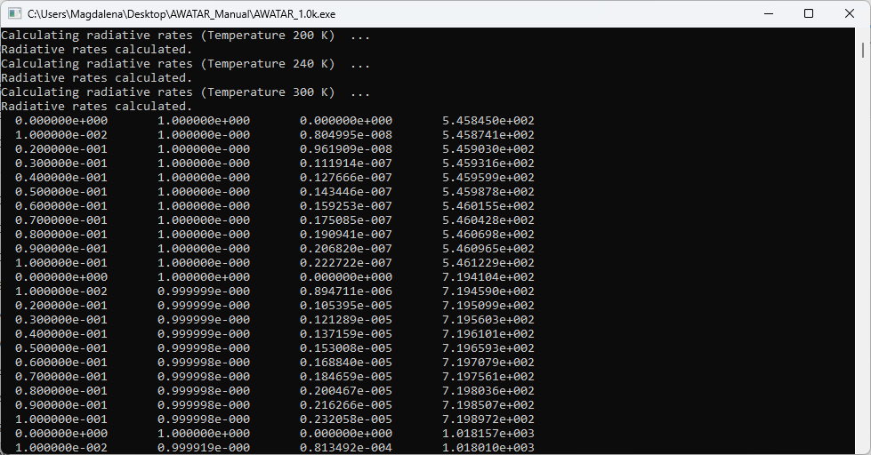
First AWATAR prints for each environmental temperature x the information, “Calculating radiative rates (Temperature x) …”. If any lines starting with “Sum of probabilities” follow, this is a hint that there could be some numerical problems and results should be interpreted with caution. This occurs usually for small systems and may be solved by adapting the parameter “Bin size in cm-1” or the ”Energy quantum for Beyer/Swinehart in cm-1”. After the calculation of radiative rates, AWATAR prints “Radiative rates calculated”.

Next follow the results which will also be printed to the panel “Results”: The first column gives the time in seconds. The second column is the proportion of reactant still intact. The following columns are the proportion of product formed in the respective channel, and the last column is the mean energy of the population in cm⁻¹.

Explanation of the results printed to the panel “Results”

After a real time MEM calculation, the panel “Results” looks for example like this:
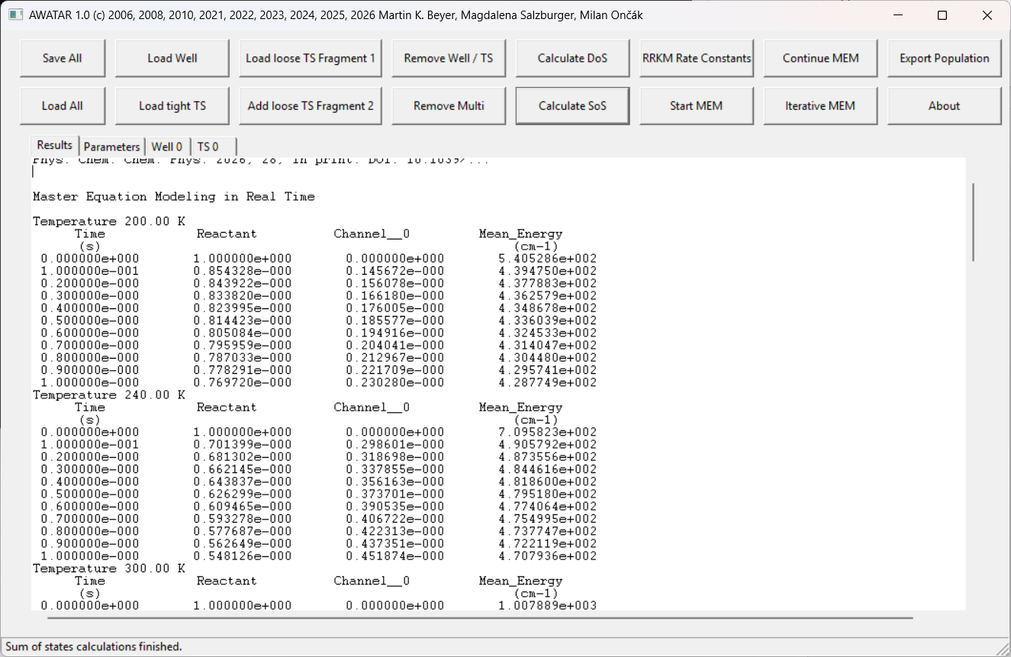
After some general information about program version and license, it is noted that the MEM was performed in real time, and the used environmental temperature is given.
Then, the MEM results are printed in several columns: The first row gives the time in seconds. The second column is the proportion of reactant still intact at the given time. The following columns are the proportion of product formed in the respective channel (if there is only one channel, this is (1 – Reactant)), and the last column is the mean energy of the population in cm⁻¹.

If the warning “Number of active degrees of freedom is not consistent. DO NOT PUBLISH THESE RESULTS!!!” is printed, check the number of active degrees of freedom. It should be the same (n) for all wells and (n-1) for all TS, whereby two dimensional rotors count twice.

Below those main results, the following further Information is printed:
- Degeneracies and energies of wells and TS
- Overview on the defined channels
- RRKM rate constants for each channel
- DoS for each well
- SoS for each TS

The last line notes that the populations are stored in the file filename_pop.txt.

Explanation of the file filename_pop.txt

The population of selected time steps (as defined in the panel “Parameters” in section “Real time MEM parameters”) is written to the file filename_pop.txt, which is stored in the folder where AWATAR is executed, or to the provided path. This file looks for example as follows:

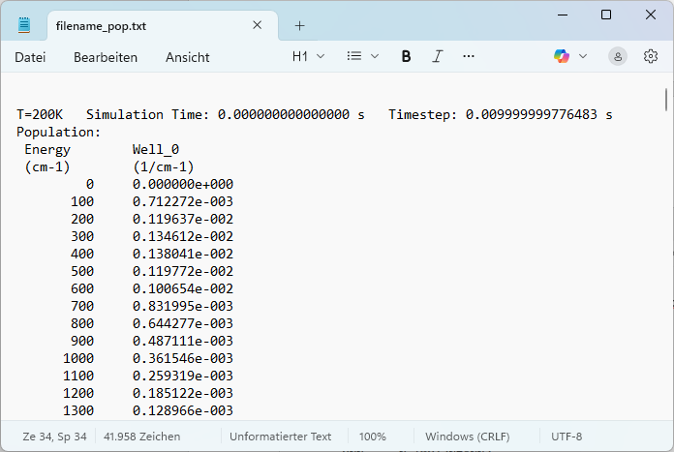

For each written population, the temperature of the environment is given, followed by the simulation time at which the population is taken. Note that the 0 s population reflects the initial Boltzmann distribution, without dissociation events. The finite time step is as well documented. Then the population follows, thereby the energy is given in cm⁻¹ in the first row, the other rows contain the population in 1/cm⁻¹ of each well.

Options

The properties of the wells and TS can be adapted as described in chapters “Definition of wells”, “Definition of transition structures (TS)”, “Adapting the energy of wells and transition structures” and “Adapting the degeneracy of wells and transition structures”.

All other parameters regarding MEM can be adapted in the panel “Parameters”, as described in chapter “Detailed information: The parameter panel”. Note, that it is possible to scale the infrared intensities using the parameter “Scaling of IR intensities”.

After changing the panel “Parameters” or a panel of a well or TS, the button “Start MEM” has to be used again to recalculate the MEM simulation with the new parameter settings.

Steady state MEM
To perform steady state MEM, you have to perform first the general preparation steps (see chapter “Perform master equation modeling (MEM)”), then:

- Set the Parameter “Run MEM in real time” in the panel “Parameters” to NO:
Run MEM in real time (YES/NO): NO

- Adjust the parameters “Minimum time step at 300 K” and “Minimum number of iterations” in the section “Steady state MEM parameters” in the panel “Parameters”. (See section “Steady state MEM parameters” in chapter “Definitions for master equation modeling (MEM)”).

- It is recommended to save the file prior to starting the calculation using the button “Save all”, since errors in the input panels may cause AWATAR to crash. Another problem is simulation time, which may be excessive. AWATAR currently does not provide an option to interrupt a simulation run, so the only way to stop an excessively long simulation is to kill the program.

- Use one of the buttons “Start MEM” or “Iterative MEM” to perform steady state MEM.

- AWATAR asks, whether you want to start your simulation with a new Boltzmann distribution. Click YES, if you have not previously prepared a population by doing a manual iteration (see Options).

- An additional console window opens, showing the progress of the calculation. Each time a new finite time step is reached during the iteration, the current status of the calculation (including the current population) is saved into a file called filename_checkpoint.rrk. Once the calculation is finished, the results are printed in the panel “Results”. The populations for all environmental temperatures and each iterative step are printed in the file filename_pop.txt. The last population for each environmental temperature can also be exported by using the button “Export Population”.

The steady state MEM calculation in AWATAR

AWATAR performs MEM as described in our PCCP Tutorial Review.⁹ Note that the MEM calculation relies on RRKM/AWATAR rate constants. These should be calculated before a MEM run and checked for consistency.

To reach a properly converged population, the used finite time step and the convergence criterion is refined iteratively. For the automatic iteration (if the button “Iterative MEM” is used), the parameters “Minimum time step at 300 K” and “Minimum number of iterations” define the timesteps and convergence criterion. For manual iteration (if the buttons “Start MEM” and “Continue MEM” are used, see Options) the parameters “Finite time step parameter” and “Convergence parameter” are used instead.

Explanation of the information in the Console Window

The console window looks for example like this:
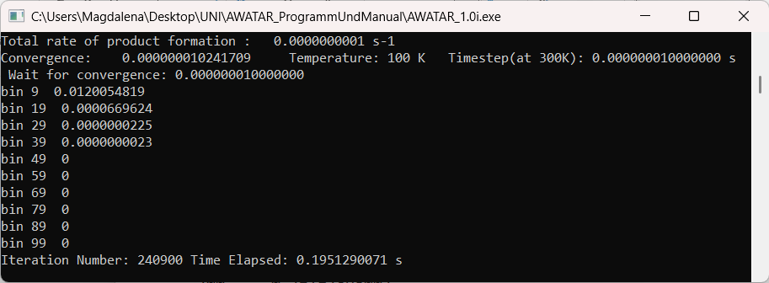
First AWATAR prints for each environmental temperature x the information, “Calculating radiative rates (Temperature x) …”. If any lines starting with “Sum of probabilities” follow, this is a hint that there may be some numerical problems. This occurs usually for small systems and may be solved by adapting the parameter “Bin size in cm-1” or the ”Energy quantum for Beyer/Swinehart in cm-1”. After the calculation of radiative rates, AWATAR prints “Radiative Rates calculated”.

Next follows the current status of the MEM: The current total rate of product formation is given, along with the current convergence, the currently used environmental temperature and current time step. The currently used convergence criterion is given after the text “Wait for convergence”. Below this information follows an overview of the current population. For 10 energy bins, the population is given for each well. (The first number is the population for Well 0, the second number is the population for Well 1 …). If more than ten wells are used, only the population for the first ten wells is printed. It follows the iteration number, and the elapsed time. Once the calculation is finished, AWATAR prints a line starting with “Done.”

If the highest bins are still populated, the population does not fit into the energy range, and a bigger “Energy range of population in cm-1 ” should be used. If most bins are not populated, some computational cost can be saved by decreasing the “Energy range of population in cm-1 ”. Verify that the population looks reasonable and the energy window provides sufficient space for all processes you want to model. E.g. if you define absorption of a 40000 cm⁻¹ photon at t = 0 s, this shifts the population by 40000 cm⁻¹, and the energy range must be large enough to accommodate the thermal population above this energy.

If the MEM calculation takes only a few seconds, it may be, that the population did not converge properly, as only very few iterative steps were done. It may be good to increase the parameter “Minimum number of iterations”.

If the calculation takes very long, it may be helpful to check:
- Are there any “NaN” (Not a Number) instead of an actual number? This means that there are some problems in the input settings, and the calculation will never converge. Restart AWATAR.
- How long does it take until the convergence criterion is reached? The current convergence (printed after the keyword “Convergence”) gets smaller and smaller, until the convergence criterion printed after “Wait for convergence” is reached. Then AWATAR goes on to the next environmental temperature, or the next time step or the next convergence criterion. If the current convergence takes very long to reach the convergence criterion, it may be better to interrupt the calculation and use a smaller number for “Minimum number of iterations”
- The use of many environmental temperatures, many wells, many transition structures, a big “Energy range of population in cm-1 ”, or a small “Bin size in cm-1” increase the computational cost and may therefore be the reason for slow calculations.
- The “Minimum time step at 300 K” defines, how long AWATAR continues to refine the parameters. Once the minimum time step is reached for all temperatures, the calculation finishes.
Note, that the “time step at 300 K” is the finite time step for an environmental temperature of 300 K, ${dt}_{300K}$. Due to the T⁴ dependence of black-body radiation power according to the Stefan-Boltzmann law, AWATAR adapts - for steady state MEM - the used finite time step dt to the environmental temperature T_{amb} using the formula:
$$dt={dt}_{300K}{\left(\frac{300 K}{T_{amb}}\right)}^{4}$$

Explanation of the file filename_checkpoint.rrk

Each time a new finite time step is reached during the iteration, the current status of the calculation (including the current population) is saved into a file called filename_checkpoint.rrk, in the folder where AWARAR is executed or in the provided path (See FILENAME in chapter “General parameters”). If a file with the same name exists already, the old file is overwritten.
The file filename_checkpoint.rrk can be opened by AWATAR using the button “Load All”. This can be useful if the calculation was interrupted manually, because it allows to retrieve the information calculated before the interruption.

Explanation of the results printed to the panel “Results”

The results of a steady state MEM calculation look for example like this:

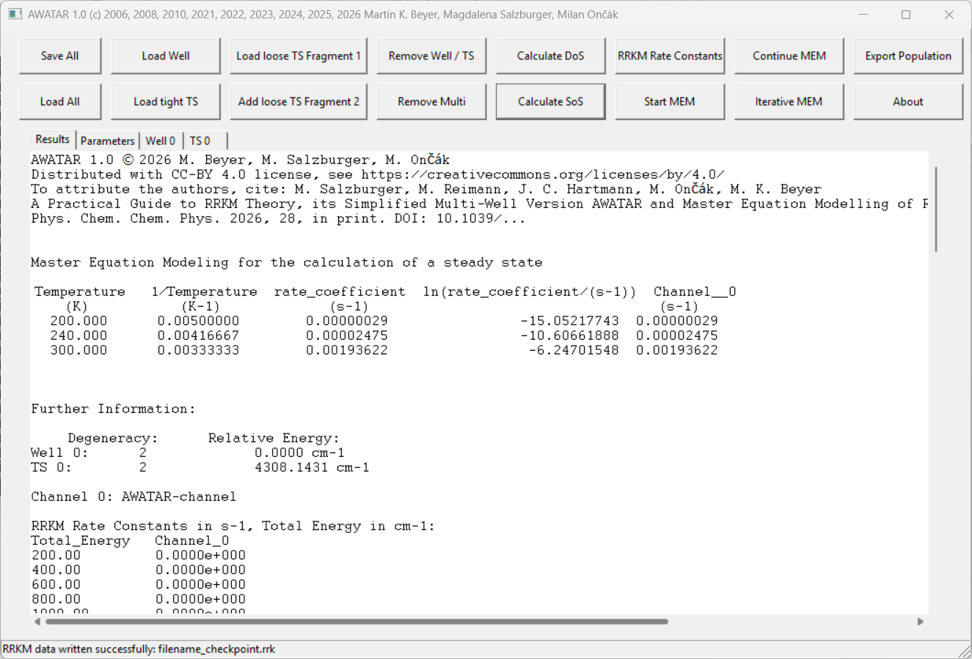

The main results are in the first table: The first row contains the used environmental temperature in Kelvin, the second row is the inverse temperature. Then follows the rate constant in s⁻¹, which is the sum over all channels (third row), and the natural logarithm of the rate constant in the fourth row. All further rows give the rate constant in s⁻¹ for each defined channel separately. The natural logarithm is useful for an Arrhenius plot.

If the warning “Number of active degrees of freedom is not consistent. DO NOT PUBLISH THESE RESULTS!!!” is printed, check the number of active degrees of freedom. It should be the same (n) for all wells and (n-1) for all TS, whereby two-dimensional rotors count twice.

Below those main results, the following further information is printed:
- Degeneracies and energies of the wells and TS
- Overview on the defined channels
- RRKM rate constants for each channel
- DoS for each well
- SoS for each TS

The second but last line contains the information, that the button “Iterative MEM” was used, which finite time step and convergence were reached in the last iterative step and the last number of iterations. This information can be interpreted as follows:
- The last finite time step should correspond to the number defined in the panel “Parameters” by the parameter “Minimum time step at 300 K”.
- The reached convergence varies, depending mainly on the settings for the parameter “Minimum number of iterations”. If the reached convergence is not fine enough, it may help to increase the “Minimum number of iterations”.
- If the last number of iterations is not much higher than the setting for the parameter “Minimum number of iterations”, it may be that the population was not converged properly. It helps to increase the parameter “Minimum number of iterations”.
The last line notes that the populations are stored in the file filename_pop.txt.

Explanation of the file filename_pop.txt

The population of all iterative steps and all temperatures is written to the file filename_pop.txt, which is stored in the folder where AWATAR is executed, or to the provided path. This file looks for example as follows:

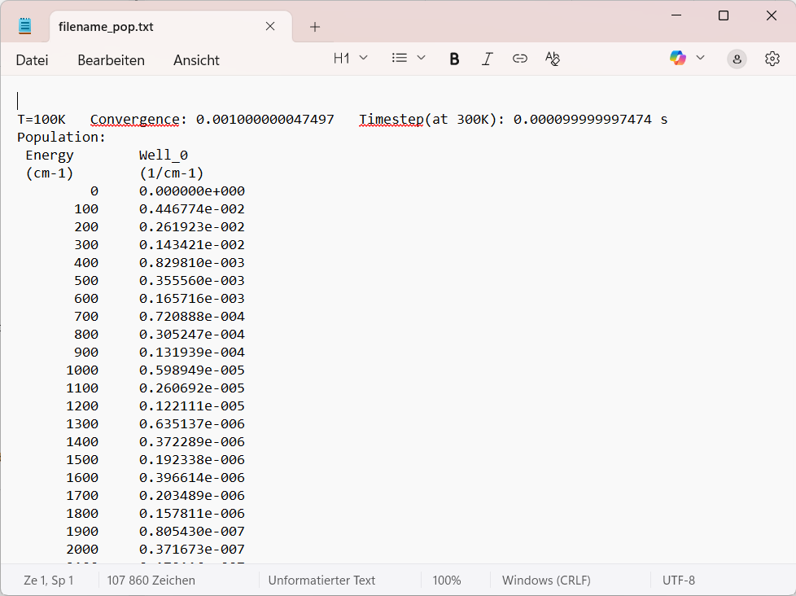

For each written population, the temperature of the environment is given, followed by the reached convergence. The used finite time step at 300 K is as well documented. Then the population follows, thereby the energy is given in cm⁻¹ in the first row, the other rows contain the population in 1/cm⁻¹ of each well at the given energy.

The populations at the bottom of the file filename_pop.txt are the converged populations of the steady state. Those populations can also be retrieved using the button “Export Population”

Using the button “Export Population”

If the button “Export Population” is used, the converged populations for each temperature is copied to the clipboard. Depending on the amount of data, this may take some time. Once AWATAR has copied everything, it prints the line “Done. Populations for all temperatures are copied to the clipboard” in the console window. The content of the clipboard starts for example like this:

T=100K
Energy Well_0
(cm-1) (1/cm-1)
0 0.000000e+000
100 0.537335e-002
200 0.184300e-002
300 0.144421e-002
400 0.754028e-003
500 0.318031e-003
600 0.150426e-003

For each environmental temperature, the environmental temperature is given, followed by the population. Thereby the energy is given in cm⁻¹ in the first columns, the other columns contain the population in 1/cm⁻¹ of each well at the given energy.

As the population is stored when using the button “Save all”, the button “Export Population” can also be used later, after reloading with the button “Load all” a file where an iterative MEM had been performed. The population can e.g. be displayed with your favourite spreadsheet software. It is instructive to analyse the shape of the population. With some experience, you will be able to judge whether a steady-state MEM calculation is properly converged.

Options

The properties of the wells and TS can be adapted as described in chapters “Definition of wells”, “Definition of transition structures (TS)”, “Adapting the energy of wells and transition structures” and “Adapting the degeneracy of wells and transition structures”.

All other parameters regarding MEM can be adapted in the panel “Parameters”, as described in chapter “Detailed information: The parameter panel”. Note, that it is possible to scale the infrared intensities using the parameter “Scaling of IR intensities”.

After changing the panel “Parameters” or a panel of a well or TS, the button “Iterative MEM” has to be used again to recalculate the RRKM rate constants with the new parameter settings.

Manual decreasing of convergence criterion and finite time steps:
Instead of the automatic decreasing of convergence criterion and finite time steps as described above, it is possible to minimize them manually. This allows full control of the stepwise refinement of those parameters. It is useful if you suspect that the automated iterative MEM procedure did not work as desired. Note that we tested the procedure with water clusters exposed to black-body radiation. Other systems may require different parameters. In any rate, it is instructive to perform real-time MEM before steady-state MEM. This provides an idea on the time scale of the radiative processes and how long it takes for the system to dissociate.
To manually converge a steady-state MEM calculation, set the parameters “Finite time step parameter” and “Convergence parameter” in the panel parameters. Then use the button “Start MEM” to simulate the steady state population with the defined finite time step until the convergence parameter is reached. The parameters “Minimum time step at 300 K” and “Minimum number of iterations” are not used when using the button “Start MEM” or “Continue MEM”. Once the calculation is finished, the results are printed to the panel “Results” and the population can be exported using the button “Export Population” or by opening the file “filename_pop.txt”. If of interest, store the current status of the file using the “Save all” button.
Next, refine the parameters “Finite time step parameter” and/or “Convergence parameter” in the panel “Parameters”. Use now the button “Continue MEM”. With this button, the new MEM simulation is initialized with the population calculated before. Again, once the calculation is finished, the results are printed to the panel “Results” and the population can be exported using the button “Export Population” or by opening the file “filename_pop.txt”.
The button “Continue MEM” can be used several times, allowing a manual refinement of the convergence criterion and the used finite time steps. Note, that the file filename_pop.txt is overwritten each time, if the filename is not changed.

Detailed information: The parameter panel
This chapter explains the “Parameters” panel systematically. All text after a semicolon is a comment and ignored when a calculation is performed. For example:
;ProgramVersion AWATAR_1.0
In the following, the rest of the settings in the panel “Parameters” is explained section by section:

General parameters
The section “General Parameters” contains parameters which are relevant for all calculations:

;General Parameters:
The filename is: FILENAME
Frequency Scale Factor: 0.96
Energy range of population in cm-1: 20000
Bin size in cm-1: 100
Energy quantum for Beyer/Swinehart in cm-1: 1
Print lines where results are zero (YES/NO): YES

Substitute the word FILENAME with the name you plan to save the file. During MEM calculations, a file with the name filename_pop.txt containing all populations, and, after usage of the button “Iterative MEM”, a file with the name filename_checkpoint.rrk are generated. Those files are saved to the folder in which the AWATAR_1.0.exe is executed. It is also possible, to provide a path to the folder, where the files should be saved, for example:
The filename is: C:\Users\AWATAR\FILENAME
The Frequency Scale Factor scales vibrational frequencies when reading data from a frequency calculation with Gaussian. This factor has to be set before loading wells or transition structures. A recommendation on which factor should be used (this depends on the used method/basis set), can be found at NIST.⁵
The Energy range of population in cm-1 defines for which energy range above the energy of the global minimum well, the calculation of interest should be performed. For MEM calculation, this range should be set with caution: A big energy range requires more calculation time, but if the energy range is too small, this may lead to cutting the upper part of the population. This can be evaluated, by plotting the populations stored in the file filename_pop.txt. The population should fit well into the energy range, with a reasonable large buffer zone.
The Bin size in cm-1 defines the finite energy elements, in which the energy range is divided. Smaller bins in general increase the accuracy, but also the computational cost. For very small molecules, too small bins may cause numerical problems. It is good practice to test if a change of the bin size within a reasonable range leads to significant change of the results, and optimize the choice for the studied system.
The Energy quantum for Beyer/Swinehart in cm-1 is used for the Beyer-Swinehart counting algorithm. The default is 1 cm⁻¹. For very small systems, a bigger number may help to avoid numerical problems. Smaller values may be chosen for large systems with small rotational constants and low-lying vibrational modes. It is advised to modify this parameter and verify that the results are robust, i.e. they do not change significantly when BS-Quantum is modified by a factor of 2.
If “Print lines where results are zero (YES/NO)” is set to NO, all rows containing only zero values are skipped, when printing RRKM rate constants or the SoS. If the parameter is set to YES, all rows are printed.

Reaction channels
For the calculation of RRKM rate constants and for the performance of MEM, one or more reaction channels have to be active. They define, from which well(s) to which transition structure(s) a reaction (dissociation or isomerization) happens.
The reaction channel section looks like this, allowing three formats:

;Reaction Channels:
Channel 0 Well all TS all
; Channel 0 Well all TS 0 1 2
; Channel 0 Well 0 TS 0

To use other options than the default channel “Channel 0 Well all TS all”, remove the semicolon at the beginning of the respective line, and put a semicolon in front of the line “Channel 0 Well all TS all” instead. If several channels are defined, the first channel is “Channel 0” and all further channels must be numbered consecutively. In the following, the formats are explained:
- AWATAR-approach for one fragmentation channel:⁴
The default option, “Channel 0 Well all TS all” connects all wells and all transition structures via one channel named “Channel 0”. Thus, for the RRKM rate constant calculation, the density of states is calculated by summing the density of states of all wells (“Well all”) and the sum of states is calculated by summing the sum of states of all transition structures (“TS all”). This channel definition is recommended to model the dissociation of clusters to the same product, e.g. loss of a water molecule from a water cluster, if isomerisation is fast compared to dissociation.

- AWATAR-approach for more than one fragmentation channel:²
The second possibility is, to define channels in the format “Channel 0 Well all TS 0 1 2”. For each possible fragment, a separate channel has to be defined (starting with Channel 0, then Channel 1, …), indicating the respective transition structures for each channel.
This channel definition is used for a parent molecule decaying in more than one fragment, as in the example of CO₄⁻(H₂O)₂, which can either lose a water molecule or a CO₂ molecule.²
If for example the transition structures TS 0 and TS 2 contain fragments for water loss and the transition structure TS 1 contains fragments for CO₂ loss, then the Reaction Channels section should be modified as follows:

; Reaction Channels:
; Channel 0 Well all TS all
Channel 0 Well all TS 0 2 ; This is the water loss channel
Channel 1 Well all TS 1 ; This is the CO2 loss channel
; Channel 0 Well 0 TS 0

- Channels defined from one well to one TS:
Finally, a channel can be defined from one specific Well to one specific TS, by using a channel definition in the format “Channel 0 Well 0 TS 0”. Several channels can be defined, each connecting a well with a transition structure. The Reaction Channels section could then look for example like this:

; Reaction Channels:
; Channel 0 Well all TS all
; Channel 0 Well all TS 0 1 2
Channel 0 Well 0 TS 0
Channel 1 Well 1 TS 1
Channel 2 Well 1 TS 2

Definitions for master equation modeling (MEM)

This section contains parameters, which are needed for MEM, but not for other calculations (calculation of DoS, SoS, or RRKM rate constants). The three parts of this section “General MEM parameters”, “Real time MEM parameters” and “Steady state MEM parameters” are explained in the following:

General MEM parameters

The parameters given in “General MEM parameters”, are needed for both real time MEM and iterative MEM. The “General MEM parameters” starts with the “BIRD parameters”. Those parameters define the environmental temperature(s) and thus the blackbody radiation to which the population of molecules is subjected to.

The BIRD parameters section looks like this:
; BIRD parameters:
Number of temperatures in loop: 3
; Manual list for temperatures in loop: 150.00 215.34 250.50
Loop starts with temperature in K: 200
Loop ends with temperature in K: 300
Proportion on solid angle of ICR cell window: 0.002
Temperature of ICR cell window in K: 288

AWATAR was developed to simulate the blackbody radiation in an ICR cell, where the cell walls can be cooled or warmed to a temperature of interest, except for a small part of the solid angle, which is at room temperature. Typically, experiments are repeated at different temperatures. This experimental setup is reflected in the default settings of the section “BIRD parameters”. To perform MEM for only one temperature covering the whole solid angle, change the “BIRD parameters” section as follows:
; BIRD parameters:
Number of temperatures in loop: 1
Manual list for temperatures in loop: x
Loop starts with temperature in K: 200
Loop ends with temperature in K: 300
Proportion on solid angle of ICR cell window: 0
Temperature of ICR cell window in K: 288
whereby x is the temperature of interest in Kelvin. Note, that the semicolon in front of the line “Manual list for temperatures in loop” has been removed. The parameters “Loop starts with temperature in K” and “Loop ends with temperature in K” are ignored if the line with the “Manual list for temperatures in loop” is active.

The MEM calculation can also be performed several times in one calculation, varying the environmental temperature. Therefore, augment the Number of temperatures in loop and list all needed temperatures in the line Manual list for temperatures in loop, for example:
Number of temperatures in loop: 3
Manual list for temperatures in loop: 200 225 250
The Number of temperatures in loop has to match the numbers of entries in the Manual list for temperatures in loop.

Alternatively, AWATAR can calculate several temperatures such, that they are equally spaced in an Arrhenius plot, where the x-axis is the inverse temperature. In this case, put a semicolon in front of the line “Manual list for temperatures in loop” (as it is the case for the default parameters panel) and use instead the parameters “Loop starts with temperature in K” and “Loop ends with temperature in K” to define the temperature range. For example, to calculate 7 datapoints in the range of 250 K to 350 K:
; BIRD parameters:
Number of temperatures in loop: 7
; Manual list for temperatures in loop: 150.00 215.34 250.50
Loop starts with temperature in K: 250
Loop ends with temperature in K: 350

The last two parameters of the section “BIRD parameters” can be used to add a part of the solid angle, which is not at the same temperature than the rest. For example,
Proportion on solid angle of ICR cell window: 0.002
Temperature of ICR cell window in K: 288
sets 0.2% of the solid angle to a temperature of 288 K. Note, that this temperature stays the same, if the MEM is performed several times for different environmental temperatures as discussed above.

The next part of the “General MEM parameters” are the “IRMPD parameters”: This part looks like this:
; IRMPD parameters:
Rate of Photon absorption for Well all in s-1: 0
; Rate of Photon absorption for Well 0 3 7 in s-1: 0
IRMPD photon energy in cm-1: 0

The default is, that there is no infrared light source included. To model IRMPD, provide the photon energy in cm⁻¹ and the rate of photon absorption in s⁻¹ . The rate of photon absorption can be either defined for all wells, using “Rate of Photon absorption for Well all in s-1”, or well specific, using (if needed several times), the line “Rate of Photon absorption for Well 0 3 7 in s-1”. For example:
Rate of Photon absorption for Well 0 in s-1: 1.3
Rate of Photon absorption for Well 1 2 in s-1: 0.5
If for one well several rates of photon absorption are defined, only the last one is considered.

Finally, there is the parameter “Finite time step parameter”:
Finite time step parameter: 0.00001
This parameter determines the used finite time step dt used in the calculation of the MEM, if the buttons “Start MEM” or “Continue MEM” are used, i. e. for real time MEM or for manual iteration for steady state MEM. The “Finite time step parameter” should be as small as possible, but smaller steps increase the computational cost. For the calculation of the steady state of a population AWATAR can decrease the used finite time step iteratively (see chapter “Steady state MEM”) in order to reach finite time steps at the scale of picoseconds. This can be done manually, by using the parameter “Finite time step parameter” or automatically, then the parameter “Minimum time step at 300 K” is used instead to define the used finite time steps.

Note, that for real time MEM the parameter “Finite time step parameter” is equal to the finite time step dt for all temperatures. For steady state MEM however, the “Finite time step parameter” is the finite time step for an environmental temperature of 300 K, dt_{300K}. Due to the T⁴ dependence of black-body radiation power according to the Stefan-Boltzmann law, AWATAR adapts the finite time step dt to the environmental temperature T_{amb} using the formula:
$$dt={dt}_{300K}{\left(\frac{300 K}{T_{amb}}\right)}^{4}$$

Real time MEM parameters

This section contains all parameters needed only for real time MEM and looks like this:

;Real time MEM parameters:
Run MEM in real time (YES/NO): YES
Total simulation time in seconds: 1
Interval for data point export in seconds: 0.01
Export population after n data points: 10
Initial Cluster Temperature in K: 0
Photon energy at t = 0 in cm-1: 0

For the performance of real time MEM, the parameter “Run MEM in real time” has to be set to YES. If the steady state of a population should be calculated (steady state MEM), write NO instead. The “Total simulation time in seconds” defines the simulation time length of the real time MEM simulation. During the simulation, the reactant and product intensity are written to the panel “Results”, whereby the parameter “Interval for data point export in seconds” defines, how often a data point should be written. Additionally, after n data points the population is written to the file filename_pop.txt. Thereby n is defined by the parameter “Export population after n data points”.

It is also possible to define an initial cluster temperature, using the parameter “Initial Cluster Temperature in K”, allowing to model heating or cooling of a thermalized ensemble, for example after electrospray ionisation. If this parameter is set to 0 (this is the default), the initial temperature is assumed to be equal to the environmental temperature. It is not advisable to use very low initial cluster temperatures, as this causes numerical problems.

Additionally, AWATAR allows the simulation of the evolution of a thermalized population after absorption of a single photon at the beginning of the simulation time. Therefore, define the energy of the absorbed photon using the parameter “Photon energy at t = 0 in cm-1”.

Steady state MEM parameters

The steady state MEM parameters section defines parameters needed only for steady state MEM (manual or automatic iteration) and looks like this:

;Steady state MEM parameters:
Minimum time step at 300 K: 12 ; give x for 10^(-x) s
Minimum number of iterations: 500
Convergence parameter: 0.0001

The first two parameters of this section, “Minimum time step at 300 K” and “Minimum number of iterations” are needed, if the button “Iterative MEM” was used, while the “Convergence parameter” is only relevant for the manual iteration (see Options of chapter “Steady state MEM”).

During the automated iteration (when the button “Iterative MEM” is used), AWATAR decreases the convergence criterion and the finite time step. Thereby, the “Minimum time step at 300 K” defines, which finite time step should be reached. The default, 12, means, that in the end of the calculation, a time step ${dt}_{300K}$ of picoseconds (10⁻¹² s) is reached. The calculation starts always with 10^{‑4} s, therefore it is not possible to use values lower than 4 for this parameter.

Note, that the “time step at 300 K” is the finite time step for an environmental temperature of 300 K, ${dt}_{300K}$. Due to the T⁴ dependence of black-body radiation power according to the Stefan-Boltzmann law, AWATAR adapts - for steady state MEM - the used finite time step dt to the environmental temperature T_{amb} using the formula:
$$dt={dt}_{300K}{\left(\frac{300 K}{T_{amb}}\right)}^{4}$$

The “Minimum number of iterations” defines, when the convergence criterion should be refined. In the beginning of the iteration, the convergence criterion is 0.001. After each cycle it is checked, how many iterations where needed to reach the convergence criterion. If less iterations than the “Minimum number of iterations” where needed, the convergence criterion is decreased. Otherwise, the finite time step is decreased instead. The parameter “Minimum number of iterations” has to be higher than 100. Low values may lead to an improper convergence, while high values increase the computational time.

For the manual iteration, this stepwise decreasing of the convergence criterion and the finite time step is done manually. In this case, the parameters “Convergence parameter” and the “Finite time step at 300 K” are used.

Fit parameters

The section “Fit parameters” contains parameters which can be used to fit the simulated rate coefficients to an experimental Arrhenius plot. By changing the energies of the transition structures, the gradient of the resulting MEM-Arrhenius plot can be varied, while changing the infrared intensities results in an offset in the Arrhenius plot. Finally, fitting the degeneracies may help to fit the relative rate coefficients for different reaction channels. The section “Fit parameters” looks like this:

;Fit parameters:
; 1) Adapt Energies
; Absolute energy of: TS 0, TS 1, TS 7 is: 3750.50
; Offset to Energy of all TS in cm-1: 100.00
; Offset to Energy of: TS 0, TS 1, TS 7 in cm-1: 100.00
; 2) Adapt infrared intensities
Scaling of IR intensities: 1
; 3) Adapt Degeneracies:
; Well-Degeneracy-List: 5 4 1 2 1 1 1 7 8 9 10 33
; TS-Degeneracy-List: 7 18 4 9 8 67 8
; Increase degeneracy of: TS 0, TS 3, TS 24 by factor: 1.0
There are three options to adapt or set the energy of transition structures in the parameters panel. (See chapter “Adapting the Energy of wells and TS” for options to modify the energy in the panels of wells/TS) To activate the respective line, the semicolon at the beginning of the line has to be removed.
- Absolute energy of: TS 0, TS 1, TS 7 is: 3750.50
This overwrites the energy defined by the panels of the respective transition structures. All transition structures defined by this line (here “TS 0”, “TS 1” and “TS 7”, have an energy (including zero-point energy) of 3750.5 cm⁻¹ above the global minimum well, independent of any energies, offsets or vibrational frequencies written in their panels. Note, that there is a space between “TS” and the number of the transition structure. An arbitrary number of TS can be defined by this line, and the line can be used several times, to define different transition structures. For example:
Absolute energy of: TS 0 is: 3750.50
Absolute energy of: TS 1 is: 3680.22
Absolute energy of: TS 3, TS 4 is: 2880.56
The energy of transition structures not defined here (in this example “TS 2”), is still defined by the respective panel.

- Offset to Energy of all TS in cm-1: 200.00 This adds an energy of 200 cm⁻¹ to the energy of all transition structures. The number can be exchanged freely, and also negative numbers are possible to lower the total energy.

- Offset to Energy of: TS 0, TS 1 in cm-1: 251.5
This adds an energy of 251.5 cm⁻¹ to the defined transition structures, in this example to “TS 0” and “TS 1”. The list of named TS can be as long as needed, and the line can also be copied to add offsets to other transition structures, for example:

Offset to Energy of: TS 0, TS 1 in cm-1: 251.5
Offset to Energy of: TS 3 in cm-1: -221.76
Offset to Energy of: TS 0, TS 9, TS 7 in cm-1: 250.00

In the example above, there are two offsets added to TS 0, so the energy of TS 0 will be augmented in total by 501.5 cm⁻¹
The parameter “Scaling of IR intensities” scales the infrared intensities for all vibrational modes of all wells with the factor provided. This can account for example for the error induced by the harmonic approximation.
The following options allow to adapt or set the degeneracy of wells or transition structures in the parameters panel (see chapter “Adapting the degeneracy of wells and transition structures” for options to modify the degeneracy in the panels of wells/TS). To activate the respective line, the semicolon “;” in the beginning of the line has to be removed.
- Well-Degeneracy-List: 7 1 6
The degeneracy of each well is multiplied with the corresponding entry of the “Well-Degeneracy-List”. In the example above, the degeneracy of “Well 0” is multiplied with 7, the degeneracy of “Well 1” is multiplied with 1 and degeneracy of “Well 2” is multiplied with 6. The length of the list has to match the number of wells.

- TS-Degeneracy-List: 7 8
Analogous to the “Well-Degeneracy-List”, the degeneracy of each TS is multiplied with the corresponding entry of the “TS-Degeneracy-List”. The length of the list has to match the number of transition structures.

- Increase degeneracy of: TS 0, TS 3, TS 24 by factor: 0.5
This increases the degeneracy of the respective transition structures by the given factor. This option can be useful to change the contribution of different dissociation channels, i.e. the product branching ratio. The list of TS can be as long as needed, and the line can also be copied to change the degeneracy of other transition structures, for example:

Increase degeneracy of: TS 0 by factor: 0.5
Increase degeneracy of: TS 1, TS 3 by factor: 1.3
Increase degeneracy of: TS 2 by factor: 1

Description of generic quantum chemical input file
Natively, AWATAR reads only vibrational frequency output files created with the Gaussian program package. However, only a few lines are actually read in and the output of most other quantum chemical programs can easily be converted into a compatible format. An example for such a generic AWATAR input looks like this:
Charge = ? Multiplicity = 2
Rotational symmetry number 1.

Frequencies -- -1887.0805 535.5161 736.5635
IR Inten -- 6042.4191 38.2998 202.9080
Frequencies -- 850.6753 1067.4810 3642.2773
IR Inten -- 191.8761 295.9299 145.5042

...

Rotational temperatures (Kelvin) 11.76953 0.48138 0.47210
Rotational constants (GHZ): 245.23725 10.03041 9.83686

Thermal correction to Energy= 0.018789
Sum of electronic and thermal Energies= -1855.447479
The file contains the spin multiplicity (here a doublet) and the rotational symmetry number of the molecular point group (which is the number of symmetry elements that represent proper rotations, here 1 such as for C₁). Frequencies are given in cm⁻¹, IR intensities in km/mol. Three values per line should be given as shown above. The imaginary frequency of a transition structure is designated with a negative sign. “…” denotes additional frequency / intensity data.
Rotational constants are given in GHz and the corresponding rotational temperatures in K. The electronic energy is read in as the difference between the thermal energy correction and the sum of electronic and thermal energies. This is convenient for reading the Gaussian output of MP2 or CCSD calculations. The input file above thus corresponds to an electronic energy of -1855.466268 Hartree. It is perfectly valid to set the thermal correction to zero and give the electronic energy directly. Note that AWATAR uses zero-point corrected energies, but calculates the zero-point correction from the frequencies. The zero-point corrected energy can also be set in the parameter window for any Well or TS, which overrides this input. However, when the file is read, energies must be there.

Acknowledgements
AWATAR is the result of a long development process, started in 2006, with significant breaks. For the initial work at TU Berlin, MKB acknowledges financial support through a Heisenberg Fellowship from the Deutsche Forschungsgemeinschaft, grant no. BE2505/3-1. Work in Innsbruck was supported in part by the Austrian Science Fund, grant DOIs 10.55776/W1259 (MS, MKB), 10.55776/P35407 (JCH, MKB), 10.55776/PAT3834224 (MS, MKB), 10.55776/ESP662 (MR) and 10.55776/P35013 (MO).

References
(1) Salzburger, M.; Ončák, M.; van der Linde, C.; Beyer, M. K. Simplified Multiple-Well Approach for the Master Equation Modeling of Blackbody Infrared Radiative Dissociation of Hydrated Carbonate Radical Anions. J. Am. Chem. Soc. 2022, 144, 21485–21493.
(2) Salzburger, M.; Hütter, M.; van der Linde, C.; Ončák, M.; Beyer, M. K. Master equation modeling of blackbody infrared radiative dissociation (BIRD) of hydrated peroxycarbonate radical anions. J. Chem. Phys. 2024, 160, 134304.
(3) Hütter, M.; Schöpfer, G.; Salzburger, M.; Beyer, M. K.; Ončák, M. Master equation modeling of water dissociation in small ionic water clusters: Ag⁺(H₂O)_{n}, n = 4-6. RSC Adv. 2024, 14, 22185–22194.
(4) Hartmann, J. C.; Madlener, S. J.; van der Linde, C.; Ončák, M.; Beyer, M. K. Magic Cluster Sizes of Cationic and Anionic Sodium Chloride Clusters Explained by Statistical Modelling of the Complete Phase Space. Phys. Chem. Chem. Phys. 2024, 26, 10904-10918.
(5) NIST Standard Reference Database 101. Precomputed vibrational scaling factors. https://​cccbdb.nist.gov​/​vibscalejustx.asp (accessed April 17, 2025).
(6) Gilbert, R. G.; Smith, S. C. Theory of Unimolecular and Recombination Reactions; Physical Chemistry Texts; Blackwell Scientific Publications: Oxford, 1990.
(7) MOLDEN a visualization program of molecular and electronic structure. https://www.theochem.ru.nl/molden/.
(8) Beyer, T.; Swinehart, D. F. Algorithm 448: Number of Multiply-Restricted Partitions [A1]. Commun. ACM 1973, 16, 379.
(9) Salzburger, M.; Reimann, M.; Hütter, M.; Hartmann, J. C.; Ončák, M.; Beyer, M. K. A Practical Guide to RRKM Theory, its Simplified Multi-Well Version AWATAR and Master Equation Modelling of Radiative Processes. Phys. Chem. Chem. Phys. 2026, submitted.

