Report on the route of synthesis for an API product – Glycopyrrolate.

Submitted by Alberdina Mariya Alexandrovna, Kazakhstan, Aturay, mariyaalberdina1980@outlook.com

Content of the Report
1. Introduction 3
1.1 Chemical Structure. 3
CAS Registry Number: 596-51-0 3
2D structure 3
3D structure 4
Names for the compound: 4
1.2. Characteristics 5
1.3. Uses 6
1.4. Side effects. 6
2. Different ways for synthesis of Glycopyrrolate. 7

1. Introduction

Below report is devoted to Glycopyrrolate or Glycopyrronium bromide, his properties, ways to obtain, his use in medicine, possible side effects from use of drugs with Glycopyrronium bromide as active pharmaceutical ingredient and other aspects of the theme.

1.1 Chemical Structure.

CAS Registry Number: 596-51-0

2D structure

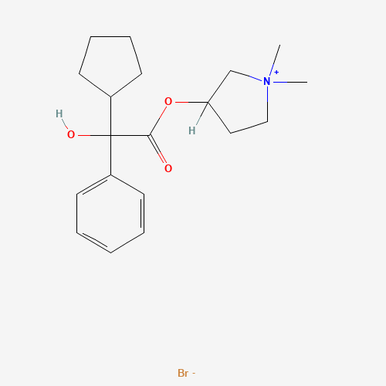

3D structure
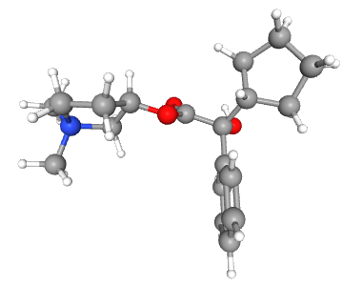

Names for the compound:

- Pyrrolidinium, 3-[(2-cyclopentyl-2-hydroxy-2-phenylacetyl)oxy]-1,1-dimethyl-, bromide (1:1)
- 3-Hydroxy-1,1-dimethylpyrrolidinium bromide α-cyclopentylmandelate
- Pyrrolidinium, 3-hydroxy-1,1-dimethyl-, bromide, α-cyclopentylmandelate
- Pyrrolidinium, 3-[(cyclopentylhydroxyphenylacetyl)oxy]-1,1-dimethyl-, bromide
- AHR-504
- 1,1-Dimethyl-3-hydroxypyrrolidinium bromide α-cyclopentylmandelate
- Glycopyrrolate
- Glycopyrronium bromide
- β-1-Methyl-3-pyrrolidyl-α-cyclopentylmandelate methobromide
- Robinul
- Glycopyrronium
- Tarodyl
- Asecryl
- Gastrodyn
- Nodapton
- Robanul
- Tarodyn
- Glycopyrrolate bromide
- Copyrrolate
- NSC 250836
- NSC 251251
- NSC 251252
- NVA 237
- Seebri
- Glycopyrrone bromide
- Qbrexza
- Cuvposa
- Sialanar
- Seebri Breezhaler
- Enurev Breezhaler
- Tovanor Breezhaler

Additional ones:

- glycopyrronium bromide
- Glycopyrronii bromidum
- Robinal
- Seebri Neohaler

1.2. Characteristics
Molecular formula: C19H28BrNO₃ · Br
Molecular weight 398.3 g/mol
Melting Point 192.5 °C
Soluble in organic solvents: ethanol, DMSO, dimethyl formamide, which should be purged with an inert gas. The solubility in these solvents is approximately 30 mg/ml.
Storage of the drug should be in a cool, dry area protected from light before administration.

1.3. Uses
Glycopyrrolate has been widely used as a preoperative medication to inhibit salivary gland and respiratory secretions. The most frequent reasons for administering anticholinergics include producing an antisialagogue effect, creating a sedative and amnesic effect, and preventing reflex bradycardia. Anticholinergics are not predictably effective in increasing gastric fluid pH or decreasing gastric fluid volume. Glycopyrrolate is among the most commonly used anticholinergic medications.

- It is used perioperatively as a muscarinic receptor antagonist.
- The topical formulation of glycopyrrolate is indicated to treat primary axillary hyperhidrosis in nine and older patients.
- It is also helpful to reduce severe or chronic drooling in pediatric patients with neurologic conditions, such as cerebral palsy. The intravenous formulation of glycopyrrolate classically works to reverse vagal reflexes and bradycardia intraoperatively and reverse the muscarinic effects of cholinergic agents such as neostigmine or pyridostigmine.
- Glycopyrrolate may be administered to reverse the neuromuscular blockade due to nondepolarizing muscle relaxants postoperatively and is frequently used in conjunction with neostigmine, a cholinesterase inhibitor.
- Various oral inhalation formulations of glycopyrrolate are indicated for the long-term maintenance treatment of airflow obstruction in patients with chronic obstructive pulmonary disease (COPD).
Most frequently, clinicians use glycopyrrolate to reduce pharyngeal, tracheal, bronchial, and sialagogue effects preoperatively; decreased secretions are the desired effect during anesthesia when a tracheal tube is in place. A blockade of reflexive vagal cardiac inhibition reflexes during intubation and anesthetic induction may also occur.
Glycopyrrolate's primary mechanism of action is the blockage of acetylcholine's effects at the parasympathetic sites in various tissues. This blockage primarily occurs in the central nervous system, smooth muscle, and secretory glands. It also reduces the rate of salivation by preventing the stimulation of the acetylcholine receptors themselves. Glycopyrrolate does not cross the blood-brain barrier or the placenta. It has a slower diffusion rate relative to other anticholinergic drugs such as atropine and scopolamine.

1.4. Side effects.
Glycopyrronium reduces the body's ability to sweat. Therefore,it may cause hyperthermia and heat stroke in hot environments.
Adverse reactions after glycopyrrolate use may include anticholinergic symptoms such as mydriasis, hyperthermia, tachycardia, and cardiac arrhythmia. They may also include blurred vision, constipation, cycloplegia, dry mouth, dry skin, flushing, photophobia, urinary retention, xerophthalmia, headaches, and diarrhea.
Glycopyrrolate may affect the patient's ability to perform tasks requiring mental alertness. In addition, the medication may induce drowsiness or blurred vision, which is exacerbated by the consumption of alcohol.
In the general population, usage may increase the risk of confusion, hallucinations, and anticholinergic effects
Usage also requires close monitoring in patients with hepatic impairment. For example, patients may not be able to operate heavy machinery safely.
Use glycopyrrolate with caution in patients with a hiatal hernia and reflux esophagitis. It can worsen prostatic hyperplasia symptoms and/or bladder neck destruction as it may increase urinary retention. In ulcerative colitis cases, a high dose may inhibit intestinal motility and worsen toxic megacolon or ileus symptoms. Glycopyrrolate administration is contraindicated in patients with ulcerative colitis. Since gastrointestinal motility may decline, constipation or intestinal pseudo-obstruction may occur.
Because of its quaternary structure, glycopyrrolate cannot cross the blood-brain barrier and is almost devoid of the central nervous system and ophthalmic activity. Potent inhibition of salivary gland and respiratory tract secretions is the primary rationale for using glycopyrrolate as a premedication. Heart rate usually increases after intravenous administration but not intramuscular.

2. Different ways for synthesis of Glycopyrrolate.

Intermediates for Glycopyrronium bromide are:
Hydrogen bromide, hydrobromide, bromane, Acide bromhydrique, Anhydrous hydrobromic acid ,Hydrogen monobromide ,HBR, Hydrobomic Acid, BROMOHYDRIC ACID.
First intermediate - Cyclopentylmagnesium bromide, or Bromo(cyclopentyl)magnesium, or Bromocyclopentylmagnesium.

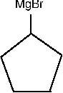

Second intermediate Phenylglyoxylic acid, or α-Oxobenzeneacetic Acid, or 2-Oxo-2-phenylacetic Acid, or 2-Oxo-2-phenylethanoic Acid, or Benzoylformic Acid, or α-Ketophenylacetic Acid. It is a colorless or pale yellow solid with a melting point of 64–66 °C and is moderately acidic.
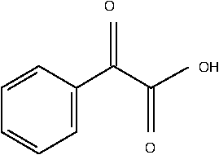

Third one is mandelic acid, or (RS)-Mandelic acid, (±)-Mandelic Acid, DL-Mandelic acid, Racemic mandelic acid

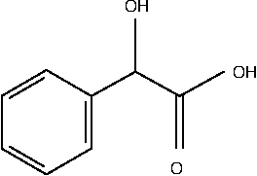

Synthesis of Phenylglyoxylic acid:
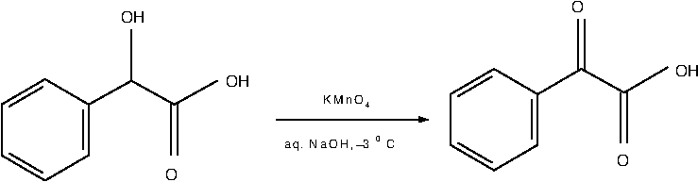

Storage of the drug should be in a cool, dry area protected from light before administration. Promptly discard unused solution as it is unstable at a pH greater than 6.

1. Conventional and more potentially harmful and dangerous synthesis of Mandelic Acid from benzaldehyd.
The first reaction is “one-pot” substitution reaction – where benzaldehyde reacts with sodium bisulfate and we obtain intermediate - Benzaldehyde sodium bisulfite (reaction 1). Then sodium bisulfite part substitutes by CN component from sodium cyanide (reaction 2).
Now that we have mandelonitrile, we should carry out the reaction of hydrolysis in excess of concentrated HCl to rise the yield of mandelic acid (reaction 3). After 12 hours of hydrolysis in cold, we should hot the mixture to remove water and excess of HCl. After heating for five to six hours it is advisable to cool the mixture and filter the ammonium chloride and mandelic acid mixture that separates. The filtrate is then evaporated to dryness. This residue is added to the solid material obtained before. The product is deeply colored and must be dried in the air and light for at least twenty-four hours. The mixture of ammonium chloride and mandelic acid should be washed twice with portions of cold benzene. The insoluble portion is transferred to a suction funnel and sucked dry.
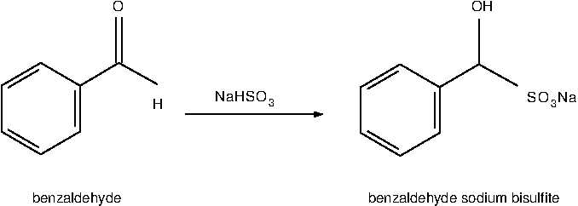
Reaction 1 (Substitution)

Reaction 2 (Substitution)
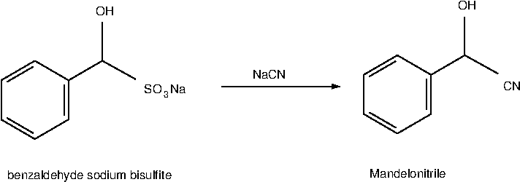
Reaction 3 (Hydrolysis)
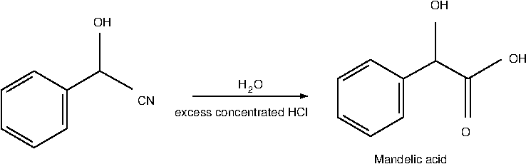

Either of two methods may be used to extract the mandelic acid from the ammonium chloride.
(A) Extraction with Benzene—The mandelic acid is separated from the ammonium chloride by extraction with hot benzene. This is best done by dividing the solid mixture into ten approximately equal parts. One of these portions is placed in a flask boiling benzene. After a few minutes the hot benzene solution is decanted through a suction funnel. The filtrate is cooled in an ice bath and the mandelic acid that crystallizes is filtered with suction. The benzene is returned to the extraction flask containing the residue from the first extraction, and a new portion of the ammonium chloride-mandelic acid mixture is added and extracted as before. The process is repeated until the mandelic acid is completely removed from the ammonium chloride.
The yield of pure white mandelic acid melting at 118° is 229–235 g. (50–52 per cent of the theoretical amount based on benzaldehyde).
(B) Extraction with Ether .—The solid mixture is shaken for ten minutes with excess of ether. The ether solution is decanted through a suction filter and the solid thrown onto the filter and pressed dry. The solid is then returned to the reactor and shaken with half of previous ether again. This mixture is filtered by suction and the solid washed twice on the filter with portion of ether. Each portion is allowed to drain through the filter several times while the solid is kept porous with a spatula. The combined ether filtrate is then filtered through an ordinary funnel. The ether solution is placed in fractionating system with toluene added. The mixture is distilled on a steam bath through an efficient fractionating column as long as it distils easily. The temperature of the vapor rises to about 70°. The mixture is then heated over a free flame until the temperature in the column is 95° for getting residuals of distillate. The residual liquid is poured while still hot into a large beaker immersed in ice water. The liquid is stirred until it has become a thick crystal mush. The cooling is continued for two hours with occasional stirring so as to bring the temperature down to 5–10°. The mixture is filtered with suction and the solid pressed dry. It is then thoroughly washed on the filter with toluene in several portions.
The yield is the same as that obtained by method (A).

As the conclusion for this method I should say that this synthesis should be made under good hood due to hydrogen cyanid obtained, moreover toluene and benzene are very toxic either. The ether is a little less toxic, but harmful too.

2. Synthesis of mandelic acid from acetophenone.

The first reaction – is a chlorination reaction, where hydrogen in methyl group of acetophenone is replaced by chlorine atoms and dichloroacetophenone is obtained (reaction 4). Chlorination is continued until an excess of the halogen has been absorbed at temperature around 60 ⁰C. This requires about 5 hours - completion of the reaction is indicated by the development of a yellow color. The reaction mixture is poured over crushed ice. The mixture is stirred several times and allowed to stand until the ice has melted. The dichloroacetophenone, which separates as a heavy lachrymatory oil, is removed. The yield is 90–97%. This product, containing only a few per cent of water and acetic acid, is pure enough for the preparation of mandelic acid. It may be purified by adding benzene, removing the water and benzene by distillation, and fractionally distilling the residual oil under reduced pressure. There is obtained 80–94% of a colorless oil boiling at 132–134°/13 mm. (142–144°/25 mm.).

The next step – to obtain Mandelic acid. We should fulfill a reaction between dichloroacetophenone and sodium hydroxide dissolved in water. The solution of sodium hydroxide is warmed to 60°, vigorous stirring is begun, and we now add dichloroacetophenone from previous step (either crude or distilled) from the dropping funnel. The dichloroacetophenone is added slowly at first so that the temperature does not exceed 65°. The addition requires about 2 hours. Stirring is continued for 1 hour longer while the temperature is maintained at 65° by means of a water or steam bath. The process is described by reaction 5 with obtaining benzaldehyde sodium carbonate. After addition of hydrochloric acid (reaction of hydrolysis – 6) the solution is extracted with ether. The extraction is continued until no more material is obtained.
The ether is removed from the ether extracts by distillation, and the residue of crude mandelic acid is dried by warming it on a steam bath under the vacuum of a water pump. Benzene should be added, and the mixture is distilled. The acid in the residual mixture is brought completely into solution with addition of ethanol. The hot solution is then filtered through a warm Büchner funnel, and the filtrate is cooled overnight at 6°.The total yield is (85–90% based on the dichloroacetophenone, or 76–87% based on the acetophenone). The white crystalline product melts at 115–117° .

Reaction 4 - (Chlorination)

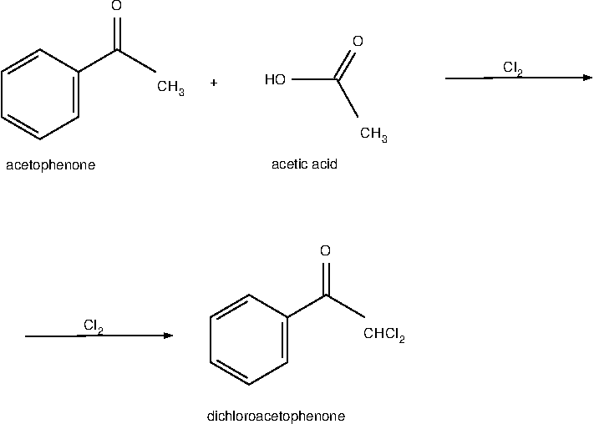
Reaction 5 - (Substitution)

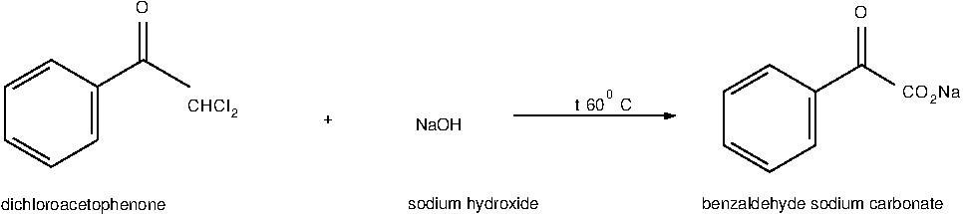
Reaction 6 - (Hydrolysis)
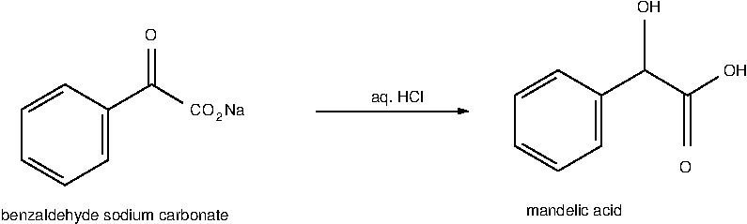
This method is more preferable as there is no so harmful and dangerous compounds and intermediates as in the conventional method with cyanide.

API (Active Pharmaceutical Ingredient),
amount of the active ingredient,
pharmaceutical excipients
APIs are broadly categorized into two types – synthetic and natural. Synthetic APIs are further classified into innovative and generic synthetic APIs, based on the type of synthesis used.

Storage conditions and main characteristics

Photosensitive (yes, no)
Melting temperature, degree Celsius
Soluble at
Molar mass, g/mol
Need humidity protection (yes, no)
Color acceptable
Consistence acceptable

https://pubchem.ncbi.nlm.nih.gov/compound/11693#section=Structures
https://pubchem.ncbi.nlm.nih.gov/compound/11693#section=3D-Conformer
https://commonchemistry.cas.org/detail?cas_rn=596-51-0
https://pubchem.ncbi.nlm.nih.gov/compound/11693#section=Depositor-Supplied-Synonyms
https://pubchem.ncbi.nlm.nih.gov/compound/11693
https://commonchemistry.cas.org/detail?cas_rn=596-51-0
https://cdn.caymanchem.com/cdn/insert/16498.pdf
https://www.ncbi.nlm.nih.gov/books/NBK526035/
https://www.ncbi.nlm.nih.gov/books/NBK526035/
https://www.trc-canada.com/product-detail/?P327504
https://en.wikipedia.org/wiki/Phenylglyoxylic_acid
https://www.sigmaaldrich.com/KZ/en/product/aldrich/m2101
http://orgsyn.org/demo.aspx?prep=cv1p0241
https://orgsyn.org/demo.aspx?prep=CV1P0336
https://orgsyn.org/demo.aspx?prep=cv3p0538

