CHEM0012 – Polymers Coursework
Format and Rules
All three questions should be answered in prose (continuous sentences). Students are limited to 600 words per question, not including figures. Work beyond the word limit will not be marked. References (if used) and AI statement do not count towards the word limit and should be put at the end of your submission. Submit as doc/docx/odf format only. Do not submit as PDF.
You must answer all questions. Marking is anonymous - PLEASE DO NOT PUT YOUR NAME OR STUDENT NUMBER ANYWHERE ON THE COURSEWORK (including in the file name)
50 marks are available overall.
- 45 marks are available for the three questions (15/20/10, respectively)
- 4 marks available for quality of writing
- 1 mark for providing an AI statement (see below)

Use of AI
This assessment is classified as Section 2- use in an assistive role for AI usage. You can use AI for this coursework, but it is not encouraged. Firstly, you must read UCLs policy on the use of AI here: https://www.ucl.ac.uk/teaching-learning/generative-ai-hub/three-categories-genai-use-assessment
At the end of your coursework, you must supply an AI statement, beginning with “I have read and understand the UCL policy on Three categories of GenAI use in assessment.” If you do not understand the policy, please let me know in advance of the deadline. For the rest of your AI statement:
- If you don't use AI you must add the statement "AI was not used in the production of this coursework"
- If you do use AI then you need to give a further 300-word commentary of how you used AI including
  - The type of AI used
  - How you have amended the AI results
  - How you have integrated AI results into your answers
Students who do not provide an AI in the requested format will not be awarded the AI statement mark, and students who do not provide any AI statement are at risk of the coursework not being accepted for marking.

Deadline
Your answers must be submitted by 13th December 2026 at 12:00 (i.e. noon) via Moodle Assignment.
Please note, due to the nature of anonymous marking, everyone who submits after the original deadline will be initially have a late penalty applied. A list of students with pre-approved extensions, including DAPs, will be provided to me afterwards and penalties will be revoked at that juncture for those students. Afterwards, I will email all students with a remaining late penalty to provide an opportunity to provide proof of an extension, in case it was missed. Please do not contact me regarding late penalties before receiving this email from me.

Follow-up
A breakdown of your marks will be provided to you as an annotated version of your submission. When scores are released and after all extended submission deadlines have elapsed (likely in the new year), I will upload a document on Moodle in the Polymer section containing model answers, a summary of common mistakes with corrections, and information on marking for transparency.

- Given a powder of pre-synthesised poly(vinyl acetate), how can you make a bulk solid with high tensile strength? For each step, explain how it will influence mechanical properties. [15]

- A sample of isotactic polypropylene is heated above its melting temperature (170 °C) and very slowly cooled to below its glass transition temperature (-15 °C) down to -50 °C, before being measured by DSC using 3 cycles, one after another

  - The sample is heated quickly (50 °C min⁻¹) from -40 °C to 250 °C before cooling quickly (50 °C min⁻¹) back to -40 °C
  - The sample is then heated slowly (1 °C min⁻¹) from -40 °C to 250 °C before cooling slowly (1 °C min⁻¹) back to -40 °C
  - The sample is finally heated quickly (50 °C min⁻¹) from -40 °C to 700 °C before cooling quickly (50 °C min⁻¹) back to -40 °C

Schematically draw the DSC curves for the three cycles (a-c) each on a separate set of axes. Below each, give a brief description of the thermogram features and an explanation of what is happening at a molecular level, comparing to previous cycles where appropriate. [20]
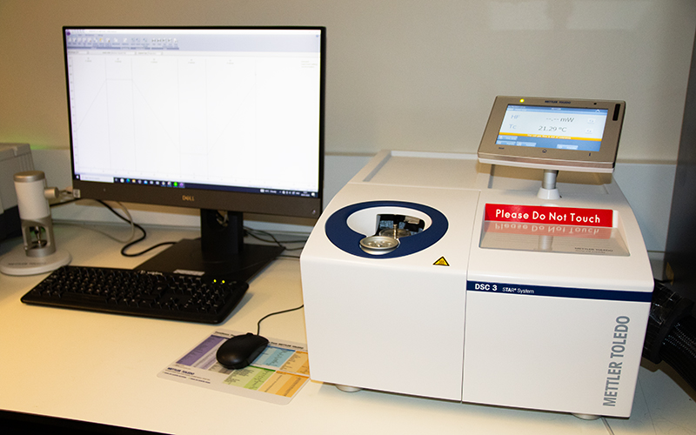
DSC (Mettler Toledo DSC 3) at UCL

- Poly(ethylene glycol) is said to be “more soluble” in water than cellulose acetate. Why is this true (or not), and how might you be able to tell? [10]

Answers

- Given a powder of pre-synthesised poly(vinyl acetate), how can you make a bulk solid with high tensile strength? For each step, explain how it will influence mechanical properties. [15]

- Compress while heating to 300-400 C to increase crystallinity and remove voids between parts of the powder
- Addition and removal of a solvent will then help further consolidate the system
- Irradiate with intense UV radiation (100-222 nm) to encourage crosslinking between chains
- Add a compositing material, extra marks for selecting rubber, for example as described in Abbasi-Soureshjani, Mohammad, et al. "Improved fatigue resistance of thermoplastic elastomer-filled natural rubber composites." Materials Chemistry and Physics 340 (2025): 130824. https://www.sciencedirect.com/science/article/pii/S0254058425004705

- A sample of isotactic polypropylene is heated above its melting temperature (170 °C) and very slowly cooled to below its glass transition temperature (-15 °C) down to -50 °C, before being measured by DSC using 3 cycles, one after another

  - The sample is heated quickly (50 °C min⁻¹) from -40 °C to 250 °C before cooling quickly (50 °C min⁻¹) back to -40 °C
  - The sample is then heated slowly (1 °C min⁻¹) from -40 °C to 250 °C before cooling slowly (1 °C min⁻¹) back to -40 °C
  - The sample is finally heated quickly (50 °C min⁻¹) from -40 °C to 700 °C before cooling quickly (50 °C min⁻¹) back to -40 °C

- The first cycle will show a small Tg due to the previous slow heating rate causing a high crystal content and low amorphous content. It will also
- The rapid cooling will lead to cracking of the polymer, moving it away from the thermocouple, preventing accurate measurements in temperature. The heat flow intensity (y-axis) will be significantly smaller than the first cycle.
- The final cycle has a high temperature which will melt the polypropylene and restore its behaviour to that of the original cycle. An endotherm of melting will be seen above the 250C maximum of previous cycles

- Poly(ethylene glycol) is said to be “more soluble” in water than cellulose acetate. Why is this true (or not), and how might you be able to tell? [10]
- It is always true. PEG can form hydrogen bonds
- PEG is therefore used in medical applications for its improved biocompatibility
- The solubility of both polymers can be tested by centrifugation, with higher Mz polymers leaving solution and precipitating
- Cellulose acetate can be made more soluble by hydrolyzing the acetate groups, exposing hydroxyls which can hydrogen bond in water. Refer to Kamide, Kenji, and Masatoshi Saito. "Cellulose and cellulose derivatives: Recent advances in physical chemistry." Biopolymers (2005): 1-56. https://link.springer.com/chapter/10.1007/BFb0023331

