|  |  |
| --- | --- |
| Job Name: | Sage Live partner assets |
| Client Name & Organisation: | Aliénor Basile - Sage |
| Brief Written by: | Aliénor Basile |
| Budget: | TBC by internal agency |
| Date of Brief: | 5th January 2017 |
| Launch/Event Date: | January 2017 |

|  |  |  |
| --- | --- | --- |
| Job Title | Name | Approved Y/N |
| Category Campaign Director | Joe Edwards |  |
| Category Partner Campaign Manager | Aliénor Basile | Y |
| VP Partner Marketing | Patrick Hannah |  |

**Purpose**

What campaign, creative idea or event is this copy a part of?

----------------------------------------------------------------------------------------------------------------------------

The purpose is to be able to supply partners with assets they can use to promote Sage Live. Partners will also need to understand how to use the assets and be given guidance around their use, to ensure they are most effective when going to market and there is some governance around the use of the assets supplied.

**Environment**

Where will the assets be used? Web, email, social etc.? Please provide template if available?

----------------------------------------------------------------------------------------------------------------------------

The assets will be used across various partner channels (see Core Assets), the playbook will be used to ensure the partners understand how to best execute the assets and adhere to any governance around logo use etc. Guidelines for logo and partners information now defined by the Brand team, cf. examples below in appendix.  
Core assets will be available via the Global Partner Portal (Sage Partner Community) when available in each country (April 2017). In the meantime, partners will continue to use their current local portals and/or DAM, Freedman’s platform (our external transcreation agency).

Most of our partners don’t have nurturing tools for developing campaigns; they need simple templates and assets to launch.

**Core Assets**

What are the key assets that need to be included?

----------------------------------------------------------------------------------------------------------------------------

Those assets have already been produced for the Sage Live campaigns launched by Sage (mostly CBC teams) to NCM prospects. The idea here is to re-use them and make less than 10% of amends so that partners can use them to generate demand:

* **1 ebook** (to be gated by the partner on his web page): provided in html, partner logo and certification spaces to add, add a space for partner content and T&C mentions. To be slightly re-worded as it is written by the partner himself. Name of the asset to tweak: “SageLive_Brochure_ManageYourBusiness”.
* **1 responsive demand generation email** promoting the LP: provided in html, partner logo and certification spaces to add, add a space for partner content and T&C mentions. To be slightly re-worded as it is written by the partner himself. Name of the asset to tweak: “16SG10001_Partner Marketing Refresh_email_090816”.
* **1 static website banner** (jpeg): resize the image of the demand gen email header (see above) in 1200*300 and add the certification logo space, and a call-to-action redirecting towards the ebook. Feel free to change the layout if required.

***Note: every assets, whether they are PDFs of htmls or any kind of formats, have to be responsive: “Mobile first”.***

**Who is reading this?**

Not just their position, but how they behave and the decisions they make. Is there an existing relationship?

----------------------------------------------------------------------------------------------------------------------------

The target here is mainly Sage resellers, but it can also be developers, integrators, ISV, etc.

Partner profile: not very specialized on marketing strategies. Some of them work with external agencies, some don’t even have marketing teams.

In terms of Business, Partners globally represent around 40% of sales. Highest contribution is 80% and lowest 22%. Partners are very important for some Tier 1 countries.

**Objective**

What are we trying to convince them of? What do we want them to believe?

----------------------------------------------------------------------------------------------------------------------------

Partners need to feel they are part of the Sage marketing strategy.  
Specifically, they will be looking for quality assets and will have a need to understand how they will be used - which channel, which target... They need to be convinced that these assets will help them improve/ease their marketing efforts and will drive new customer acquisition.

**Tone of Voice**

What is the writing style? Authoritative, friendly, factual, hard-sell, vibrant, journalistic? Or is this being written in someone else’s name?

----------------------------------------------------------------------------------------------------------------------------

Trust, rigour, confidence, personable.

**Principles**

Always make sure your message aligns with the Sage values:

* Customers first
* Velocity
* Do the right thing
* Innovate
* Make a difference

**Formats**

Include all relevant formats material.

----------------------------------------------------------------------------------------------------------------------------

Banner:

* Jpeg
* Source art work files (PSD)
* Word document (source copy)
* PDF of visuals

eDM:

* PSD
* HTML
* Word document (source copy)
* Hi res imagery

Ebook:

* PDF
* Word document (source copy)
* Hi res imagery
* Source art work files (PSD)

**Deadlines**

What is needed and when?

----------------------------------------------------------------------------------------------------------------------------

Sage Live partner assets (US master versions) need to be ready by end of January 2017 – after approval by Aliénor Basile. Transcreation will then occur in February when the internal Agency Services will have delivered everything. 2 weeks are needed for transcreation.

**Appendix**

How assets should look like?

----------------------------------------------------------------------------------------------------------------------------

**EBOOK:**

Page 1:

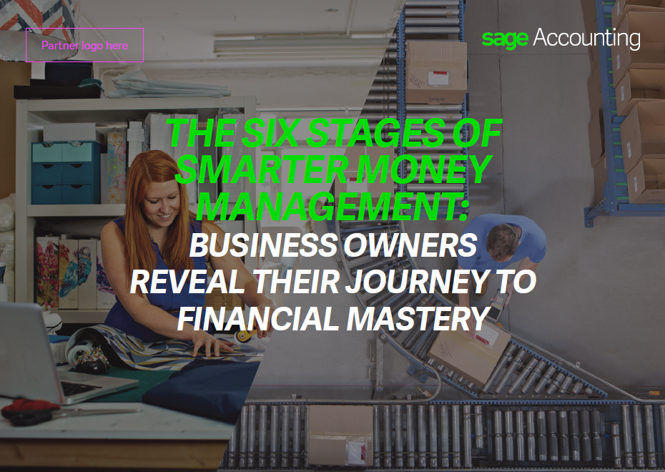

Page 2:

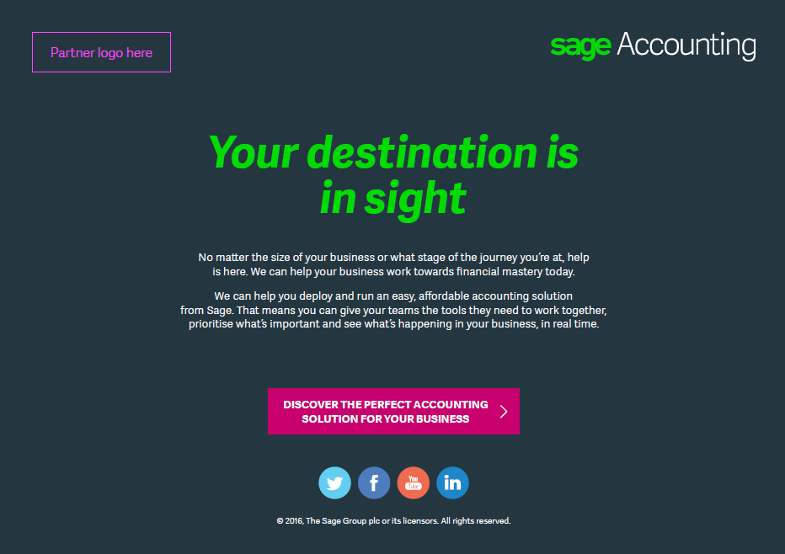

**Demand gen email:**

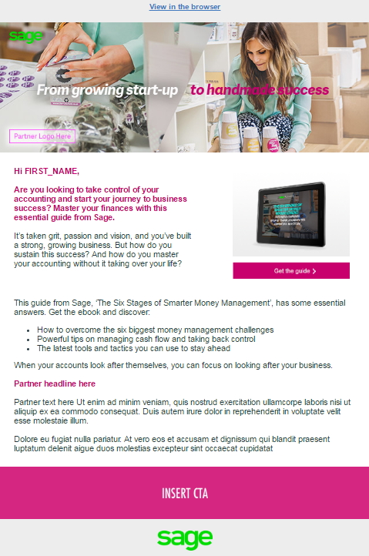

**Static web banner:**

