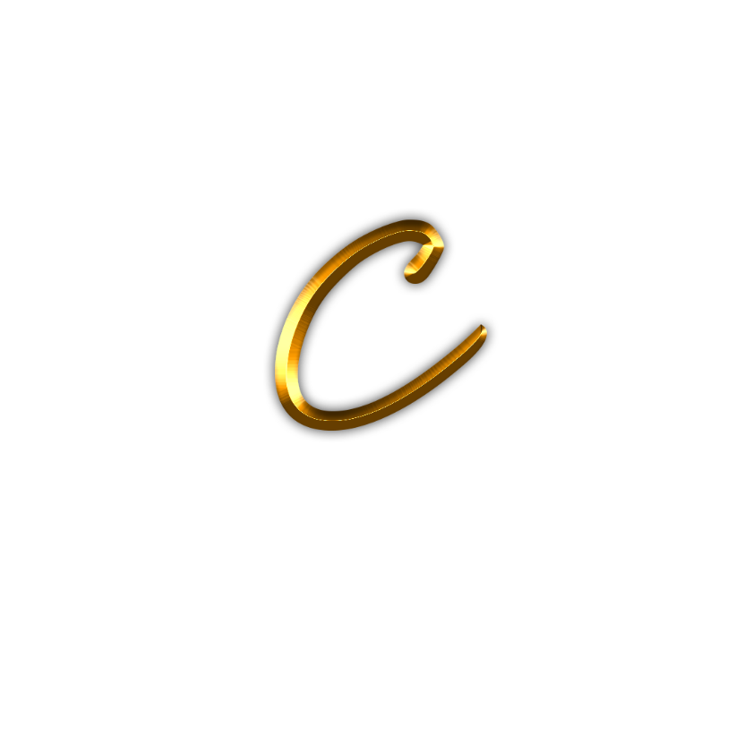

Chemmangat Edits

Work Samples

Chemmangat Edits

Here are some of my works that you might want to see.

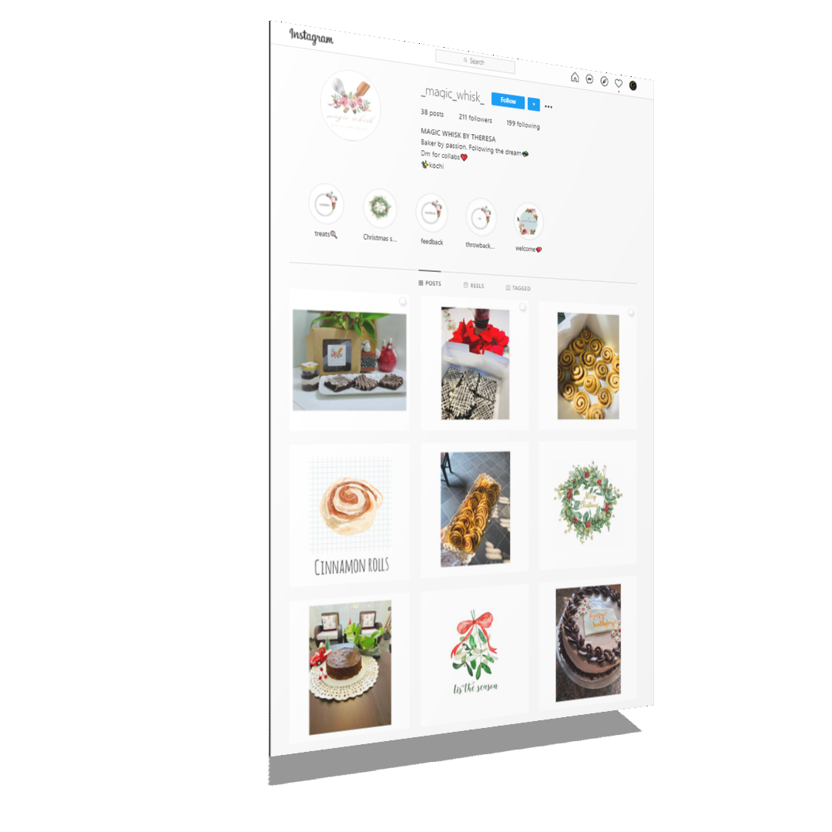

Logo Design for an Online Bakery Shop

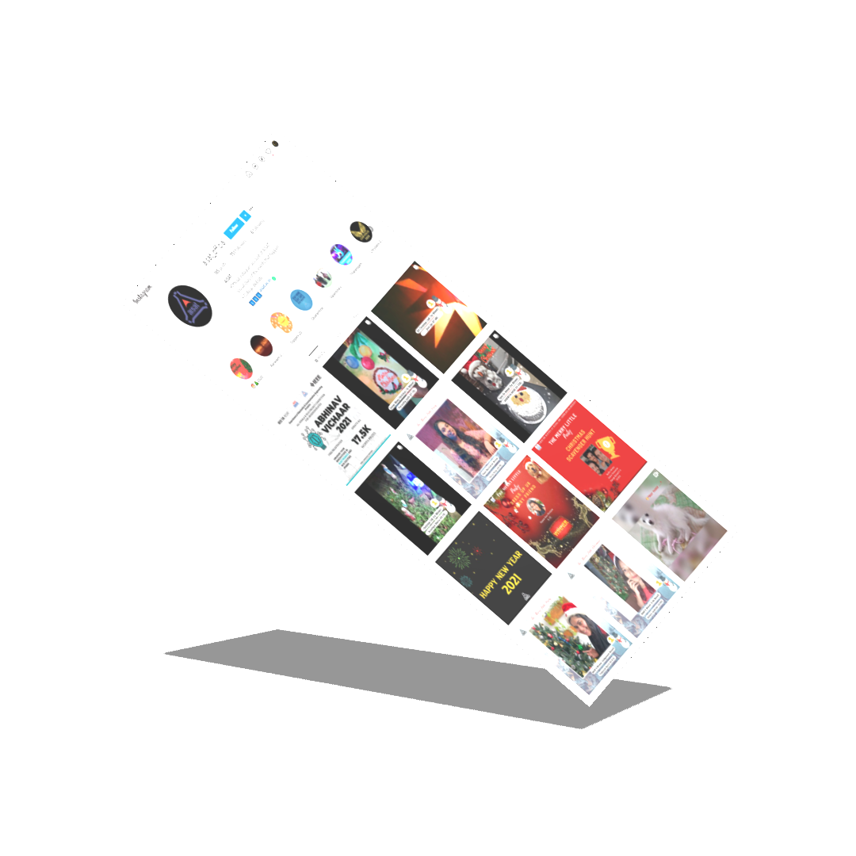Editor for AISAT Engineering College

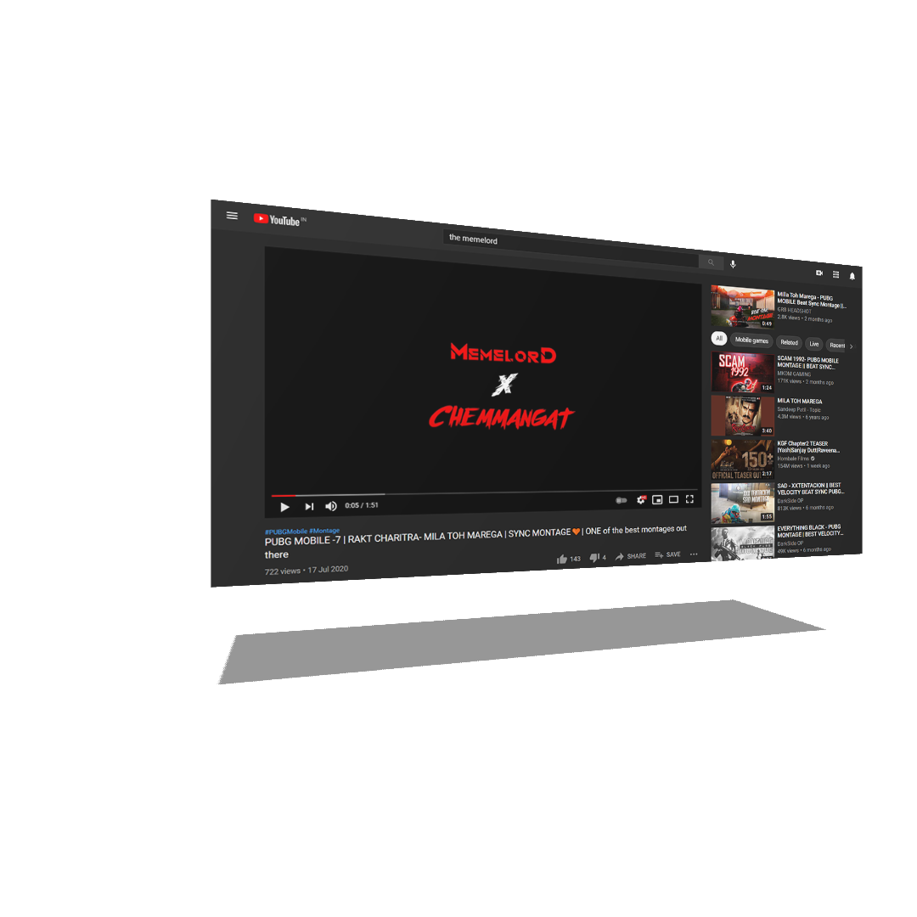Gaming Montage (PUBG) for a client.

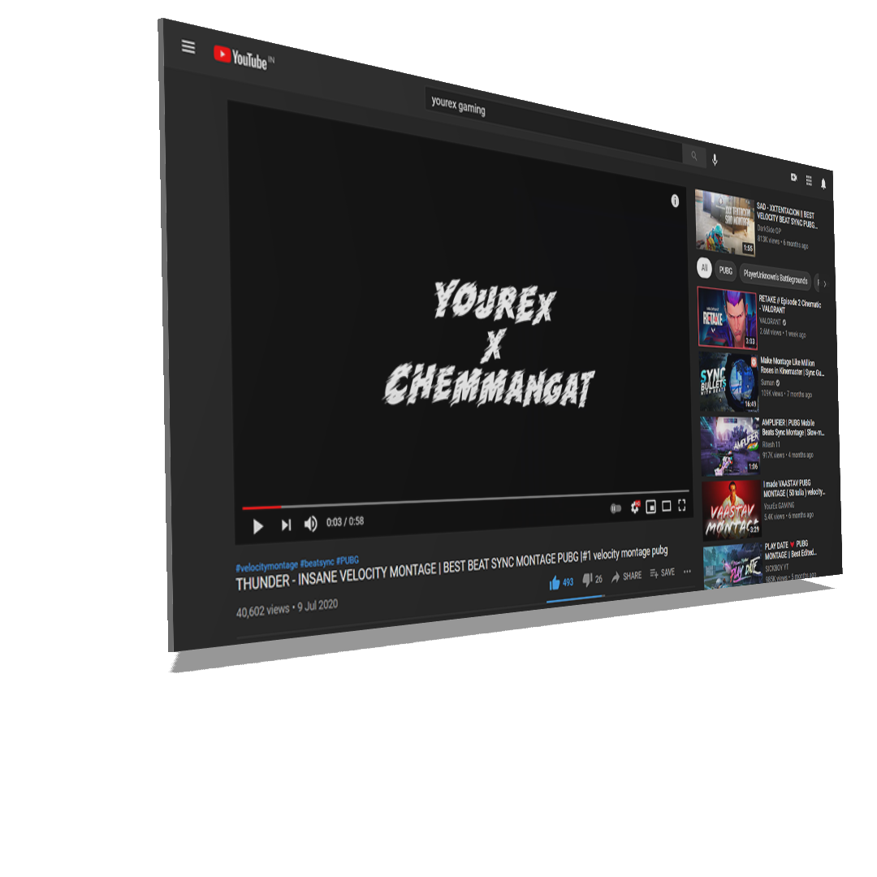

Gaming Montage (PUBG) with 40,000 views and counting!