单位：kg，mm

1. 连杆1

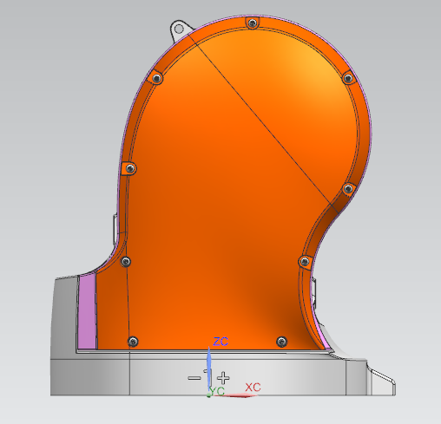

电机型号：MSMJ042S1V

减速器型号：LCS-32-80-C-I

质量 = 5.324788784

质心

Xcbar, Ycbar, Zcbar = 8.635534249, 22.078877642, 105.579222681

惯性矩 (WCS)

Ix, Iy, Iz = 124372.233581975, 103483.894473137, 51346.058739032

惯性矩（质心）

Ixc, Iyc, Izc = 62421.249509926, 43731.539045188, 48353.264985372

1. 连杆2

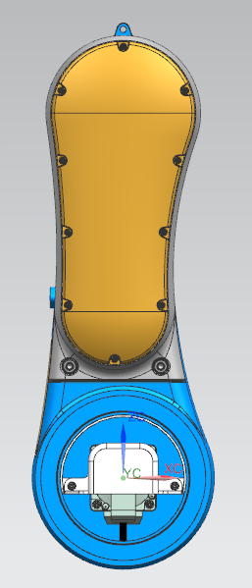

电机型号：MSMJ042S1V

减速器型号：LCSG-32-100-C-I

质量 = 13.902462570 kg

质心

Xcbar, Ycbar, Zcbar = -1.427352938, 36.871700154, 131.572207346

惯性矩 (WCS)

Ix, Iy, Iz = 609901.450272270, 559771.853230650, 83127.866942130

惯性矩（质心）

Ixc, Iyc, Izc = 350331.796753717, 319074.583221930, 64198.835445944

1. 连杆3

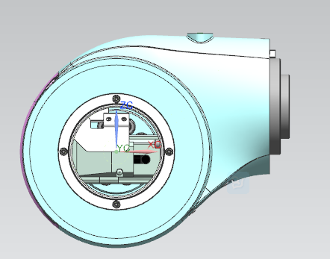

电机型号：MSMJ022S1V

减速器型号：LCS-25-80-C-I

质量 = 4.273511023 kg

质心

Xcbar, Ycbar, Zcbar = 56.447045603, 2.955757942, 18.979434468

惯性矩 (WCS)

Ix, Iy, Iz = 10844.546910660, 35790.862876629, 31771.027625045

惯性矩（质心）

Ixc, Iyc, Izc = 9267.811780595, 20634.907787233, 18117.136564792

1. 连杆4

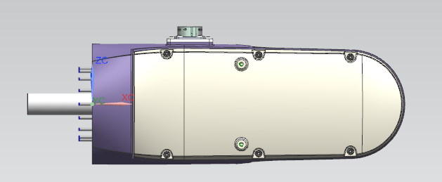

电机型号：MSMD012S1V

减速器型号：LHS-20-50-C-III

实际减速比：80

质量 = 2.827166087 kg

质心

Xcbar, Ycbar, Zcbar = 118.698230181, 8.891989709, -1.877809956

惯性矩 (WCS)

Ix, Iy, Iz = 7240.257104052, 56998.737225731, 59760.129242341

惯性矩（质心）

Ixc, Iyc, Izc = 7006.751134353, 17156.062254650, 19703.886439354

1. 连杆5

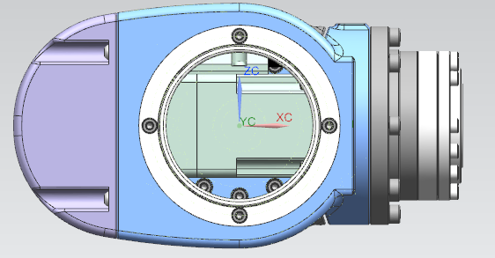

电机型号：MSMD5AZS1V

减速器型号：LHD-17-100-C-I

实际减速比：78.125

质量 = 1.572932739 kg

质心

Xcbar, Ycbar, Zcbar = 18.216351912, 0.616278338, 2.097523091

惯性矩 (WCS)

Ix, Iy, Iz = 1012.311657608, 4157.007021053, 3962.715764993

惯性矩（质心）

Ixc, Iyc, Izc = 1004.793979558, 3628.131855629, 3440.163481088

1. 连杆6

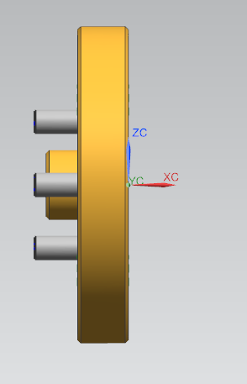

电机型号：MSMD5AZS1V

减速器型号：LCSG-14-50-C-I

质量 = 0.048214662 kg

质心

Xcbar, Ycbar, Zcbar = -4.816718006, -0.000004828, -0.117928819

惯性矩 (WCS)

Ix, Iy, Iz = 13.625706532, 8.333955866, 8.442702356

惯性矩（质心）

Ixc, Iyc, Izc = 13.625036001, 7.214667927, 7.324084948