Hollywood Nails
Database Design & ER Model
Business Analytics Portfolio - Phase 1
Prepared for Chen Chung Huang | Version 1.0

1. Project Objective
Design a normalized operational database that supports salon revenue, customer retention, appointment, workforce, purchasing, and inventory analytics. The model is intentionally structured for PostgreSQL and can later feed Excel, Power BI, and a GitHub portfolio.

2. Design Assumptions
- Approximately 10 customer visits per day, with room to scale to multiple technicians and locations.
- One appointment may include multiple services, so appointment services are stored in a bridge table.
- Each completed appointment may produce one transaction record.
- Inventory is tracked through purchases, physical counts, and service-level product usage.
- Customer-identifying fields should be anonymized before publishing portfolio datasets.

3. Entity-Relationship Diagram
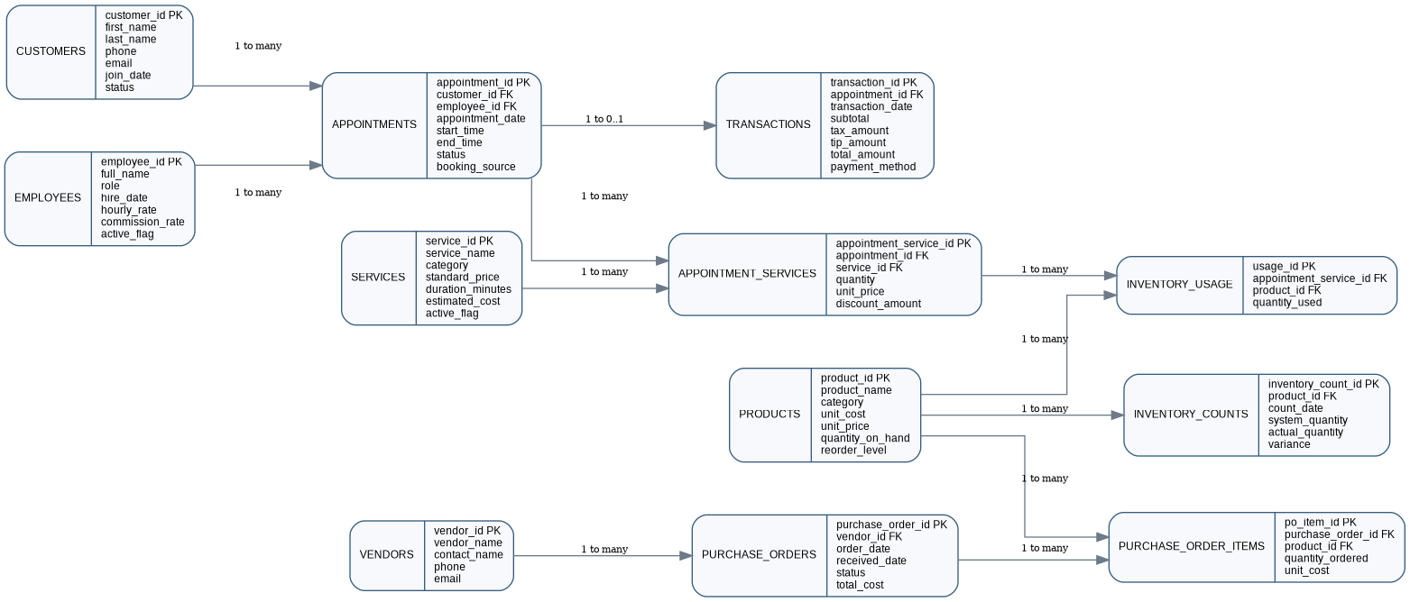

4. Core Tables and Business Purpose
Table | Purpose | Primary Analytics
customers | Customer master data and lifecycle status. | Retention, visit frequency, lifetime value
employees | Staff and owner records. | Workload, productivity, staffing
services | Service catalog, prices, duration, and cost. | Service mix, margins, pricing
appointments | Scheduled customer visits and outcomes. | Demand, cancellations, peak hours
appointment_services | Services attached to each appointment. | Multi-service ticket analysis
transactions | Payment and revenue facts. | Revenue, tips, average ticket, payment mix
products | Inventory item master. | Stock levels and reorder alerts
vendors | Supplier master data. | Vendor concentration and sourcing
purchase_orders | Inventory orders and receiving status. | Purchasing cadence and spend
purchase_order_items | Products and quantities on each order. | Unit cost and purchase volume
inventory_counts | Monthly physical inventory snapshots. | Shrinkage, variance, accuracy
inventory_usage | Product consumption by service. | True service cost and inventory forecasting

5. Key Relationships
- Customer 1-to-many Appointments
- Employee 1-to-many Appointments
- Appointment 1-to-many Appointment Services
- Service 1-to-many Appointment Services
- Appointment 1-to-zero-or-one Transaction
- Vendor 1-to-many Purchase Orders
- Purchase Order 1-to-many Purchase Order Items
- Product 1-to-many Purchase Order Items and Inventory Counts
- Appointment Service many-to-many Product through Inventory Usage

6. Analytics Questions Enabled
- What are monthly revenue, average ticket, tips, and payment mix?
- Which services produce the highest revenue and estimated gross margin?
- What are the repeat-visit rate, rebooking interval, and customer lifetime value?
- Which weekdays and appointment hours have the highest demand?
- What are cancellation and no-show rates by booking source?
- Which products are below reorder level, and where do physical counts differ from system quantity?
- How frequently are orders placed, and which vendors account for the most spend?

7. Data Governance and Portfolio Use
For public portfolio use, names, telephone numbers, email addresses, and other personally identifiable information must be replaced with synthetic values. Business totals may also be scaled or simulated. The portfolio must clearly state which data is real, anonymized, or synthetic.

8. Deliverables
- Hollywood_Nails_Database_Design.docx - database specification and ER model
- Hollywood_Nails_PostgreSQL_Schema.sql - executable PostgreSQL DDL
- Hollywood_Nails_ER_Diagram.png - visual relationship diagram

