Andrew

General English III (GEHA 1040.01)

Teacher Lynn Celek

3 June 2018

Research Question: How and Why Class Time Affects Students’ Academic Performance

The Intrinsic Mechanism That Class Time Affects the Students’ Academic Performance: A Case Study of the Two Classes of Mathematical Analysis Course in ShanghaiTech University

Introduction

It is universally agreed and repeatedly verified that students’ learning effect and academic performance are affected by a series of factors, especially the factors concerned with class teaching and learning, which play an important and even almost indispensable role in students’ study. Therefore, having an insight into the mechanisms of these factors, class time, for example, affecting students’ academic performance is significant to the revolution of the teaching methods and regulations and the improvement of students’ learning effect, which, however, has not received due attention from the researchers. In ShanghaiTech University, the students who take the course of Mathematical Analysis are divided into two groups to attend the class at different time. The two classes are all the same only except the class time and it is noticed that the group of students called Class 2, who take later class, always got higher scores in the examinations than the other group of students, Class 2, in history. This study is aimed at finding how and why class time affect students’ academic performance through this case and considers the hypothesis that it is because students taking later classes are less likely to be late for or miss class and are more energetic in class than those taking earlier ones that later class time can make students’ better academic performance. Therefore, the students’ attendance rate and appraisal of mental status of Class 2 should be better than Class 1’s according to the hypothesis.

Literature Review

The relationships between a long list of factors, especially those concerned with class teaching and learning, and students’ academic performance have already been found. For instance, James Monks and Robert Schmidt found that both class size and student load (total number of students taught across all courses) has a negative impact on the assessments of courses and instructors (Monks and Schmidt 2). Later in 2013, Samira Mehralizadeh’s group suggested that enough rest time for students, teachers’ good skills in demonstration of materials and enough lighting and ventilation of the classroom will all promote students’ concentration in class. (Mehralizadeh et al. 663) Following on from Samira Mehralizadeh in 20015, Ulla Haverinen-Shaughnessy testified that not only good ventilation, but also comfortable temperature of classroom can significantly improve students’ academic achievement. (Haverinen-Shaughnessy and Richard e0136165) In the same year, Timothy Ado Shamaki also investigated into the relationships between students’ learning and the lighting and air condition of the class, deriving the same conclusions. (Shamaki 40) Besides, Shamaki also found that enough number and appropriate arrangement of seats, interesting painting of the classrooms and high-qualitied chalkboards will facilitate students learning. (Shamaki 40) More recently in 2016, Caroline Stéffani studied the impact from students’ and teachers’ subjective attitude and found that students’ motivation for learning teachers’ dedication to teaching can improve students’ learning effect. (Pavione et al. 192) However, in the case of ShanghaiTech University’s Mathematical Analysis course, the two classes share the almost completely same conditions mentioned above.

It suggests that the only difference between the two class is the class time. Actually, there is also some research found some relationships between class time and students’ academic performance. For example, in Asım A. R. I’s experiment as early as in 2007, students tended to get higher scores in physics courses if they took the lesson in the evening rather than in the morning or afternoon (A. R. I 38). However, Asım A. R. I’s experiment was only conducted with the middle school students in the 8th grade and can not explain the reason for the phenomenon. Whether this phenomenon will happen to the university students, whose schedules are more flexible, and in China’s higher education system, which is quite different from those of other countries around the world, and whether the students will behave differently in academy even the classes are both in the morning but at different period, has not been studied yet. This research is aimed at looking into the intrinsic mechanism of class time affecting students’ academic performance based on the case of the two classes of ShanghaiTech University’s Mathematical Analysis course with the above doubts.

Methods and Materials

In order to find out the intrinsic mechanism of class time affecting students’ academic performance, a research was carried out in both two classes of Mathematical Analysis, Class 1 and Class 2, which consists 120 and 139 students respectively. The students are all first-year students from School of Information Science and Technology, ShanghaiTech University, most of who are 18 or 19 years old, and the class time is 8:15-9:55 (period 1-2) for Class 1 and 10:15-11:55 for Class 2 both in Tuesday and Thursday and as mentioned above, the lessons the two classes take are under the almost completely same conditions, which means they are taught by the same teacher with the same content in the same classroom.

First of all, an e-questionnaire consisting ten questions covering the aspect of basic information, attendance, mental statue in class, homework status and the opinion about the difference of learning effect between the two classes was randomly handed out to 31 students in each class through QQ group, covering about a quarter of the students taking the course, feedback recorded. Next, the anonymous grade distribution graphs with average scores of four examinations held in different learning period respectively (two of them are held last semester, others this semester), each of which was taken by both two classes at the same time and place and under the same conditions, are acquired from the teaching assistants. Finally, all the data was collected and analyzed.

Results

Comparing the four distribution diagrams of both two classes’ grades (Fig_1.), it is found that Class 2 always got higher average grade than Class 1 does and the gap of the average grades between the two classes are continuously enlarged, from less than 1 point in last semester’s first examination to over 4 points in this semester’s mid-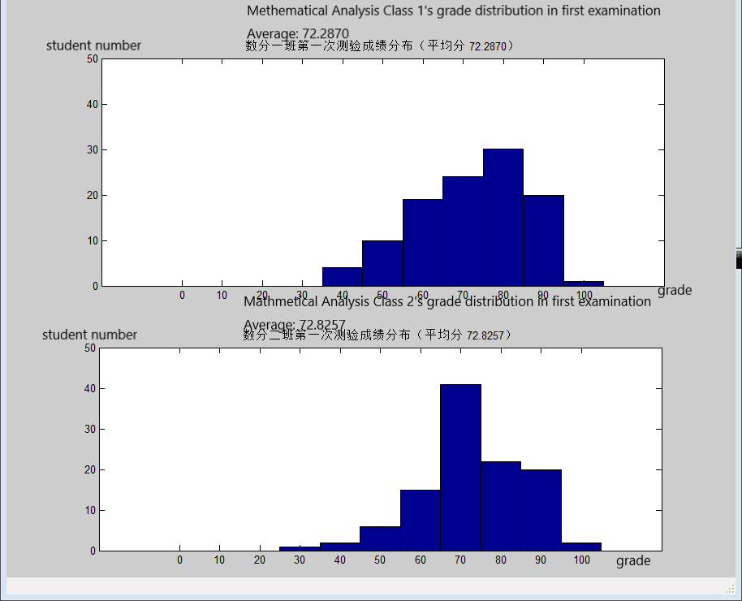term examination.

Fig_1(a). Grade distribution graph of Class 1 and 2 in last semester’s first examination

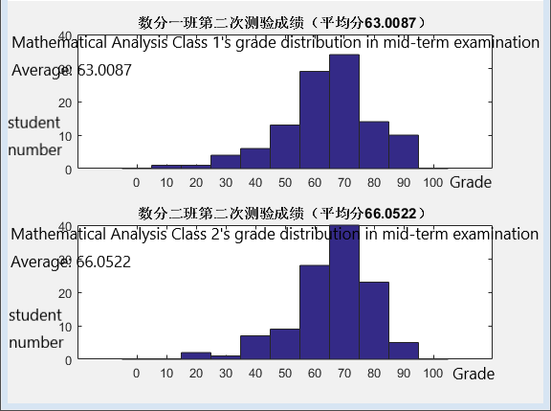Fig_1(b). Grade distribution graph of Class 1 and 2 in last semester’s mid-term examination

Fig_1(c). Grade distribution graph of Class 1 and 2 in this semester’s first examinatio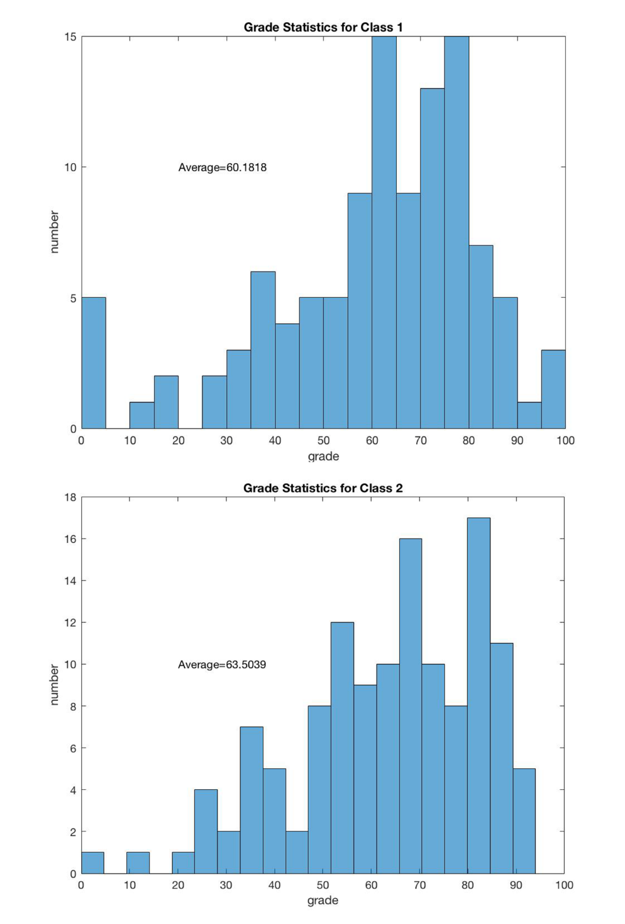n

Fig_1(d). Grade distribution graph of Class 1 and 2 in this semester’s mid-term examinatio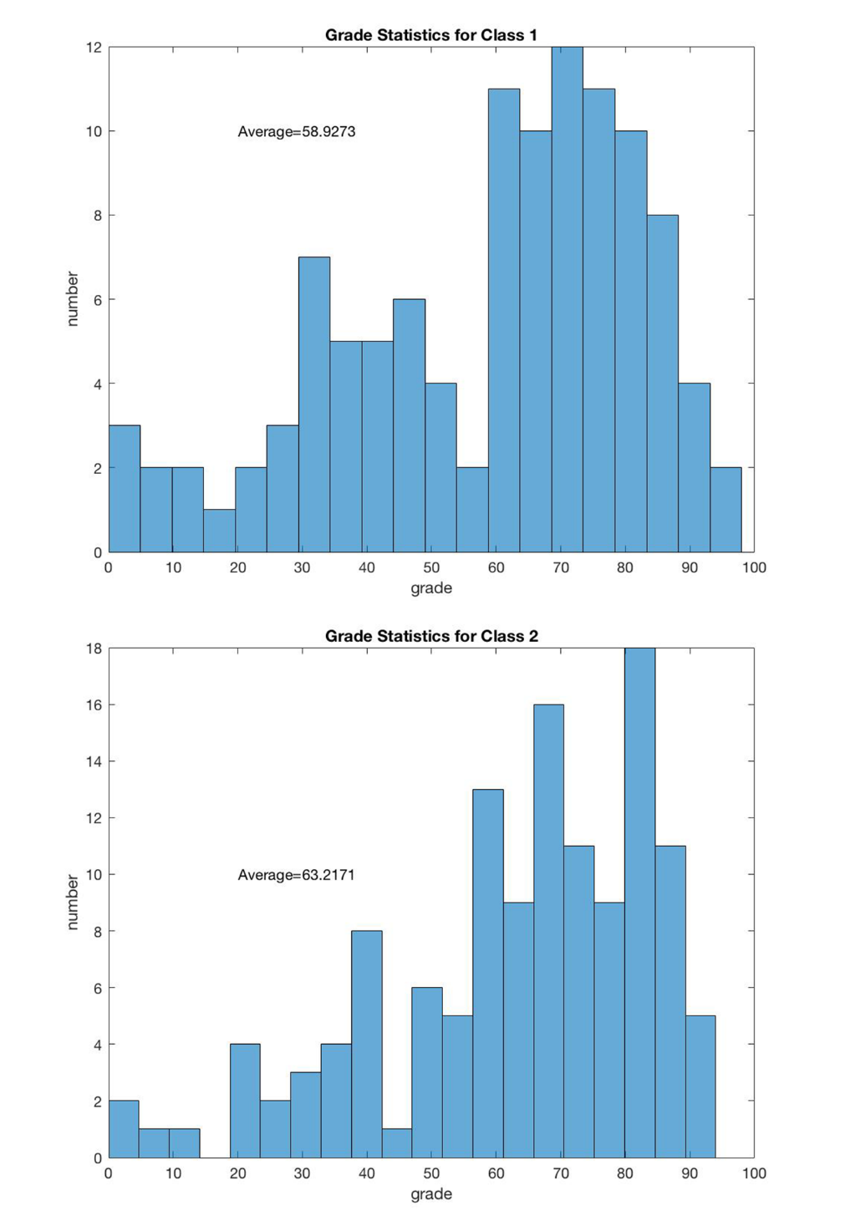n

However, according to the survey statistics, the students’ homework completing percentage in both class are fairy high, reaching almost 100%. (Fig_2.)

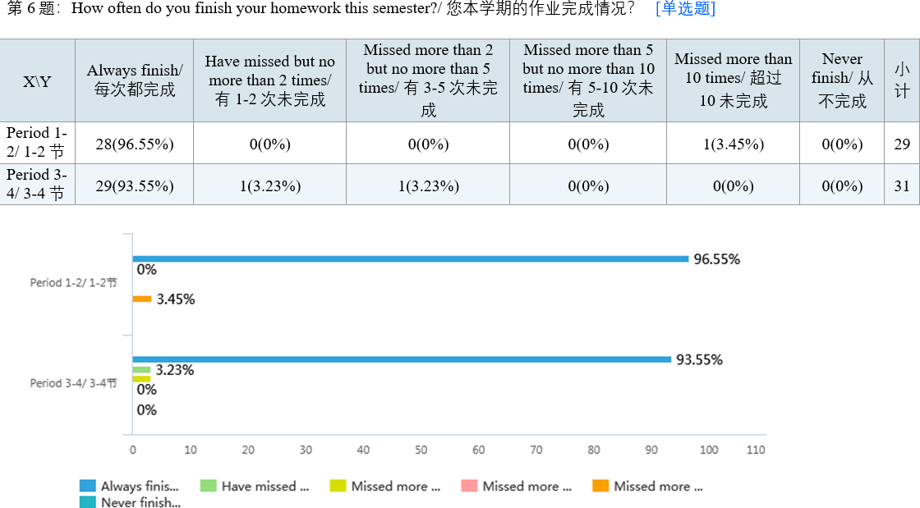Fig_2. Homework completing rate of Class 1 and 2

More surprisingly, the data also shows that the extend that students concentrate on class (Fig_3.) and follow the teacher’s thinking process(Fig_4.) of class 1 are even better than Class 2.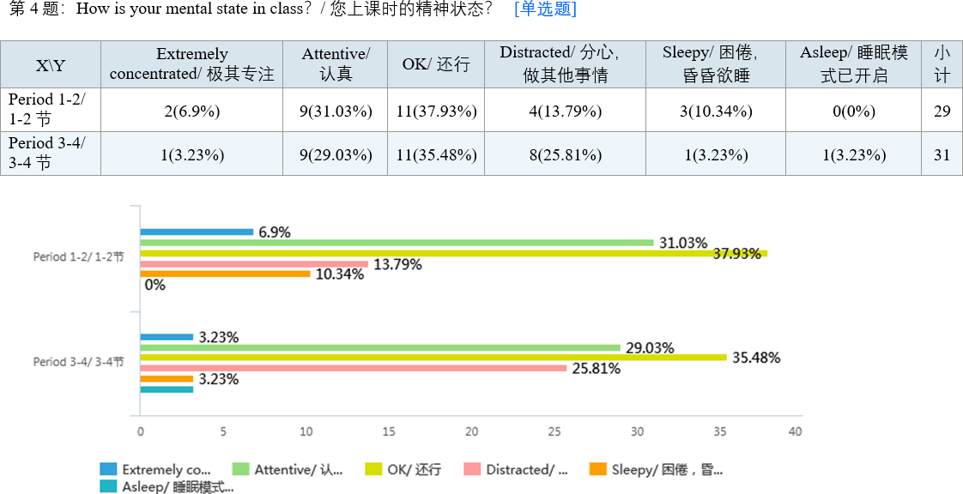

Fig_3. The extend of Class 1 and Class 2 students concentrate on class

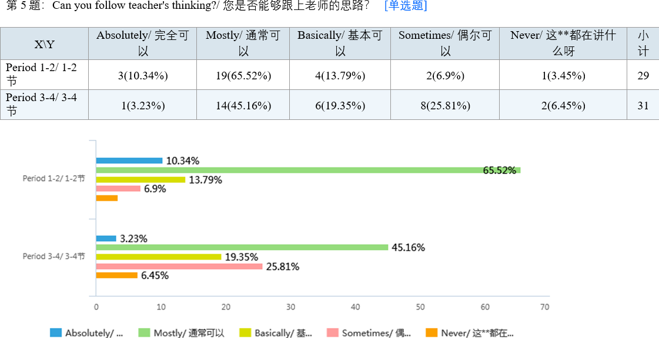Fig_4. The extend of Class 1 and 2 students follow teacher’s thinking track

The only two aspects that Class 2 performed better than Class 1 are the attendance rating and the punctuality. It is obvious that the rate of being late for or missing class of Class 1 are higher than Class 2’s.(Fig_5.)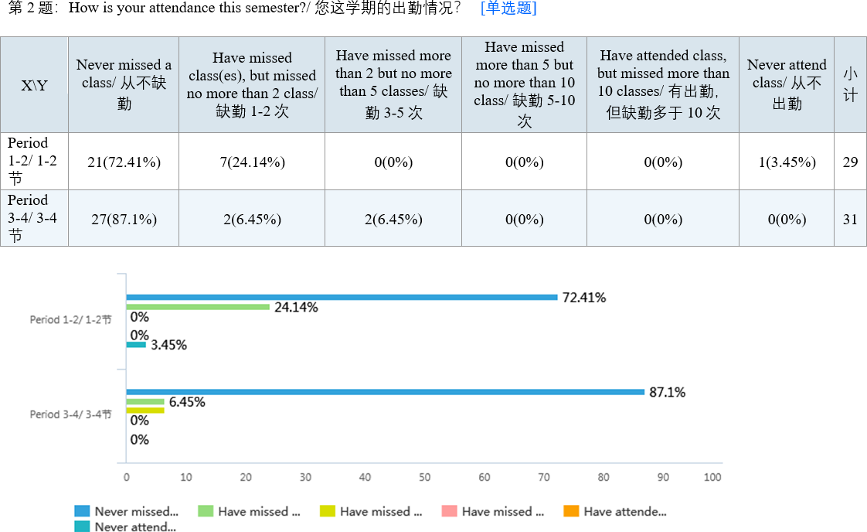

Fig_5(a). The attendance rate of Class 1 and 2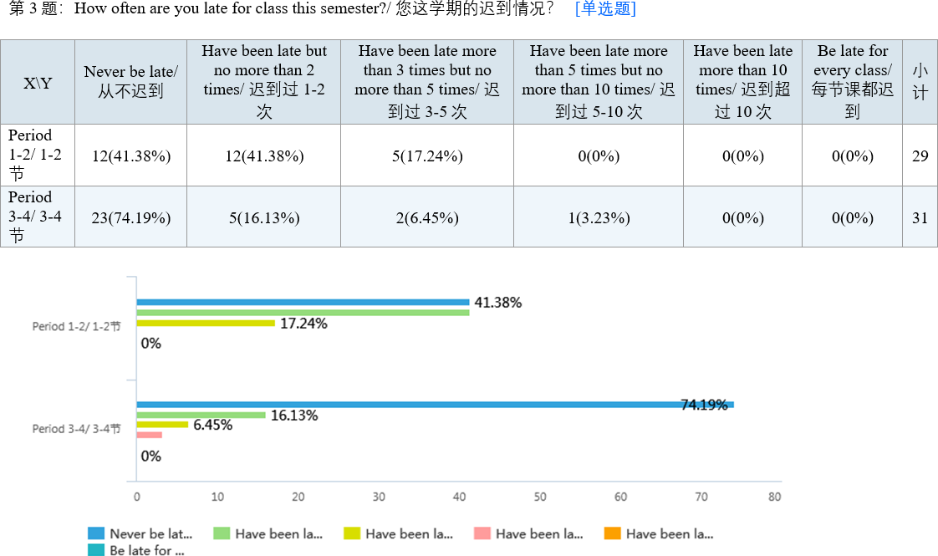

Fig_5(b). The punctuality of Class 1 and 2

Analysis

The continuously largening gap of average grades between the two classes implies that there does exist some factors determined by the class time affecting students’ grades in the two classes and making Class 2 learns better than Class 1 does and the caused effect are aggravated with the difficulty and quantity of teaching content increasing. However, the homework completing rate reaching almost 100% shows that both two classes have a serious attitude towards the course of Mathematical Analysis and the better extend of concentrating and following teacher of Class 1 negates the hypothesis that the students taking later class are more energetic in class while those taking earlier class tend to be sleepier and have worse learning effect because they have to get up early for class. However, the better attendance rate and punctuality of Class 2 may explain the advantage of Class 1 in academic performance over Class 2. It suggests that although the students in Class 2 may be more tired and sleepier to attend Mathematical classes after period 1-2’s learning, it is less likely that they get late for or miss class than Class 2. It may be because most students who choose to take Mathematical Analysis at period 3-4 must take General English at period 1-2 and these two courses are given in the same building. The General English usually ends 30 minutes before Mathematical Analysis of period 3-4’s beginning, allowing enough time for students to get the correct classroom on time. In contrast, the students in Class 1 have to get up early and appear in the class after a series of daily trifles like washing and breakfast, which may make it difficult for those who got to bed late last night or like sleeping late to get to classroom on time and even more likely to miss the whole class. Besides, the difficulty of Mathematical is so high and so is its teaching pace that once students missed a small part of the class, it will cost large amount of time and energy for them to catch up with the teacher’s track again. Therefore, being late for or missing class may cause serious learning obstacle for the students, many of which is in Class 1, and have negative influences on their academic performance. This is one potential reason that different class time affects students’ academic performance.

Discussion

This research is aimed at finding the intrinsic mechanism that class time affecting students’ academic performance. The data derived from the survey shows that students taking later class in the morning tend to get higher grades than those taking earlier class and the attendance and punctuality rate of students taking earlier class is relatively lower than those taking later class’s. One reasonable explanation is that some students taking early class have difficulties in getting up early in the morning for the class and be late for or miss their class, causing negative effects on their academic performance.

There are a few potential issues with this research. Firstly, it is noteworthy that a small amount (definite numbers unknown) of students in each class chose to switch to the other class after the first semester, which may cause slight uncertainty to the results. Besides, this research does not take the teacher’s teaching statue into consideration. After all, the teacher may have fatigue but, on the other hand, get more familiar with the teaching materials after teaching Class 1, which are variables of students’ learning effect. Finally, the student number of the two classes is not completely the same. Although the difference of the class size is small, it may cause some unknown effects to the result.

Conclusion

Many factors including class time have been found to have relationships with students’ academic performance but few research has reveal the intrinsic mechanisms of these relationships. This research is aimed at finding the intrinsic mechanism of class time affecting students’ academic performance. It suggests that the reason with highest possibility for the difference of academic performance between the students who take class of different time is that some students taking early class have difficulties in getting up early for class, causing their relatively low attendance and punctuality rate of the class and, therefore, having a negative impact on their learning. Regarding the fact that students taking earlier class is more likely to be late or even miss the class, it is suggested that some measure, like adjusting the class schedule and switching the important or difficult classes’ time to the middle of the day, can be taken by the school administrator to improve students’ learning effect and academic performance.

Works Cited

A. R. I, Asım. “How Does the Teaching Time Period Affect the Students’ Learning Level?” *Elektronik Sosyal Bilimler Dergisi*, vol. 22, no. 22, 2007, pp. 38-45.

Haverinen-Shaughnessy, Ulla, and Richard J. Shaughnessy. “Effects of classroom ventilation rate and temperature on students’ test scores.” *PLOS one*, vol. 10, no. 8, 2015, pp.e0136165.

Mehralizadeh, Samira, et al. “Factors Affecting Student Concentration in Classroom: Medical Students’ Viewpoints in Semnan University of Medical Sciences.” *Iranian Journal of Medical Education*, vol. 13, no. 8, 2013, pp. 663-671.

Monks, James, and Schmidt, Robert. “The Impact of Class Size and Number of Students on Outcomes in Higher Education.” *DigitalCommons@ILR*. n.p, n.d. Web. Sept 2018.

Shamaki, Timothy Ado. “Influence of Learning Environment on Students’ Academic Achievement in Mathematics: A Case Study of Some Selected Secondary Schools in Yobe State-Nigeria.” *Journal of Education and Practice*, vol. 6, no. 34, 2015. pp. 40-44.

Pavione, Caroline Stéffani Santos Nério et al. “Factors that Influence the Teaching-Learning Process from the Perspective of Accountancy Students: Analysis at a Higher Education Institution in Minas Gerais.” *Revista de Educação e Pesquisa em Contabilidade*, vol 10, no .2, 2016, pp. 192-215.

The Whole Set of the Survey Questions and Their Result

**A survey about the factors affect students' Mathematical Analysis grade/ 一份关于影响学生数学分析成绩的调查问卷**

第1题 Which time slot is your current class?/ 您当前的数学分析课程的上课时间？ [单选题]

|  |  |  |
| --- | --- | --- |
| 选项 | 小计 | 比例 |
| Period 1-2/ 1-2节 | 31 | 50% |
| Period 3-4/ 3-4节 | 31 | 50% |
| 本题有效填写人次 | 62 |  |

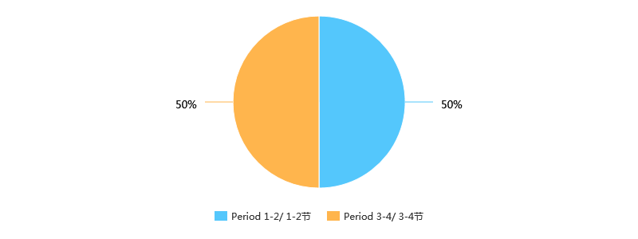

第2题 How is your attendance this semester?/ 您这学期的出勤情况？ [单选题]

|  |  |  |
| --- | --- | --- |
| 选项 | 小计 | 比例 |
| Never missed a class/ 从不缺勤 | 49 | 79.03% |
| Have missed class(es), but missed no more than 2 class/ 缺勤1-2次 | 9 | 14.52% |
| Have missed more than 2 but no more than 5 classes/ 缺勤3-5次 | 2 | 3.23% |
| Have missed more than 5 but no more than 10 class/ 缺勤5-10次 | 1 | 1.61% |
| Have attended class, but missed more than 10 classes/ 有出勤，但缺勤多于10次 | 0 | 0% |
| Never attend class/ 从不出勤 | 1 | 1.61% |
| 本题有效填写人次 | 62 |  |

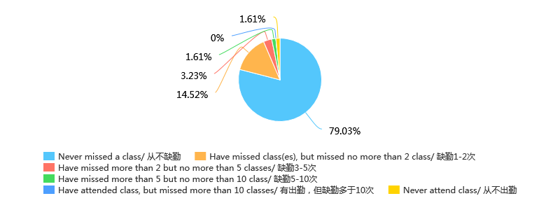

第3题 How often are you late for class this semester?/ 您这学期的迟到情况？ [单选题]

|  |  |  |
| --- | --- | --- |
| 选项 | 小计 | 比例 |
| Never be late/ 从不迟到 | 36 | 58.06% |
| Have been late but no more than 2 times/ 迟到过1-2次 | 18 | 29.03% |
| Have been late more than 3 times but no more than 5 times/ 迟到过3-5次 | 7 | 11.29% |
| Have been late more than 5 times but no more than 10 times/ 迟到过5-10次 | 1 | 1.61% |
| Have been late more than 10 times/ 迟到超过10次 | 0 | 0% |
| Be late for every class/ 每节课都迟到 | 0 | 0% |
| 本题有效填写人次 | 62 |  |

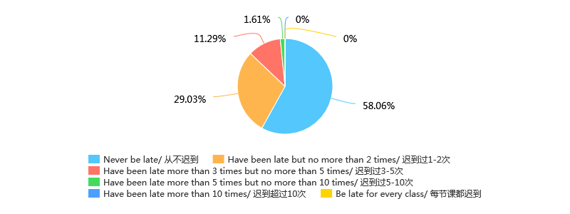

第4题 How is your mental state in class？/ 您上课时的精神状态？ [单选题]

|  |  |  |
| --- | --- | --- |
| 选项 | 小计 | 比例 |
| Extremely concentrated/ 极其专注 | 3 | 4.84% |
| Attentive/ 认真 | 18 | 29.03% |
| OK/ 还行 | 23 | 37.1% |
| Distracted/ 分心，做其他事情 | 13 | 20.97% |
| Sleepy/ 困倦，昏昏欲睡 | 4 | 6.45% |
| Asleep/ 睡眠模式已开启 | 1 | 1.61% |
| 本题有效填写人次 | 62 |  |

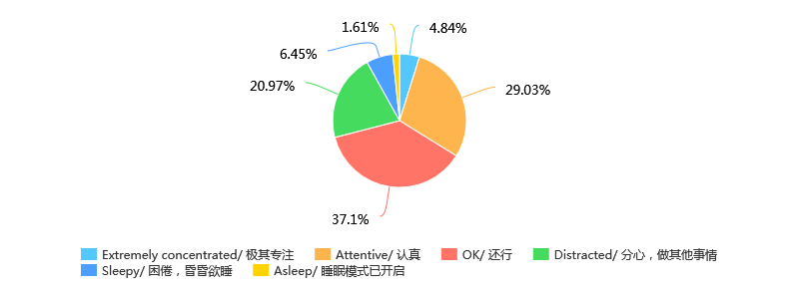

第5题 Can you follow teacher's thinking?/ 您是否能够跟上老师的思路？ [单选题]

|  |  |  |
| --- | --- | --- |
| 选项 | 小计 | 比例 |
| Absolutely/ 完全可以 | 5 | 8.06% |
| Mostly/ 通常可以 | 33 | 53.23% |
| Basically/ 基本可以 | 10 | 16.13% |
| Sometimes/ 偶尔可以 | 11 | 17.74% |
| Never/ 这**都在讲什么呀 | 3 | 4.84% |
| 本题有效填写人次 | 62 |  |

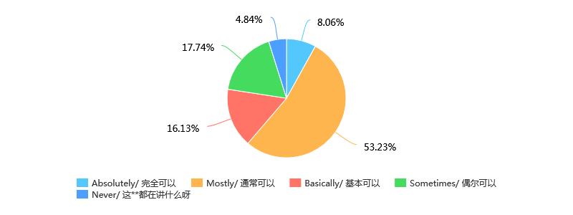

第6题 How often do you finish your homework this semester?/ 您本学期的作业完成情况？ [单选题]

|  |  |  |
| --- | --- | --- |
| 选项 | 小计 | 比例 |
| Always finish/ 每次都完成 | 58 | 93.55% |
| Have missed but no more than 2 times/ 有1-2次未完成 | 2 | 3.23% |
| Missed more than 2 but no more than 5 times/ 有3-5次未完成 | 1 | 1.61% |
| Missed more than 5 but no more than 10 times/ 有5-10次未完成 | 0 | 0% |
| Missed more than 10 times/ 超过10未完成 | 1 | 1.61% |
| Never finish/ 从不完成 | 0 | 0% |
| 本题有效填写人次 | 62 |  |

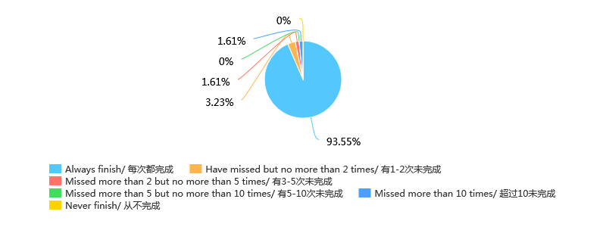

第7题 How difficult is the homework for you?/ 您觉得作业的难度？ [单选题]

|  |  |  |
| --- | --- | --- |
| 选项 | 小计 | 比例 |
| Too simple/ 过于简单 | 0 | 0% |
| Simple/ 偏简单 | 1 | 1.61% |
| Normal/ 难度适中 | 32 | 51.61% |
| Difficult/ 偏困难 | 27 | 43.55% |
| Too difficult/ 过于困难 | 2 | 3.23% |
| 本题有效填写人次 | 62 |  |

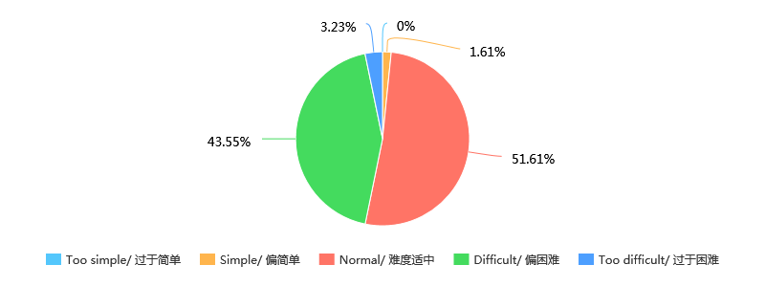

第8题 Which time slot is your class last semester?/ 您上学期的数学分析课程的上课时间？ [单选题]

|  |  |  |
| --- | --- | --- |
| 选项 | 小计 | 比例 |
| Period 1-2/ 1-2节 | 34 | 54.84% |
| Period 3-4/ 3-4节 | 28 | 45.16% |
| 本题有效填写人次 | 62 |  |

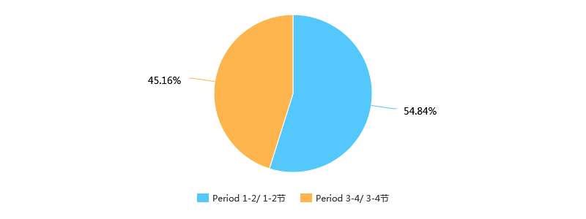

第9题 What range is of your grade of the first examination this semester at?[avg——average grade]/ 您这学期第一次数学分析考试的成绩区间？[avg——平均成绩] [单选题]

|  |  |  |
| --- | --- | --- |
| 选项 | 小计 | 比例 |
| [0, avg - 20) | 5 | 8.06% |
| [avg - 20, avg - 10) | 2 | 3.23% |
| [avg - 10, avg) | 16 | 25.81% |
| [avg, avg + 10) | 14 | 22.58% |
| [avg + 10, avg + 20) | 15 | 24.19% |
| [avg + 20, 100] | 10 | 16.13% |
| 本题有效填写人次 | 62 |  |

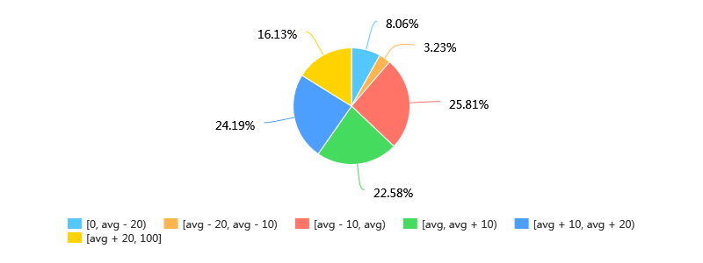

第10题 What range is your grade of the mid-term examination last semester at?/ 您上学期期中考试(第二次考试)的成绩区间？[avg——平均成绩] [单选题]

|  |  |  |
| --- | --- | --- |
| 选项 | 小计 | 比例 |
| [0, avg - 20) | 3 | 4.84% |
| [avg - 20, avg - 10) | 4 | 6.45% |
| [avg - 10, avg) | 15 | 24.19% |
| [avg, avg + 10) | 21 | 33.87% |
| [avg + 10, avg + 20) | 13 | 20.97% |
| [avg + 20, 100] | 6 | 9.68% |
| 本题有效填写人次 | 62 |  |

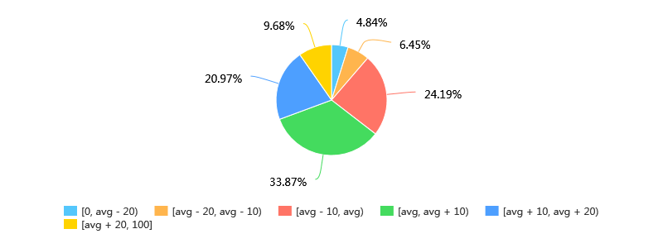

第11题 Do you think that there is any difference of learning effect between the students taking Period 1-2 and 3-4 class?(Glad if you can offer your reason.)/ 您认为上第1-2节课和第3-4节课的同学的学习效果有什么差异吗？(如果能填上您认为的原因，感激不尽) [单选题]

|  |  |  |
| --- | --- | --- |
| 选项 | 小计 | 比例 |
| Students taking Period 1-2 class learn better/ 上第1-2节课的同学学习效果更好 | 7 | 11.29% |
| Students taking Period 3-4 class learn better/ 上第3-4节课的同学学习效果更好 | 33 | 53.23% |
| No difference/ 没有差异 | 9 | 14.52% |
| I do not Know/ 不知道 | 13 | 20.97% |
| 本题有效填写人次 | 62 |  |

