## 太阳能电池的特性测量

 总分：100

**一、实验目的**       共 **5** 分，得 0 分

（1）通过对太阳能电池基本特性的测量，了解和掌握它的特性和有关的测量方法；

（2）测量不同照度下太阳能的伏安特性、开路电压 $U_{0}$ 和短路电流 $I_{s}$；

（3）测量不同照度下太阳电池的输出功率和负载电阻 $R$ 的函数关系；

（4）确定太阳能电池的最大输出功率 $P_{max}$ 以及相应的负载电阻 $R_{max}$ 和填充因数.

**二、实验原理**       共 **10** 分，得 0 分

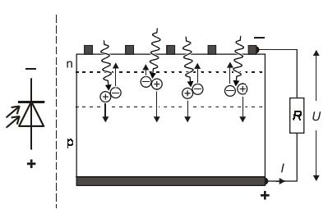太阳能电池的工作原理是光伏效应：当光子能量大于禁带宽度的光照射太阳能电池的PN结，就会产生电子-空穴对. 当这些载流子扩散到结节界面处，在由N区指向P区的内建电场作用下，来自N区的空穴被拉向P区，来自P区的电子被拉向N区，从而在N区积累光生电子，在P区积累光生空穴，他们产生由P区指向N区的光生电场，从而在PN结上产生光生电动势.

图1 太阳能电池光伏效应原理图

在实际工作中，除由N流向P区的光生电流 $I_{S}$（取决于辐照度 $Φ$），还存在由P区流向N区的正向二极管电流 $I_{D}$（取决于负载端电压 $U$），通过负载电阻 $R$ 的电流为两者之差：

$$I=I_{S}\left(Φ\right)-I_{D}\left(U\right).$$

当太阳能电池被短路（$R=0$）时， $I_{D}\left(0\right)=0$， $I=I_{S}$，短路电流等于光生电流；

当太阳能电池开路（$R=∞$）时，开路电压满足 $I_{S}\left(Φ\right)-I_{D}\left(U_{0}\right)=0$；

在固定光强下，电池的输出功率取决于负载电阻

$$P=P\left(R\right)=UI,$$

其中负载电阻满足

$$R=\frac{U}{I}.$$

当负载 $R_{max}$ 近似等于电池内阻

$$R_{i}=\frac{U_{0}}{I_{S}}$$

时，输出功率达到最大， $P_{max}=P\left(R_{max}\right)=U_{max}I_{max}$，其中 $U_{max}$ 和 $I_{max}$ 是功率最大时的电流和电压.

最大功率与开路电压和短路电流之积的比例定义为填充因数：

$$F=\frac{P_{max}}{U_{0}I_{S}}.$$

**三、实验仪器**       共 **5** 分，得 0 分

太阳能电池2块、插件版（A4大小）1块、万用表（附带表笔）2台、卤素灯1台、稳压源（电压范围2-12V）1台、桥接插头3个.

**四、实验内容**       共 **5** 分，得 0 分

1. 仪器搭建（如图2）

（1）将两个太阳能电池板插到插件板上，并用桥接插头串联其异极；

（2）将电位器与太阳能电池板串联作为可变电阻；

（3）将一个万用表与电池和电位器串联作为电流表，档位选择直流 $200$ mA；

（4）将另一个万用电表与电池并联作为电压表，档位选择直流 $3V$；

（5）连接卤素灯和稳压源，调节卤素灯位置使灯光与电池成一线，以使电池均匀受光.

2. 测量不同照度下太阳能电池的伏安特性、开路电压 $U_{0}$ 和短路电流 $I_{S}$

（1）将电位器阻值调至最小以短路电池，改变卤素灯与电池的距离和稳压源输出功率，使短路电流大约为 $45$ mA；

（2）逐步改变电位器电阻值，测量和记录电流和电压；

（3）断开电流表和电路的连接，测量和记录开路电压；

（4）用（1）中的方法调节短路电流分别为 $35$ mA， $25$ mA和 $15$ mA，重复（2）（3）的步骤.

3.数据处理：绘制各照度下电池的 $U-I$ 曲线，计算对应的最大功率和填充因数.

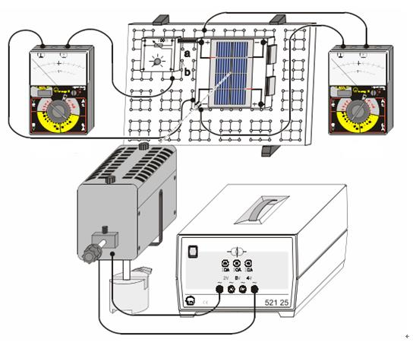图2 实验装置图

**五、数据处理**

实验：太阳能电池的特性测量       总分值：**70分**   得分：0

★ **1.** 测量不同照度下太阳能电池的伏安特性、开路电压U0和短路电流Is

**(1) 接通电路，记录短路电流Is=45mA时，记录开路电压 $U_{0}$ (V)=_2.05V_（5分）**

评分规则：偏差在-2%~2%，得5分

偏差在-5%~5%，得2分

**（2）调节短路电流大约为45mA. 逐步改变负载电阻值降低电流，分别读取电流和电压值，记入表格1中**

|  |  |  |  |  |  |  |  |  |  |  |  |  |  |  |  |  |  |  |  |  |
| --- | --- | --- | --- | --- | --- | --- | --- | --- | --- | --- | --- | --- | --- | --- | --- | --- | --- | --- | --- | --- |
| **内容** | 1 | 2 | 3 | 4 | 5 | 6 | 7 | 8 | 9 | 10 | 11 | 12 | 13 | 14 | 15 | 16 | 17 | 18 | 19 | 20 |
| **I/mA** | 44.9 | 44.9 | 44.9 | 44.9 | 42.5 | 36.0 | 30.8 | 26.9 | 23.8 | 21.4 | 19.4 | 17.7 | 16.3 | 15.1 | 14.1 | 13.2 | 12.4 | 11.7 | 11.1 | 10.5 |
| **U/V** | 0.01 | 0.46 | 0.90 | 1.37 | 1.70 | 1.80 | 1.85 | 1.88 | 1.90 | 1.90 | 1.91 | 1.92 | 1.93 | 1.94 | 1.94 | 1.95 | 1.96 | 1.96 | 1.96 | 1.97 |
| **R/Ω** | 2E-01 | 1.0E+01 | 2.0E+01 | 3.05E+01 | 4.00E+01 | 5.00E+01 | 6.01E+01 | 6.99E+01 | 7.98E+01 | 8.88E+01 | 9.85E+01 | 1.08E+02 | 1.18E+02 | 1.28E+02 | 1.38E+02 | 1.48E+02 | 1.58E+02 | 1.68E+02 | 1.77E+02 | 1.88E+02 |
| **P/mW** | 4E-01 | 2.1E+01 | 4.0E+01 | 6.15E+01 | 7.23E+01 | 6.48E+01 | 5.70E+01 | 5.06E+01 | 4.52E+01 | 4.07E+01 | 3.71E+01 | 3.40E+01 | 3.15E+01 | 2.93E+01 | 2.74E+01 | 2.57E+01 | 2.43E+01 | 2.29E+01 | 2.18E+01 | 2.07E+01 |

**续表**

|  |  |  |  |  |  |  |  |  |  |  |  |  |  |  |  |  |  |  |  |  |
| --- | --- | --- | --- | --- | --- | --- | --- | --- | --- | --- | --- | --- | --- | --- | --- | --- | --- | --- | --- | --- |
| **内容** | 21 | 22 | 23 | 24 | 25 | 26 | 27 | 28 | 29 | 30 | 31 | 32 | 33 | 34 | 35 | 36 | 37 | 38 | 39 | 40 |
| **I/mA** | 10.0 | 9.5 | 9.1 | 8.7 | 8.4 | 8.1 | 7.8 | 7.6 | 7.3 | 7.0 | 6.8 | 6.6 | 6.4 | 6.2 | 6.0 | 5.8 | 5.7 | 5.5 | 5.4 | 5.2 |
| **U/V** | 1.97 | 1.97 | 1.98 | 1.98 | 1.98 | 1.98 | 1.98 | 1.98 | 1.99 | 1.99 | 1.99 | 1.99 | 1.99 | 1.99 | 1.99 | 1.99 | 2.00 | 2.00 | 2.00 | 2.00 |
| **R/Ω** | 1.97E+02 | 2.1E+02 | 2.2E+02 | 2.3E+02 | 2.4E+02 | 2.4E+02 | 2.5E+02 | 2.6E+02 | 2.7E+02 | 2.8E+02 | 2.9E+02 | 3.0E+02 | 3.1E+02 | 3.2E+02 | 3.3E+02 | 3.4E+02 | 3.5E+02 | 3.6E+02 | 3.7E+02 | 3.8E+02 |
| **P/mW** | 1.97E+01 | 1.9E+01 | 1.8E+01 | 1.7E+01 | 1.7E+01 | 1.6E+01 | 1.5E+01 | 1.5E+01 | 1.5E+01 | 1.4E+01 | 1.4E+01 | 1.3E+01 | 1.3E+01 | 1.2E+01 | 1.2E+01 | 1.2E+01 | 1.1E+01 | 1.1E+01 | 1.1E+01 | 1.0E+01 |

**续表**

|  |  |  |  |  |  |  |  |  |  |  |  |  |  |  |  |  |  |  |  |  |
| --- | --- | --- | --- | --- | --- | --- | --- | --- | --- | --- | --- | --- | --- | --- | --- | --- | --- | --- | --- | --- |
| **内容** | 41 | 42 | 43 | 44 | 45 | 46 | 47 | 48 | 49 | 50 | 51 | 52 | 53 | 54 | 55 | 56 | 57 | 58 | 59 | 60 |
| **I/mA** | 5.1 | 5.0 | 4.8 | 4.7 | 4.6 | 4.5 | 4.4 | 4.3 | 4.2 | 4.1 | 4.1 | 4.0 | 3.9 | 3.8 | 3.7 | 3.6 | 3.5 | 3.4 | 3.3 | 3.2 |
| **U/V** | 2.00 | 2.00 | 2.00 | 2.00 | 2.00 | 2.00 | 2.00 | 2.00 | 2.00 | 2.00 | 2.01 | 2.01 | 2.01 | 2.01 | 2.01 | 2.01 | 2.01 | 2.01 | 2.01 | 2.01 |
| **R/Ω** | 3.9E+02 | 4.0E+02 | 4.2E+02 | 4.3E+02 | 4.3E+02 | 4.4E+02 | 4.5E+02 | 4.7E+02 | 4.8E+02 | 4.9E+02 | 4.9E+02 | 5.0E+02 | 5.2E+02 | 5.3E+02 | 5.4E+02 | 5.6E+02 | 5.7E+02 | 5.9E+02 | 6.1E+02 | 6.3E+02 |
| **P/mW** | 1.0E+01 | 1.0E+01 | 9.6E+00 | 9.4E+00 | 9.2E+00 | 9.0E+00 | 8.8E+00 | 8.6E+00 | 8.4E+00 | 8.2E+00 | 8.2E+00 | 8.0E+00 | 7.8E+00 | 7.6E+00 | 7.4E+00 | 7.2E+00 | 7.0E+00 | 6.8E+00 | 6.6E+00 | 6.4E+00 |

**续表**

|  |  |  |  |  |  |  |  |  |  |  |  |  |  |  |  |  |  |  |  |
| --- | --- | --- | --- | --- | --- | --- | --- | --- | --- | --- | --- | --- | --- | --- | --- | --- | --- | --- | --- |
| **内容** | 61 | 62 | 63 | 64 | 65 | 66 | 67 | 68 | 69 | 70 | 71 | 72 | 73 | 74 | 75 | 76 | 77 | 78 | 79 |
| **I/mA** | 3.1 | 3.0 | 2.9 | 2.8 | 2.7 | 2.6 | 2.5 | 2.5 | 2.4 | 2.3 | 2.2 | 2.1 | 2.0 | 1.9 | 1.8 | 1.7 | 1.6 | 1.5 | 1.4 |
| **U/V** | 2.01 | 2.01 | 2.01 | 2.01 | 2.01 | 2.01 | 2.01 | 2.02 | 2.02 | 2.02 | 2.02 | 2.02 | 2.02 | 2.02 | 2.02 | 2.02 | 2.02 | 2.02 | 2.02 |
| **R/Ω** | 6.5E+02 | 6.7E+02 | 6.9E+02 | 7.2E+02 | 7.4E+02 | 7.7E+02 | 8.0E+02 | 8.1E+02 | 8.4E+02 | 8.8E+02 | 9.2E+02 | 9.6E+02 | 1.0E+03 | 1.1E+03 | 1.1E+03 | 1.2E+03 | 1.3E+03 | 1.3E+03 | 1.4E+03 |
| **P/mW** | 6.2E+00 | 6.0E+00 | 5.8E+00 | 5.6E+00 | 5.4E+00 | 5.2E+00 | 5.0E+00 | 5.1E+00 | 4.8E+00 | 4.6E+00 | 4.4E+00 | 4.2E+00 | 4.0E+00 | 3.8E+00 | 3.6E+00 | 3.4E+00 | 3.2E+00 | 3.0E+00 | 2.8E+00 |

**评分规则：不评分**

**（3）根据表格1，拟合出U~I曲线，并上传曲线（6.5分）**

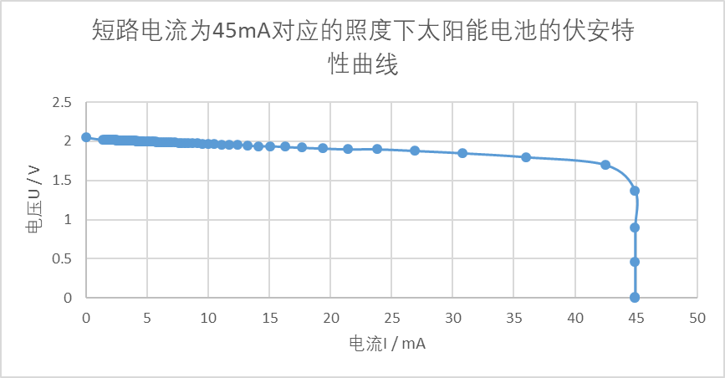

评分规则：

（a）坐标纸大小适中，不能太大或太小，坐标纸的最小分格是百分位；   
（b）标明直线的名称和横、纵坐标轴物理量及其单位；   
（c）实验数据落点要尽量均匀分布在直线两侧；

（d）在作出的直线上选取相距较远的两个非实验数据点，并标明所选点坐标及坐标值

**(4)调节短路电流**Is=35mA时，记录开路电压 $U_{0}$ (V)=_2.01V_ （5分）

评分规则：偏差在-2%~2%，得5分

偏差在-5%~5%，得2分

**（5）调节短路电流大约为35mA. 逐步改变负载电阻值降低电流，分别读取电流和电压值，记入表格1中**

|  |  |  |  |  |  |  |  |  |  |  |  |  |  |  |  |  |  |  |  |  |
| --- | --- | --- | --- | --- | --- | --- | --- | --- | --- | --- | --- | --- | --- | --- | --- | --- | --- | --- | --- | --- |
| **内容** | 1 | 2 | 3 | 4 | 5 | 6 | 7 | 8 | 9 | 10 | 11 | 12 | 13 | 14 | 15 | 16 | 17 | 18 | 19 | 20 |
| **I/mA** | 34.9 | 34.9 | 34.9 | 34.9 | 34.9 | 33.5 | 29.4 | 25.9 | 23.1 | 20.8 | 18.9 | 17.3 | 16.0 | 14.8 | 13.8 | 12.9 | 12.2 | 11.5 | 10.9 | 10.3 |
| **U/V** | 0.01 | 0.35 | 0.70 | 1.04 | 1.38 | 1.65 | 1.74 | 1.79 | 1.82 | 1.84 | 1.86 | 1.87 | 1.89 | 1.90 | 1.90 | 1.91 | 1.92 | 1.92 | 1.93 | 1.93 |
| **R/Ω** | 3E-01 | 1.0E+01 | 2.0E+01 | 2.98E+01 | 3.95E+01 | 4.93E+01 | 5.92E+01 | 6.91E+01 | 7.88E+01 | 8.85E+01 | 9.84E+01 | 1.08E+02 | 1.18E+02 | 1.28E+02 | 1.38E+02 | 1.48E+02 | 1.57E+02 | 1.67E+02 | 1.77E+02 | 1.87E+02 |
| **P/mW** | 3E-01 | 1.2E+01 | 2.4E+01 | 3.63E+01 | 4.82E+01 | 5.53E+01 | 5.12E+01 | 4.64E+01 | 4.20E+01 | 3.83E+01 | 3.52E+01 | 3.24E+01 | 3.02E+01 | 2.81E+01 | 2.62E+01 | 2.46E+01 | 2.34E+01 | 2.21E+01 | 2.10E+01 | 1.99E+01 |

**续表**

|  |  |  |  |  |  |  |  |  |  |  |  |  |  |  |  |  |  |  |  |  |
| --- | --- | --- | --- | --- | --- | --- | --- | --- | --- | --- | --- | --- | --- | --- | --- | --- | --- | --- | --- | --- |
| **内容** | 21 | 22 | 23 | 24 | 25 | 26 | 27 | 28 | 29 | 30 | 31 | 32 | 33 | 34 | 35 | 36 | 37 | 38 | 39 | 40 |
| **I/mA** | 9.8 | 9.4 | 9.0 | 8.6 | 8.2 | 7.9 | 7.6 | 7.4 | 7.1 | 6.9 | 6.6 | 6.4 | 6.2 | 6.0 | 5.9 | 5.7 | 5.6 | 5.4 | 5.3 | 5.1 |
| **U/V** | 1.93 | 1.94 | 1.94 | 1.94 | 1.95 | 1.95 | 1.95 | 1.95 | 1.96 | 1.96 | 1.96 | 1.96 | 1.96 | 1.96 | 1.97 | 1.97 | 1.97 | 1.97 | 1.97 | 1.97 |
| **R/Ω** | 2.0E+02 | 2.1E+02 | 2.2E+02 | 2.3E+02 | 2.4E+02 | 2.5E+02 | 2.6E+02 | 2.6E+02 | 2.8E+02 | 2.8E+02 | 3.0E+02 | 3.1E+02 | 3.2E+02 | 3.3E+02 | 3.3E+02 | 3.5E+02 | 3.5E+02 | 3.6E+02 | 3.7E+02 | 3.9E+02 |
| **P/mW** | 1.9E+01 | 1.8E+01 | 1.7E+01 | 1.7E+01 | 1.6E+01 | 1.5E+01 | 1.5E+01 | 1.4E+01 | 1.4E+01 | 1.4E+01 | 1.3E+01 | 1.3E+01 | 1.2E+01 | 1.2E+01 | 1.2E+01 | 1.1E+01 | 1.1E+01 | 1.1E+01 | 1.0E+01 | 1.0E+01 |

**续表**

|  |  |  |  |  |  |  |  |  |  |  |  |  |  |  |  |  |  |  |  |  |
| --- | --- | --- | --- | --- | --- | --- | --- | --- | --- | --- | --- | --- | --- | --- | --- | --- | --- | --- | --- | --- |
| **内容** | 41 | 42 | 43 | 44 | 45 | 46 | 47 | 48 | 49 | 50 | 51 | 52 | 53 | 54 | 55 | 56 | 57 | 58 | 59 | 60 |
| **I/mA** | 5.0 | 4.9 | 4.8 | 4.7 | 4.6 | 4.5 | 4.4 | 4.3 | 4.2 | 4.1 | 4.0 | 3.9 | 3.8 | 3.7 | 3.6 | 3.5 | 3.4 | 3.3 | 3.2 | 3.1 |
| **U/V** | 1.97 | 1.97 | 1.97 | 1.97 | 1.97 | 1.98 | 1.98 | 1.98 | 1.98 | 1.98 | 1.98 | 1.98 | 1.98 | 1.98 | 1.98 | 1.98 | 1.98 | 1.98 | 1.98 | 1.98 |
| **R/Ω** | 3.9E+02 | 4.0E+02 | 4.1E+02 | 4.2E+02 | 4.3E+02 | 4.4E+02 | 4.5E+02 | 4.6E+02 | 4.7E+02 | 4.8E+02 | 5.0E+02 | 5.1E+02 | 5.2E+02 | 5.4E+02 | 5.5E+02 | 5.7E+02 | 5.8E+02 | 6.0E+02 | 6.2E+02 | 6.4E+02 |
| **P/mW** | 9.9E+00 | 9.7E+00 | 9.5E+00 | 9.3E+00 | 9.1E+00 | 8.9E+00 | 8.7E+00 | 8.5E+00 | 8.3E+00 | 8.1E+00 | 7.9E+00 | 7.7E+00 | 7.5E+00 | 7.3E+00 | 7.1E+00 | 6.9E+00 | 6.7E+00 | 6.5E+00 | 6.3E+00 | 6.1E+00 |

**续表**

|  |  |  |  |  |  |  |  |  |  |  |  |  |  |  |  |  |  |  |  |
| --- | --- | --- | --- | --- | --- | --- | --- | --- | --- | --- | --- | --- | --- | --- | --- | --- | --- | --- | --- |
| **内容** | 61 | 62 | 63 | 64 | 65 | 66 | 67 | 68 | 69 | 70 | 71 | 72 | 73 | 74 | 75 | 76 | 77 | 78 | 79 |
| **I/mA** | 3.0 | 2.9 | 2.8 | 2.7 | 2.6 | 2.5 | 2.4 | 2.3 | 2.2 | 2.1 | 2.0 | 1.9 | 1.8 | 1.8 | 1.7 | 1.6 | 1.5 | 1.4 | 1.3 |
| **U/V** | 1.99 | 1.99 | 1.99 | 1.99 | 1.99 | 1.99 | 1.99 | 1.99 | 1.99 | 1.99 | 1.99 | 1.99 | 1.99 | 2.00 | 2.00 | 2.00 | 2.00 | 2.00 | 2.00 |
| **R/Ω** | 6.6E+02 | 6.9E+02 | 7.1E+02 | 7.4E+02 | 7.7E+02 | 8.0E+02 | 8.3E+02 | 8.7E+02 | 9.0E+02 | 9.5E+02 | 1.0E+03 | 1.0E+03 | 1.1E+03 | 1.1E+03 | 1.2E+03 | 1.3E+03 | 1.3E+03 | 1.4E+03 | 1.5E+03 |
| **P/mW** | 6.0E+00 | 5.8E+00 | 5.6E+00 | 5.4E+00 | 5.2E+00 | 5.0E+00 | 4.8E+00 | 4.6E+00 | 4.4E+00 | 4.2E+00 | 4.0E+00 | 3.8E+00 | 3.6E+00 | 3.6E+00 | 3.4E+00 | 3.2E+00 | 3.0E+00 | 2.8E+00 | 2.6E+00 |

**评分规则：不评分**

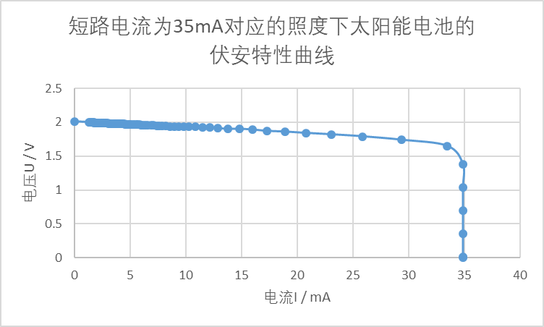**（6）根据表格1，拟合出U~I曲线，并上传曲线（6.5分）**

评分规则：

（a）坐标纸大小适中，不能太大或太小，坐标纸的最小分格是百分位；   
（b）标明直线的名称和横、纵坐标轴物理量及其单位；   
（c）实验数据落点要尽量均匀分布在直线两侧；

（d）在作出的直线上选取相距较远的两个非实验数据点，并标明所选点坐标及坐标值

**(7)调节短路电流**Is=25mA时，记录开路电压 $U_{0}$ (V)=_1.99V_ （5分）

评分规则：偏差在-2%~2%，得5分

偏差在-5%~5%，得2分

（8）调节短路电流大约为25mA. 逐步改变负载电阻值降低电流，分别读取电流和电压值，记入表格1中

|  |  |  |  |  |  |  |  |  |  |  |  |  |  |  |  |  |  |  |  |  |
| --- | --- | --- | --- | --- | --- | --- | --- | --- | --- | --- | --- | --- | --- | --- | --- | --- | --- | --- | --- | --- |
| **内容** | 1 | 2 | 3 | 4 | 5 | 6 | 7 | 8 | 9 | 10 | 11 | 12 | 13 | 14 | 15 | 16 | 17 | 18 | 19 | 20 |
| **I/mA** | 24.9 | 24.9 | 24.9 | 24.9 | 24.9 | 24.9 | 24.8 | 23.4 | 21.3 | 19.3 | 17.6 | 16.2 | 15.0 | 13.9 | 13.0 | 12.2 | 11.5 | 10.9 | 10.3 | 9.8 |
| **U/V** | 0.01 | 0.26 | 0.51 | 0.76 | 1.01 | 1.26 | 1.51 | 1.66 | 1.72 | 1.76 | 1.78 | 1.80 | 1.82 | 1.83 | 1.84 | 1.85 | 1.86 | 1.86 | 1.87 | 1.88 |
| **R/Ω** | 4E-01 | 1.0E+01 | 2.0E+01 | 3.1E+01 | 4.06E+01 | 5.06E+01 | 6.09E+01 | 7.09E+01 | 8.08E+01 | 9.12E+01 | 1.01E+02 | 1.11E+02 | 1.21E+02 | 1.32E+02 | 1.42E+02 | 1.52E+02 | 1.62E+02 | 1.71E+02 | 1.82E+02 | 1.9E+02 |
| **P/mW** | 2E-01 | 6.5E+00 | 1.3E+01 | 1.9E+01 | 2.51E+01 | 3.14E+01 | 3.74E+01 | 3.88E+01 | 3.66E+01 | 3.40E+01 | 3.13E+01 | 2.92E+01 | 2.73E+01 | 2.54E+01 | 2.39E+01 | 2.26E+01 | 2.14E+01 | 2.03E+01 | 1.93E+01 | 1.8E+01 |

**续表**

|  |  |  |  |  |  |  |  |  |  |  |  |  |  |  |  |  |  |  |  |  |
| --- | --- | --- | --- | --- | --- | --- | --- | --- | --- | --- | --- | --- | --- | --- | --- | --- | --- | --- | --- | --- |
| **内容** | 21 | 22 | 23 | 24 | 25 | 26 | 27 | 28 | 29 | 30 | 31 | 32 | 33 | 34 | 35 | 36 | 37 | 38 | 39 | 40 |
| **I/mA** | 9.3 | 8.9 | 8.5 | 8.2 | 7.8 | 7.5 | 7.3 | 7.0 | 6.8 | 6.5 | 6.3 | 6.1 | 5.9 | 5.8 | 5.6 | 5.4 | 5.3 | 5.2 | 5.0 | 4.9 |
| **U/V** | 1.88 | 1.89 | 1.89 | 1.89 | 1.90 | 1.90 | 1.90 | 1.90 | 1.91 | 1.91 | 1.91 | 1.91 | 1.92 | 1.92 | 1.92 | 1.92 | 1.92 | 1.92 | 1.92 | 1.93 |
| **R/Ω** | 2.0E+02 | 2.1E+02 | 2.2E+02 | 2.3E+02 | 2.4E+02 | 2.5E+02 | 2.6E+02 | 2.7E+02 | 2.8E+02 | 2.9E+02 | 3.0E+02 | 3.1E+02 | 3.3E+02 | 3.3E+02 | 3.4E+02 | 3.6E+02 | 3.6E+02 | 3.7E+02 | 3.8E+02 | 3.9E+02 |
| **P/mW** | 1.7E+01 | 1.7E+01 | 1.6E+01 | 1.5E+01 | 1.5E+01 | 1.4E+01 | 1.4E+01 | 1.3E+01 | 1.3E+01 | 1.2E+01 | 1.2E+01 | 1.2E+01 | 1.1E+01 | 1.1E+01 | 1.1E+01 | 1.0E+01 | 1.0E+01 | 1.0E+01 | 9.6E+00 | 9.5E+00 |

**续表**

|  |  |  |  |  |  |  |  |  |  |  |  |  |  |  |  |  |  |  |  |  |
| --- | --- | --- | --- | --- | --- | --- | --- | --- | --- | --- | --- | --- | --- | --- | --- | --- | --- | --- | --- | --- |
| **内容** | 41 | 42 | 43 | 44 | 45 | 46 | 47 | 48 | 49 | 50 | 51 | 52 | 53 | 54 | 55 | 56 | 57 | 58 | 59 | 60 |
| **I/mA** | 4.8 | 4.7 | 4.6 | 4.5 | 4.4 | 4.3 | 4.2 | 4.1 | 4.0 | 3.9 | 3.8 | 3.7 | 3.6 | 3.5 | 3.4 | 3.3 | 3.2 | 3.1 | 3.0 | 2.9 |
| **U/V** | 1.93 | 1.93 | 1.93 | 1.93 | 1.93 | 1.93 | 1.93 | 1.93 | 1.93 | 1.94 | 1.94 | 1.94 | 1.94 | 1.94 | 1.94 | 1.94 | 1.94 | 1.94 | 1.94 | 1.94 |
| **R/Ω** | 4.0E+02 | 4.1E+02 | 4.2E+02 | 4.3E+02 | 4.4E+02 | 4.5E+02 | 4.6E+02 | 4.7E+02 | 4.8E+02 | 5.0E+02 | 5.1E+02 | 5.2E+02 | 5.4E+02 | 5.5E+02 | 5.7E+02 | 5.9E+02 | 6.1E+02 | 6.3E+02 | 6.5E+02 | 6.7E+02 |
| **P/mW** | 9.3E+00 | 9.1E+00 | 8.9E+00 | 8.7E+00 | 8.5E+00 | 8.3E+00 | 8.1E+00 | 7.9E+00 | 7.7E+00 | 7.6E+00 | 7.4E+00 | 7.2E+00 | 7.0E+00 | 6.8E+00 | 6.6E+00 | 6.4E+00 | 6.2E+00 | 6.0E+00 | 5.8E+00 | 5.6E+00 |

**续表**

|  |  |  |  |  |  |  |  |  |  |  |  |  |  |  |  |  |  |  |
| --- | --- | --- | --- | --- | --- | --- | --- | --- | --- | --- | --- | --- | --- | --- | --- | --- | --- | --- |
| **内容** | 61 | 62 | 63 | 64 | 65 | 66 | 67 | 68 | 69 | 70 | 71 | 72 | 73 | 74 | 75 | 76 | 77 | 78 |
| **I/mA** | 2.8 | 2.7 | 2.6 | 2.5 | 2.4 | 2.3 | 2.2 | 2.1 | 2.0 | 1.9 | 1.8 | 1.8 | 1.7 | 1.6 | 1.5 | 1.5 | 1.4 | 1.3 |
| **U/V** | 1.95 | 1.95 | 1.95 | 1.95 | 1.95 | 1.95 | 1.95 | 1.95 | 1.95 | 1.95 | 1.95 | 1.96 | 1.96 | 1.96 | 1.96 | 1.98 | 1.98 | 1.98 |
| **R/Ω** | 7.0E+02 | 7.2E+02 | 7.5E+02 | 7.8E+02 | 8.1E+02 | 8.5E+02 | 8.9E+02 | 9.3E+02 | 9.8E+02 | 1.0E+03 | 1.1E+03 | 1.1E+03 | 1.2E+03 | 1.2E+03 | 1.3E+03 | 1.3E+03 | 1.4E+03 | 1.5E+03 |
| **P/mW** | 5.5E+00 | 5.3E+00 | 5.1E+00 | 4.9E+00 | 4.7E+00 | 4.5E+00 | 4.3E+00 | 4.1E+00 | 3.9E+00 | 3.7E+00 | 3.5E+00 | 3.5E+00 | 3.3E+00 | 3.1E+00 | 2.9E+00 | 3.0E+00 | 2.8E+00 | 2.6E+00 |

**评分规则：不评分**

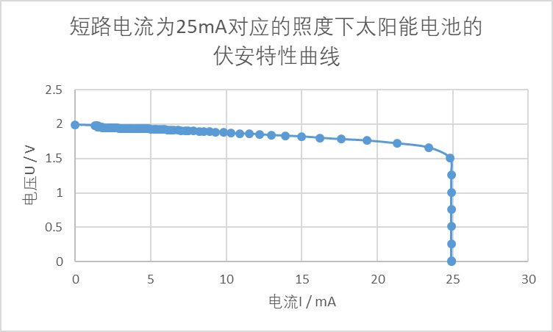**（9）根据表格1，拟合出U~I曲线，并上传曲线（6.5分）**

评分规则：

（a）坐标纸大小适中，不能太大或太小，坐标纸的最小分格是百分位；   
（b）标明直线的名称和横、纵坐标轴物理量及其单位；   
（c）实验数据落点要尽量均匀分布在直线两侧；

（d）在作出的直线上选取相距较远的两个非实验数据点，并标明所选点坐标及坐标值

**(10)调节短路电流**Is=15mA时，记录开路电压 $U_{0}$ (V)=_1.92V_ （5分）

评分规则：偏差在-2%~2%，得5分

偏差在-5%~5%，得2分

（11）调节短路电流大约为15mA. 逐步改变负载电阻值降低电流，分别读取电流和电压值，记入表格1中

|  |  |  |  |  |  |  |  |  |  |  |  |  |  |  |  |  |  |  |  |  |
| --- | --- | --- | --- | --- | --- | --- | --- | --- | --- | --- | --- | --- | --- | --- | --- | --- | --- | --- | --- | --- |
| **内容** | 1 | 2 | 3 | 4 | 5 | 6 | 7 | 8 | 9 | 10 | 11 | 12 | 13 | 14 | 15 | 16 | 17 | 18 | 19 | 20 |
| **I/mA** | 15.0 | 15.0 | 15.0 | 15.0 | 15.0 | 15.0 | 15.0 | 15.0 | 15.0 | 14.9 | 14.4 | 13.6 | 12.8 | 12.1 | 11.4 | 10.8 | 10.2 | 9.7 | 9.2 | 8.8 |
| **U/V** | 0.00 | 0.31 | 0.46 | 0.61 | 0.77 | 0.92 | 1.07 | 1.22 | 1.37 | 1.52 | 1.62 | 1.67 | 1.70 | 1.72 | 1.74 | 1.76 | 1.77 | 1.78 | 1.79 | 1.79 |
| **R/Ω** | 0E+00 | 2.1E+01 | 3.1E+01 | 4.1E+01 | 5.1E+01 | 6.1E+01 | 7.13E+01 | 8.13E+01 | 2.74E+02 | 1.02E+02 | 1.13E+02 | 1.23E+02 | 1.33E+02 | 1.42E+02 | 1.53E+02 | 1.63E+02 | 1.74E+02 | 1.8E+02 | 1.9E+02 | 2.0E+02 |
| **P/mW** | 0E+00 | 4.7E+00 | 6.9E+00 | 9.2E+00 | 1.2E+01 | 1.4E+01 | 1.61E+01 | 1.83E+01 | 6.85E+00 | 2.26E+01 | 2.33E+01 | 2.27E+01 | 2.18E+01 | 2.08E+01 | 1.98E+01 | 1.90E+01 | 1.81E+01 | 1.7E+01 | 1.6E+01 | 1.6E+01 |

**续表**

|  |  |  |  |  |  |  |  |  |  |  |  |  |  |  |  |  |  |  |  |  |
| --- | --- | --- | --- | --- | --- | --- | --- | --- | --- | --- | --- | --- | --- | --- | --- | --- | --- | --- | --- | --- |
| **内容** | 21 | 22 | 23 | 24 | 25 | 26 | 27 | 28 | 29 | 30 | 31 | 32 | 33 | 34 | 35 | 36 | 37 | 38 | 39 | 40 |
| **I/mA** | 8.4 | 8.1 | 7.7 | 7.4 | 7.2 | 6.9 | 6.7 | 6.4 | 6.2 | 6.0 | 5.8 | 5.7 | 5.5 | 5.3 | 5.2 | 4.9 | 4.8 | 4.7 | 4.6 | 4.5 |
| **U/V** | 1.80 | 1.81 | 1.81 | 1.82 | 1.82 | 1.83 | 1.83 | 1.83 | 1.84 | 1.84 | 1.84 | 1.84 | 1.85 | 1.85 | 1.85 | 1.86 | 1.86 | 1.86 | 1.86 | 1.86 |
| **R/Ω** | 2.1E+02 | 2.2E+02 | 2.4E+02 | 2.5E+02 | 2.5E+02 | 2.7E+02 | 2.7E+02 | 2.9E+02 | 3.0E+02 | 3.1E+02 | 3.2E+02 | 3.2E+02 | 3.4E+02 | 3.5E+02 | 3.6E+02 | 3.8E+02 | 3.9E+02 | 4.0E+02 | 4.0E+02 | 4.1E+02 |
| **P/mW** | 1.5E+01 | 1.5E+01 | 1.4E+01 | 1.3E+01 | 1.3E+01 | 1.3E+01 | 1.2E+01 | 1.2E+01 | 1.1E+01 | 1.1E+01 | 1.1E+01 | 1.0E+01 | 1.0E+01 | 9.8E+00 | 9.6E+00 | 9.1E+00 | 8.9E+00 | 8.7E+00 | 8.6E+00 | 8.4E+00 |

**续表**

|  |  |  |  |  |  |  |  |  |  |  |  |  |  |  |  |  |  |  |  |  |
| --- | --- | --- | --- | --- | --- | --- | --- | --- | --- | --- | --- | --- | --- | --- | --- | --- | --- | --- | --- | --- |
| **内容** | 1 | 2 | 3 | 4 | 5 | 6 | 7 | 8 | 9 | 10 | 11 | 12 | 13 | 14 | 15 | 16 | 17 | 18 | 19 | 20 |
| **I/mA** | 4.4 | 4.3 | 4.2 | 4.1 | 4.0 | 3.9 | 3.8 | 3.7 | 3.6 | 3.5 | 3.5 | 3.4 | 3.3 | 3.2 | 3.1 | 3.0 | 2.9 | 2.8 | 2.8 | 2.7 |
| **U/V** | 1.86 | 1.86 | 1.87 | 1.87 | 1.87 | 1.87 | 1.87 | 1.87 | 1.87 | 1.87 | 1.88 | 1.88 | 1.88 | 1.88 | 1.88 | 1.88 | 1.88 | 1.88 | 1.89 | 1.89 |
| **R/Ω** | 4.2E+02 | 4.3E+02 | 4.5E+02 | 4.6E+02 | 4.7E+02 | 4.8E+02 | 4.9E+02 | 5.1E+02 | 5.2E+02 | 5.3E+02 | 5.4E+02 | 5.5E+02 | 5.7E+02 | 5.9E+02 | 6.1E+02 | 6.3E+02 | 6.5E+02 | 6.7E+02 | 6.8E+02 | 7.0E+02 |
| **P/mW** | 8.2E+00 | 8.0E+00 | 7.9E+00 | 7.7E+00 | 7.5E+00 | 7.3E+00 | 7.1E+00 | 6.9E+00 | 6.7E+00 | 6.5E+00 | 6.6E+00 | 6.4E+00 | 6.2E+00 | 6.0E+00 | 5.8E+00 | 5.6E+00 | 5.5E+00 | 5.3E+00 | 5.3E+00 | 5.1E+00 |

**续表**

|  |  |  |  |  |  |  |  |  |  |  |  |  |  |  |  |  |  |
| --- | --- | --- | --- | --- | --- | --- | --- | --- | --- | --- | --- | --- | --- | --- | --- | --- | --- |
| **内容** | 61 | 62 | 63 | 64 | 65 | 66 | 67 | 68 | 69 | 70 | 71 | 72 | 73 | 74 | 75 | 76 | 77 |
| **I/mA** | 2.6 | 2.5 | 2.4 | 2.3 | 2.2 | 2.1 | 2.0 | 2.0 | 1.9 | 1.8 | 1.7 | 1.6 | 1.5 | 1.4 | 1.3 | 1.3 | 1.2 |
| **U/V** | 1.89 | 1.89 | 1.89 | 1.89 | 1.89 | 1.89 | 1.89 | 1.90 | 1.90 | 1.90 | 1.90 | 1.90 | 1.90 | 1.90 | 1.90 | 1.91 | 1.91 |
| **R/Ω** | 7.3E+02 | 7.6E+02 | 7.9E+02 | 8.2E+02 | 8.6E+02 | 9.0E+02 | 9.5E+02 | 9.5E+02 | 1.0E+03 | 1.1E+03 | 1.1E+03 | 1.2E+03 | 1.3E+03 | 1.4E+03 | 1.5E+03 | 1.5E+03 | 1.6E+03 |
| **P/mW** | 4.9E+00 | 4.7E+00 | 4.5E+00 | 4.3E+00 | 4.2E+00 | 4.0E+00 | 3.8E+00 | 3.8E+00 | 3.6E+00 | 3.4E+00 | 3.2E+00 | 3.0E+00 | 2.9E+00 | 2.7E+00 | 2.5E+00 | 2.5E+00 | 2.3E+00 |

**评分规则：不评分**

**（12）根据表格1，拟合出U~I曲线，并上传曲线（6.5分）**

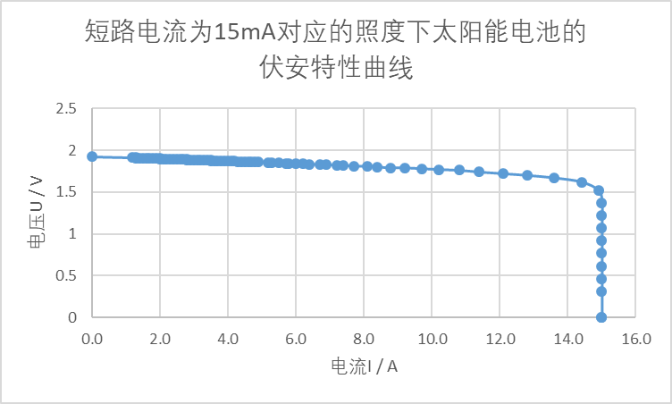

评分规则：

（a）坐标纸大小适中，不能太大或太小，坐标纸的最小分格是百分位；   
（b）标明直线的名称和横、纵坐标轴物理量及其单位；   
（c）实验数据落点要尽量均匀分布在直线两侧；

（d）在作出的直线上选取相距较远的两个非实验数据点，并标明所选点坐标及坐标值

★ **2.** 在不同照度下，测量太阳能电池的最大功率

(1)将最大功率Pmax和开路电压与短路电流的乘积填入下表（24分）

|  |  |  |  |  |
| --- | --- | --- | --- | --- |
| 测量值/组数 | 第一组 | 第二组 | 第三组 | 第四组 |
| Pmax/mW | 72.3 | 55.3 | 38.8 | 23.3 |
| (Uo*Is)/mW | 92.0 | 70.1 | 49.6 | 28.8 |
| F=Pmax/(Uo*Is) | 0.785 | 0.788 | 0.784 | 0.809 |

评分规则：

Pmax:

偏差在-2%~2%，得2分

偏差在-5%~5%，得1分

(Uo*Is)：

偏差在-2%~2%，得2分

偏差在-5%~5%，得1分

F：

偏差在-2%~2%，得2分

偏差在-5%~5%，得1分

**六、思考题**       总分值：5分

1. 温度会对太阳能电池带来什么影响？

（1）温度对开路电压的影响：温度升高，晶格膨胀，原子间距增大，且温度升高也导致费米面更接近价带，这两方面共同作用，从而导致禁带宽度变窄，开路电压减小；

（2）温度对短路电流的影响；温度升高导致禁带宽度变窄，入射光更容易激发出光生电子-空穴对，因此在相同照度下，有更多的光生电子-空穴对产生，短路电流增大；

（3）温度对输出功率的影响：一般来说，温度升高导致开路电压下降的影响比导致短路电流升高的影响更为显著，因此在一定照度下温度升高往往导致太阳能电池输出功率降低.

**七、实验总结**

本次实验分别在四个不同照度的光照下，通过改变负载阻值，测量了太阳能电池的伏安特性曲线、开路电压 $U_{0}$ 和短路电流 $I_{S}$，并计算得到了对应的最大功率和填充因数.