【说明】 区别于往次作业，本次作业所有题目选择依据，均以源代码形式保存于./sourcecode文件路径下，其中第X题对应的源代码文件命名为solutionX.sas

1、选择d.

select Rep, min(Cost+Ship)

from WORK.TRANSACT

group by Rep

order by Rep;

2、选择a.

JONES 280

JONES 280

SMITH 280

SMITH 280

SMITH 280

3、选择c. outer union corr

4、选择a.

select Id, sum(Expense) label='COST'

from WORK.VISIT1

group by 1

union all

select Id, sum(Cost)

from WORK.VISIT2

group by 1

order by 1,2;

5、选择a.

Common X Y

------ --- --

A 10 1

A 13 3

B 14 4

B 9 2

6、选择b. select Salary, Salary*.10 label='Bonus'

7、选择b. except all

8、选择d. having Average > (select avg(Cost) from WORK.ONE)

9、选择c. full join

10、见 ./sourcecode/solution10.sas 程序源代码。运行结果如下：

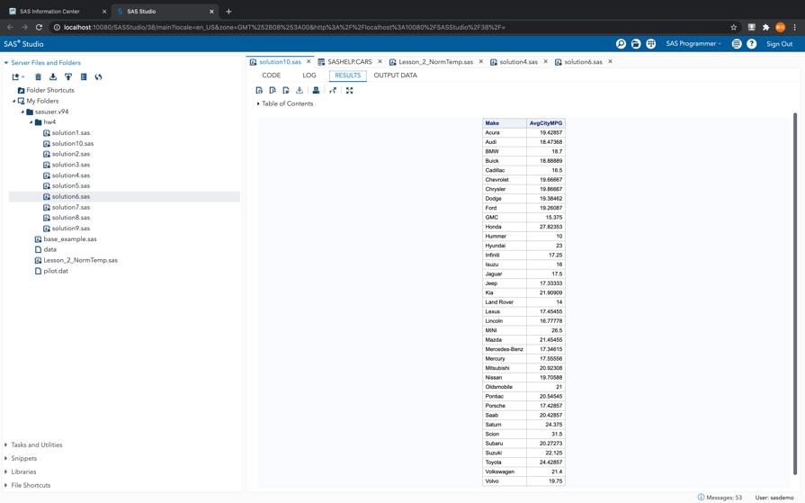

郑重声明

**本作业由作者独立完成。抄袭行为在任何情况下都是不能容忍的(COPY is strictly prohibited under any circumstances)！由抄袭所产生的一切后果由抄袭者承担，勿谓言之不预也。**

**陈麒先**