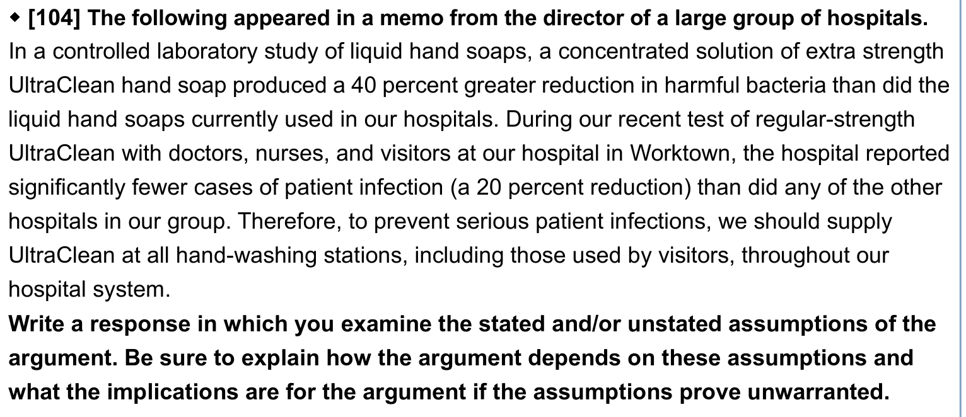

The author claimed that supplying UltraClean hand soap throughout their hospital system can prevent serious patient infections. This recommendation bases (is based) on the laboratory study result that UltraClean hand soap can reduce more harmful bacteria and the test at their hospital which reported fewer cases of patient infection than other hospitals. The argument, however, needs to be explained from the implication as well stated or unstated assumptions to prove unwarranted for the conclusion.

Citing ~~from~~ the controlled laboratory study of liquid hand soaps and the test of patient infection rate from hospitals, it is absolutely baseless as the arguer mentions utilizing UltraClean hand soap can prevent patient infections. The arguer has not mentioned that UltraClean hand soap can inhibit all the sources of infection. As is known, many infectious diseases are caused by organisms, take bacteria, fungi, and viruses for instance. Not only harmful bacteria contribute~~s~~ to serious symptoms, but viruses also cause a deadly impact. Furthermore, the arguer has not mentioned the exact date of their “recent” test in Worktown. We cannot ensure that the environment has not changed drastically since they carried out the test between hospitals. It is possible that the pandemic had appeared 6 months ago before that the infection rate of certain diseases increased, however, after 4 months, the curve of thenumber of cases becomes flattening (flattened) (這段邏輯不懂)pandemic 高峰期過了. (infection rate decrease 因為policy)If the epidemic has been controlled by the compulsory policies from the government, we cannot hastily promise the effectiveness of the UltraClean hand soap.

If the epidemic has already reached its peak and the cases start to decrease. The infection rate has not decreased until the compulsory policies adopted by the government work successfully. In short, there is no evidence to indicate that the significantly fewer cases of patient infection and the implementation of the UltraClean hand soap have a direct cause and effect relation.

On the same note, a 20 percent reduction of (in) patient infection seems quite impressive. But something is missing: the absolute numbers on which this percentage is based. Wouldn’t we be less alarmed if we knew this decrease was 5 patients to 4 patients, rather than 200 patients to 160 patients? If the test was taken during the pandemic, it is reasonable that there are fewer patients who prefer to go to hospitals. Additionally, the author presumes that liquid hand soap can substantially prevent infection. Other factors may also lead to this consequence. To be more concise, there are many methods to control the environment~~s~~ in hospitals. For instance, conducting restrictions on mass gathering, taking crowd control measures, and applying disinfectants appropriately in your surroundings. (沒有動詞?) These are also some methods that CDC recommends people to protect themselves from infectious diseases. Unless the evidence about which method is most optical is provided, we cannot make a quick conclusion that utilizing UltraClean at all hand-washing stations is the most plausible way.

In addition, the argument rests on the assumption that, according to the report in the laboratory, only harmful bacteria cause serious infections. Some bacteria seem not immediately noxious to a healthy man, on the contrary, it can be quite perilous for a chronic disease patient. For example, Periodontal Disease can be infectious to those who have a weakened immune system. If the UltraClean hand soap can produce a reduction in harmful bacteria for healthy people, does it have the same result (impact) on a weak person? Or if a patient can not block the invasion of the bacteria which does not infect healthy people, while people believe that hand soap can defend against the disease, will it increase the risk of patient infections? (用否定比較好?難道不會造成感染上升) In such a case, the author’s assertion that UltraClean can reduce ~~the~~ patient infections in hospitals is hasty and porous.

In conclusion, the argument is not completely sound. The evidence in support of the conclusion is not enough to prove the conclusion – that using UltraClean hand soap is the top decision for reducing infections in hospitals—because it failed to address the several points mentioned above. To strengthen the argument, the author can make it plain that (through?) the absolute cases of infection in the hospital, the exact date of the test, and a more thorough analysis of infections in different health conditions.

controlled lab study 條件可能與外面環境不同

小推大：assumption: UltraClean可以抑制所有感染 bacteria到infection (patient infection也可能由病毒引起

a2:只有洗手乳能抑制感染? 除了handsoap 管控人流? 人多的空間增設酒精消毒/ 定時以次氯酸水消毒呢

打數字 20% seems impressive, however, during pandamic period 很少人出門看去醫院 5個人感染變成四個人感染宇是降低20%5

實驗室說的harmful 是否是指重大住院的感染 但很多bacteria對健康的人來說沒有影響 是對有慢性病的人有影響 這也可能造成lab數據和真實運用在醫院的誤差

e.g.牙周病會傳染 但是要對免疫力低下的人才會有立即的傷害 萬一此款洗手乳無法對付其實harmful的細菌，是否會對醫院內的病人造A成感染?

recent 打時間