The manager of Happy Pancake House restaurants claims that Happy Pancake House should replace butter with margarine in their restaurants throughout the rest of (the) country. While it may be true that this strategy can save money and it seems to be successful throughout the southwestern United States, there are still some assumptions that need to be evaluated. The argument, however, needs to explain from the implication as well stated or unstated assumptions to prove unwarranted for the conclusion.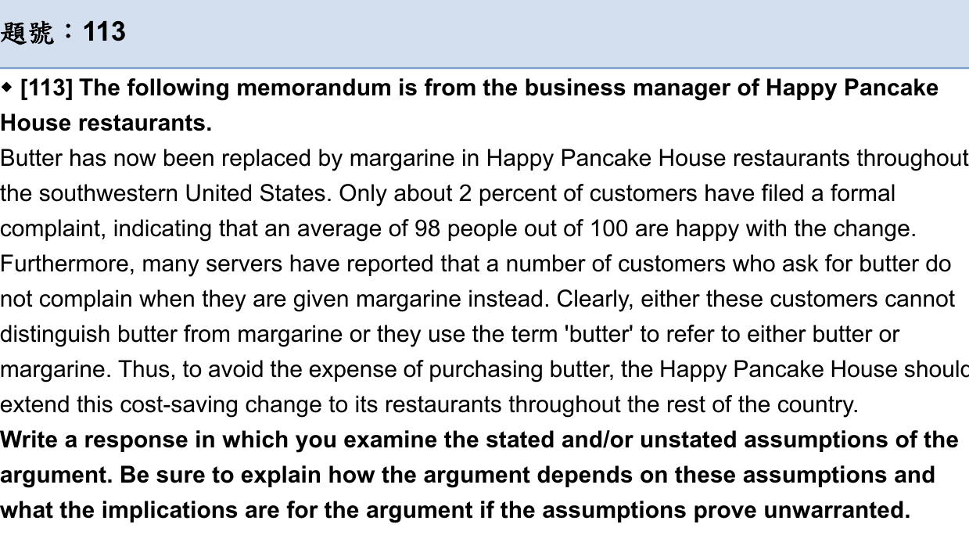

Citing the report from the servers, we need to know if the Happy Pancake House can conduct the survey independently and professionally. For example, the servers could ask the customers if(which) they prefer ,buffer or ma ,but tell the customers that butter has sold out and the customers can spend less money if they choose margarine. The sample of customers may not have been representative of formal complaints, asking those who are more willing to spend less money on dishes. Moreover, there is no absolutely (absolute) evidence provided that many people are happy with the change. Only 2 percent of customers filed (filling) a formal complaint seems quite impressive. But something is missing: the absolute numbers on which this percentage is based. Wouldn’t we be alarmed if we knew this number of complaints was from ~~complaints from customers to~~ 400 complaints from 20000 customers, rather than 2 people out of 100?

Even though assuming the number of complaints is at a low rate, the author still fails to consider the preference of the customers on the whole. To be more concise, although people do not grumble about butter, they got the margarine (getting margarine instead), we cannot ensure will they (whether they will) come to the restaurants again since the service of the restaurants cannot totally satisfy their needs. Additionally, the argument rests on the assumption~~s~~ that since the customers are not able to differentiate butter and margarine, they have fewer complaints about the substitute of the ingredients. This line of reasoning is invalid in certain critical respects. (<-這段前後關係?->)If one suggests that the quality of butter deteriorates, he/she may not tell the server because of his/her busy schedule. If a customer who is a butter lover does not denounce the ingredient and tell the server, it is more likely for the butter lover to choose other pancake houses once they need to make a decision. In such a case, the author’s assertion that costumers (customers) do not grumble about the margarine since they cannot distinguish it from butter is hasty and porous.

Finally, people in southwestern ~~of the~~ United States complain little is (an) insufficient evidence to warrant the author’s recommendation. We cannot hastily make the conclusion based on the information because the situation in the southwestern might just be one of the facts that can not be used to assess all cases. Precisely speaking, what is known in the information provided by servers cannot apply the cases to customer preference throughout the States.

In sum, the argument is not completely sound. This evidence in support of the conclusion is not solid enough to prove the conclusion—that rather than providing butter, providing margarine is a cost-saving way to the restaurants (這個寫法好像有點改變作者主張)complaint /margarine關係—because it failed to address the several points I have raised. To strengthen the argument, the author can make it plain the exact number of complaints and the inclination of customers after they apply this change.