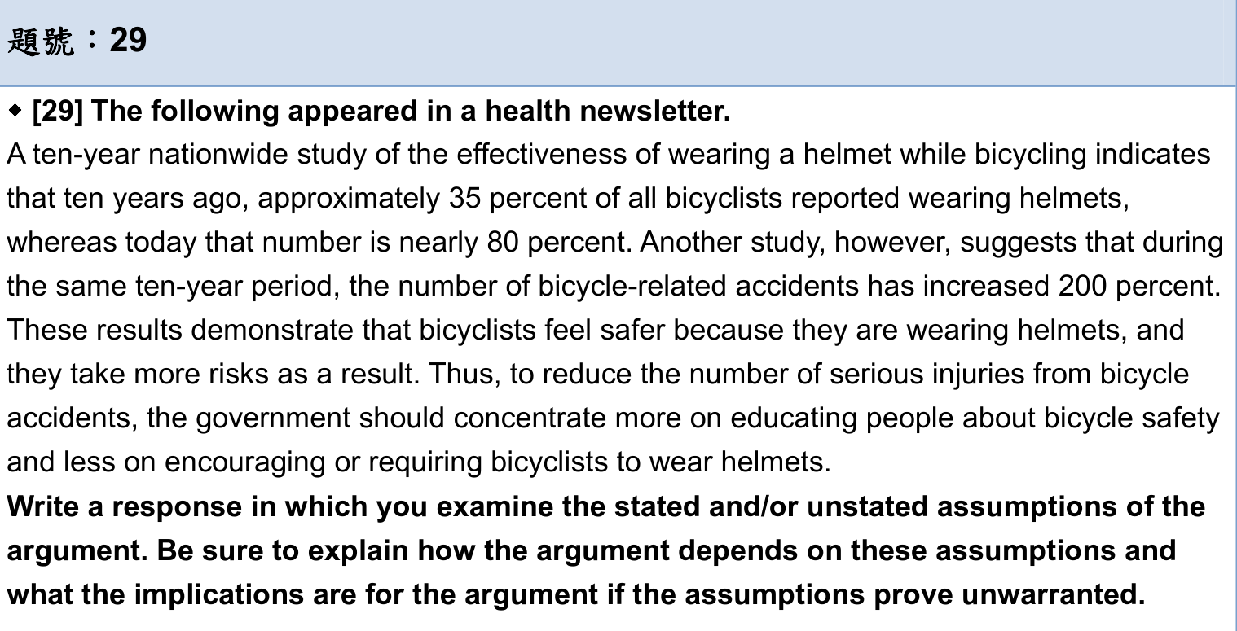

The author claimed that rather than encouraging bicyclists to wear helmets, the government should educate them about bicycle safety to reduce serious accidents. While it may be true that wearing a helmet does not reduce bicycle-related accidents according to the study mentioned in the argument. This argument, however, is rife with holes and assumptions, and thus, not strong enough to lead to the action that the government tries to take.

Citing the ten-year nationwide study from the newsletter, the ratio of bicyclists wearing helmets grows from 35 to 80 percent in ten years. 80 percent seems quite impressive. But something is missing: the absolute numbers on which this percentage is based. To be more concise, we can not ensure that the exact number of bicyclists who wear helmets has increased during the ten years. Maybe it is the total number of bicyclists increases enormously that causes the total number of accidents to increase. Moreover, there is absolutely no evidence provided that another study which pointed out the number of bicycle-related accident has increased during ten years has the same participants with the former study. If the latter study mentioned above only considered students in high schools and universities as their participants? If the students may be under higher risk of accidents that they need to arrive to school on time. We can not know. Unless the author provides sufficient information about the exact number people who ride bikes and the participants in the study, we can not make a quick conclusion of the accidents that has increased in ten years with such information.

Even though assuming wearing helmets is not an effective way to reduce accidents for the bicyclists, the author still fails to consider the serious injuries are caused the unawareness of people who wear helmets on the whole. In other words, bicycle-related accidents are not always severe, and there are several accidents that only cause little scrapes. Also, Helmets are protective gear which is intended to reduce the effect of accidents. Maybe a person will get more serious injuries if he or she does not wear a helmet. Furthermore, we can not rashly conclude that the accidents are caused by bicyclists. If the total number of the bicyclists decrease and the government decides to merge the Bike Exclusive Lane into Bike and Motorbike Lane, will the vehicle accidents increase? In such a case, the author’s assertion that serious injuries often cause by the unawareness of people who wear helmets is hasty and porous.

Furthermore, the author fails to construct the causal relationship between the population of wearing helmets and the bicycle-related accidents. In other words, to lead to traffic accidents, there are many other possible explanations, such as the road condition ten years ago may be better than now due to the bike usage rate was higher at that time. Since the number of bicyclists has decreased, the government then put their capital into maintaining the other traffic projects. Also, when we put bicycle safety education into practice, the government needs to put down capital for new educational program. This further action is skeptical in terms of reducing serious injuries. Whatever how promising the future assumption is, the policy has to be made, which might be a risky decision for the original stable condition. Thus, by adopting the new policy, which only encourages the on educating the public safety knowledge, may be not comprehensive enough.

In conclusion, the argument is not completely sound. The evidence in support the conclusion is not solid enough to prove the conclusion—that educating people about bicycle safety will be more effective than wearing helmets in preventing serious injuries—because it failed to address the several points I have raised. To strengthen the argument, the author can make it plain that the exact number of people wearing helmets, a more detailed piece of information about accidents, and the traffic conditions for bicyclists.

劉柏寬:

1. **has the same participants 只有這段覺得不對**

Allen: 紅字是我的部分

OK 感謝