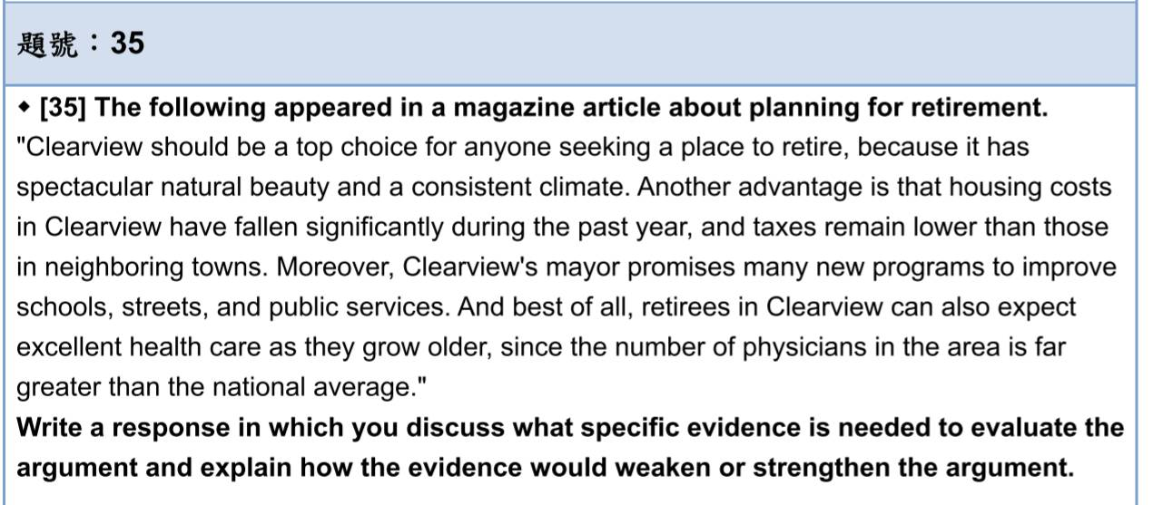The author claimed that Clearview is the best choice for anyone seeking a place to retire. While it may be true that this town has beautiful scenery and a consistent climate that can attract people to live there. However, more pieces of specific evidence are warranted to evaluate whether Clearview is suitable ~~to~~(for) every retiree.

In the first place, the author assumed that Clearview is the most livable place for housing costs in Clearview have fallen significantly last year. What the author mentioned seems quite impressive. But something is missing: the absolute numbers on the housing costs. Wouldn’t we be less interested in this if we know that the exact total of housing costs and taxes are higher in Clearview than those other neighboring towns? Unless the author provides a sufficient number to examine the total costs, we cannot hastily make a conclusion of the advantage to live in Clearview. Also, the arguer has not mentioned whether the crime rate in Clearview is relatively high or low compar~~ing~~ed to other towns. If, for example, there are a lot of robberies and burglaries, the retirees will be anxious ~~for~~(about) being a victim of crime, which is not an ideal retire(ment) life for most people.

In the second place, the author has focused only on the numbers of physicians ~~is~~ greater than (the) national average. A more detailed analysis of the medical specialty might reveal the dearth of some specialties for (the) elderly. Take Ophthalmologists and Surgeons for instance. Many elderlies are suffer from blurred vision and cardiovascular disease, which need ~~the~~ medical prescriptions from Ophthalmologists and Surgeons. Besides, some physicians have (an) inclination to open a clinic than to work in (a) hospital. (We cannot ensure the number of the hospitals in this town is enough to provided for elderly. If an elderly person had a stroke, is it available for the patient to accept the treatment immediately? Unless it can be shown that the health care centers in Clearview have included comprehensive and sufficient medical teams, the medical condition in Clearview cannot guarantee ~~the~~ excellent health care for anyone seeking a place to retire.

Even though the medical condition in Clearview is feasible for the comprehensive medical team, the author still fails to consider the distance to the health care center in the whole picture. In other words, according to (the) author, Clearview is a town with spectacular natural beauty. Suppose this town is surrounded by mountains and the health care centers are only located ~~in~~ downtown, if a retiree with reduced mobility needs to do rehabilitation, it is inconvenient and time-consuming for him or her to move that far. In addition, ~~the~~ Clearview’s mayor promises to improve public facilities. We do not know the original condition of these facilities and the specific improv~~ing~~ment plans for the schools, streets, and ~~the~~ public services. Perhaps these programs are more applicable to high school students since they utilize libraries or gyms more often than retirees. Without(applying) accounting for (taking account of) these other potential factors, the author fails to provide a convincing argument that the medical condition and the public services are suitable for retirees.

In conclusion, the argument is not completely sound. The evidence in support (of) the conclusion is not enough to prove the conclusion—that Clearview is the top decision for people seeking a place to retire—because it failed to address the several points mentioned above. To strengthen the argument, the author can make it plain that the absolute number of housing costs in Clearview and a more thorough analysis of (the) health care system including medical specialty and distances to the hospital.

草稿:

B1:數據未提供 housing cost have fallen? 多少 也許原本housing+tax比隔壁鎮貴超多 雖然大降下來且tax比隔壁鎮便宜 total 仍較貴?

證據未提供 犯罪率怎麼樣 便宜是否是因為治安不佳?

B2:

數據未提供 比全國多出多少內科醫生? 醫生種類呢 眼科(opthalmologist)

只有醫師夠嗎?是診所多還是醫院多 ? 也許只能治依些小感冒 但是CVA呢?醫療團隊夠多嗎 healthcare center夠嗎? 也許這才是最重要的

B3:

natural beauty 是否表示其實這裡地廣人稀 萬一醫生多但是都集中down town商業區呢? 就醫不方便對老人來說是否為不適合退休人士

promises new programs, 可否提供比較 或是原本這些設施的狀態? 如果已經很老舊 那也需要花很多時間才有可能

目前也只有promise 沒有更具體的操作時間或是規劃