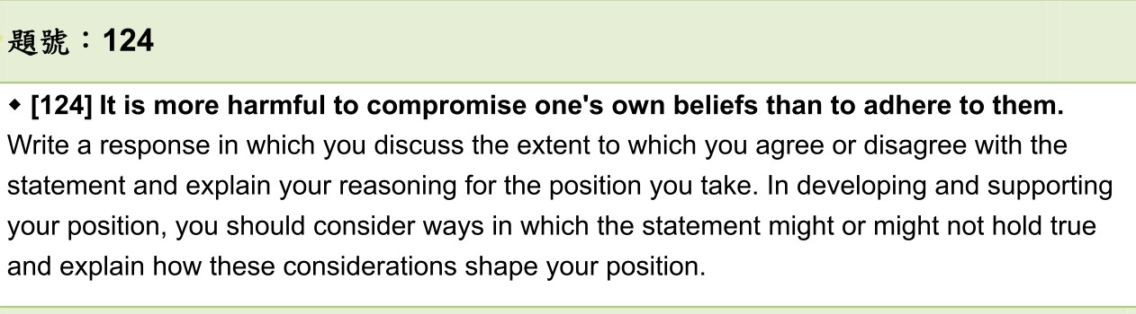

Must we choose between compromising our own beliefs and adhering to them, as the speaker contends? I agree that in certain cases, the two are mutually exclusive. However, for the most part, compromising ~~to~~ your own beliefs does not mean to relinquish all of them. Examples from democratic movements, restaurants strategies, and business guides to success might lend credence to my position.

Admittedly, some benefits are thwarted by one’s own beliefs. (正向) Some crises may switch to turning points or even better opportunities if one could reconcile himself/herself to change (changing) in some trivial parts. Consider some traditional restaurants, for example. Many restaurants resist the take-out services for presenting the~~ir~~ satisfying dishes because they claim that only by dining in the restaurants can the guests savor the impeccable taste of food. However, during the COVID-19 pandemic, it is not allowed to dine in the restaurants according to the regulations of infection prevention. The restaurants eventually alter their services, by means of cooperating with food delivery platforms, in order to run their business and guarantee their employees’ jobs.

Nonetheless, insisting on beliefs that you buttress also plays a pivotal role in accomplishment. Certainly, some generally accepted thoughts, which endure~~s~~ for years, are not always the optimal choices ~~if someone can persuade the crowd to accept what he/she believes reasonably. 說服不同的地方 背景~~For example, democratic movements rise from people who are not satisfied with the situations and try hard to convince other(s) of what they urge to do for their country’s future. (Consider the Jasmine Revolution, for example. )Since// As for Jasmine Revolution, the autocracy regime persists for years which causes people in Tunisia a lack of political freedoms and high unemployment, they started street demonstrations to speak up for their rights. Unfortunately, while the crowd appealed for their freedom of speech and a better living condition(s), many ~~of~~ deaths and injuries attributed to police occurred. Many people sacrificed in this movement, but the Tunisian finally led to a thorough democratic country by this revolution. In short, if people do not cling to their faith which may also generate challenges, it will be implausible to take the actions or even achieve their goals.

Moreover, it is reasonable to take both compromising one’s belief and adhere (adhering) to one’s belief into account. Although these two may come into conflict under certain circumstances, it is crucial to find a balance between them. Take for instance the many teams of people working for Google. In this corporation, they find out that ~~a~~ good teamwork usually shares two characteristics: the same proportion for every member to speak and high average social sensitivity. Equality in distribution of communication makes sure that every member can deliver what they insist on, whereas social sensitivity acquaints the members with what others think. 選擇聆聽意見而非固執己見(這裡有點接不上下一句這個結論?) Moreover, One needs to modify obdurate(rebuke) opinion but remain the most important part if they (he/she) share(strive for) the same goal with their members. As a result, totally refusing to change or accepting all the ideas seems to be implausible in ~~a~~ teamwork.

In sum, aside from sweeping generalization that it is more harmful to compromise one’s belief than to stick to it, in some cases, applying some changes in your beliefs does lead you to success. Therefore, I only partially agree with the statement because people are able to succeed if they agree with others partially and amend their beliefs.

B1有時候需要對自己的信念妥協 才能獲得成功

e.g. 很多餐廳堅持不外帶是想要將最好吃的給客人吃，但在疫情時代，不改成外送無法做生意，因此很多餐廳轉為和外送平台合作

B2堅持對的信念是好事 才能突破現狀

e.g.民主運動 2000埃及茉莉花革命 香港雨傘革命

B3不需要完全妥協或完全固守 可以適時做改變 這也是我們需要團隊合作的原因

可以保留自己堅持的一部分 並且改變一部分 才能合作創造最大利益

e.g. google’s research for good teamwork