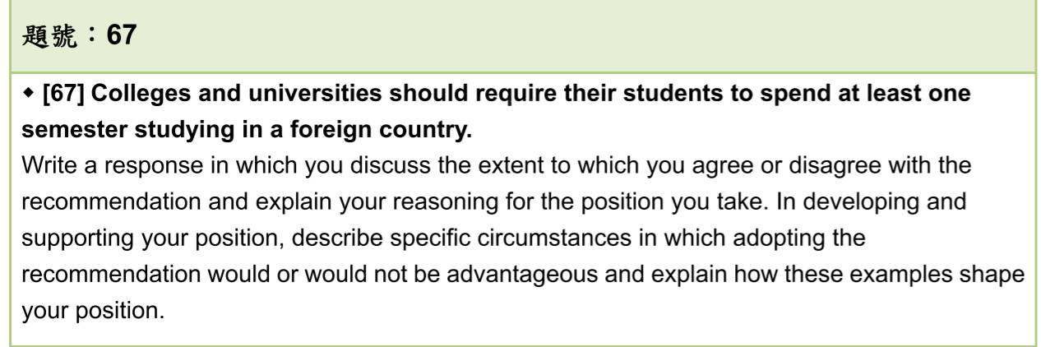

**Whether** universities should require their students to spend at least one semester studying abroad **depends primarily on the students’ specific conditions.** **In many cases,** studying at least one semester in a foreign country does benefit students.

The statement requires qualifications in two aspects. **First**, for certain students, who(suffer from student loans/cannot afford) are not prepared to pay student loans, going abroad will not be the first option if they still need to worry about their tuition fee. This is especially true for the student who needs to do a part-time job while studying; after all, why does a student need to study abroad when they cannot afford the cost which is more expensive than that in their country? **Secondly, the statement fails to consider** that in certain fields, the programs are too burdensome for a student to pass unless they really devoted themselves entirely to their assignments and exams. Examples abound in medicine, whose specialty must be cultivated by rigorous intern training.

**Despite the generalizations,** living and studying abroad serve to develop students’ abilities to become independent. Living abroad is not as easy as living in their countries. Take for instance the accommodation in foreign countries. The procedure to look for ideal rooms ~~that a student (mostly living in)~~ may be very onerous to a foreigner. Also, not all landlords welcome a foreigner to rent their apartments since some landlords assume that foreigners have inappropriate behaviors and (are) difficult to communicate (with).

(To overcome these difficulties, they 要靠自己找書、主動問同學去解決困難) Thus, through these challenges, students living abroad ~~can be more flexible and~~ (have) more courage to handle every task ~~with~~ (on) their own. (缺點介紹太多?)

The second reason is that (broaden their horizon 後面再詳細描述foreign language跟culture )being proficient in foreign languages requires students to stay one semester or even longer. Once you live in a place over one month, you will find some differences in language usage that you did not notice at first glance. There are many tips that you cannot acquire from textbooks. For instance, some collocations will only appear in occasional contexts. People are more likely to use some slang~~s~~ during their talks which makes the atmosphere livelier. In addition, students get more opportunities to experience the exotic cultures if they stay abroad for at least one semester. One month may be enough for a tourist to explore some renown sites, however, if one really wants to experience what the locals live and learn to accept some culture shocks, it is crucial to spend for a while to really get a taste of life there. In short, real experience and learning for languages and culture take time but the results are worth it.

**To sum up, aside from the sweeping generalization that every college and university student should study in a foreign country at least one semester**, I fundamentally agree that students will be more independent and acquire a foreign language fluently(精熟地) (learn foreign language deeply)through experiencing exotic cultures and learning abroad.

B1:修正條件：考量金錢 不是每個學生都能出國留學

B2:大學生已夠成熟且獨立來面對生活在別的國家 也能培養獨立自主

e.g. 到一個語言相通的國家 雖然法律不同 還是可以自己handle every tasks (rent a house, health insurance) 還能有其他好處:增廣見聞

~~e.g. 歷史系學生到中國 可以深度探索博物館 及 史跡~~

B3: 至少要待超過一個月才能真正融入該國家 體驗不同的文化及學習語言

e.g. only one week 是旅遊 只能走馬看花 如果想要真正融入並且體驗不同文化 還是要待一個學期以上

e.g. 學習語言 慣用語以及pronunciation 要到當地才得以學習 且在學校通常會認識同學 能更了解在不同情境如何使用該語言