EK381 Chen-Yu Chang Computational Problems

CP3.1

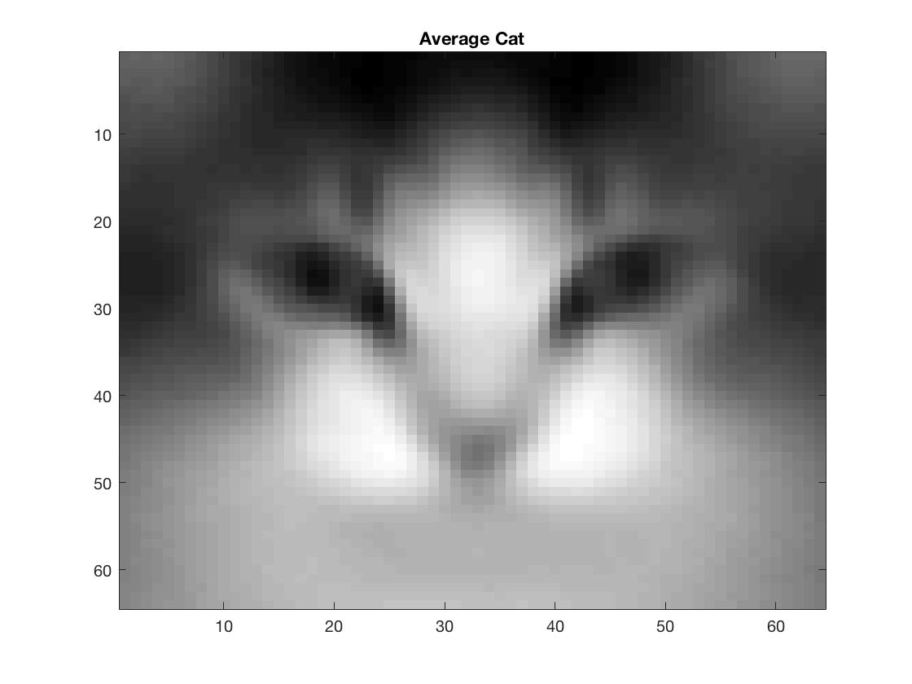

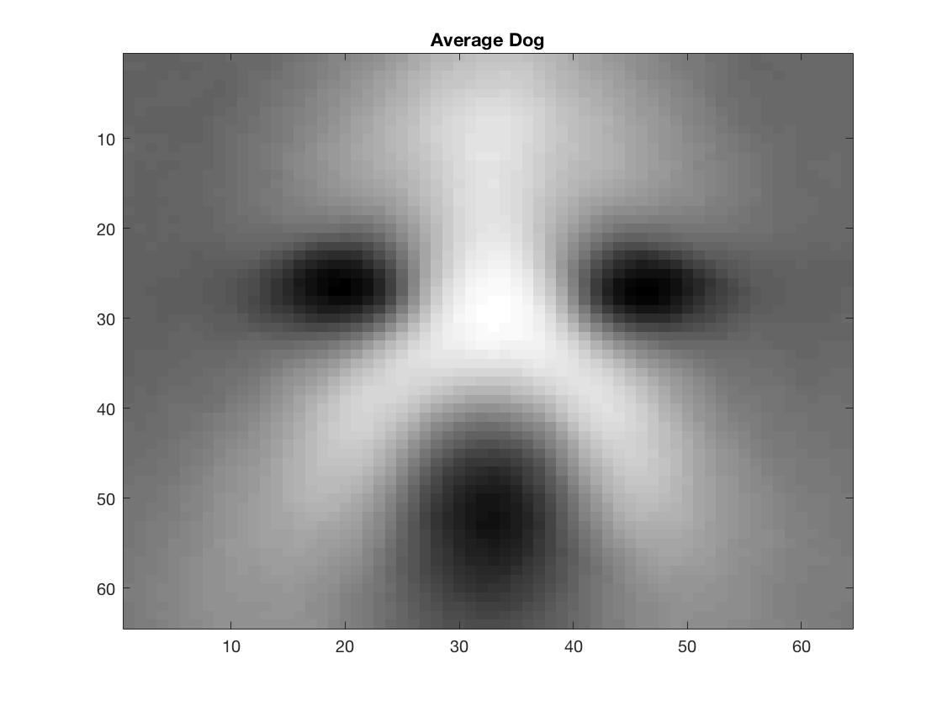

CP3.2



CP3.3

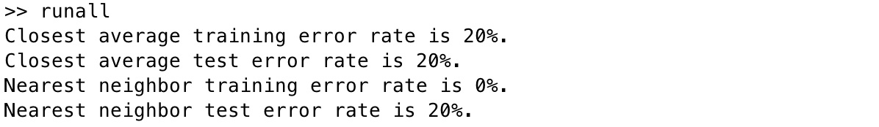

CP3.4

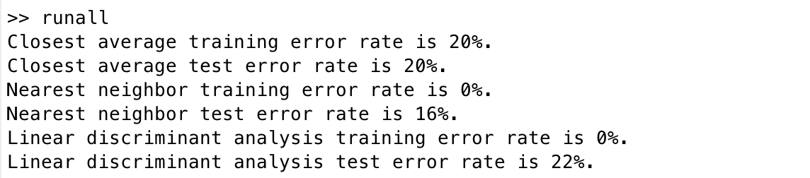

CP3.5

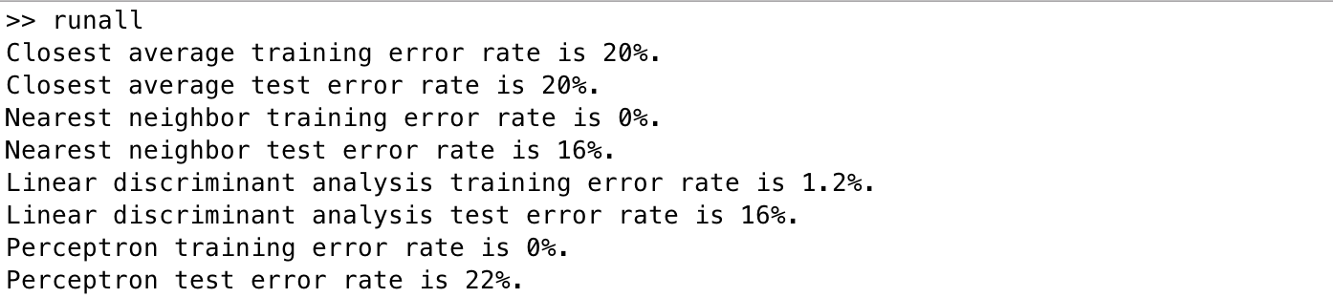

CP3.6

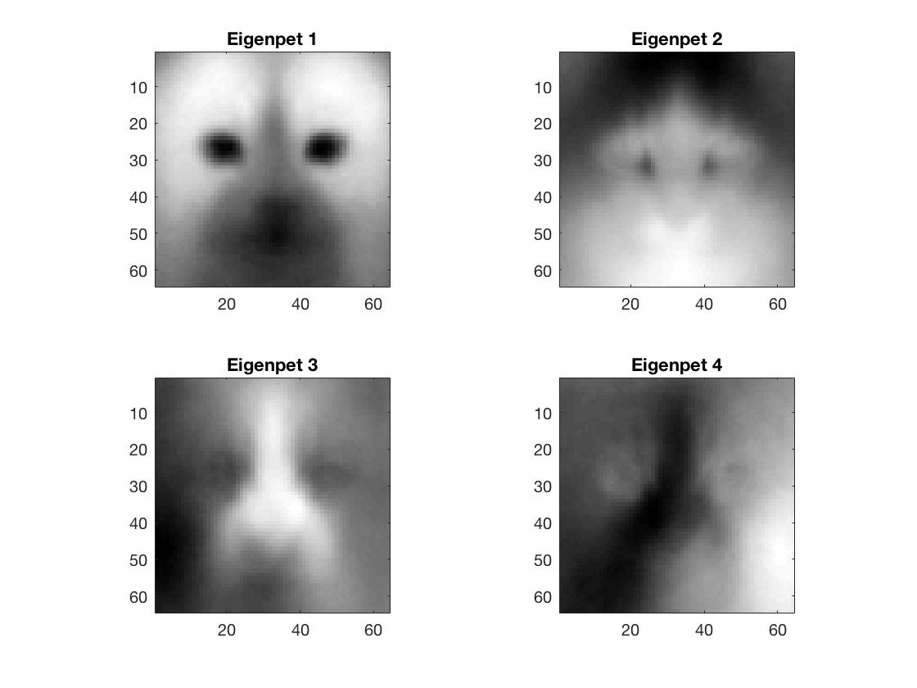

CP3.7

