

Project Documentation

Christopher Huynh  
Michael Harkess  
Hanming Wang  
Chen-Yu Chang  
Yiquin Zhang  
Samarah Uriarte

GreenMate

December 11, 2019

EC327

**GitHub Repository**

* <https://github.com/samarahu/SustainabilityApp>

**Description**

GreenMate is a sustainability-promoting Android application that uses various mechanics to encourage users in creating an environmentally-friendly society. The app’s features include a step counter, a recycling database and counter, and a point system. Additionally, a happy polar bear character is used to motivate users in living eco-friendly lifestyles and changes states based on user inputs, which proportionally affects the point amount assigned to the user.

**Functions**

Step Counter:

This feature includes a “Home Activity” module which employs a step listener, a step detector, a sensor filter, and a step calculation to record the distance a user walks or bikes. Additionally, the counter is coupled with a GPS which allows location tracking. The point system is affected by the step calculator, which directly converts steps to points which are then added to the user’s unique point amount.

By Friday, we plan to implement a map to allow the user to visually observe their progress by having their location displayed on the map GUI.

Recycling Feature:

This component of the application includes a database that contains which general items may or may not be recycled and allows the user to search through the provided information to help them recycle their own items. The point system is connected to this feature as well: the user is able to input how many items they recycled, and this number is recorded to the application for future use.

At this moment, the recycling database is extremely fundamental, but we will be updating it by Friday, and it will include a greater variety of items that will then be grouped based on their characteristics.

Points Feature:

This system operates through user input in the form of steps or number of objects recycled. The user’s point amount falls into certain ranges and changes the bear character’s state. This functions as a form of incentive, since the bear is a wholesome and friendly anthropomorphized animal that most individuals would want to keep happy. It also provides a unique and visually stimulating aesthetic that adds a positive tone to the application.

Example of a bear changing from one state to the other if the user opens the app and proceeds to walk a large enough distance:

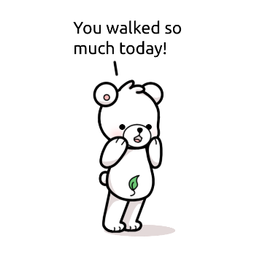

Currently, the point system is fundamental in complexity but by Friday, we plan to add a feature that recognizes the user’s patterns and compares how the user is performing based on these past trends. For example, if the user enters many recycled items one day and only recycles one item the following day, the bear will change from happy to tired, even though the total points accrued in those two days would satisfy the conditions that would result in a happy bear state. This addition would create a more logical interaction between the user and bear character.

**Compiling Instructions**

**Test Cases**

1. Activating the step counter and walking to a different location

* Displays the number of steps taken and simultaneously increments points