EC527 Assignment 5 Chen-Yu Chang

Part 1:

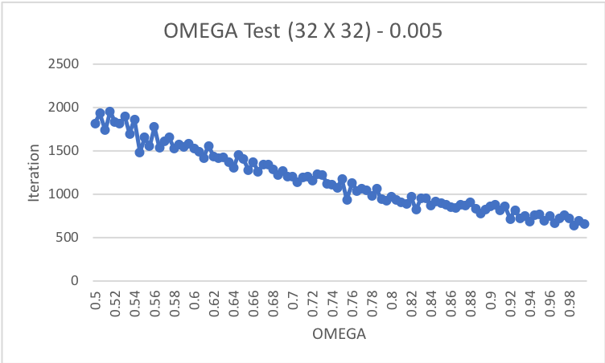

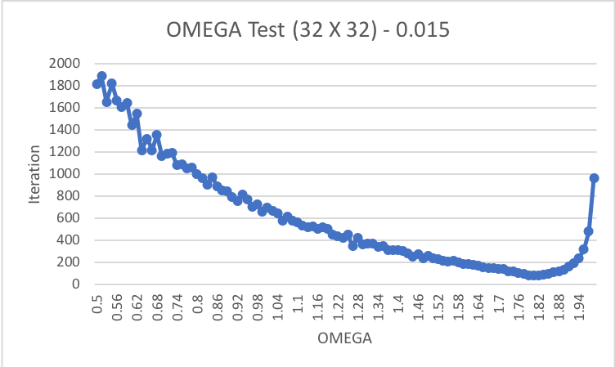

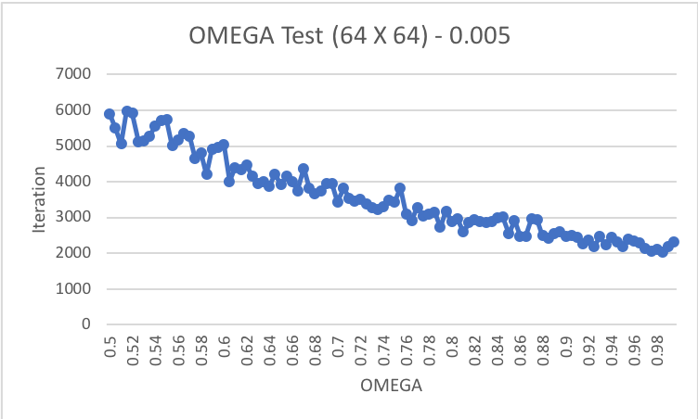

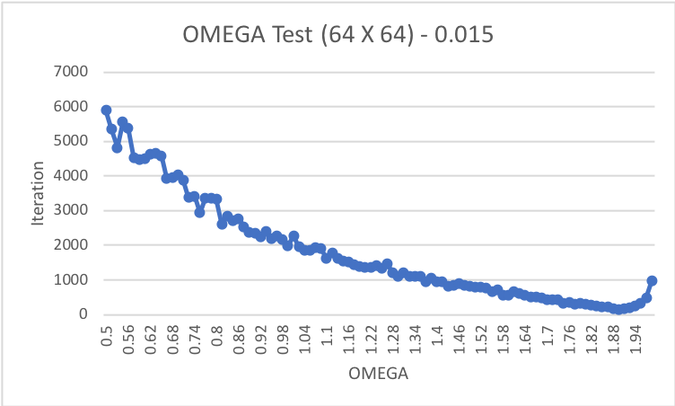

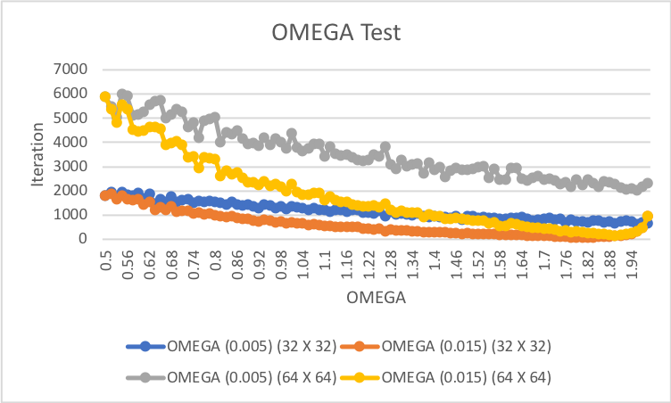

Overall, the graph looks like a U shape that start to rise when the OMEGA is about 1.9. The array with a smaller size tends to iterate less than the larger ones.

Part 2:

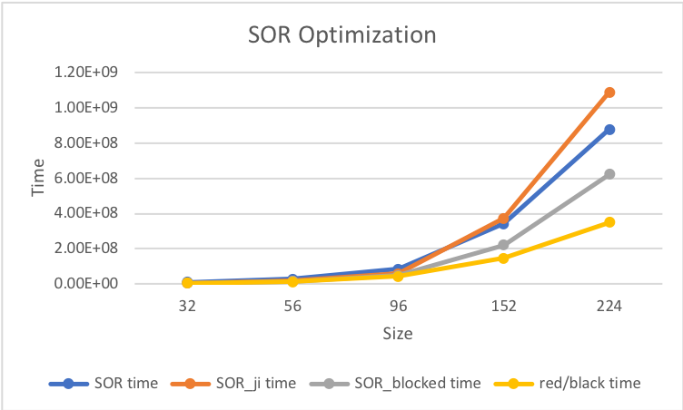

Based on the graph, the blocking improves among the other methods. The larger the size is, the more obvious the difference is. However, mmm still has a more remarkable improvement.

Part 3:

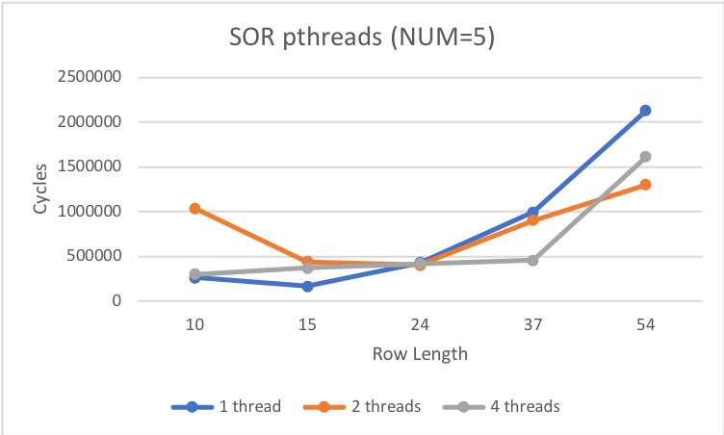

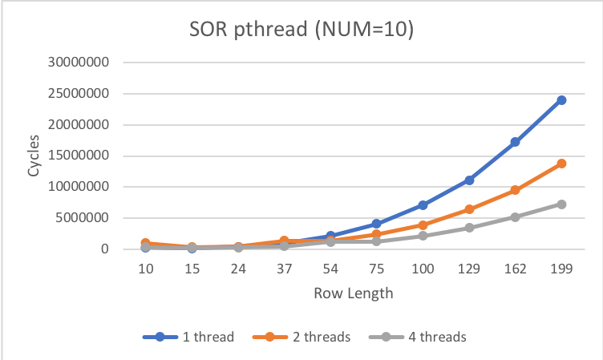

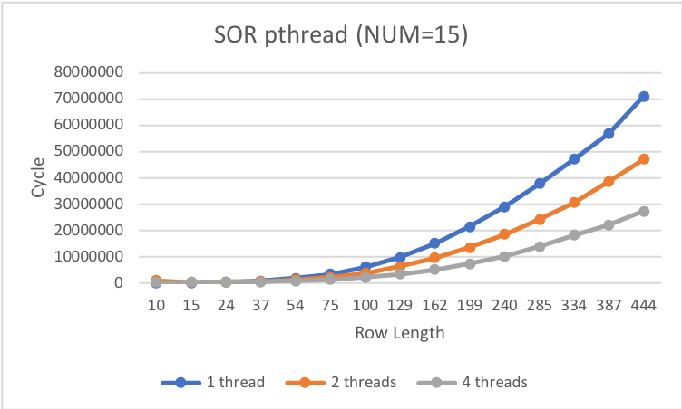

From the graphs and tests, we can see that as the number of tests and the length increased, the more threaded function has been more efficient. When there are 5 iterations, the breakeven point is estimated about the row length of 24.

Part 4:

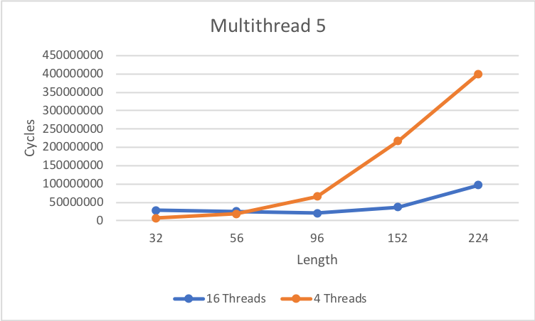

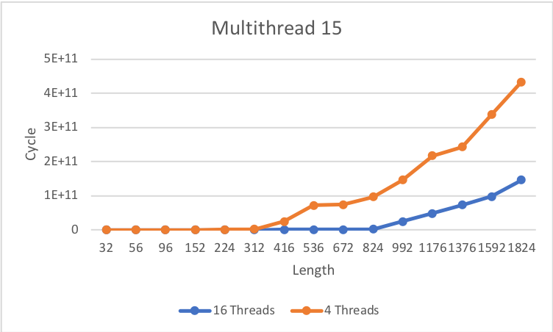

The code is in the folder.