EC527 Assignment 6 – Chen-Yu Chang

Part 1:

1a.

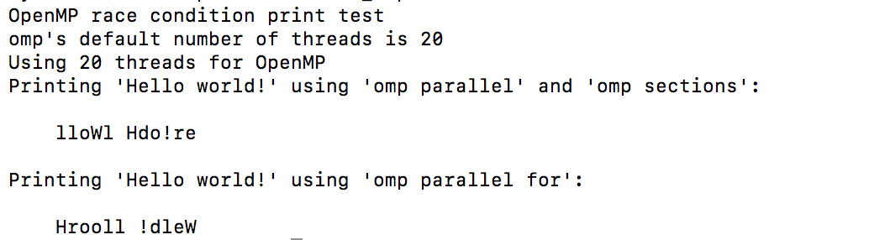

1b.

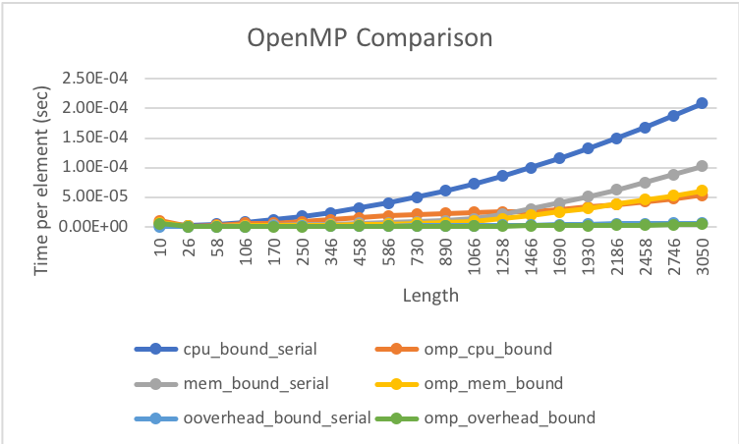

From the graph, we found that serial spent more time than omp for all different methods. It is overall two times faster comparing each other. I used different array sizes and found that about the array with 10 elements in the row length seems to be the break-even point.

1c.

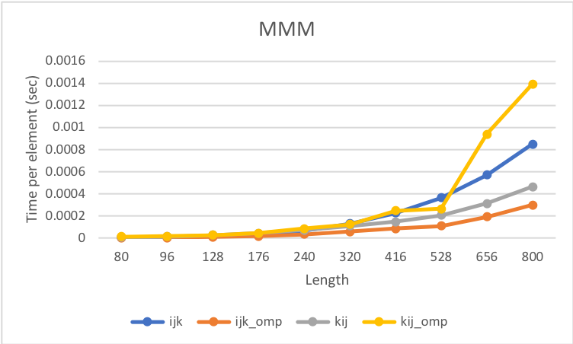

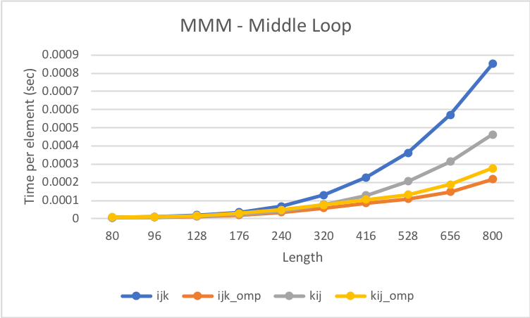

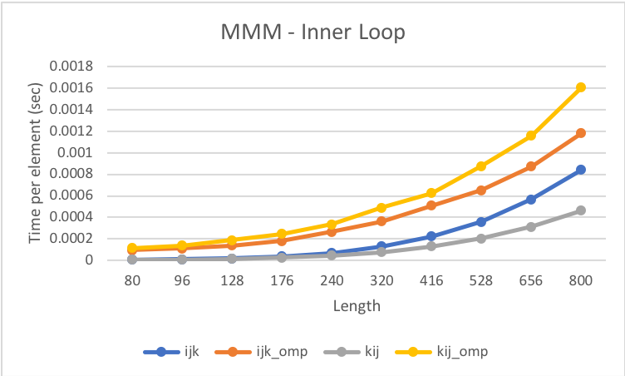

From the above graphs, we know that when private variables are changed to shared variables, it spends more time since more work is done to maintain the synchronization. We can also compare the efficiency of where pragma is placed. Placing at the outer loop is the fastest. However, comparing middle and inner loops, it seems to be faster when we put in the middle loop since the more outer pragma is written, the more synchronizations are required.

Part 2:

2a.

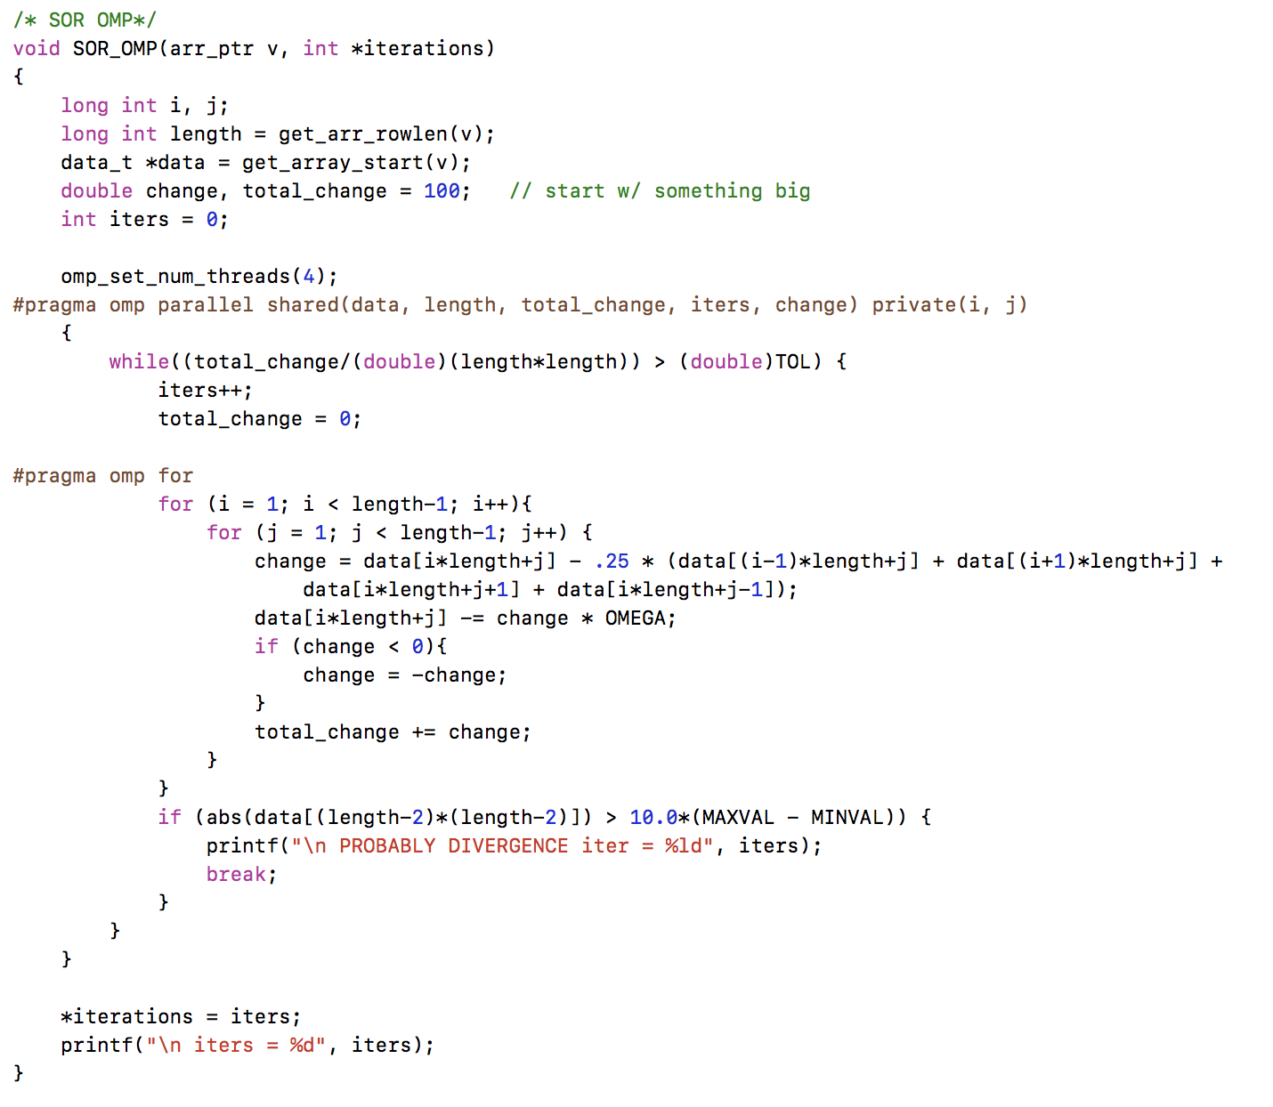

I added the pragma in the SOR function as data, length, total_change, iters, and change being shared variables since synchronizations are required and the variable used in loops are set as private variables.

2b.

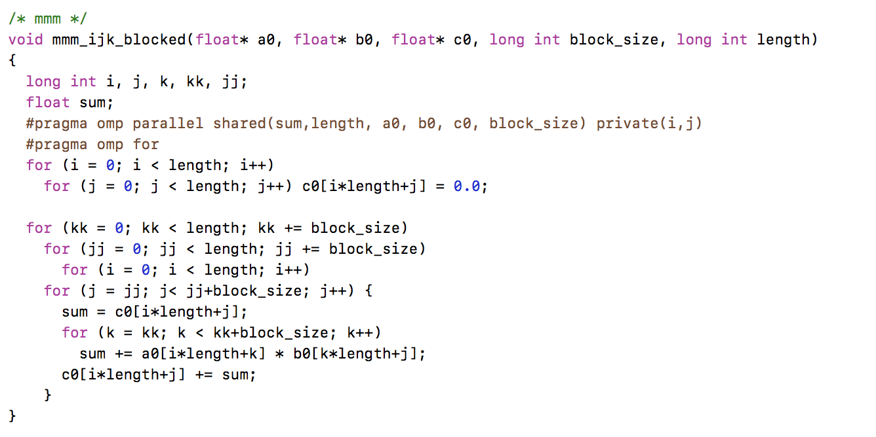

I added the pragma in the mmm function as sum, length, a0, b0, c0, and block_size being shared variables since these are all used for all threads; thus, synchronizations are required and the variable used in loops are set as private variables.