**EC527 Assignment 8 Chen-Yu Chang**

How I generate the matrix elements is by using initialize_array () function which uses a known seed for random number generation.

Part 1:

1024 X 1024

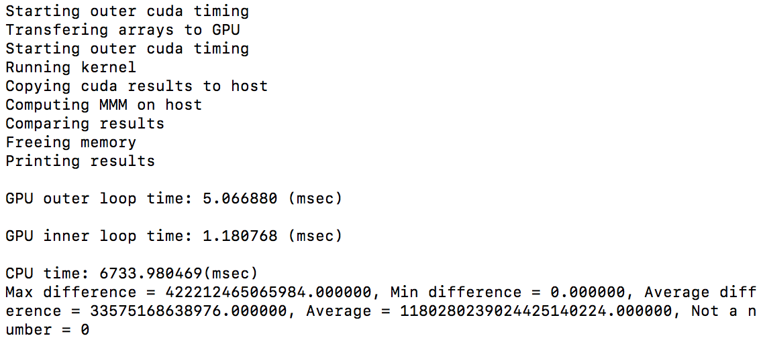

2048 X 2048

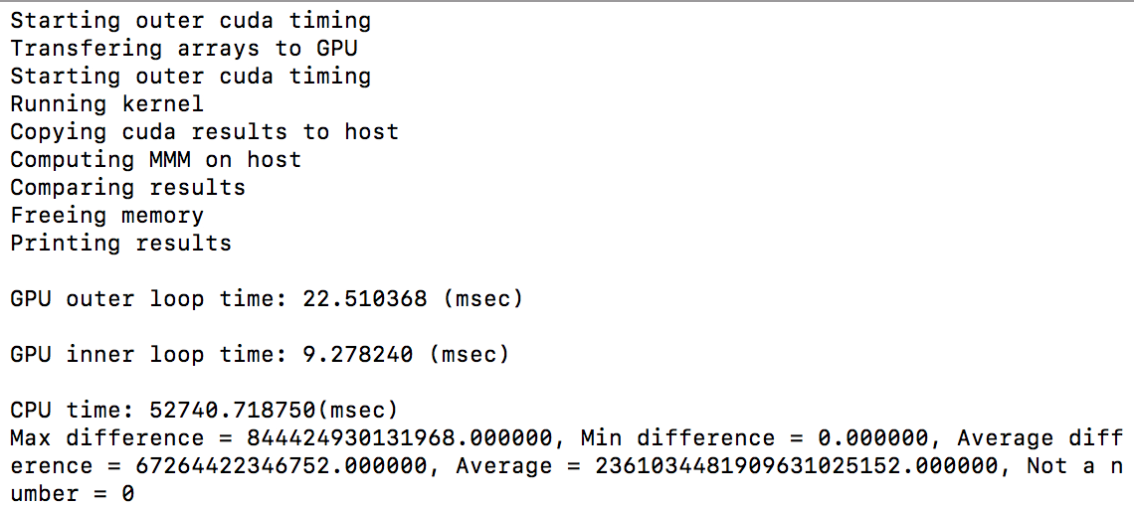

Part 2:

1024 X 1024

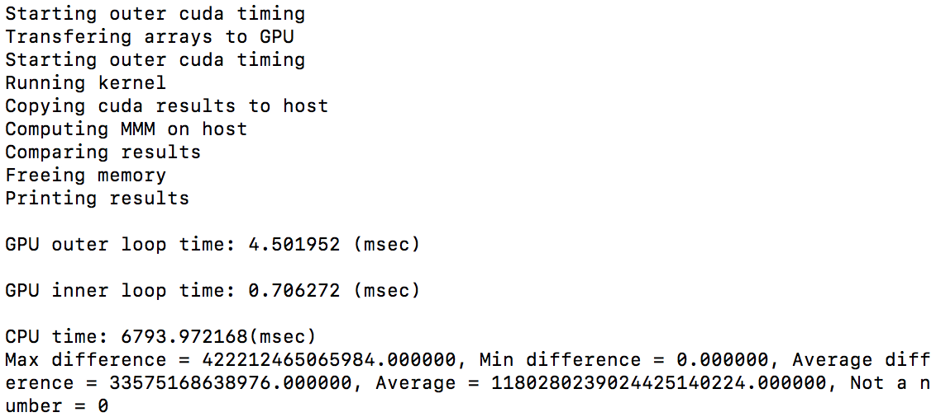

2048 X 2048:

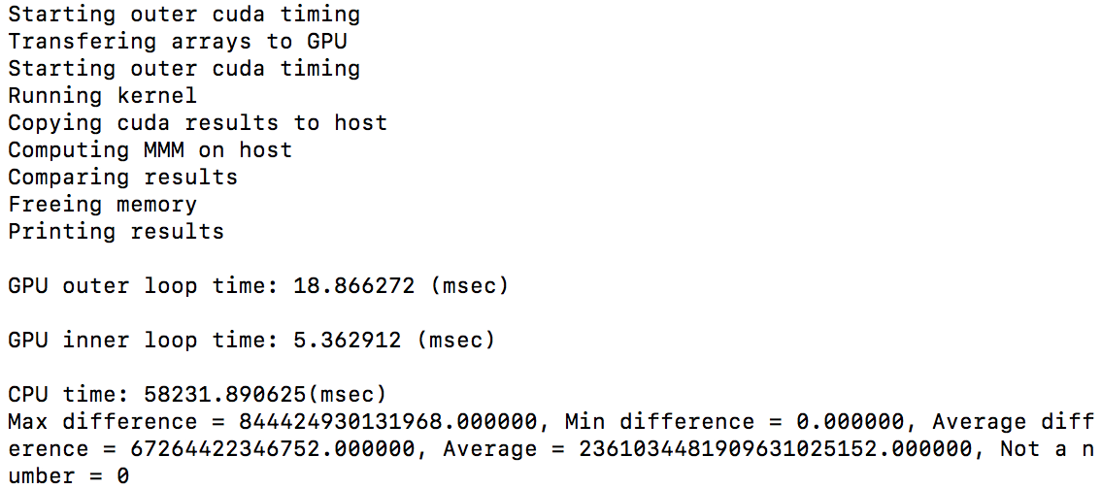

Part 3:

1024 X 1024:

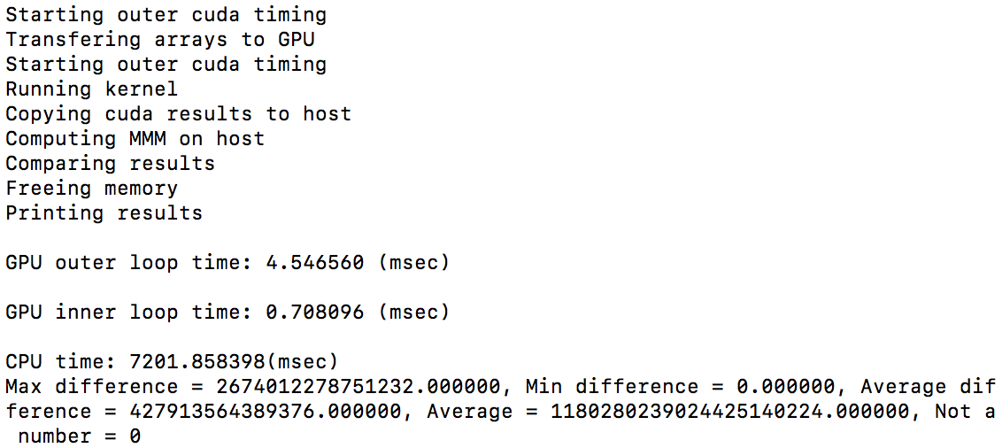

2048 X 2048:

