Assignment 3 - Explanation

Description
This homework will explore how neural networks can be trained to accurately produce a time-stepping mapping. An example is shown in Ref1,section 6.6.
Use the accompanying matlab files to generate two data sets in mat format.
(i) file1_KS.m: the Kuramoto-Sivashinsky (KS) equation;
(ii) file2_reaction_diffusion.m and reaction_diffusion_rhs.m:, the reaction-diffusion system of equations, generating a large data set.
Based on the two data sets:
1. Train two NNs that can advance the solution from t to t + dt for the two equations
2. Compare your evolution trajectories for your NN against using the ODE solver provided with different initial conditions

Problem i
In Problem 1, we can use the existing MATLAB code to calculate the numerical solution of a KS equation.
$$\frac{∂u}{∂t}=-u\frac{∂u}{∂x}-\frac{∂^{2}u}{∂x^{2}}-\frac{∂^{4}u}{∂x^{4}}$$
The MATLAB code (file1_KS.m) discretizes the time dimension and the space dimension. After setting the initial conditions, the code simulates the evolution process of Kuramoto-Sivashinsky equation through a certain number of iterations. Finally, it stores the results for us to analyze later. In this problem, we need to design a neural network by ourselves and train it with the solution obtained by the above MATLAB code, so that the neural network can finally output the state of the system at time 𝑡+Δ𝑡 with the input of the system state at time 𝑡.
The code for problem 1 generates a “.mat” file containing three matrix variables 𝒕𝒕_{1×251} , 𝒙_{1024×1}, 𝒖𝒖_{1024×251}. The 𝒕𝒕 is time vector, 𝒙 is space vector, and 𝒖𝒖 records the state of the system at different times and in different spatial positions. Therefore, when we use 𝒖𝒖 to train the neural network, every column of matrix 𝒖𝒖 will be a sample for neural network
We select the first 250 columns of 𝒖𝒖 as the input, and last 250 column as the output to evaluate the quality of the forecast from the neural network.
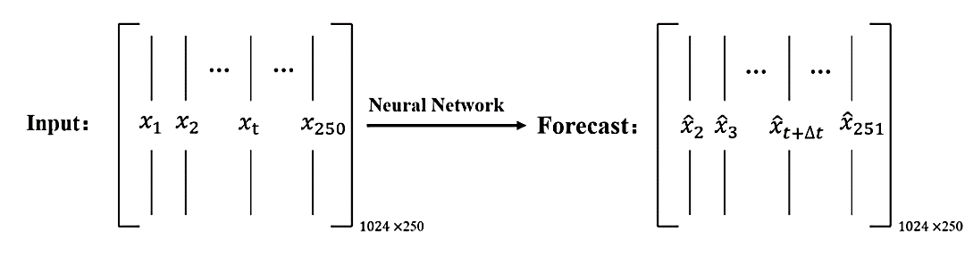
In file1_KS.m, the initial condition is generated
u = cos(x/16).*(1+sin(x/16));
We can change the initial condition to get different training data. The new initial conditions can be defined as follows:
div1 = 20*rand() + 5;
div2 = 20*rand() + 5;
u = cos(x/div1).*(1+sin(x/div2));

Problem ii
lambda-omega reaction-diffusion system
$$\begin{matrix}\frac{∂u}{∂t} & =λ(A)u-ω(A)v+d_{1}∇^{2}u \\ \frac{∂v}{∂t} & =ω(A)u+λ(A)v+d_{2}∇^{2}v\end{matrix}$$
Where:
- $A^{2}=u^{2}+v^{2}$
- $λ(A)=1-A^{2}$
- $ω(A)=-βA^{2}$
- $d_{1}$ and $d_{2}$ are diffusion coefficients.
This model is often used to simulate spiral wave formation in excitable media like chemical reactions or cardiac tissue.

The code for problem 2 generates a “.mat” file containing five matrix variables 𝒕_{201×1} , 𝒙_{1×512} , 𝒚_{1×512} , 𝒖_{512×512×201}, 𝒗_{512×512×201} . The 𝒕 is time vector, 𝒙 and 𝒚 are two space vectors. 𝒖 and 𝒗 record two state indicators at different time and at different plane coordinates x and y.
We can see that both 𝒖 and 𝒗 are stacks of matrices. Each matrix represents the values of 𝒖 or 𝒗 in different plane coordinates 𝑥 and 𝑦 at some time 𝑡. Such a data structure means that even if we rearrange the 𝒖 or 𝒗 matrix at time 𝑡 into a column vector, if we want to predict the values of 𝒖 or 𝒗 at 𝑡+Δ𝑡 respectively, we need to feed the neural network a vector of 512×512=262144 elements and let the neural network return a vector of the same size. Such a large vector dimension is expected to greatly reduce the training and prediction speed of neural networks, so we need to use SVD decomposition or other tools to reduce the dimensionality of the original data.
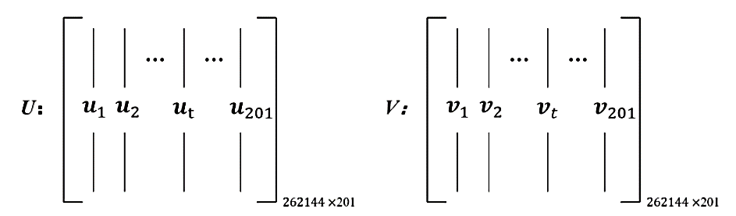

In file2_reaction_diffusion.m, the initial condition is generated
u(:,:,1)=tanh(sqrt(X.^2+Y.^2)).*cos(m*angle(X+i*Y)-(sqrt(X.^2+Y.^2)));
v(:,:,1)=tanh(sqrt(X.^2+Y.^2)).*sin(m*angle(X+i*Y)-(sqrt(X.^2+Y.^2)));
Options for Other Initial Conditions:
1) Multiple Spirals
m=2; % number of spirals, or 3,4..
…
2) or superimpose spirals at different locations
…
r1 = sqrt((X+5).^2 + (Y+5).^2);
theta1 = atan2(Y+5, X+5);
u(:,:,1) = tanh(r1).*cos(m*theta1 - r1);
v(:,:,1) = tanh(r1).*sin(m*theta1 - r1);
…
3) or add small random noise
…
u(:,:,1) = u(:,:,1) + 0.01*randn(n);
v(:,:,1) = v(:,:,1) + 0.01*randn(n);
…

Data Driven Science & Engineering Machine Learning, Dynamical Systems, and Control

