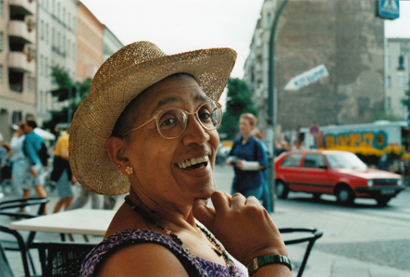

**Audre Lorde - the Berlin Years (1984 to 1992)** documents Audre Lorde's influence on the German political and cultural scene during a decade of profound social change, a decade that brought about the fall of the Berlin Wall and the re-unification of East and West Germany. The film chronicles an untold chapter of Lorde’s life: her empowerment of Afro-German women, as she challenged white women to acknowledge the significance of their white privilege and to deal with difference in constructive ways.

Documentary film screening

UMass Amherst *Herter Hall 231*

*Thursday, October 11, 2012*

*7:30 p.m.*

*Q&A with director, Dagmar Schultz*

**Invisible Woman: Growing up Black in Germany**

**Author Reading**

Ika Hügel-Marshall reads from her autobiography *Invisible Woman: Growing up Black in Germany,* which details her childhood, her search for her African- American father, and her close friendship with Audre Lorde.

**Wednesday, October 10 at 4:00 Herter 301**



Sponsored by: At UMass Amherst: German and Scandinavian Studies, W.E.B. Du Bois Department of Afro-American Studies, Social Thought and Political Economy Program, Stonewall Center, Women, Gender, Sexuality Studies, Interdepartmental Program in Film Studies; at Amherst College: Department of German, Department of Women's and Gender Studies; at Hampshire College: Africana Studies and Feminist Studies; at Mount Holyoke College: African American and African Studies, Gender Studies, and German Studies; at Smith College: Afro-American Studies, German Studies, Women and Gender Studies, and Five College Women's Studies Research Center.