|  |
| --- |
| **Real-time Transmission Line Parameter Calculator** |
| OpenECA Analytic Design Document  *Test Results* |
|  |
|  |
| **Chen Wang** |
| **4/11/2017** |
|  |

# **Work Description**

In order to realize the analytic of real-time transmission line parameter calculator we firstly use PSS\E to conduct the power flow of the IEEE standard 118-bus system to gather the simulated voltage and current data; then, realize the functionality on Matlab to validate the methodology; finally, create measurements on the openECA platform and generate C# project to implement the analytic and demonstrate the calculation results on the test harness window.

# **Test Results(Alpha Version)**

* 1. *Algorithm validation - Matlab*

## *Data Structure*



## *Validation Flow Chart*



## *Calculation Results*

The calculation results of the real-time impedance calculator are shown in the following figures. The application use the data frames which contain complex voltage phasors and current phasors of both sides of the concerned transmission line as the input. The line parameters are calculated every time one data frame is provided and 1800 times in total.

We can see that the line parameter results are not smooth with respect to time. But the actual error rates are at the 0.1% level. Such minor fluctuations does indicate that the calculation is valid.





* 1. *Application realization - openECA*

## *Application Flow Chart*



The simulated voltage and current measurements are integrated into the openECA platform as shown in the following figures.

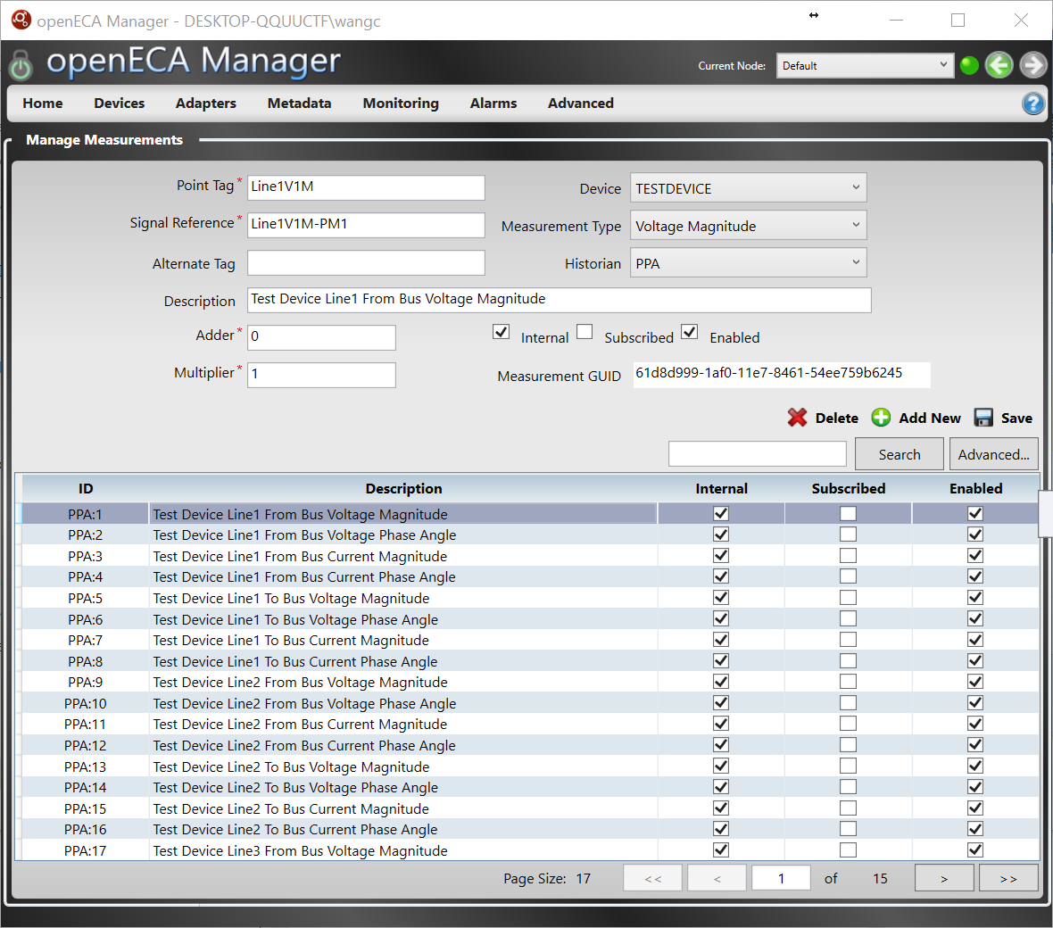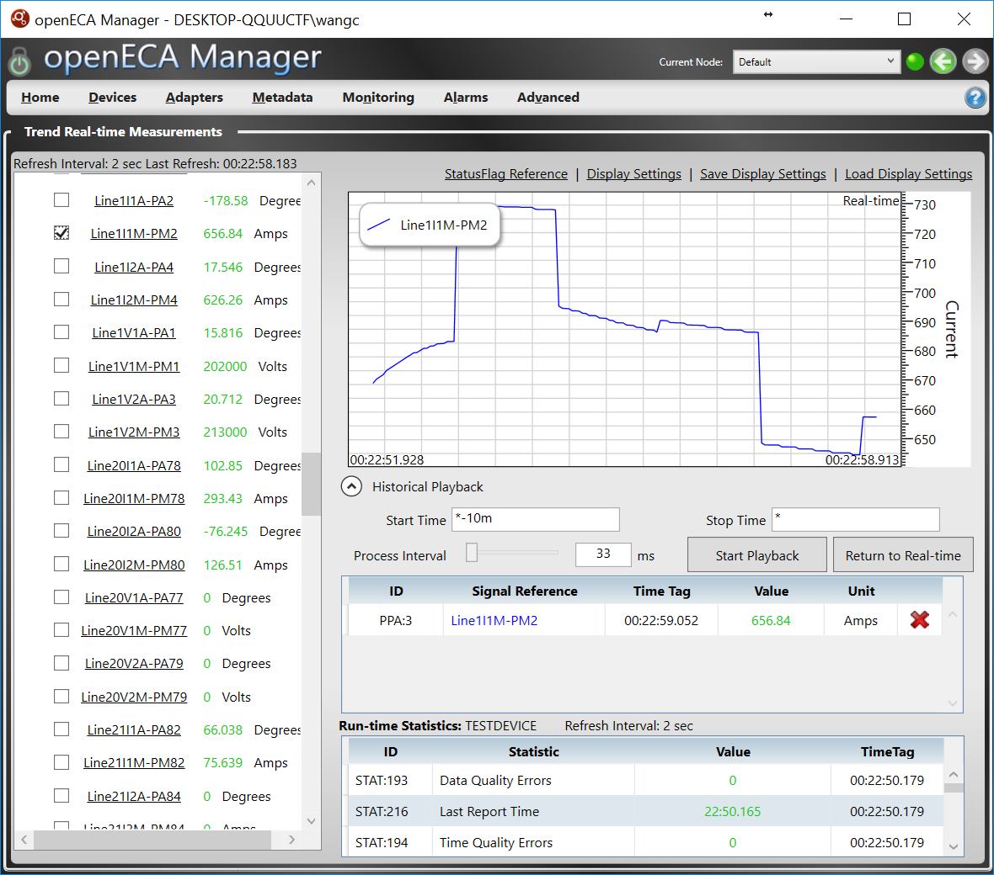

There have been some problems during the integration process. At first, considering the data set scale, we planned to create more than 190 measurements in the metadata. But the method of inputting the measurements meanually is much time-consuming and easy to cause errors. After communicating with GPA, we were provided the suggestion of utilizing MySQL base script to complete the configuration of the openECA platform. Such method does provide an efficient way to create and alter large scale of measurements.

The second problem we met is that for the Alpha version, the CSV adapter provided by the platform has some restrictive script and raw data file requirements. Most of the restrictions has been identified after the communication with GPA. The CSV adapter is still the most reliable and efficient way to upload local database

There is also a problem awaiting fixed. When using the openECA client generating C# projects, we found that not all the data channels created in the manager can be found and maaped to the objects defined. We are still seeking the inner logic and solution to this issue.

The C# project is generated from the openECA client. Corresponding algorithm is realized in the project and the calculation results are shown in the test harness window as following:

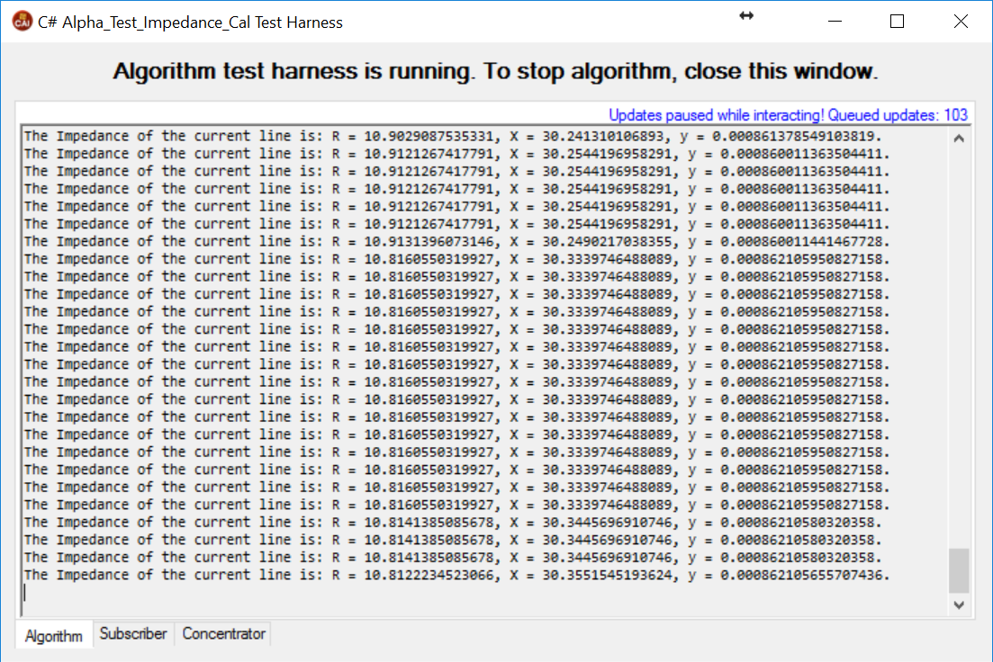

The calculated line resistance, reactance, and susceptance are physically reasonable, stable, and close to the true value. And for future versions, the user interface will be improved.

# **From Alpha to Beta**

## *Application Realization*

The alpha version of the application is only dealing with one transmission line parameters calculation.

For the beta version, the system configuration will be created and analyzed. The computation will be conducted on all the transmission lines that have enough voltage and current measurements.

## *User Interface Design and Realization*

The user interface will be developed. Such interface will be designed as a universal media of all the three analytics including CT/PT Calibration, Transmission Line Impedance Calibration, and Real-time Impedance Calculation. The system topology will be demonstrated and the calculation results of different analytics will also be demonstrated.