SAR Despeckling via Fourier Refinement and
Representation-Consistent Reconstruction
Hongyu Chen, Peng Liu, Senior Member, IEEE, and Yaqiu Jin, Life Fellow, IEEE

Abstract— The mismatch between simulated speckle and real synthetic aperture radar (SAR) observations limits the transfer of supervised despeckling models. We extend the public Trans-SAR backbone with full-spectrum Fourier residual refinement and representation-consistent reconstruction. One bottleneck block and five decoder blocks combine local features with real–imaginary channel mixing, and bounded log-intensity predictions are inverted before intensity compensation. Masked adaptation updates reconstruction on noisy real SAR while freezing the Transformer encoder. Across 8,400 simulated pairs from 21 UCMerced classes and four look numbers, one model without look-number input achieves macro-averaged peak signal-to-noise ratio (PSNR) and structural similarity index (SSIM) of 28.14 dB and 0.7791. PSNR is highest among evaluated methods at every look. Removing Fourier refinement reduces PSNR by 1.68 dB. On 592 patches from held-out parent images, adaptation lowers the M-index from 1.8213 to 1.3365 and raises the edge-preservation index from 0.4229 to 0.8214. These results support the reconstruction design and adaptation on the evaluated datasets.
Index Terms— Synthetic aperture radar, despeckling, Transformer, Fourier refinement, self-supervised adaptation.

I. Introduction
Synthetic aperture radar (SAR) speckle obscures edges, texture, and bright scatterers. Despeckling must recover these structures despite signal-dependent noise and the scarcity of clean references [1]. Unit-mean Gamma corruption supports controlled multilook experiments, but focused real SAR also contains spatially correlated speckle and processing artifacts. Consequently, restoration learned from simulated pairs can transfer poorly to real observations.
Lee filtering uses local statistics [2], whereas SAR-BM3D exploits nonlocal recurrence and transform-domain shrinkage [3]. Supervised CNNs learn paired restoration priors [4], with SAR-CAM adding continuous multiscale attention [5]. Trans-SAR combines a hierarchical Transformer encoder with convolutional reconstruction [6]; subsequent models introduce dynamic gates and noise-guided multiscale fusion [7], [8]. Frequency decomposition in SAR-FDD and DATNet complements spatial processing [7], [9], while transformed conditional diffusion offers another representation for multiplicative statistics [10]. Speckle and scene structure nevertheless overlap in frequency, motivating joint local and spectral refinement without predefined frequency bands.
Learning from real observations also depends on the available supervision. SAR2SAR exploits multitemporal acquisitions [11]; Speckle2Void combines blind-spot likelihood training with decorrelation [12]; and Speckle2Self uses masked self-supervision with attention [13]. SDS-SAR constructs intensity-only training pairs through correlation-aware sampling [14], whereas SDUDNet uses unpaired clean and noisy images [15]. These approaches motivate adaptation without clean targets, although their differing assumptions require care when comparing restoration outcomes.
We extend the public Trans-SAR backbone along three complementary directions. First, six Fourier residual refinement (FDR) blocks combine local filtering with full-spectrum real–imaginary channel mixing at the bottleneck and five decoder scales. Second, an exact inverse maps bounded log predictions back to intensity before residual compensation, keeping output fusion within one representation. Third, encoder-frozen masked post-adaptation (AMS) calibrates reconstruction to real SAR without clean targets. Fig. 1 distinguishes inherited operators from the additions. Controlled ablations assess the reconstruction components, and evaluation uses one model across four look numbers plus a real-SAR split with disjoint parent images. The real-data evidence is empirical: masked noisy targets do not ensure unbiased restoration under correlated speckle.

II. Proposed Method

A. Observation and Reconstruction Path
Let $X,Y∈[0,1]^{H×W}$ denote a clean intensity proxy and its noisy observation. Synthetic pairs use independent Gamma speckle with look number $L$:
$\begin{aligned}Y&=clip(X⊙N,0,1), \\ N_{ij}&∼Gamma(L,L^{−1}).\end{aligned}$ (1)
The shape–scale parameterization gives unit mean and variance $L^{−1}$ before clipping. This controlled corruption does not reproduce the full statistics of focused SAR. The bounded log mapping and its exact inverse are
$T_{α}(Y)=\frac{log(1+αY)}{log(1+α)}, α=10,$ (2)
$T_{α}^{−1}(\hat{Z})=\frac{exp[\hat{Z}log(1+α)]−1}{α}.$ (3)
The mapping moderates bright intensities without assuming additive Gaussian noise in the transformed domain.
The encoder and basic upsampling operators follow Trans-SAR, including overlap embeddings and attention with spatial reduction [6]. Its five stages have widths (32, 64, 128, 320, 512), head counts (1, 1, 2, 4, 8), and depths (3, 3, 4, 6, 3), with resolutions from ${128}^{2}$ to $8^{2}$. Reconstruction applies bottleneck refinement followed by five decoder stages, each ordered as upsampling, available skip fusion, FDR, residual convolution, and guidance modulation. A sigmoid head predicts bounded log intensity; inversion precedes intensity compensation.

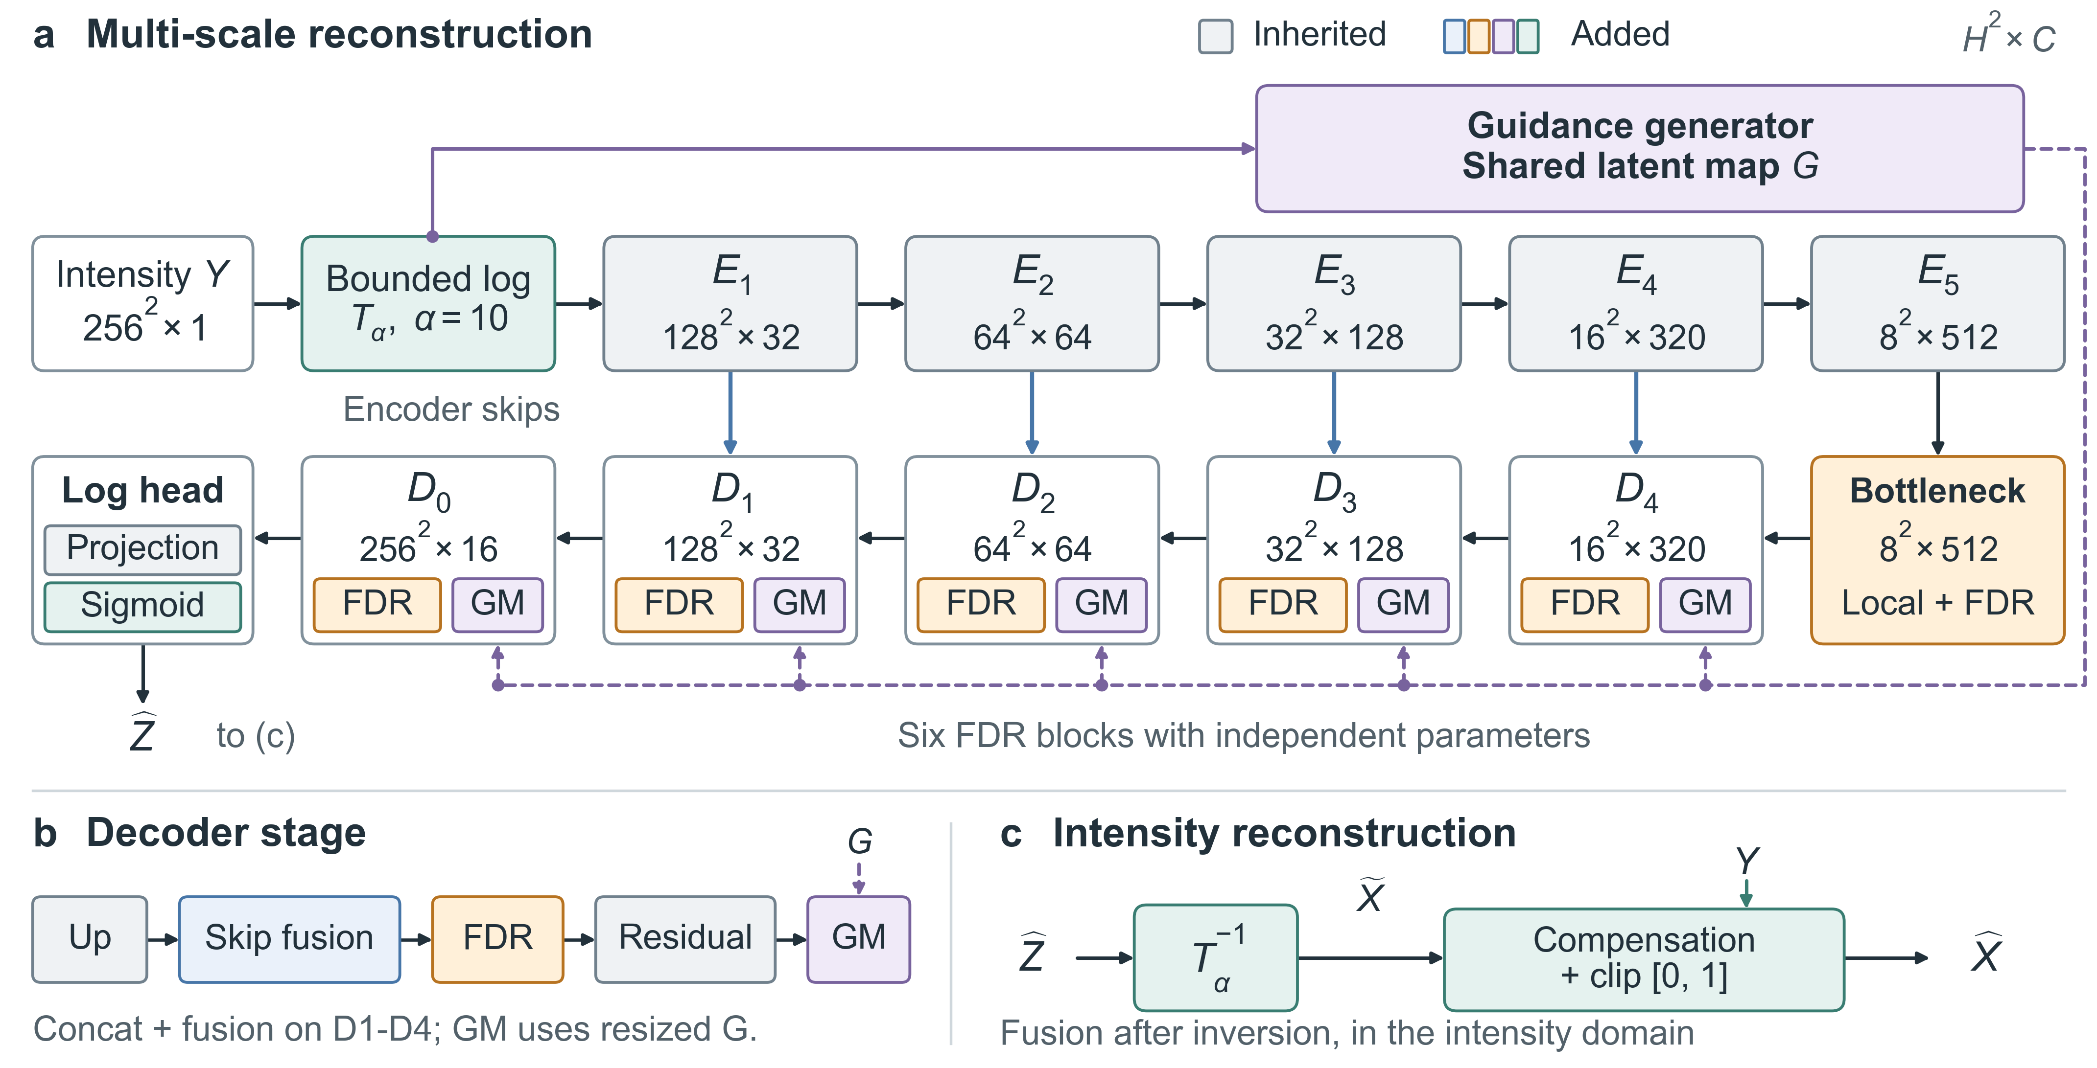
Fig. 1. (a) Encoder–decoder overview; tensor labels give spatial size $×$ channels. Gray marks inherited operators, and colors mark additions. Six FDR blocks have independent parameters. (b) Decoder order: skips concatenate encoder features before fusion; $D_{0}$ has no skip. GM denotes stage-specific guidance modulation using the resized shared map $G$. (c) Log predictions are inverted before intensity compensation with original $Y$ and clipping.

B. Fourier Refinement and Guided Compensation
For feature $F$, FDR runs a spatial branch (depthwise $3×3$, pointwise projection, and GELU) alongside an orthonormal two-dimensional real fast Fourier transform (FFT):
$\begin{aligned}Q&=rFFT2(F), \\ Q_{c}&=[Re(Q),Im(Q)].\end{aligned}$ (4)
Two real-valued $1×1$ convolutions separated by GELU mix the concatenated real–imaginary channels. Their weights are shared across frequency coordinates; neighboring frequencies are not convolved. Splitting the output and applying the inverse real FFT yields $F_{f}$, which is fused with the spatial feature $F_{s}$:
$\begin{aligned}U&=GELU\left(W_{o,1}*[F_{s},F_{f}]\right), \\ FDR(F)&=F+W_{o,2}*U.\end{aligned}$ (5)
FDR processes the full spectrum without explicit bands or complex-valued convolution. Six independent blocks act at the bottleneck and decoder resolutions ${16}^{2}$ through ${256}^{2}$. The bottleneck also sums the FDR output with a local feature, projects the sum, and adds it to the input through a learnable scale initialized to 0.1. In (5), $W_{o,1}$ and $W_{o,2}$ are $1×1$ and $3×3$ convolutions, respectively.
A shared guidance branch jointly learns a single-channel latent map from the log input, without noise-map or look-number targets. At each decoder scale, the resized map is concatenated with the feature; pointwise and $3×3$ convolutions produce $tanh$ modulation with a learnable scale initialized to 0.1. For the sigmoid prediction $\hat{Z}$, let $\tilde{X}=T_{α}^{−1}(\hat{Z})$. Intensity compensation is
$\begin{aligned}R_{c}&=F_{comp}([Y,\tilde{X}]), \\ \hat{X}&=clip(\tilde{X}+γ_{c}R_{c},0,1).\end{aligned}$ (6)
The compensator has two $3×3$, 32-channel GELU layers and a single-channel residual head. Its learnable $γ_{c}$ starts at 0.1 without bounding the correction; final clipping constrains intensity. Both summands in (6) are in the same intensity representation.

C. Supervision and Masked Adaptation
Supervised training minimizes mean squared intensity error and total variation (TV):
$L_{sup}=\frac{1}{HW}{\left\|\hat{X}−X\right\|}_{2}^{2}+5​×​{10}^{−7}TV(\hat{X}).$ (7)
TV sums the mean absolute horizontal and vertical neighbor differences. AMS masks pixels independently with probability 0.2, forming $Y_{m}=Y⊙(1−M)$, and supervises only masked positions using their original noisy values:
$\begin{aligned}L_{AMS}=​&\frac{{\left\|M⊙[f_{θ}(Y_{m})−Y]\right\|}_{1}}{max({\left\|M\right\|}_{1},1)} \\ &+{10}^{−3}TV(f_{θ}(Y_{m})).\end{aligned}$ (8)
Only the Transformer encoder is frozen; the bottleneck, decoder, guidance, head, and compensator adapt for eight epochs at learning rate ${10}^{−6}$. Training masks are resampled, whereas fixed validation masks support checkpoint selection at identical locations. Inference uses unmasked observations. During AMS, $Y_{m}$ replaces $Y$ throughout the network, including the compensator.
Supplementary Figs. S1 and S2 illustrate the refinement and adaptation operations specified above.

III. Experiments

A. Datasets and Evaluation Protocol
NWPU-RESISC45 [16] supplies 900 training and 225 validation images (20/5 per class). Squared grayscale values provide clean intensity proxies. A deterministic schedule distributes 100,000 training presentations equally across $L∈\{1,2,4,8\}$; four fixed realizations per validation source yield 900 pairs. Augmentation uses paired flips and right-angle rotations.
All 2,100 UCMerced images from 21 classes [17], excluded from model selection, provide 8,400 fixed test pairs across four looks. Each source is corrupted once per look. Images are bilinearly resized to $256×256$ where needed before corruption by (1), with no subsequent corruption. This evaluates transfer between optical collections under simulated speckle.
Real SAR uses only noisy images from Mendeley dataset fs455tz88y, version 1 [18]. The split assigns 1,175 parent images to training, 146 to validation, and 148 to testing, yielding 4,700, 584, and 592 patches, respectively. All four children of each $512×512$ parent stay together. Reference images are excluded from adaptation, selection, measurement, and visualization.
All methods share test IDs. Unsigned 8-bit inputs are divided by 255; normalized floating-point inputs remain unchanged. Evaluation uses normalized linear intensity without percentile normalization or display stretching.

B. Implementation, Baselines, and Metrics
Training uses Adam, batch size 1, initial learning rate ${10}^{−3}$, weight decay ${10}^{−5}$, and 100,000 updates. Every 5,000 updates, validation mean squared error (MSE) in intensity is averaged equally by class and look; the lowest value selects the checkpoint. A plateau scheduler halves the rate with patience four validation events and a ${10}^{−6}$ floor. One checkpoint handles all looks; Full and Ours-base denote the pre-adaptation model. Lee-MMSE uses a window selected on NWPU validation. SAR-BM3D uses square-root input and squared output; both receive nominal $L$ (oracle-$L$). SAR-CAM [5], Trans-SAR [6], and our model receive only corrupted intensity.
UCM-21 PSNR and SSIM average per-image scores equally across classes and looks. For 592 real patches, each noisy input supplies five nonoverlapping $32×32$ regions of interest (ROIs) on a grid, ranked by increasing squared coefficient of variation after rejecting dark, zero-dominated, and saturated candidates. The equivalent number of looks (ENL) averages $μ^{2}/σ^{2}$ over these 2,960 method-shared ROIs.
Both real evaluations use M-index [19], combining ratio-image mean/ENL deviations and homogeneity changes under random permutation, and the edge-preservation index (EPI) [20], Eq. (16), the output-to-input ratio of summed absolute diagonal-neighbor differences. ENL is reported as a mean and diagnoses smoothness rather than overall quality. Lower M-index is preferred; EPI requires joint interpretation with ENL and ratio structure because residual speckle also increases it [21].

TABLE I
UCM-21 Gamma-Speckle Results on 8,400 Fixed Pairs
Method | Look mode | $L=1$  PSNR / SSIM | $L=2$  PSNR / SSIM | $L=4$  PSNR / SSIM | $L=8$  PSNR / SSIM | Macro  PSNR / SSIM
Noisy | – | 12.95 / 0.2069 | 14.98 / 0.2870 | 17.37 / 0.3840 | 20.01 / 0.4916 | 16.33 / 0.3424
Lee-MMSE | oracle-$L$ | 21.23 / 0.5212 | 23.05 / 0.5999 | 24.71 / 0.6757 | 26.33 / 0.7455 | 23.83 / 0.6356
SAR-BM3D | oracle-$L$ | 25.24 / 0.7234 | 26.78 / 0.7612 | 28.14 / 0.7967 | 29.77 / 0.8243 | 27.48 / 0.7764
SAR-CAM | blind | 22.68 / 0.5622 | 23.54 / 0.6138 | 25.89 / 0.7295 | 28.10 / 0.7949 | 25.05 / 0.6751
Trans-SAR | blind | 25.53 / 0.6446 | 27.22 / 0.6963 | 28.12 / 0.7397 | 29.78 / 0.7336 | 27.66 / 0.7036
Ours (Full) | blind | 25.93 / 0.7169 | 27.94 / 0.7930 | 28.57 / 0.7754 | 30.13 / 0.8312 | 28.14 / 0.7791
PSNR is in dB. Best and second-best values among despeckling methods are bold and underlined, respectively. Oracle-$L$ methods receive the nominal look number; blind methods do not.

C. Synthetic Comparison
Our single blind model achieves the highest PSNR point estimates in Table I, exceeding the strongest alternatives by 0.40, 0.72, 0.43, and 0.35 dB at $L=1,2,4,8$, respectively. Macro PSNR is 28.14 dB: 0.48 dB above Trans-SAR and 0.66 dB above oracle-$L$ SAR-BM3D. Macro SSIM is 0.7791, with respective gains of 0.0755 and 0.0027. SAR-BM3D leads SSIM at $L=1,4$; ours leads at $L=2,8$.
In Fig. 2, our restoration suppresses speckle while retaining roof contours and rooftop structures; LEE blurs these details. Building outlines remain in our ratio image, indicating incomplete separation of structure from speckle.
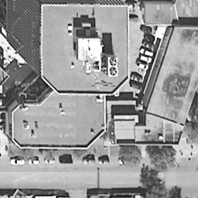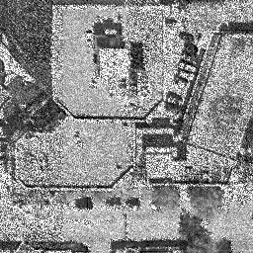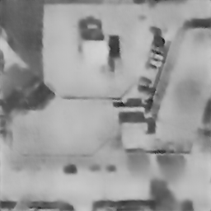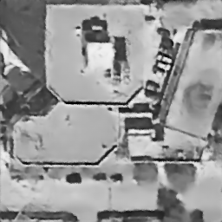
(a) (b) (c) (d)
Clean Noisy LEE SAR-BM3D
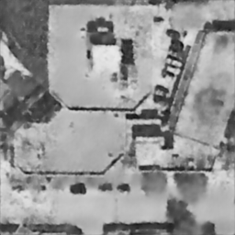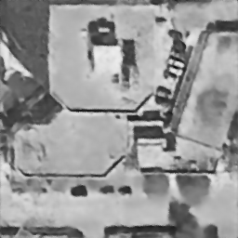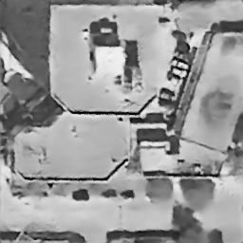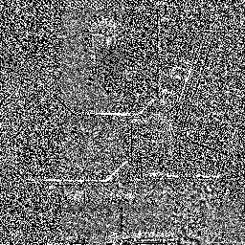
(e) (f) (g) (h)
SAR-CAM Trans-SAR Ours Ours ratio
Fig. 2. Visual comparison for a UCMerced buildings scene. LEE denotes Lee-MMSE. All panels show the same field of view in their original grayscale renderings. Panel (h) shows the ratio image for Ours and is assessed separately from the restorations.

D. Generalization across Three UCMerced Scene Types
Table II separately evaluates 100 agricultural, 100 buildings, and 100 dense residential UCMerced samples at $L=4$, representing smooth cover, regular boundaries, and dense texture. These sources are excluded from supervised development.
TABLE II
Generalization on Three UCMerced Scene Types at $L=4$
Scene | Num. | Noisy  PSNR / SSIM | Ours-base  PSNR / SSIM
Agricultural | 100 | 17.7573 / 0.4218 | 29.1523 / 0.7446
Buildings | 100 | 16.6583 / 0.4625 | 27.6827 / 0.7883
Dense residential | 100 | 17.5475 / 0.4557 | 30.4376 / 0.7941
Average | 300 | 17.3211 / 0.4467 | 29.0909 / 0.7757
PSNR is in dB. All 300 samples use $L=4$, and Average summarizes the three scene groups. Ours-base denotes the model before real-SAR adaptation. Bold values mark improvements over the noisy input.
Across these categories, Ours-base gains 11.02–12.89 dB in PSNR and 0.3228–0.3384 in SSIM over the input. Mean PSNR increases from 17.3211 to 29.0909 dB, and mean SSIM from 0.4467 to 0.7757. Dense residential scenes attain the highest restored scores.

E. Ablation Study
Table III compares representation, compensation, and FDR variants.
TABLE III
Compact Ablation on UCM-21
Variant | Active path | PSNR | SSIM
Intensity-only | Intensity; FDR | 23.6841 | 0.6871
Log-only | Log, inverse; FDR | 22.2196 | 0.7121
Full w/o all FDR | Log, inverse, comp. | 26.4634 | 0.7612
Full | Log, inverse, comp.; FDR | 28.1425 | 0.7791

With the log transform, inverse, and compensator retained, removing all six FDR blocks reduces macro PSNR from 28.1425 to 26.4634 dB and SSIM from 0.7791 to 0.7612. The losses are 1.6791 dB and 0.0179, respectively.
Full exceeds Log-only by 5.9229 dB and 0.0670 SSIM, supporting compensation with FDR present. These comparisons assess conditional component contributions, not their interaction.
Compared with Intensity-only, Log-only lowers PSNR but raises SSIM. Removing modules also reduces capacity, so this ablation does not isolate spectral processing from parameter count.

F. Real-SAR Adaptation
Table IV compares 592 shared test patches from 148 held-out parents.
TABLE IV
No-Reference Results on 592 Real-SAR Patches
Method | ENL | M-index $↓$ | EPI $↑$
Noisy | 26.25 | – | 1.0000
SAR2SAR | 158.39 | 2.4566 | 0.5643
SDUDNet | 83.24 | 1.7403 | 0.6786
SAR-BM3D | 25.87 | 1.6579 | 0.7528
Trans-SAR | 124.60 | 1.9455 | 0.5313
Ours-base | 530.85 | 1.8213 | 0.4229
Ours + AMS | 84.72 | 1.3365 | 0.8214
Mean ENL is reported as a smoothness diagnostic and is not ranked. For Noisy in this evaluation, M-index is undefined and EPI equals 1.0000 by identity. Bold and underlined values mark the best and second-best filtered results.
AMS achieves the best M-index and EPI among filtered outputs. Against Ours-base, M-index decreases from 1.8213 to 1.3365 (26.62%), EPI increases from 0.4229 to 0.8214 (94.23%), and mean ENL falls from 530.85 to 84.72, consistent with less smoothing. SDUDNet has similar ENL but less favorable M-index/EPI, illustrating their complementary information. Differing training assumptions limit cross-method attribution; the matched base/AMS comparison most directly supports adaptation.
Fixed input-selected ROIs limit method-dependent selection bias. Their homogeneity still governs ENL, making the whole-image metrics and ratio images essential complements.
Fig. 3 shows clearer boundaries and bright structures after AMS, consistent with the EPI increase. Scene-aligned ratio residuals persist, and this selected example cannot establish restoration fidelity without a clean reference.
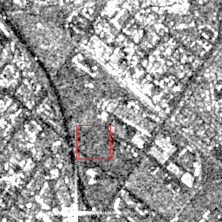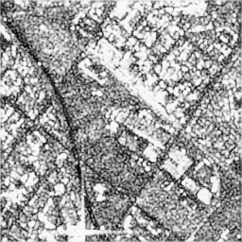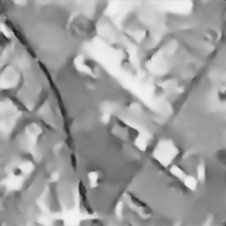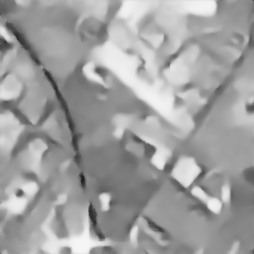
(a) (b) (c) (d)
Noisy SAR-BM3D SAR2SAR SDUDNet
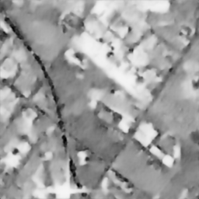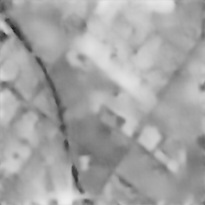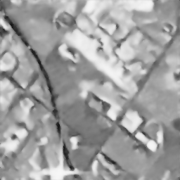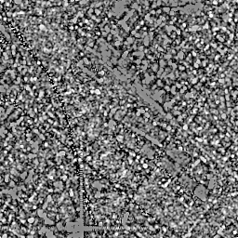
(e) (f) (g) (h)
Trans-SAR Ours-base Ours+AMS Ours+AMS ratio
Fig. 3. Visual comparison for a real-SAR scene. Ours-base denotes the model before adaptation. The original renderings are retained, including the red inspection box in (a). Panel (h) shows the Ours+AMS ratio image, which is assessed separately from the restorations. No clean reference is shown.

G. Scene-Wise No-Reference Evaluation on Real SAR
Table V gives a separate descriptive evaluation of 60 real patches: 20 each from homogeneous, structural, and texture scenes. These summaries are not pooled with the 592-patch benchmark.
TABLE V
No-Reference Results by Real-SAR Scene Type
Model | ENL | $M$-index$↓$ | EPI$↑$
Homogeneous: 20 patches; Noisy ENL = 32.0025
Ours-base | 740.6812 | 4.386215 | 0.312438
Ours+AMS | 88.3567 | 3.742691 | 0.818562
Structural: 20 patches; Noisy ENL = 24.3142
Ours-base | 429.6054 | 0.682143 | 0.343582
Ours+AMS | 74.2189 | 0.521876 | 0.742615
Texture: 20 patches; Noisy ENL = 14.9264
Ours-base | 620.8473 | 0.152604 | 0.461294
Ours+AMS | 55.6948 | 0.098531 | 0.835476
Average: 60 patches; Noisy ENL = 23.7477
Ours-base | 597.0446 | 1.740321 | 0.372438
Ours+AMS | 72.7568 | 1.454366 | 0.798884
Each category uses the same 20 patches before and after AMS. Bold values mark the better M-index and EPI for each comparison. ENL is reported as a mean and is not ranked.
AMS improves M-index and EPI in every category. The reported Average changes from 1.740321 to 1.454366 for M-index and 0.372438 to 0.798884 for EPI; mean ENL falls from 597.0446 to 72.7568. Mean ENL decreases in each group but stays above the noisy-input value, supporting the same adaptation trend across the evaluated structures.

H. Limitations
Optical proxies do not reproduce focused SAR statistics, and one real collection does not establish cross-region or cross-sensor transfer. Results lack uncertainty estimates and efficiency measurements. Independent acquisitions, source/parent-clustered confidence intervals, and matched training and capacity comparisons remain necessary. Confidence intervals should group the four looks of each UCM source and the four child patches of each real parent.

IV. Conclusion
Full-spectrum Fourier refinement and intensity compensation after exact log inversion improve the evaluated Trans-SAR reconstruction. The complete model leads macro PSNR/SSIM on UCM-21, and ablations support both additions within the tested configurations. Encoder-frozen masked adaptation improves M-index and EPI on parent-disjoint real patches and in all three scene categories. These empirical results motivate validation on independent acquisitions with uncertainty and efficiency analysis.

References
[1] G. Fracastoro et al., “Deep learning methods for synthetic aperture radar image despeckling: An overview of trends and perspectives,” IEEE Geosci. Remote Sens. Mag., vol. 9, no. 2, pp. 29–51, 2021, doi: 10.1109/MGRS.2021.3070956.
[2] J.-S. Lee, “Digital image enhancement and noise filtering by use of local statistics,” IEEE Trans. Pattern Anal. Mach. Intell., vol. PAMI-2, no. 2, pp. 165–168, 1980, doi: 10.1109/TPAMI.1980.4766994.
[3] S. Parrilli, M. Poderico, C. V. Angelino, and L. Verdoliva, “A nonlocal SAR image denoising algorithm based on LLMMSE wavelet shrinkage,” IEEE Trans. Geosci. Remote Sens., vol. 50, no. 2, pp. 606–616, 2012, doi: 10.1109/TGRS.2011.2161586.
[4] G. Chierchia, D. Cozzolino, G. Poggi, and L. Verdoliva, “SAR image despeckling through convolutional neural networks,” in Proc. IEEE IGARSS, 2017, pp. 5438–5441, doi: 10.1109/IGARSS.2017.8128234.
[5] J. Ko and S. Lee, “SAR image despeckling using continuous attention module,” IEEE J. Sel. Topics Appl. Earth Observ. Remote Sens., vol. 15, pp. 3–19, 2022, doi: 10.1109/JSTARS.2021.3132027.
[6] M. V. Perera, W. G. C. Bandara, J. M. J. Valanarasu, and V. M. Patel, “Transformer-based SAR image despeckling,” in Proc. IEEE IGARSS, 2022, pp. 751–754, doi: 10.1109/IGARSS46834.2022.9884596.
[7] Y. Shen, Y. Chen, Y. Wang, L. Ma, and X. Zhang, “DATNet: Dynamic adaptive Transformer network for SAR image denoising,” Remote Sens., vol. 17, no. 17, Art. no. 3031, 2025, doi: 10.3390/rs17173031.
[8] L. Zhang, L. Zheng, Y. Wen, F. Zhang, F. Bo, and Y. Cen, “Effective SAR image despeckling using noise-guided Transformer and multi-scale feature fusion,” Remote Sens., vol. 17, no. 23, Art. no. 3863, 2025, doi: 10.3390/rs17233863.
[9] X. Zhao, F. Ren, H. Sun, and Q. Qi, “Synthetic aperture radar image despeckling based on a deep learning network employing frequency domain decomposition,” Electronics, vol. 13, no. 3, Art. no. 490, 2024, doi: 10.3390/electronics13030490.
[10] Y. Ma, P. Ke, H. Aghababaei, L. Chang, and J. Wei, “Despeckling SAR images with Log-Yeo–Johnson transformation and conditional diffusion models,” IEEE Trans. Geosci. Remote Sens., vol. 62, pp. 1–17, 2024, doi: 10.1109/TGRS.2024.3419083.
[11] E. Dalsasso, L. Denis, and F. Tupin, “SAR2SAR: A semi-supervised despeckling algorithm for SAR images,” IEEE J. Sel. Topics Appl. Earth Observ. Remote Sens., vol. 14, pp. 4321–4329, 2021, doi: 10.1109/JSTARS.2021.3071864.
[12] A. B. Molini, D. Valsesia, G. Fracastoro, and E. Magli, “Speckle2Void: Deep self-supervised SAR despeckling with blind-spot convolutional neural networks,” IEEE Trans. Geosci. Remote Sens., vol. 60, pp. 1–17, 2022, doi: 10.1109/TGRS.2021.3065461.
[13] H. Lin, X. Su, Z. Zeng, C. Xing, and J. Yin, “Speckle2Self: Learning self-supervised despeckling with attention mechanism for SAR images,” Remote Sens., vol. 17, no. 23, Art. no. 3840, 2025, doi: 10.3390/rs17233840.
[14] L. Chen, Y. Yin, H. Shi, J. He, and W. Li, “Self-supervised despeckling based solely on SAR intensity images: A general strategy,” ISPRS J. Photogramm. Remote Sens., vol. 231, pp. 854–873, 2026, doi: 10.1016/j.isprsjprs.2025.11.025.
[15] F. Bo, X. Ma, S. Hu, G. An, Y. Li, and Y. Cen, “Speckle-driven unsupervised despeckling for SAR images,” IEEE J. Sel. Topics Appl. Earth Observ. Remote Sens., vol. 18, pp. 13023–13034, 2025, doi: 10.1109/JSTARS.2025.3568854.
[16] G. Cheng, J. Han, and X. Lu, “Remote sensing image scene classification: Benchmark and state of the art,” Proc. IEEE, vol. 105, no. 10, pp. 1865–1883, 2017, doi: 10.1109/JPROC.2017.2675998.
[17] Y. Yang and S. Newsam, “Bag-of-visual-words and spatial extensions for land-use classification,” in Proc. ACM SIGSPATIAL Int. Conf. Adv. Geogr. Inf. Syst., 2010, pp. 270–279, doi: 10.1145/1869790.1869829.
[18] R. Vasquez et al., “Labeled dataset for despeckling SAR imagery,” Mendeley Data, ver. 1, 2024, doi: 10.17632/fs455tz88y.1.
[19] L. Gómez, R. Ospina, and A. C. Frery, “Unassisted quantitative evaluation of despeckling filters,” Remote Sens., vol. 9, no. 4, Art. no. 389, 2017, doi: 10.3390/rs9040389.
[20] X. Ma, L. Li, and G. Wang, “Blind edge-retention indicator for assessing the quality of filtered (Pol)SAR images based on a ratio gradient operator and confidence interval estimation,” Remote Sens., vol. 16, no. 11, Art. no. 1992, 2024, doi: 10.3390/rs16111992.
[21] R. D. Vásquez-Salazar, W. S. Puche, A. C. Frery, and L. Gómez, “Quality assessment of despeckling filters based on the analysis of ratio images,” Remote Sens., vol. 17, no. 24, Art. no. 4048, 2025, doi: 10.3390/rs17244048.

(Corresponding author: Peng Liu.) The authors are with the Key Laboratory of Information Science of Electromagnetic Waves, Fudan University, Shanghai, China (e-mail: pliu@fudan.edu.cn).

