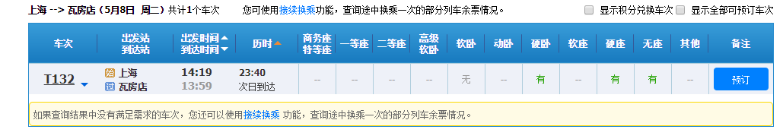 {"data":{"flag":"1","map":{"SHH":"上海","WDT":"瓦房店"},"result":["8yoPOvK06YEcDSyInuXmzz0FMpBGB6l3mwYwCkpXWLx8cx16xH9Hfvp6Iug9asXaiKechZa3F%2Bds%0AzFUDlEzDuW8hKjFGeY7M7hdjLpIp1qqUaoWefJYKbxAtDcv1Srg0VfvqSXECFU4Y12lS2mbnuYa4%0AYGFnxwjH44KJTZPEUdHh08ASYpF8nY9tiHKJuIJ80MYyr04nLJmmg1cZBtv%2Fcu%2Bn5dvJ1V%2FI9aWd%0ALiwYcTbdBgelcXHFlR08TdhylqpRJINPfxWmYpw%3D

|预订

|550000T132B1

|T132

|SHH

|DLT

|SHH

|WDT

|14:19

|13:59

|23:40

|Y

|L8Ah3zTvfPkCBjKoC4JlnJiniuZCLB%2Bxh%2B%2FcqQ7QN0lA6AmutPfc%2BOeg2Lg%3D

|20180508

|3|H3

|01

|22

|0|0||||无|||有||有|有|||||

10401030|1413|0"]},"httpstatus":200,"messages":"","status":true}