题目1:
商品模块
新增接口：http://localhost:8080/product/add
入参json：
String productCode; （必填）
String productName; （必填）
double productPrice;
String productRemark;
返回格式
{
flag：true/false,
"message": "入库成功",
"data"：null
}

编辑接口：http://localhost:8080/product/edit
入参json：
Integer:id, （必填）
String productCode; （必填）
String productName; （必填）
double productPrice;
String productRemark;
返回格式
{
flag：true/false,
"message": "编辑成功",
"data"：null
}

删除接口：http://localhost:8080/product/delete
入参：Integer id,
返回格式
{
flag：true/false,
"message": "删除成功",
"data"：null
}

分页查询接口：http://localhost:8080/product/findPage
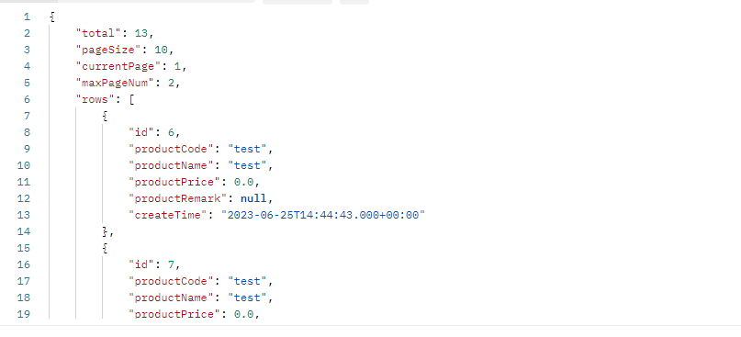
入参：
{
"currentPage":1, 查询页码
"pageSize":10, 每页显示条数
"queryString":"test" 查询条件
}

返回json：
{
"total": 13, 总数量
"pageSize": 10, 页面显示数量
"currentPage": 1, 查询的第几页
"maxPageNum": 2, 最大显示页数
"rows": [ 对应产品信息
{
"id": 6,
"productCode": "test",
"productName": "test",
"productPrice": 0.0,
"productRemark": null,
"createTime": "2023-06-25T14:44:43.000+00:00"
},
{
"id": 7,
"productCode": "test",
"productName": "test",
"productPrice": 0.0,
"productRemark": null,
"createTime": "2023-06-25T14:44:55.000+00:00"
},
{
"id": 8,
"productCode": "test",
"productName": "test",
"productPrice": 0.0,
"productRemark": null,
"createTime": "2023-06-25T14:44:56.000+00:00"
},
{
"id": 9,
"productCode": "test",
"productName": "test",
"productPrice": 0.0,
"productRemark": null,
"createTime": "2023-06-25T14:44:56.000+00:00"
},
{
"id": 10,
"productCode": "test",
"productName": "test",
"productPrice": 0.0,
"productRemark": null,
"createTime": "2023-06-25T14:44:57.000+00:00"
},
{
"id": 11,
"productCode": "test",
"productName": "test",
"productPrice": 0.0,
"productRemark": null,
"createTime": "2023-06-25T14:45:00.000+00:00"
},
{
"id": 12,
"productCode": "test",
"productName": "test",
"productPrice": 0.0,
"productRemark": null,
"createTime": "2023-06-25T14:45:00.000+00:00"
},
{
"id": 13,
"productCode": "test",
"productName": "test",
"productPrice": 0.0,
"productRemark": null,
"createTime": "2023-06-25T14:45:01.000+00:00"
},
{
"id": 14,
"productCode": "test",
"productName": "test",
"productPrice": 0.0,
"productRemark": null,
"createTime": "2023-06-25T14:45:03.000+00:00"
},
{
"id": 15,
"productCode": "test",
"productName": "test",
"productPrice": 0.0,
"productRemark": null,
"createTime": "2023-06-25T14:45:03.000+00:00"
}
]
}

台账模块
新增接口：http://localhost:8080/store/add
入参json：
String storeCode; （必填）
String storeName; （必填）
String remake;
String productRemark;
返回格式 json
{
flag：true/false,
"message": "新增成功",
"data"：null
}

新增接口：http://localhost:8080/store/edit
入参json：
Integer id （必填）
String storeCode; （必填）
String storeName; （必填）
String remake;
String productRemark;
返回格式json
{
flag：true/false,
"message": "编辑成功",
"data"：null
}

新增接口：http://localhost:8080/store/delete
入参：Integer id （必填）
返回格式json
{
flag：true/false,
"message": "编辑成功",
"data"：null
}

入库：http://localhost:8080/store/inputStore
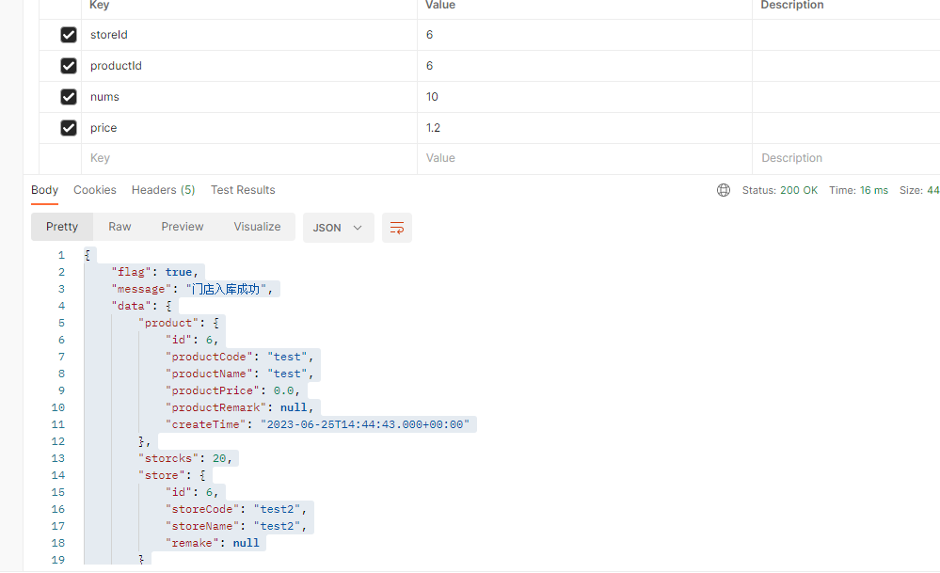
参数
"storeId":6, 仓库主键
"productId":6, 产品主键
"nums":10, 入库数量
"price":1.2, 产品价格
"remark":"" 备注
返回json
{
"flag": true,
"message": "门店入库成功",
"data": {
"product": {
"id": 6,
"productCode": "test",
"productName": "test",
"productPrice": 0.0,
"productRemark": null,
"createTime": "2023-06-25T14:44:43.000+00:00"
}, 入库的产品信息
"storcks": 20, 产品库存
"store": { 仓库信息
"id": 6,
"storeCode": "test2",
"storeName": "test2",
"remake": null
}
}
}

出库：http://localhost:8080/store/outputStore
入参和返回参数和入库一样

商品入库流水查询接口：http://localhost:8080/store/
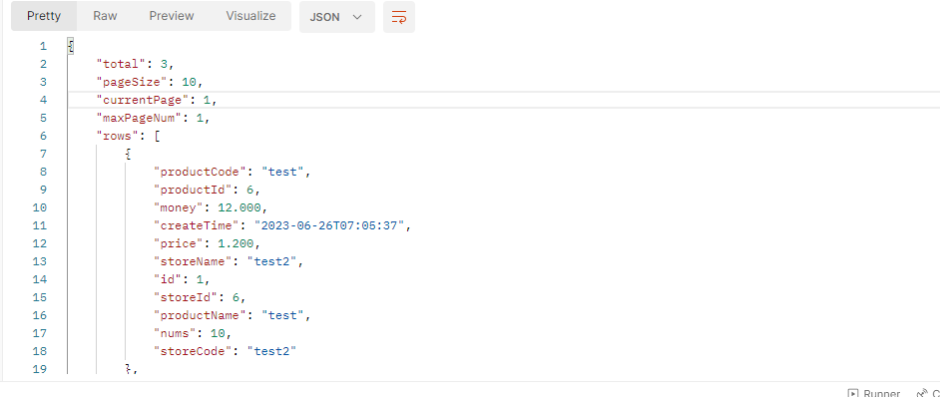
入参：
{
"currentPage":1, 查询页码
"pageSize":10, 每页显示条数
"queryString":"test" 查询条件
}
返回json
{
"total": 3,
"pageSize": 10,
"currentPage": 1,
"maxPageNum": 1,
"rows": [
{
"productCode": "test",
"productId": 6,
"money": 12.000,
"createTime": "2023-06-26T07:05:37",
"price": 1.200,
"storeName": "test2",
"id": 1,
"storeId": 6,
"productName": "test",
"nums": 10,
"storeCode": "test2"
},
{
"productCode": "test",
"productId": 6,
"money": 6.000,
"createTime": "2023-06-26T07:51:53",
"price": 1.200,
"storeName": "test2",
"id": 3,
"storeId": 6,
"productName": "test",
"nums": 5,
"storeCode": "test2"
},
{
"productCode": "test",
"productId": 6,
"money": 12.000,
"createTime": "2023-06-26T09:12:00",
"price": 1.200,
"storeName": "test2",
"id": 4,
"storeId": 6,
"productName": "test",
"nums": 10,
"storeCode": "test2"
}
]
}

统计特定商品接口：http://localhost:8080/store/checkStorck
入参：productId
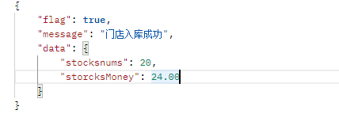

返回json
{
"flag": true,
"message": "查询成功",
"data": {
"stocksnums": 20, 库存数量
"storcksMoney": 24.00 库存金额
}
}

