development environment:我在windows上 使用python2.7執行

引入:

numpy做矩陣運算

sklearn.decomposition做PCA

pylab 畫圖

glob 方便開啟一個資料夾內的檔案

PIL 開啟圖片的模組

1. Show the mean (average) face, top 5 eigenfaces and their corresponding eigenvalues in a descending order?

Meanface:

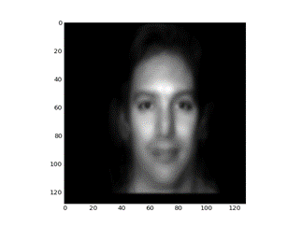

Top 5 eigenface:

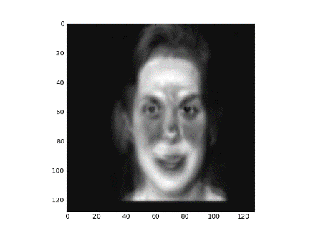 eigenvalue: 0.529331479079

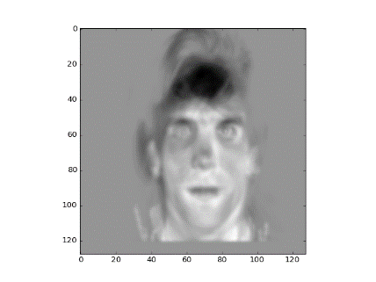 eigenvalue: 0.143168962358

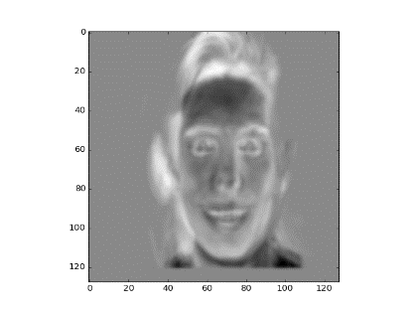 eigenvalue:0.0846481984675

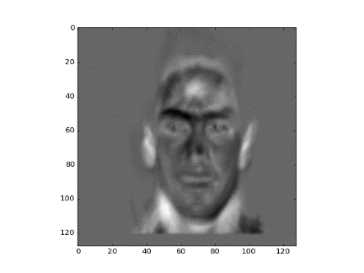 eigenvalue: 0.0430098780893

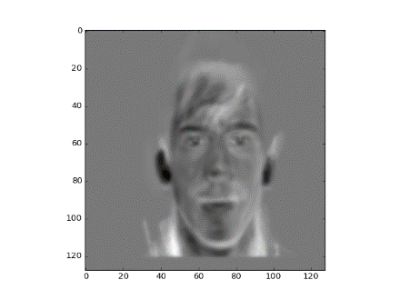 eigenvalue:0.0376659374403

1. Given a test image (hw01-test.tif, or you can use your own image), compute the top 10 eigenface coefficients?

4519.32336406

166.30766382

-1335.99122882

-795.68890574

-675.67662483

-105.78272149

-94.22467703

64.86271144

450.06180331

-383.4782626

1. Keep only first K (K=5,10,15,20, and 25) coefficients and use them to reconstruct the image in the pixel domain. Compare the reconstructed image with the original image by PSNR (Peak Signal to Noise Ration) value?

Reconstruct face:

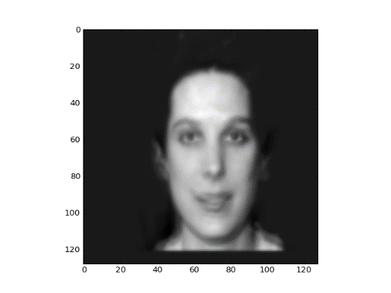k=5 ,PSNP= 27.8773232377

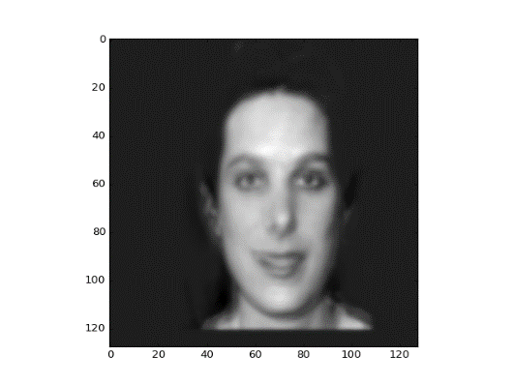k=10,PSNR= 28.9287965411

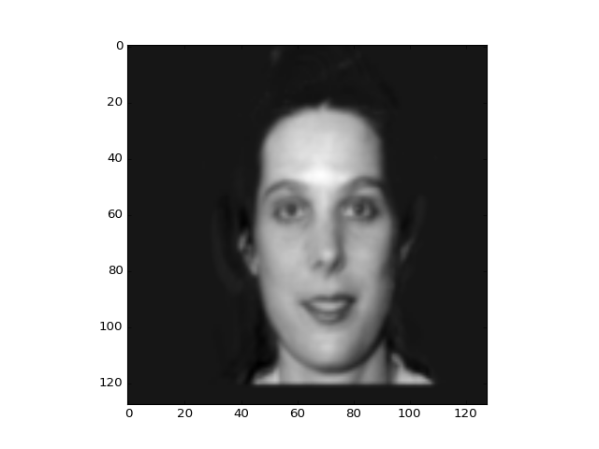k=15,PSNR= 34.7811437195

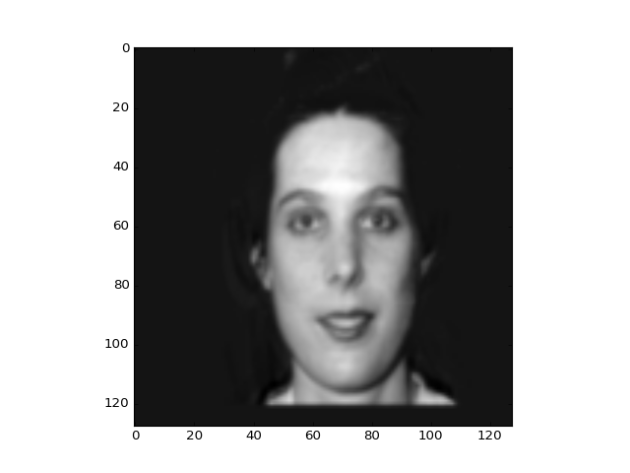k=20,PSNR= 36.178543736

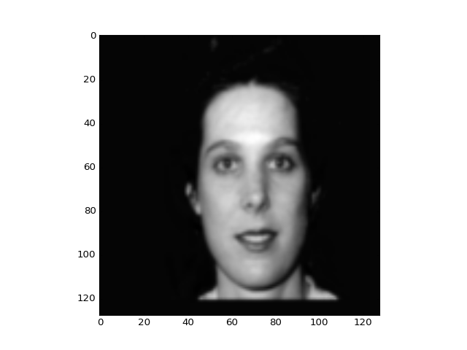k=25,PSNR= 46.705778506

Observations:使用越多張eigenface重組 越容易接近原圖