Problem 1: Image classification
1. (2%)Print the network architecture of your model.
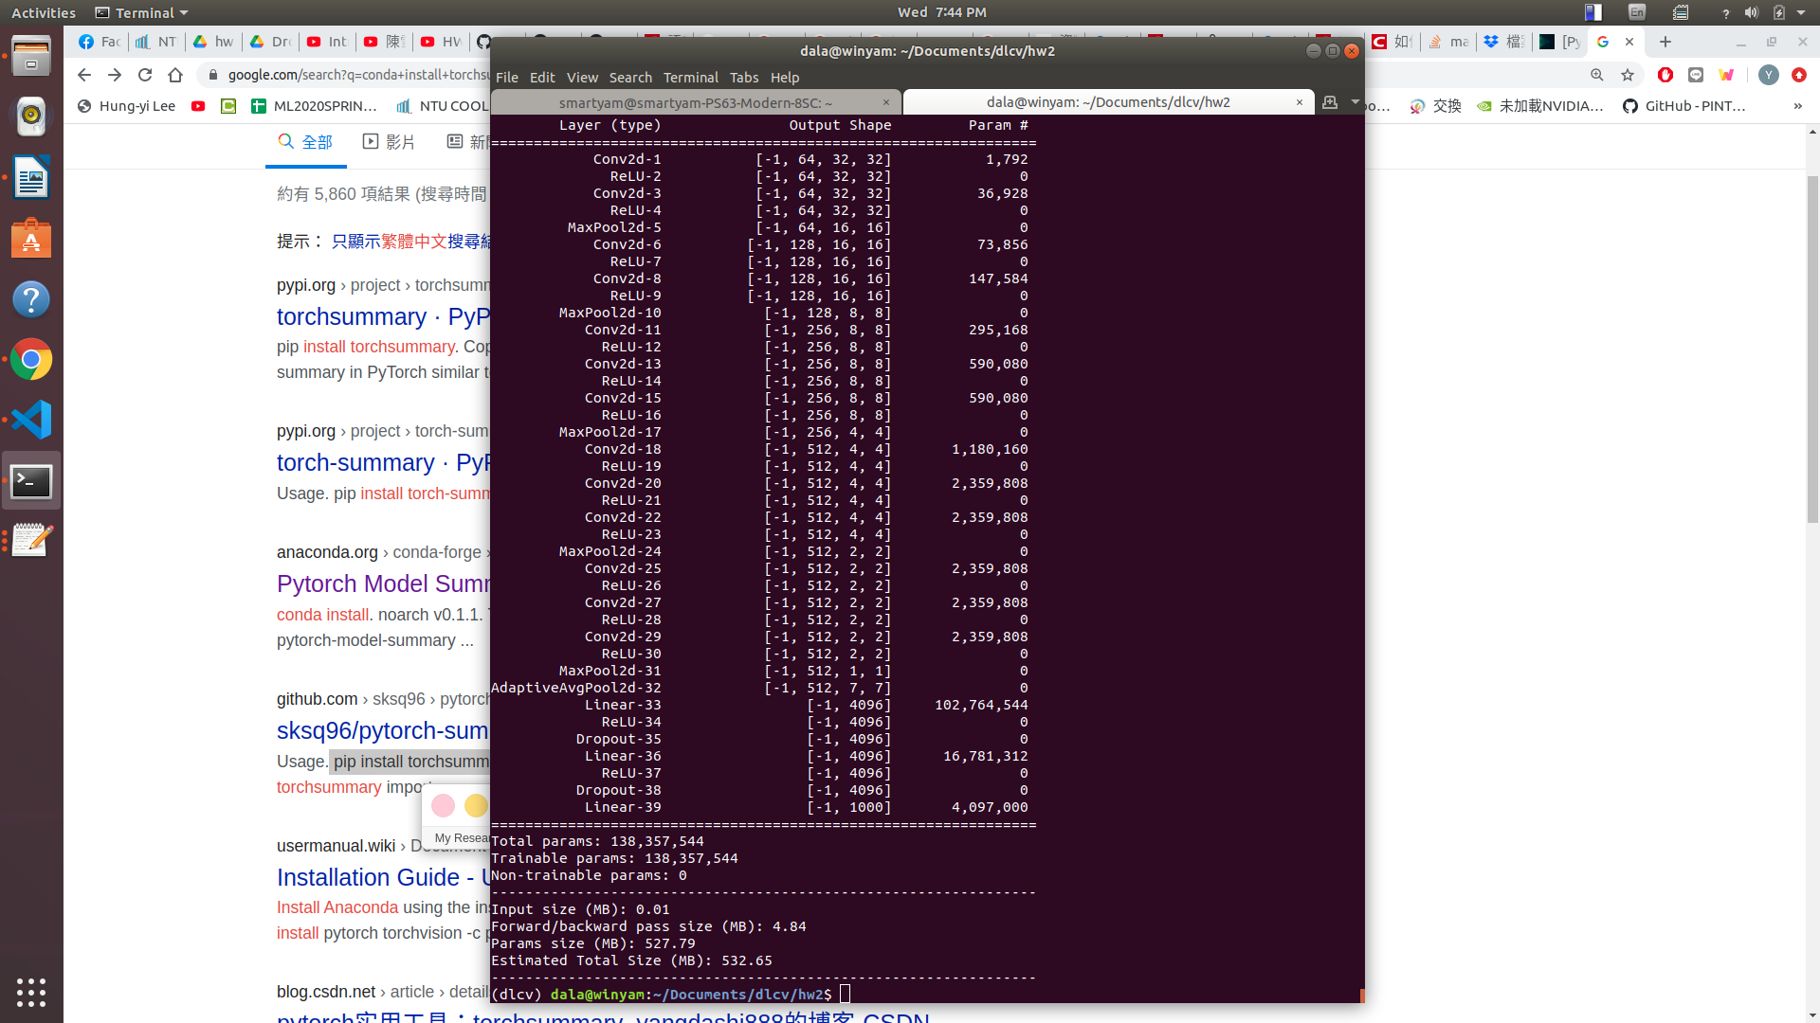

2. (2%)Report accuracy of model on the validation set.
0.723600

3. (6%)Visualize the classification result on validation set by implementing t-SNE on output
features of the second last layer. Briefly explain your result of tSNE visualization.
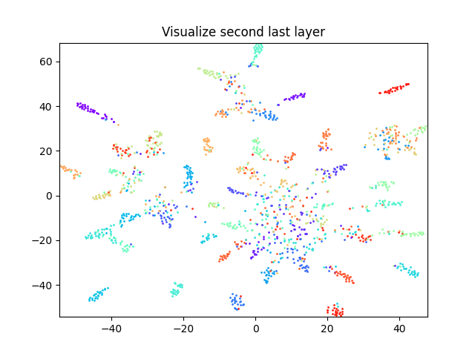
From the above plotting result, we can briefly find that there are lots of outputs(among 50 classes) from the last second layer have merged together with the same labels. However, there are still quite a lot of them can’t be distinguished by our eyes, especially the part at the middle left of the picture, there are a bunch of data can’t be tell from each other. Still, we can find good cluster results from the outlier. Maybe the result can be explained by the wrong recognition of labels(Below is the 50 classes confusion matrix), or slightly difference from those features output.

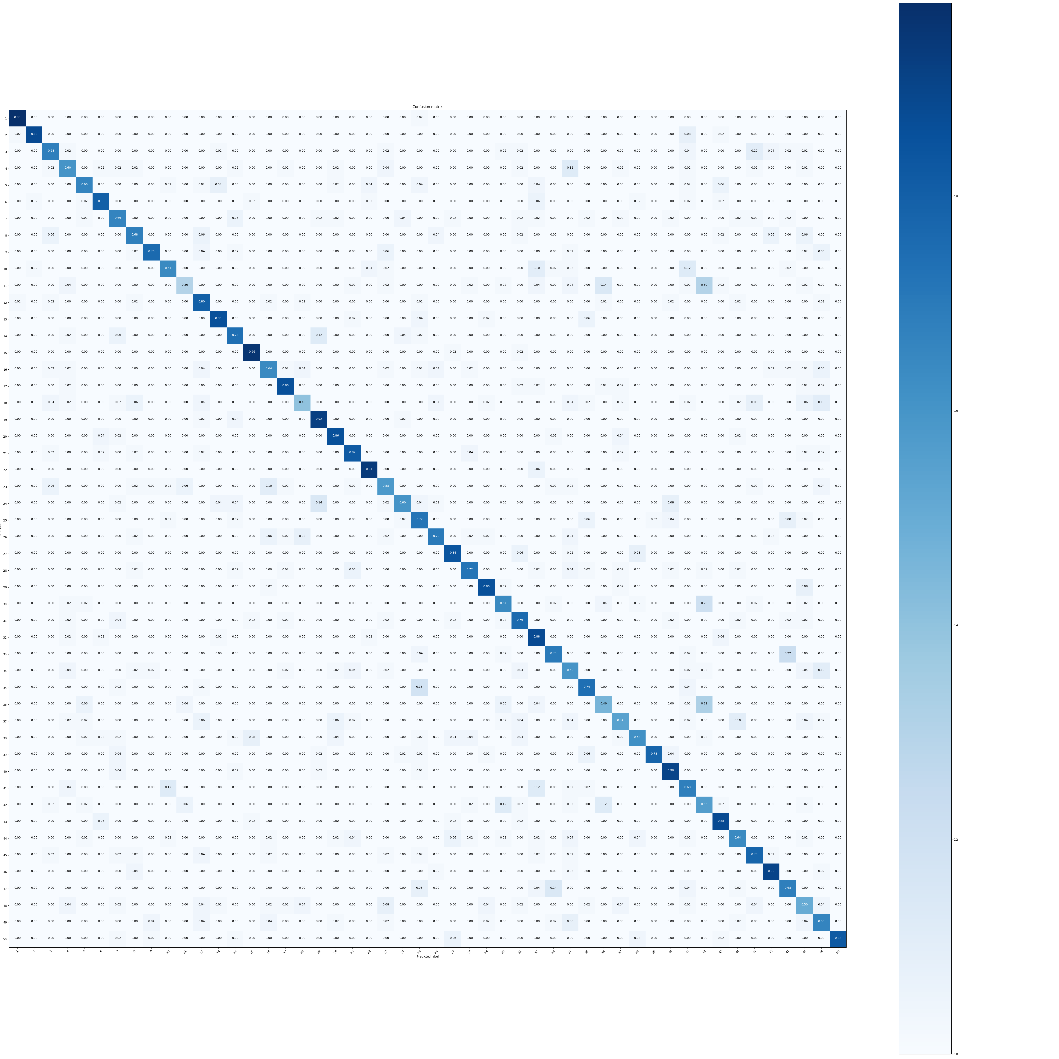

Problem 2: Semantic segmentation(70%)
reference: https://github.com/wkentaro/pytorch-fcn
https://github.com/pochih/FCN-pytorch
1. (5%) Print the network architecture of your VGG16-FCN32s model.
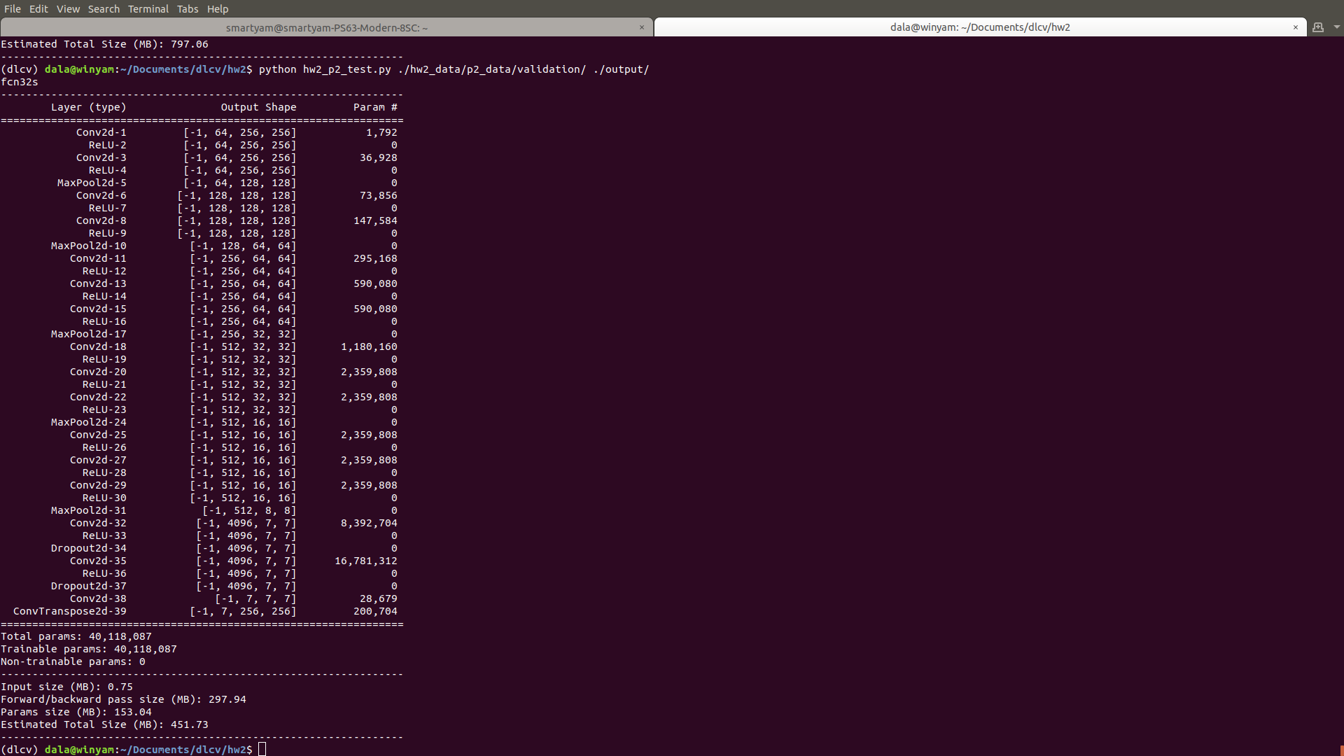
2. (5%) Show the predicted segmentation mask of “validation/0010_sat.jpg”, “validation/0097_sat.jpg”, “validation/0107_sat.jpg” during the early, middle, and the final stage during the training stage. (For example, results of 1st, 10th, 20th epoch)
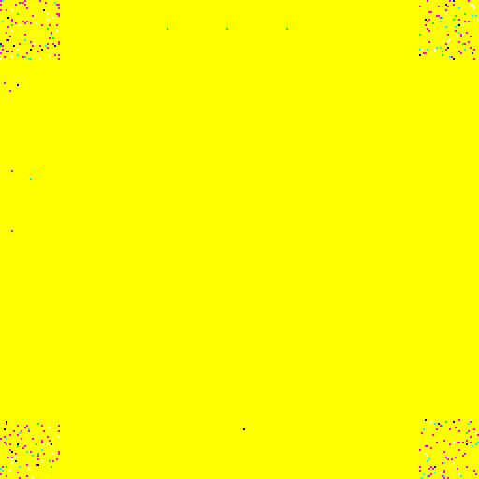 | 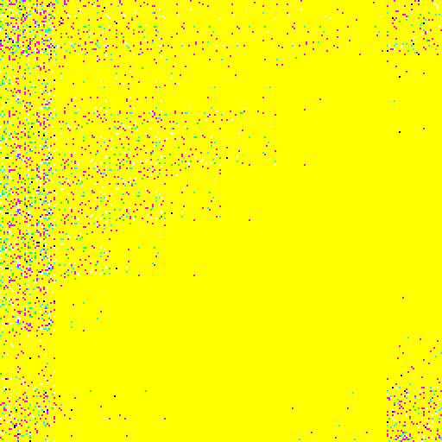 | 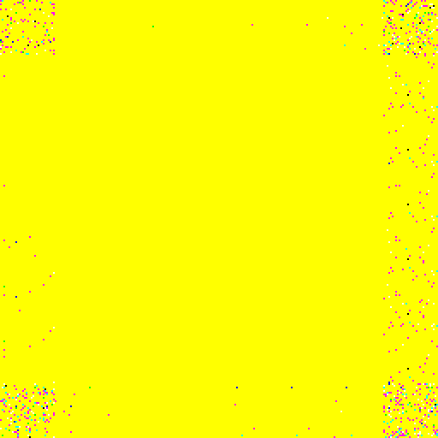
fcn32s_1_0010_mask | fcn32s_1_0097_mask.png | fcn32s_1_0107_mask.png
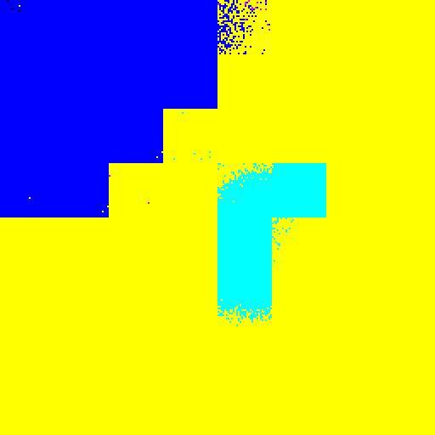 | 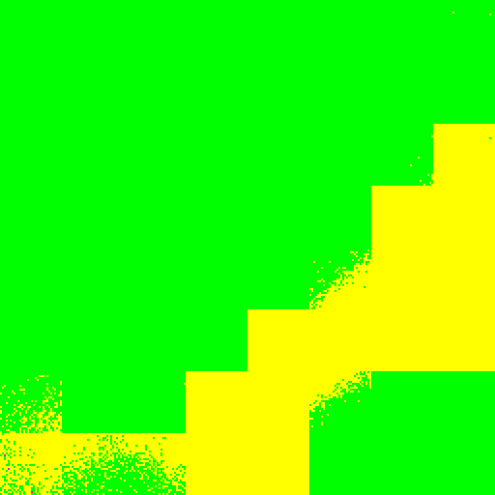 | 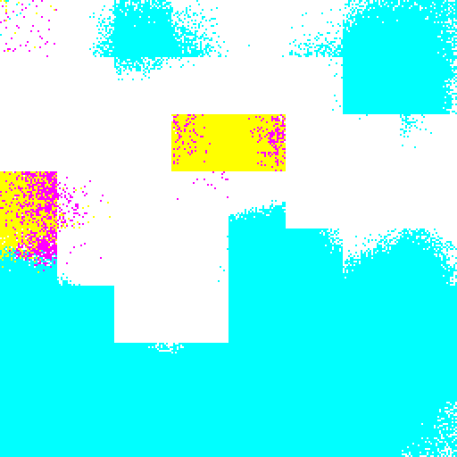
fcn32s_1_0010_mask.png | fcn32s_1_0097_mask.png | fcn32s_1_0107_mask.png
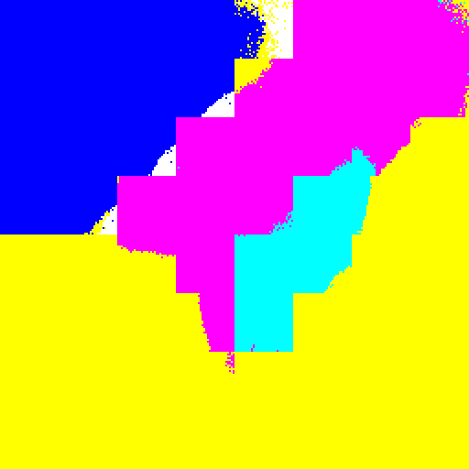 | 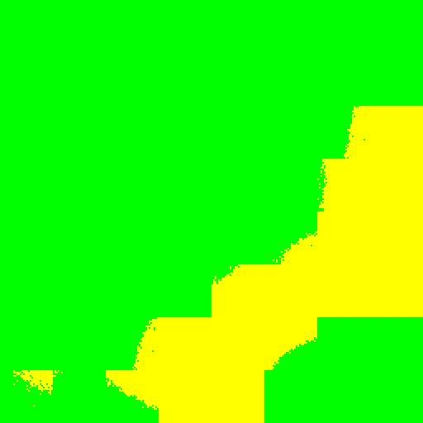 | 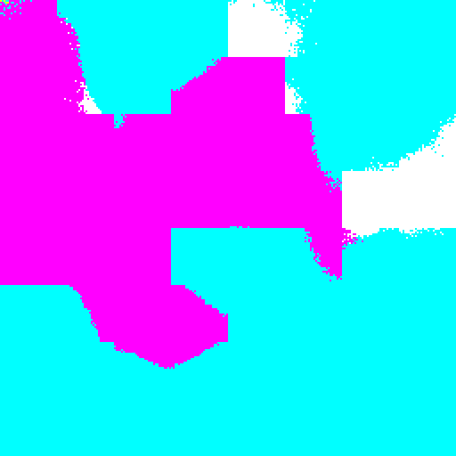
fcn32s_1_0010_mask.png | fcn32s_1_0097_mask.png | fcn32s_1_0107_mask.png

3. (5%) Implement an improved model which performs better than your baseline model. Print the network architecture of this model.
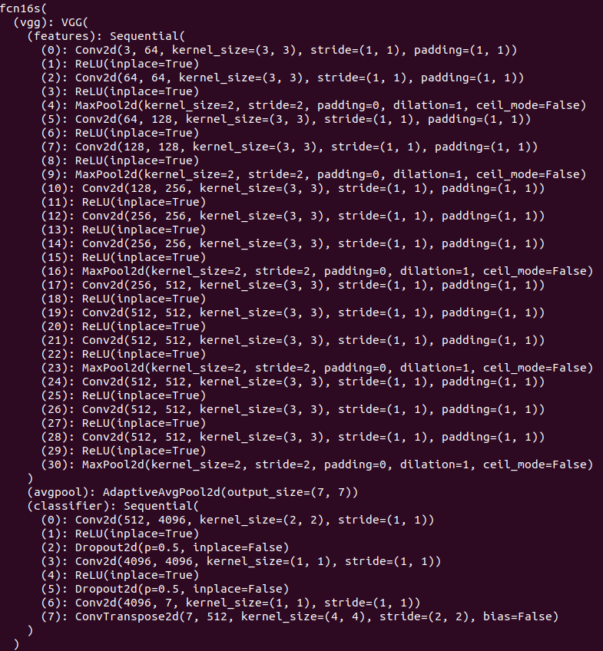

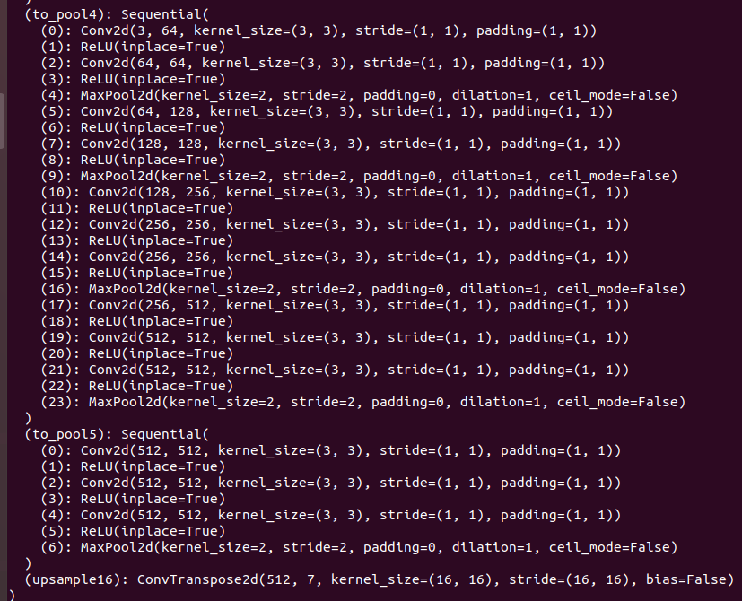

4. (5%) Show the predicted segmentation mask of “validation/0010_sat.jpg”, “validation/0097_sat.jpg”, “validation/0107_sat.jpg” during the early, middle, and the final stage during the training process of this improved model.
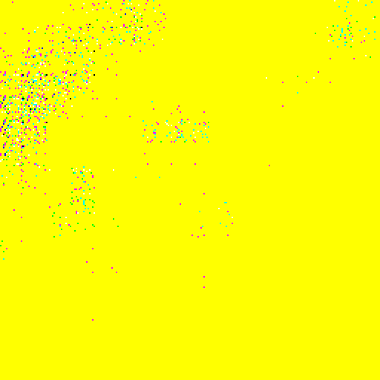 | 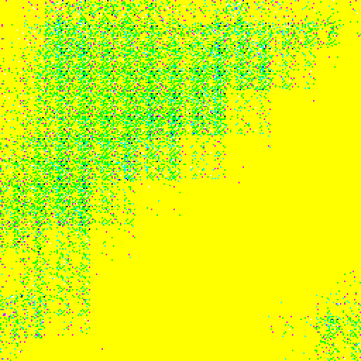 | 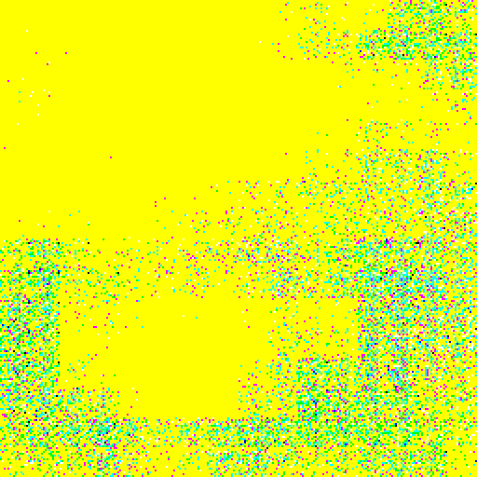
fcn16s_1_0010_mask | fcn16s_1_0097_mask | fcn16s_1_0107_mask
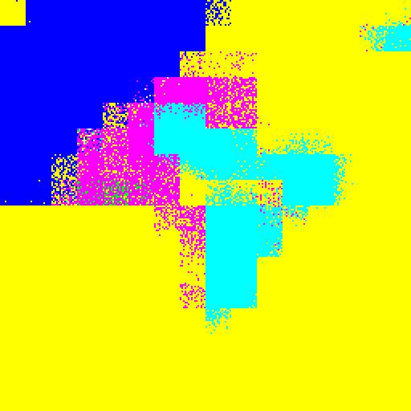 | 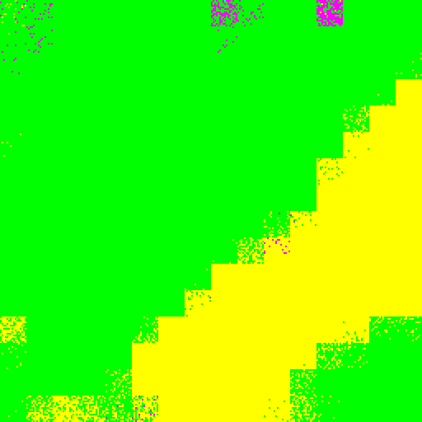 | 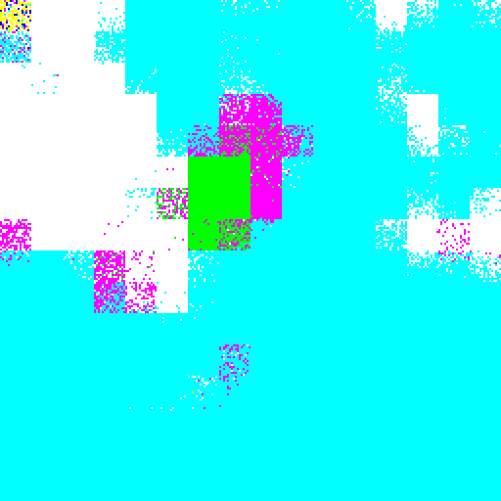
fcn16s_1_0010_mask | fcn16s_1_0097_mask | fcn16s_1_0107_mask
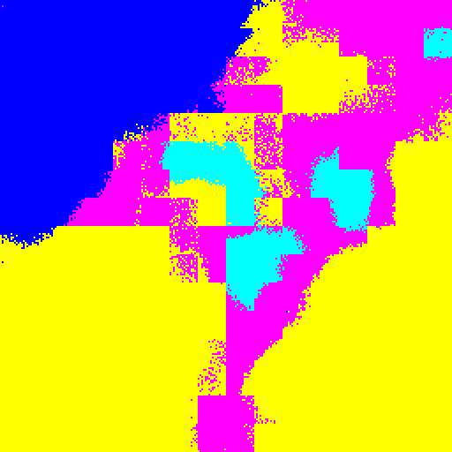 | 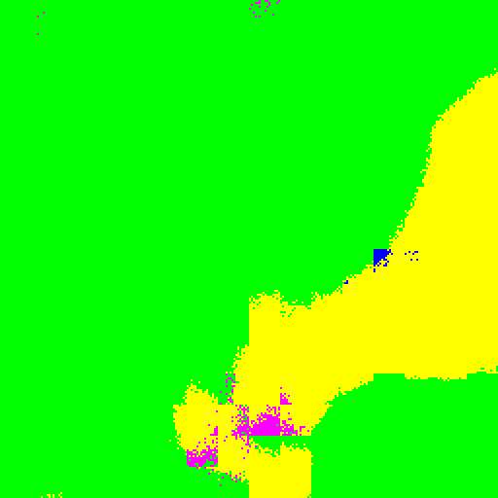 | 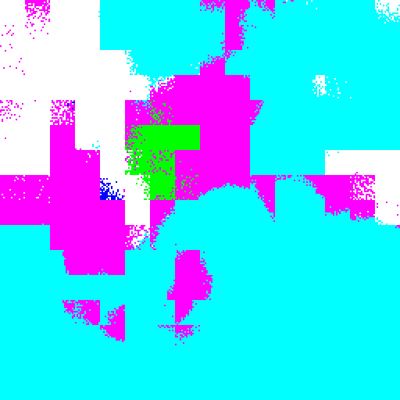
fcn16s_1_0010_mask | fcn16s_1_0097_mask | fcn16s_1_0107_mask

5. (10%) Report mIoU score of both models on the validation set. Discuss the reason why the improved
model performs better than the baseline one. You may conduct some experiments and show some
evidences to support your reasoning.

FCN32s mIoU | FCN16s mIoU
0.670 | 0.709

epoch | FCN32s mIoU | FCN16s mIoU
1 | 0.43 | 0.54
5 | 0.56 | 0.58
10 | 0.59 | 0.61
15 | 0.61 | 0.64
20 | 0.65 | 0.67

From the above table, we can find out that FCN16s predicts masks better than FCN32s does. Since the improved model combine predictions from the final layer and the former pooling layer (pool4), the model could predict finer details on the mask from the value of mean_IOU and get high-level information from FCN. The previous sections have shown the output masks of segmentation by FCN32s and FCN16s. Also,we can find that FCN16s converge faster than FCN32s in this case, which could be observed by the output mask after the first epoch(fcn16s_1_0097_mask on the above question has the significant improvement).From the score of meanIOU in each epoch, the FCN16s indeed improves segmentation detail by combining information from previous layers.

