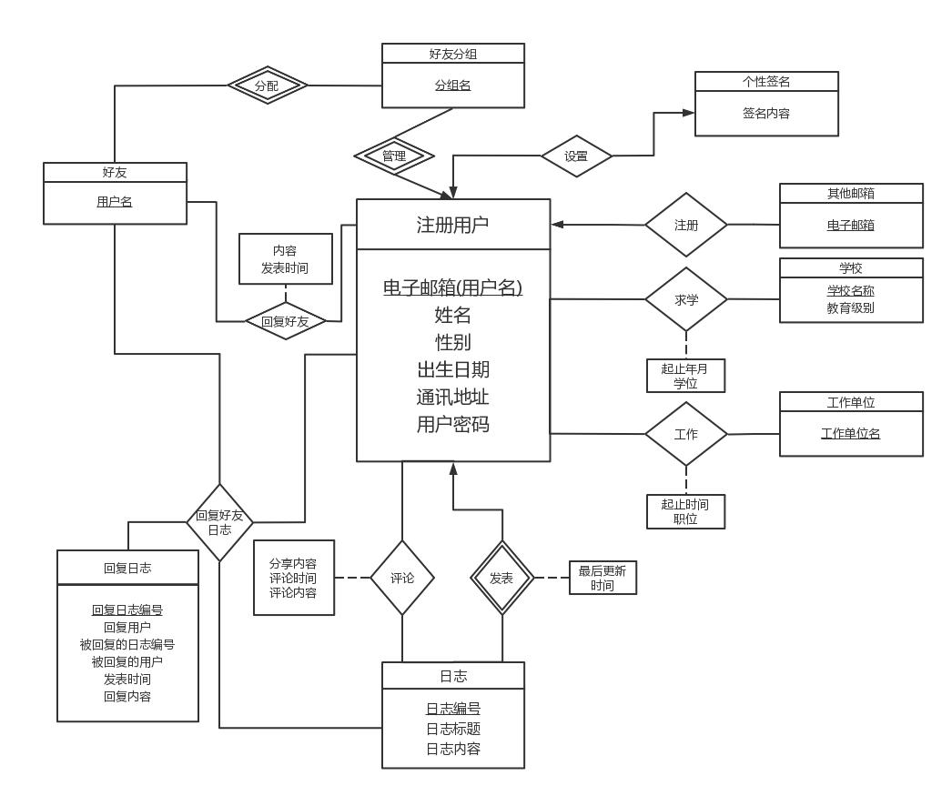

### ****show table status where comment='view';****

### ****SELECT * FROM mysql.`innodb_index_stats` a WHERE a.`database_name` = 'social';****

### ****show index from REGISTER_USERS;****

### ****show index from OTHER_EMAIL ;****

### ****show index from SCHOOLS;****

### ****show index from WORKPLACES ;****

### ****show index from LEARNS_IN;****

### ****show index from WORKS_ON;****

### ****show index from LOGS;****

### ****show index from UPDATE_LOGS;****

### ****show index from REVIEW_LOGS;****

### ****show index from REPLY_LOGS;****

### ****show index from FRIEND_GROUP;****

### ****show index from FRIENDS;****

### ****show index from REPLY_FRIENDS;****

### ****show index from Signature;****