**AN8001**

**Application Notes**

**Rev 1.00 2022/7/29**



**MM32-LINK MINI User Guide**

**Introduction**

The basic functions and the use methods of MM32-LINK MINI emulator are introduced in this paper, as well as the solutions of FAQ.

MM32-LINK MINI basic functions:

* Support MM32 whole series emulating and debugging
* Support CDC virtual serial port
* Support updating and configurating via USB drive

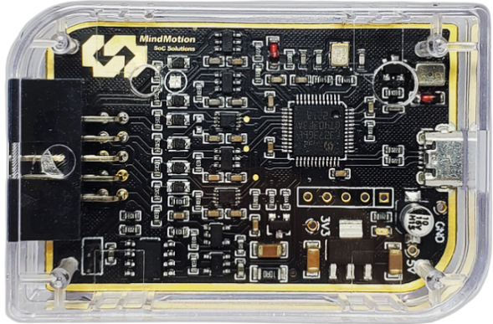

# Basic Functions

The basic functions of MM32-LINK MINI(hereinafter referred to as MINI) are as follows：

|  |  |  |
| --- | --- | --- |
| Functions | Descriptions | Notes |
| MM32-V1 Debug | Programming via SWD port under USB-HID mode. CMSIS debug channel is compliant. | No drivers are required under all Windows systems (Win98 and later versions). |
| CDC virtual serial port | Logging, tracing and terminal emulation. | - |
| MSC updating / configurating | Firmware updating and functional configurations via USB drive. | - |

# Use Methods

## MM32-V1 Debug

### Fundamentals

MM32-V1 Debug adopts CMSIS-DAP Protocol and uses USB-HID communication mode internal to realize MM32 Cortex-M whole series MCU emulating and debugging requirements.

### Interface Circuit

MINI debugger has one Micro-USB interface and 10-pin ARM Cortex debugging connector socket. The interface designation of debugging connector and the definition of factory configuration cable are as follows.

|  |  |  |
| --- | --- | --- |
| Pin Name | Cable Color | Descriptions |
| TVCC | ●Red | Power line of target board. Support 3.3V / 5V configuration and 200mA maximum limiting current. |
| VREF | ●Orange | Power feedback line of target board. VREF can be connected to TVCC directly internal and does no need other wires in this condition. |
| GND | ●Black | GND |
| CLK | ●Blue | SWD clock line |
| DIO | ●Yellow | SWD data line |
| nRST | ●Gray | Reset line: connected with reset pin on target board. |
| Pin Name | Cable Color | Descriptions |
| TXD | ●Green | Virtual serial port TX line: connected with RX pin on target board. |
| RXD | ○White | Virtual serial port RX line: connected with TX pin on target board. |
| SWO | ●Purple | Serial port trace output line |

The specific connecting way is shown in Figure 1：

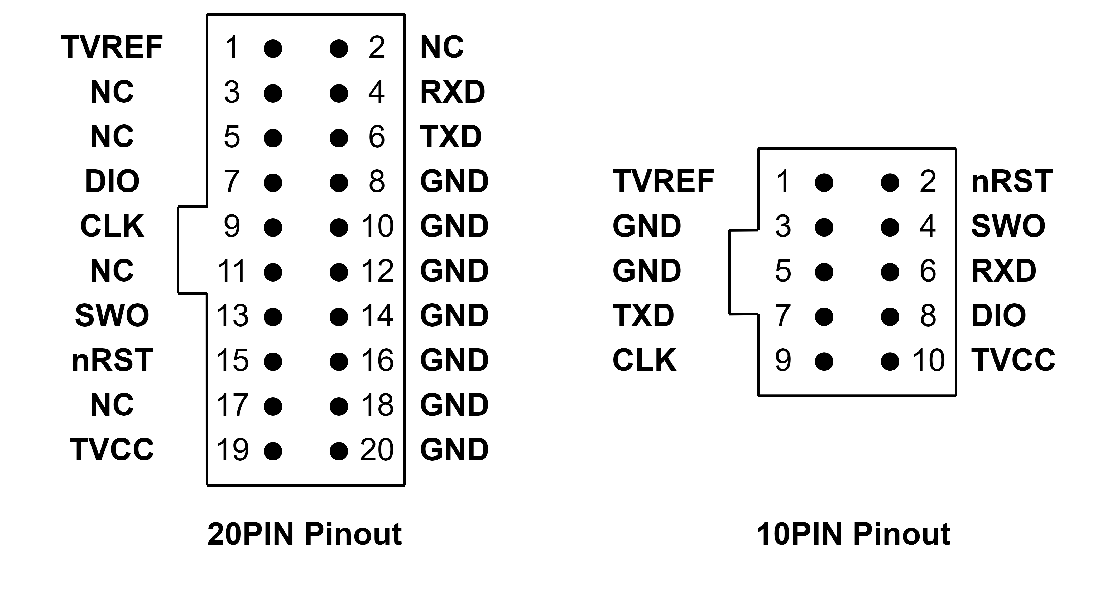

Figure 1 10P-To-20P connections

### Device Serial Number

The device serial number of MM32-LINK Series is encoded in 19 bits. The specific rules are as follows：

|  |  |  |
| --- | --- | --- |
| Member | Bit width | Contents |
| Board ID | Total 3 bit. Bit [0] – Bit [2]. | “088”：MB-088 |
| Chip UID | Total 16 bit. Bit [9] – Bit [24]. | MCU-UUID 64 bit |

### Tutorial

#### Keil

① Open the *Options for Target – Debug* dialog to choose driver.

Enable Use and select CMSIS-DAP Debugger in pull-down list.

② Click Settings button and configure debugging option.

*Cortex-M Target Driver Setup* dialog pop out, consisting of three sets of information and configurations which are shown in table below：

**CMSIS-DAP JTAG/SW Adapter**

|  |  |  |
| --- | --- | --- |
| Info. | Descriptions | Notes |
| Serial No | Display the identifier of the debugger adapter in use. When more adapters are connected, use the drop-down list to specify the adapter or driver. | MM32-LINK Series specifications: Board[3] + UUID[16] |
| Firmware Version | Display the firmware version detected on the device. | - |
| SWJ | Enable the driver to switch between JTAG and SW mode. | Enable (Recommended) |
| Port | Set the internal debugging interface: SW or JTAG. | SW default in MM32 whole series. |
| Max Clock | Set the debugging clock rate for communicating to the target board. | Suggest 5MHz maximum. Update later. |

Choose MM32_V1 CMSIS-DAP adapter in use. Dialog is shown in figure below：

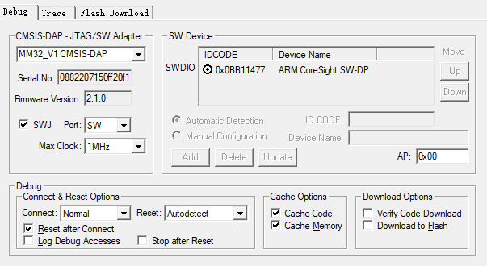

**SW Device**

SW Device shows one or more debug targets connected through the Serial Wire interface. The IDCODE and Device Name are displayed automatically for each device.

**Debug**

The Debug section provides controls for connecting and resetting the device, and caching and downloading the code. The settings are applied each time a debugging session is started.

* + - Connect & Reset Options

Choose Normal as connecting way and Autodetect as reset way by default.

* + - Cache Options

By default, caching options are enabled to get maximum performance.

* + - Download Options

Download Options control the downloading of code to the target system when starting a debugging session.

Enable Verify Code Download option by default to ensure program correlation between the image loaded in target system and the image loaded in the µVision debugger. Download to Flash option is disabled by default.

Users could set these options according to the project debugging requirements.

#### IAR

① Open the *Project - Options – Debugger* dialog to select driver.

Select CMSIS DAP in pull-down list.

② Click CMSIS DAP on the left and set debugging options.

* + - **Setup**

Select System (default) as reset strategy. Switch to another reset strategy if download and debugging is abnormal due to the different target chip environments.

* + - **Interface**

Ensure SWD mode is selected and Auto Detect could be selected as maximum interface rate。

## CDC Virtual Serial Port

Bi-direction communication can be realized between MINI debugger serial port and target microcontroller. Support baud rate of 9600 / 14400 / 19200 / 28800 / 38400 / 56000 / 57600 / 115200 and so on.

## USB Drive Updating / Configurating

* + - Firmware updating

By default, MM32LINK-Series latest firmware has been burned into MINI in factory. Users can update firmware as required. Specific operations are as follows:

① Normal mode：

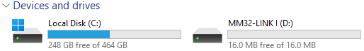

First, create a blank file named “*START_BL.ACT*”; After ensuring the emulator is in idle mode, save the file under “MM32-LINK *” USB drive content by sending or dragging.

Note：Identifier of MM32LINK Series USB drive

|  |  |  |
| --- | --- | --- |
| Identifier | Type | Notes |
| MM32-LINK A | MM32-LINK MAX | A: MAX |
| MM32-LINK I | MM32-LINK MINI | I: MIN |

② Maintenance mode:

After MINI has been read and reset successfully, “BOOTLOADER” portable disk is displayed on PC interface.

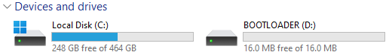

③ Drag to update firmware

Drag “*mm32link_mini_xxxx.hex*” firmware file to USB drive. Emulator will exit maintenance mode automatically after updating is done.

* + - 3.3V / 5V configuration

5V output enable(default): First, create a blank file named “*VT_5V.CFG*”; After ensuring the emulator is in idle mode, save the file under “MM32-LINK *” USB drive content by sending or dragging.

3.3V output enable: File name is “*VT_3V3.CFG*” and other configuration methods are the same.

Power off: File name is “*VT_OFF.CFG*” and other configuration methods are the same.

* + - Beep configuration

Beep enable(default): First, create a blank file named “*BEEP_ON.CFG*”; After ensuring the emulator is in idle mode, save the file under “MM32-LINK *” USB drive content by sending or dragging.

Beep disable: File name is “*BEEP_OFF.CFG*” and other configuration methods are the same.

# FAQ

## Power related

Q: What should user pay attention to when connecting target power feedback line VREF and output line TVCC?

A: Emulator TVCC support 3.3V/5V power output and < 200mA working current. Do not suggest enabling TVCC output in other conditions. VREF and TVCC can be short connected internal by jumper cap.

⑴ When 3.3V/5V power output is enabled, VREF and TVCC could be short connected only if VREF = TVCC and must not be short connected if VREF≠TVCC.

⑵ When target power output is disabled, VREF must be connected to power port of the target board.

## IDE related

Q: How to solve the error in emulating and downloading process if CMSIS DAP debugging has been selected in IDE?

A: ⑴ Check USB cable or change it if necessary.

⑵ Check interface mode is SWD and reduce SWD communication rate.

⑶ Switch to suitable reset way: System (Recommended) / Hardware / Software;

# Revision history

Table 4‑1 Document revision history

|  |  |  |
| --- | --- | --- |
| Date | Revision | Changes |
| 2022/7/29 | 1.00 | Initial release |