Ben-Gurion University of the Negev
Deep Learning – Assignment 1 Report
Amit Ner-Gaon (211649801) | Chen Frydman (208009845)

1. Forward Propagation
This section implements the forward-pass building blocks for a fully-connected L-layer neural network. All hidden layers use ReLU activation; the output layer uses Softmax.
- initialize_parameters(layer_dims): Weights W ~ N(0, 0.1) drawn with a fixed seed (42) for reproducibility; biases b initialised to zero. Parameters stored in a dict keyed by layer index.
- linear_forward(A, W, b): Computes Z = WA + b and stores (A, W, b) in a cache for the backward pass.
- softmax(Z): Numerically-stable softmax: max(Z) is subtracted before exponentiation to prevent overflow. Both Z and the output AL are cached for the fused backward shortcut.
- relu(Z): Returns max(0, Z). Z is cached to enable gradient masking in the backward pass.
- linear_activation_forward(A_prev, W, B, activation): Combines linear_forward with the chosen activation; returns A and a joint cache.
- apply_batchnorm(A): Normalises each feature across the batch: NA = (A − μ) / √(σ² + ε), ε = 1e-5. No learnable γ/β parameters (z_norm variant). Pre-BN activations are cached for the backward pass.
- l_model_forward(X, parameters, use_batchnorm): Chains [LINEAR → ReLU (→ BN)] × (L−1) then LINEAR → Softmax. When use_batchnorm=True batch-norm is applied after each hidden ReLU layer.
- compute_cost(AL, Y): Categorical cross-entropy: −(1/m) Σ Σ y_i log(ŷ_i + 1e-7). When lambda_reg > 0 an L2 penalty (λ/2m) Σ_l ||W^[l]||² is added.
2. Backward Propagation
Gradients are propagated from the output layer back to the input, computing dW and db at each layer for the gradient-descent update.
- linear_backward(dZ, cache): dW = (1/m) dZ A_prevᵀ, db = (1/m) Σ dZ, dA_prev = Wᵀ dZ.
- relu_backward(dA, activation_cache): Masks dA with the indicator (Z > 0) to yield dZ.
- softmax_backward(dA, activation_cache): Fused derivative: dZ = AL − Y. Y is passed as the "dA" argument, exploiting the algebraic simplification ∂L/∂Z = p_i − y_i for softmax + cross-entropy.
- linear_activation_backward(dA, cache, activation): Dispatches to the correct activation-backward function, then calls linear_backward.
- batchnorm_backward(dA_bn, A_pre_bn): Propagates gradients through the normalisation layer using cached pre-BN activations: dA = dA_bn/σ + dvar·2(A−μ)/m + dmu/m.
- l_model_backward(AL, Y, caches): Applies softmax_backward once (output layer), batchnorm_backward + relu_backward iteratively for each hidden layer (L−1 → 1).
- update_parameters(parameters, grads, learning_rate): SGD: W ← W − α·(dW + (λ/m)·W), b ← b − α·db. L2 weight-decay term active only when lambda_reg > 0.
3. Full Training Loop
- l_layer_model: Mini-batch SGD: each epoch the training set is shuffled with a fixed RNG. Train and validation costs are evaluated on the full training set every 100 gradient steps. Early stopping monitors the validation cost, halting when no improvement exceeds 1e-4 for patience consecutive 100-step checks. The best-validation parameter snapshot is returned.
- predict(X, Y, parameters): Full forward pass → argmax over the class dimension → fraction of correctly classified examples.
4. MNIST Experiments
4a. Data Preparation
The MNIST dataset (70,000 grayscale 28×28 images, 10 classes) was fetched via sklearn.datasets.fetch_openml. Pixels normalised to [−1, 1]: X = ((X/255) − 0.5) × 2. The standard 60,000 / 10,000 train/test split was preserved; 20 % of the training set (12,000 examples, stratified) formed the validation set, leaving 48,000 for training. All inputs were transposed to shape (784, m).
4b. Network Configuration
Hyperparameter | Value
Architecture | [784 → 20 → 7 → 5 → 10]
Hidden activations | ReLU
Output activation | Softmax
Batch size | 64
Learning rate (α) | 0.009
Max gradient steps | 30,000
Early-stopping patience | 10 check intervals (1,000 steps without improvement)
Batch normalisation | Off (Section 4); On (Section 5)
L2 regularisation (λ) | 0 (Sections 4–5); 0.1 (Sections 6–7)

4c. Baseline Results (No Batchnorm, No L2)
Training ran for the full 30,000 gradient steps over 40 epochs (108 s). Table 1 shows the final accuracy; Figure A1 shows the loss curve and accuracy bars.
Split | Accuracy
Train | 94.10 %
Validation | 92.93 %
Test | 92.86 %
Table 1. Final accuracy – baseline (no BN, no L2).
The training loss decreases smoothly from ≈2.30 to ≈0.20 across 30,000 steps, with the validation loss closely tracking it, indicating negligible overfitting on this compact architecture.
5. Experiment: Batch Normalisation
The experiment was repeated with use_batchnorm=True. Batch normalisation is applied after every hidden ReLU layer, normalising each feature to zero mean and unit variance (z_norm, no learnable γ/β). All other hyperparameters are unchanged.
Metric | No BN | BN
Train acc. | 94.10 % | 95.00 %
Val acc. | 92.93 % | 94.17 %
Test acc. | 92.86 % | 94.11 %
Steps | 30,000 | 30,000
Time | 108 s | 126 s
Table 2. Baseline vs. batch-normalisation – key metrics.
Key observations (see Figure A2):
- Faster convergence: the BN loss curve falls more steeply in the first 5,000 steps; the validation gap vs. no-BN visible from ≈step 1,000.
- Higher final accuracy: BN gains approximately 0.9–1.3 pp on every split.
- Smoother loss curve: BN reduces step-to-step oscillation, consistent with its gradient-smoothing effect.
- Modest wall-clock overhead: +17 s (≈16 %) per 30,000 steps due to the normalisation and backward computation.
6. Experiment: L2 Regularisation
6a. Code Changes
Two functions were modified and one was extended to support L2:
- compute_cost: Added parameters and lambda_reg arguments. When lambda_reg > 0, the penalty (λ/2m) Σ_l ||W^[l]||² is added to the cross-entropy loss. This penalises large weights during training.
- update_parameters: Added lambda_reg and m arguments. The effective weight gradient becomes dW_eff = dW + (λ/m)·W, equivalent to weight decay W ← W·(1 − αλ/m) − α·dW. Biases are not regularised.
- l_layer_model: Accepts and threads lambda_reg through to the two functions above; no other changes to the training loop logic.
6b. Results (No BN, λ = 0.1)
Metric | No L2 | L2 (λ=0.1)
Train acc. | 94.10 % | 94.10 %
Val acc. | 92.93 % | 92.87 %
Test acc. | 92.86 % | 93.08 %
Steps | 30,000 | 30,000
Time | 108 s | 112 s
Table 3. Baseline vs. L2 regularisation – key metrics.
With λ = 0.1 the model converges in the same number of steps and achieves nearly identical accuracy to the baseline (see Figure A3). The L2 penalty has a negligible effect on classification performance at this scale, confirming the network does not strongly overfit without regularisation. The penalty does successfully constrain weight growth: mean |W| in Layer 1 decreases from 0.086 to 0.063, with smaller reductions in deeper layers (Figure A3, right panel). The slight test-accuracy improvement (+0.22 pp) suggests a weak regularisation benefit.
7. Combined Experiment: Batchnorm + L2
Running with both use_batchnorm=True and lambda_reg=0.1 (Table 4) yields the strongest overall performance: 95.14 % train / 94.21 % val / 94.06 % test. The combination largely inherits the BN accuracy gains while the L2 penalty provides marginal additional weight regularisation.
The main cost is wall-clock time: 207 s vs. 126 s for BN alone — the combined batchnorm backward and L2 weight-decay computation roughly doubles the per-step overhead relative to the no-BN, no-L2 baseline (Figure A4).
8. Summary Comparison
Configuration | Train | Val | Test | Steps | Time
No BN / No L2 | 94.10 % | 92.93 % | 92.86 % | 30,000 | 108 s
BN / No L2 | 95.00 % | 94.17 % | 94.11 % | 30,000 | 126 s
No BN / L2 (λ=0.1) | 94.10 % | 92.87 % | 93.08 % | 30,000 | 112 s
BN / L2 (λ=0.1) | 95.14 % | 94.21 % | 94.06 % | 30,000 | 207 s
Table 4. Summary of all four experimental configurations.

Appendix – Figures
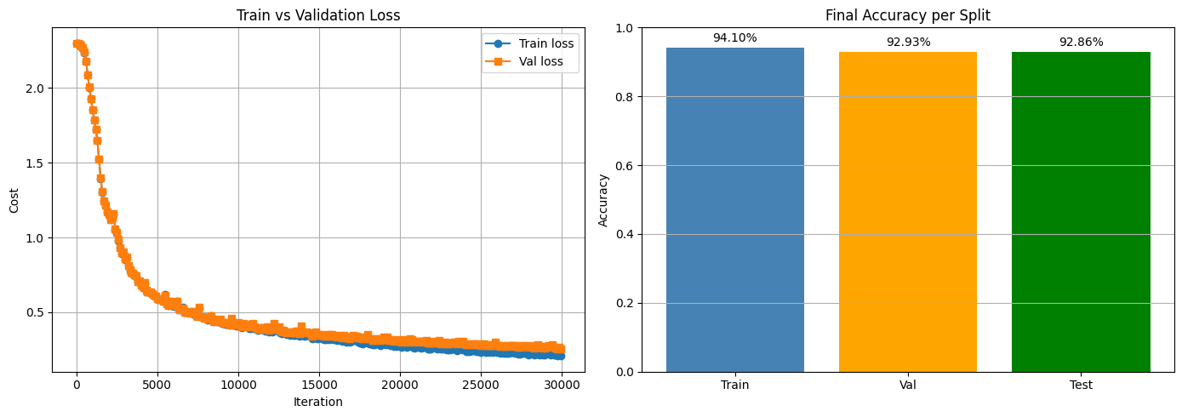
Figure A1. Baseline (no BN, no L2): training/validation loss curve (left) and final accuracy per split (right).

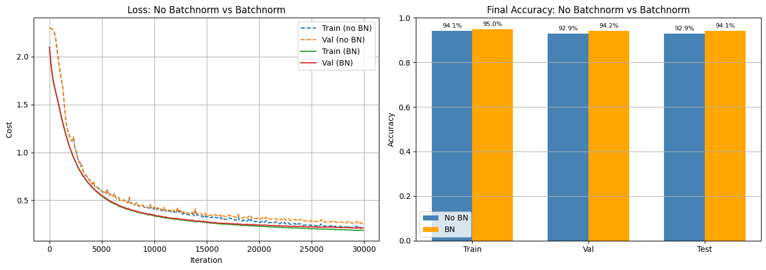
Figure A2. Batchnorm comparison: loss curves (left) and final accuracy per split (right). BN (solid lines) converges faster and reaches higher accuracy.

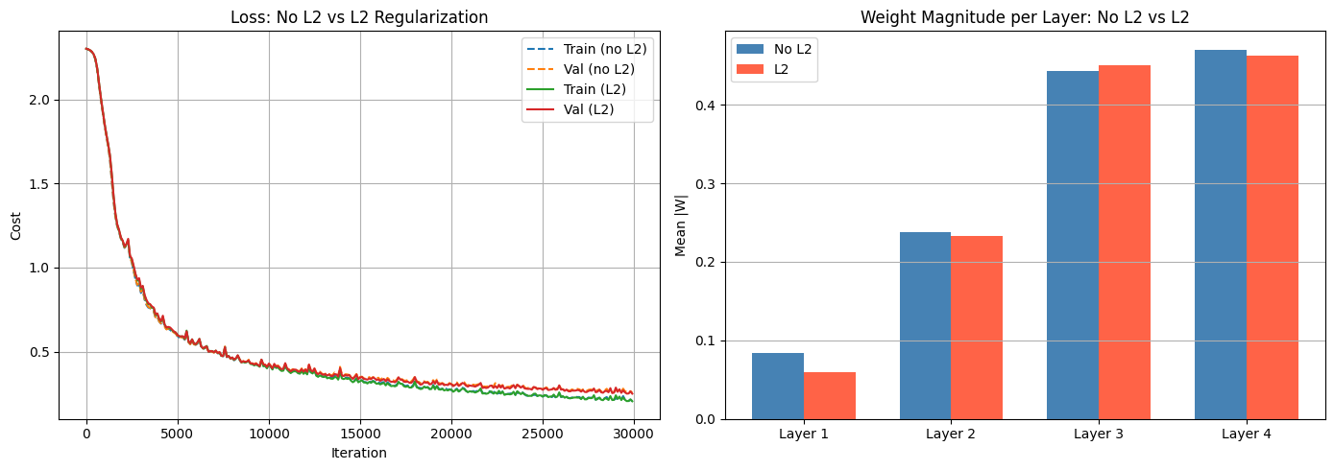
Figure A3. L2 comparison: loss curves (left) and mean weight magnitude per layer (right). L2 reduces weights (especially Layer 1) with minimal accuracy impact.

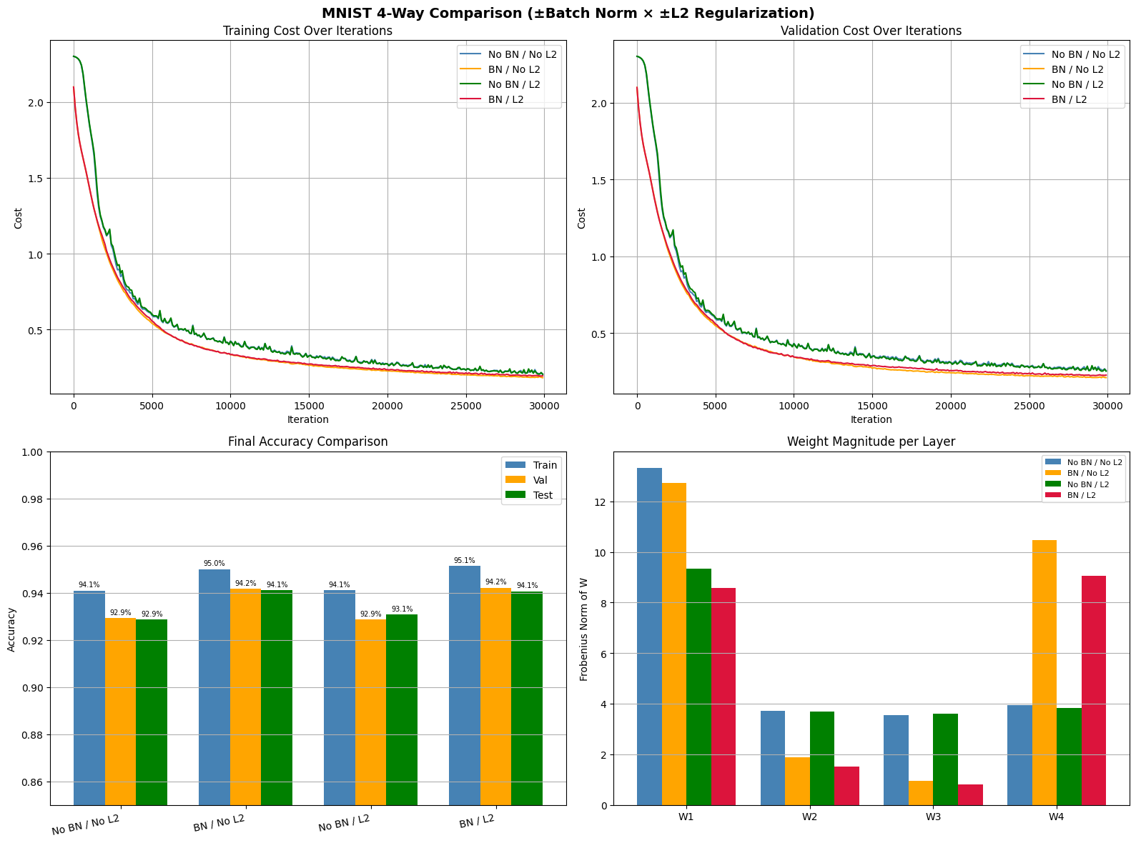
Figure A4. Four-way comparison: training cost (top-left), validation cost (top-right), final accuracy (bottom-left), weight Frobenius norms (bottom-right).

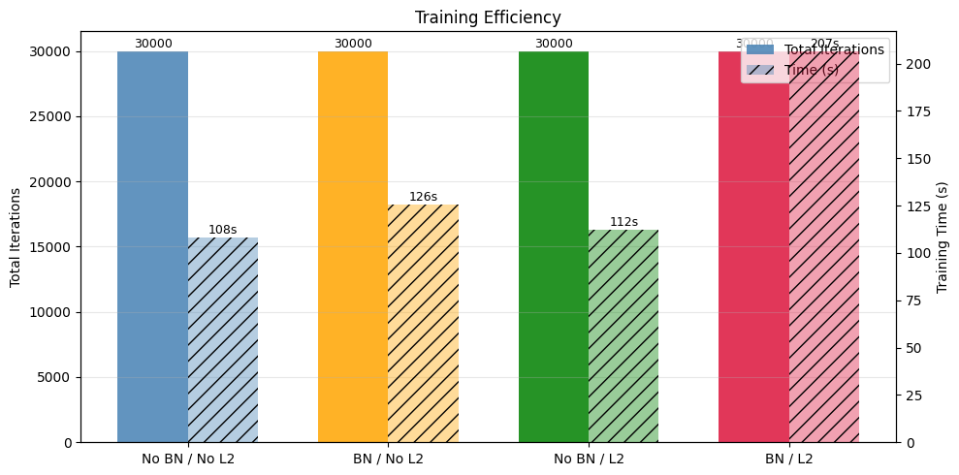
Figure A5. Training efficiency: total gradient steps and wall-clock time per configuration. BN + L2 incurs the largest overhead (207 s).

