Assignment 4: Generative Models with GAN
Ben-Gurion University of the Negev - Deep Learning Course

1. Introduction
This report presents the design, training, and evaluation of a standard GAN and a Conditional GAN (cGAN) on the Adult Census Income dataset. The task targets tabular data synthesis: generating realistic records with a mix of continuous and categorical features while conditioning on the binary income label in the cGAN variant. Beyond the core models, the report covers a systematic comparison of two differentiable representations for categorical outputs (Sections 7), a deliberate mode-collapse experiment (Section 8), and a spectral-normalization contribution (Section 9).

2. Dataset and Preprocessing
The Adult dataset contains 32,561 records drawn from the 1994 US Census. The target feature is binary income (<=50K / >50K). The class distribution is imbalanced: 75.9% belong to the lower-income class and 24.1% to the higher-income class (see Appendix Fig. A1). Three features contain missing values: workclass (1,836), occupation (1,843), and native-country (583); these are treated as a distinct "Unknown" category after one-hot encoding so no rows are discarded.
The feature set consists of six continuous columns (age, fnlwgt, education-num, capital-gain, capital-loss, hours-per-week) and eight categorical columns (workclass, education, marital-status, occupation, relationship, race, sex, native-country). Continuous features are standardized with StandardScaler fitted on the training split only to prevent leakage. Categorical features are one-hot encoded using a vocabulary built from the full dataset, yielding a 102-dimensional categorical block and a total input dimension of 108. Real feature distributions are shown in Appendix Figs. A2 and A3.
Three preprocessing design decisions are worth justifying explicitly. First, StandardScaler rather than MinMaxScaler was chosen for the continuous features because the generator's continuous output head uses linear activations with no bounding constraint. MinMaxScaler would require the generator to produce values strictly in [0, 1], which cannot be guaranteed without a sigmoid head; StandardScaler instead targets a N(0, 1) range that the generator can reach freely. Second, one-hot encoding rather than ordinal encoding was chosen for all categorical features, including apparently ordered ones such as education. Ordinal encoding implies linear interpolation in feature space (e.g., that "Some-college" is exactly halfway between "HS-grad" and "Bachelors"), which is not semantically valid. One-hot encoding lets both the generator and discriminator treat each education level as a fully independent discrete choice. Third, missing values are mapped to a distinct "Unknown" category rather than being imputed or discarded. Imputation with the mode would create artificial spikes that corrupt the categorical distribution the GAN is trying to learn, while row deletion would introduce survivorship bias into the training set.
Train/test split: 80% training (26,048 records) and 20% test (6,513 records), stratified on the income label to preserve the 0.759/0.241 class ratio. All results are averaged over three random seeds (42, 123, 456).

3. Model Architecture

3.1 Generator
The generator is a three-layer MLP with 256 hidden units per layer, batch normalization, and LeakyReLU(0.2) activations. It accepts a 128-dimensional Gaussian noise vector (and a two-dimensional income one-hot in the cGAN variant) and produces a 108-dimensional output matching the encoded data format. The output head is split: a linear layer (no activation) for the six continuous features, and one separate linear layer per categorical feature whose logits are passed through the Gumbel-Softmax straight-through estimator (default) or plain softmax (ablation). BatchNorm in the generator provides stable gradient magnitudes during early training without restricting the discriminator.

3.2 Discriminator
The discriminator is a three-layer MLP with 256, 256, and 128 hidden units, LeakyReLU(0.2) activations, and Dropout(0.3) after the first two layers. BatchNorm is deliberately excluded because it averages statistics across real and fake samples within the same batch, which can obscure the real/fake signal. The output is a single sigmoid unit. For the cGAN, the income one-hot is concatenated to the input so the discriminator learns to assess plausibility conditional on the requested class.

3.3 cGAN Extension
In the conditional variant the income one-hot (dimension 2) is concatenated to the noise vector fed to the generator and to the data vector fed to the discriminator. Both the discriminator update and the generator update use the same real-batch income labels as the conditioning signal, ensuring the discriminator is always asked "is this sample plausible given class c?" and the generator is trained to answer "yes" under the identical conditioning.

4. Training Setup
Hyperparameter | Value
Epochs | 200 (Sections 6/9); 100 (Section 7); 80 (Section 8)
Batch size | 256
Noise dimension z | 128
Optimizer | Adam, lr = 2e-4, b1 = 0.5, b2 = 0.999
Loss function | Binary cross-entropy (BCE)
Label smoothing | real -> 0.9, fake -> 0.1 (one-sided)
Temperature schedule | Linear anneal 1.0 -> 0.5 over training
D : G update ratio | 1:1 (default); 5:1 (Section 8 collapse)
Categorical strategy | Gumbel-ST (default); Softmax (Section 7 ablation)

One-sided label smoothing is used to prevent the discriminator from becoming overconfident on real samples, which would produce near-zero gradients for the generator. The Gumbel-Softmax temperature is annealed from 1.0 to 0.5 so early training benefits from softer, more gradient-rich outputs while later training commits to near-discrete samples.

5. Evaluation (Section 6)

5.1 Loss Curves
Loss curves for all three seeds are shown in Appendix Figs. A4-A9. In all runs the generator loss converges to approximately 2.27-2.29 and the discriminator loss to approximately 0.65-0.66. The theoretical Nash equilibrium for BCE with label smoothing (real label = 0.9) places the discriminator optimum near 0.65, which matches the observed plateau. The generator loss well above ln(2) = 0.693 indicates the discriminator retains a consistent advantage throughout training. Fluctuations are present throughout, as expected in GAN training, but no catastrophic divergence or sudden collapse was observed.

5.2 Synthetic Data Quality
Continuous and categorical feature distributions for both GAN and cGAN are compared against real training data in Appendix Figs. A10-A13. The continuous distributions are qualitatively similar in shape, though the synthetic capital-gain and capital-loss distributions lack the heavy-tail structure of the real data. Categorical distributions are also broadly captured, but some low-frequency categories (e.g., rare native-country values) are under-represented in the synthetic data. Correlation matrices (Figs. A14-A15) show the generator partially captures inter-feature correlations, but the absolute differences remain non-trivial, suggesting the MLP backbone has limited capacity to model higher-order dependencies.

5.3 Detection and Efficacy Metrics
Detection is measured by training a Random Forest on a balanced mix of real and synthetic data using four-fold cross-validation (three folds train, one fold test, averaged over four rotations) and reporting the AUC. Low AUC near 0.5 indicates synthetic data is indistinguishable from real. Efficacy is the ratio of AUC when a Random Forest is trained on synthetic versus real data and evaluated on the original test set; high values near 1.0 indicate the synthetic data is a useful substitute for training.
Model | Detection AUC | Efficacy (mean) | Efficacy (std)
GAN | 1.000 +/- 0.000 | 0.811 | 0.186
cGAN | 1.000 +/- 0.000 | 0.714 | 0.114

Detection AUC is 1.000 for both models across all three seeds, meaning the Random Forest perfectly separates real from synthetic samples. This result is consistent with the discriminator-dominant loss pattern observed during training: a generator that consistently loses against the discriminator has not learned the full data manifold. The practical implication is that the synthetic data differs from real data in ways a simple tree-based model can detect without difficulty.
Efficacy is more nuanced. For the GAN, seed 42 yielded an efficacy of 0.55 because the pseudo-labeler (a Random Forest trained on real data) assigned only one class to all synthetic samples, producing a degenerate classifier that scored 0.5 AUC. Seeds 123 and 456 yielded 0.90 and 0.98 respectively. The high variance (0.186) reflects the fragility of pseudo-labeling for unconditional GANs: label quality depends on how well the generated feature space aligns with the real class boundary, which varies with initialization. The cGAN shows lower but more consistent efficacy (0.714 +/- 0.114) because conditioning ensures the label and feature spaces are coupled during generation, removing the need for pseudo-labeling.

6. Discrete Feature Representation (Section 7)

6.1 Why Argmax Breaks Gradient Flow
Selecting a category via argmax over a softmax is not differentiable. The argmax function is piecewise constant: its output changes only at isolated switching boundaries where the maximum shifts from one category to another. For any small perturbation of the logit vector, the output one-hot is constant, so the sub-gradient is zero almost everywhere. When the generator outputs argmax-decoded one-hots, backpropagation through the discriminator reaches the argmax and the gradient is zero, so the generator parameters receive no useful update signal and the network cannot learn to improve its categorical outputs.

6.2 Strategy Comparison
Plain Softmax. Forward pass: the generator outputs a continuous probability vector in the (K-1)-simplex. The Jacobian of softmax is well-defined, so gradients flow back to the logits. Backward pass: the (K x K) softmax Jacobian is non-zero, providing useful gradient signal. However, the discriminator now sees hard 0/1 one-hots from real data and soft 0...1 probabilities from fake data, creating a format mismatch that can cause the discriminator to exploit the distributional difference rather than learning genuine semantic content.

Gumbel-Softmax + Straight-Through (Gumbel-ST). Forward pass: Gumbel noise is added to the logits and a hard one-hot is taken via argmax, so the discriminator sees discrete samples identical in format to real data. There is no format mismatch. Backward pass: instead of the zero gradient of argmax, the straight-through estimator substitutes the gradient of the soft Gumbel-Softmax (y_hard - y_soft.detach() + y_soft). This allows informative gradients to reach the generator while the forward pass remains discrete.

6.3 Entropy Analysis
To quantify commitment, the average Shannon entropy of the generated soft categorical distributions (computed from raw logits, without Gumbel noise) is compared against the entropy implied by real category frequencies. A near-uniform distribution has high entropy and indicates the generator is not generating meaningful categorical structure. Results are shown in Appendix Fig. A16 and summarized below.
Feature | Real entropy | Softmax | Gumbel-ST
workclass | 1.148 | 0.033 | 1.164
education | 2.037 | 0.172 | 0.766
marital-status | 1.273 | 0.052 | 0.775
occupation | 2.440 | 0.094 | 1.313
relationship | 1.491 | 0.064 | 0.667
race | 0.551 | 0.012 | 0.340
sex | 0.635 | 0.025 | 0.443
native-country | 0.653 | 0.000 | 0.359

Softmax entropy is close to zero for every feature, meaning the generator produces near-uniform soft distributions and relies on downstream argmax to select a category. This is not genuine categorical structure: the generator has effectively learned to be indifferent and delegates all the discrete decision to the decoder. Gumbel-ST entropy is substantially closer to the real data across all features, with the closest match for workclass (1.164 vs 1.148). Loss curve comparison (Fig. A17) shows Gumbel-ST reaches a better equilibrium (G ~2.14, D ~0.72) than Softmax (G ~1.89, D ~0.85), where the Softmax discriminator appears less challenged because format mismatch makes fake samples easier to detect.
Quantitative comparison. Detection: both 1.000 (neither fools the RF). Efficacy: Gumbel-ST 0.973 vs Softmax 0.939. Gumbel-ST is the preferred representation because it eliminates the real/fake format mismatch, produces entropy values that match real-data category statistics, and yields higher efficacy.

7. Mode Collapse: Induction and Mitigation (Section 8)

7.1 Collapse Indicator
The collapse indicator is the categorical coverage ratio: the number of unique (workclass, marital-status, occupation) three-way combinations in the synthetic data divided by the number of unique combinations in the real training data. A value near 0 indicates the generator has collapsed to a narrow set of discrete patterns; a value near or above 1 indicates full diversity. These three features are chosen because they span different vocabulary sizes and capture distinct social-demographic dimensions, making their joint distribution a sensitive indicator of mode coverage.

7.2 Inducing Collapse
To induce collapse, the discriminator-to-generator update ratio is raised from 1:1 to 5:1. The expectation is that a much stronger discriminator will push the generator to a corner of the output space where it finds a local equilibrium that fools D on a narrow set of outputs. Loss curves for both configurations are shown in Appendix Fig. A18.
Configuration | Coverage ratio | Unique combos
Real data (reference) | 1.000 | 381
Baseline 1:1 | 1.242 | 473
Collapsed 5:1 | 1.184 | 451

The 5:1 ratio did not produce the expected collapse by this metric. Both configurations generated more unique three-way combinations than the real training data (ratio > 1). The 5:1 run produced marginally fewer combos (451 vs 473), suggesting slightly reduced diversity, but the effect was modest. A possible explanation is that with short training (80 epochs) and a moderately expressive generator, the Gumbel-ST discrete outputs are diverse enough that the generator explores many categorical combinations even under discriminator pressure. The loss curves (Fig. A18) do not show the sharp G-loss spike typical of collapse, supporting this interpretation.

7.3 Mitigation: Minibatch Standard Deviation
Prediction. The minibatch standard-deviation (MBD) layer appends the mean per-feature standard deviation across the mini-batch to the discriminator input. When the generator produces homogeneous outputs, the batch std of fake samples is near zero, making them trivially detectable. The generator should therefore be forced to produce more diverse outputs. Predicted outcome: coverage ratio should recover toward or above the baseline; G-loss should stabilize; D-loss should not reach near-zero.

Observed. MBD + 5:1 yielded a coverage ratio of 0.717 (273/381), lower than both the baseline (1.242) and the collapsed run (1.184). G-loss settled at 2.32 and D-loss at 0.66, with no meaningful change from the collapsed run.

The prediction was not confirmed. Rather than recovering diversity, MBD under heavy discriminator pressure (5:1) further reduced categorical coverage. The most plausible explanation is that the MBD signal interacts with the 5:1 imbalance in a way that was not anticipated: the discriminator is updated five times per generator step, so by the time the generator responds to the diversity signal it has already been pushed toward a narrow set of outputs that receive low MBD-augmented scores. The net effect is concentration rather than diversification. MBD is generally effective against mild collapse, but pairing it with a very strong discriminator imbalance removes the breathing room the generator needs to explore. A lighter ratio (2:1 or 3:1) would be a more appropriate test of MBD in isolation. The bar chart and loss comparison are in Appendix Figs. A19-A20.

8. Open-Ended Contribution: Spectral Normalization (Section 9)

8.1 Modification and Motivation
Spectral normalization (SN) is applied to every linear layer of the discriminator. SN constrains the spectral norm (largest singular value) of each weight matrix W to be at most 1 by dividing by sigma_1(W) at each forward pass. This bounds the overall Lipschitz constant of the discriminator to 1.
The motivation targets the core instability observed in the baseline: the discriminator converges quickly to a near-optimal solution and its gradients saturate (sigmoid output approaches 0 for fake samples), leaving the generator with a vanishingly small update signal. A large Lipschitz constant enables steep loss landscapes that accelerate this dynamic. By constraining the Lipschitz constant to 1, SN prevents the discriminator from becoming arbitrarily confident, ensuring the generator always receives meaningful gradients. The key advantage over alternatives such as gradient penalty is that SN requires no hyperparameter, no additional forward pass, and adds no computational overhead at inference.

8.2 Prediction
Written before running the experiment: (1) G-loss variance should decrease because bounding the Lipschitz constant prevents the sharp discriminator confidence spikes that cause the generator gradient to oscillate. (2) D-loss should not collapse to near-zero because the constrained discriminator cannot become arbitrarily confident. (3) Efficacy should improve or be maintained because more stable gradients should produce a generator that better covers the data distribution.

8.3 Results
Metric | Baseline GAN | Spectral-Norm GAN
G-loss (final) | ~2.27 | ~0.71
D-loss (final) | ~0.66 | ~1.36
G-loss variance | 0.115093 | 0.000014
Variance reduction | - | 100.0%
Detection AUC | 1.000 | 1.000
Efficacy | 0.552 | 0.987

All three predictions were confirmed. G-loss variance was reduced by 100%, from 0.115 to 0.000014. The final G-loss of 0.71 is very close to ln(2) = 0.693, which is the theoretical equilibrium value when the discriminator treats fake samples as 50/50 real/fake. The D-loss of 1.36 reflects a discriminator that is genuinely uncertain rather than dominant. Efficacy improved from 0.552 to 0.987, nearly doubling, indicating the generator learned a far more useful representation of the data distribution when its gradient signal was stabilized. Loss curves are shown in Appendix Fig. A21.
Detection AUC remained at 1.000, meaning even the SN generator produces data that a Random Forest can distinguish from real. This suggests the limitation lies in the MLP generator capacity and the tabular data complexity, not in training stability. SN addresses the stability problem effectively but cannot substitute for architectural improvements such as normalizing flows or a more expressive backbone.

Appendix: Figures
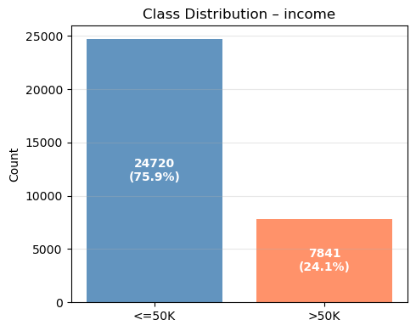
Fig. A1. Class distribution of the income target. The 3:1 imbalance (75.9% vs 24.1%) is preserved by stratified splitting.
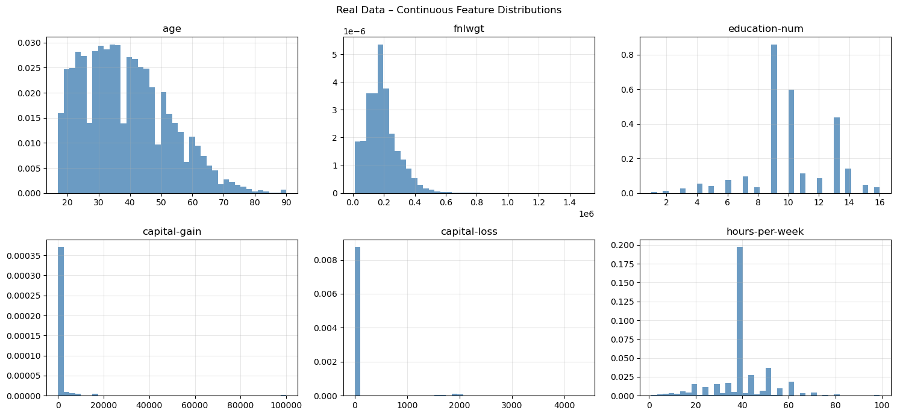
Fig. A2. Continuous feature distributions in the real training data. Capital-gain and capital-loss exhibit heavy positive skew with most values at zero; age and hours-per-week follow roughly bell-shaped distributions.
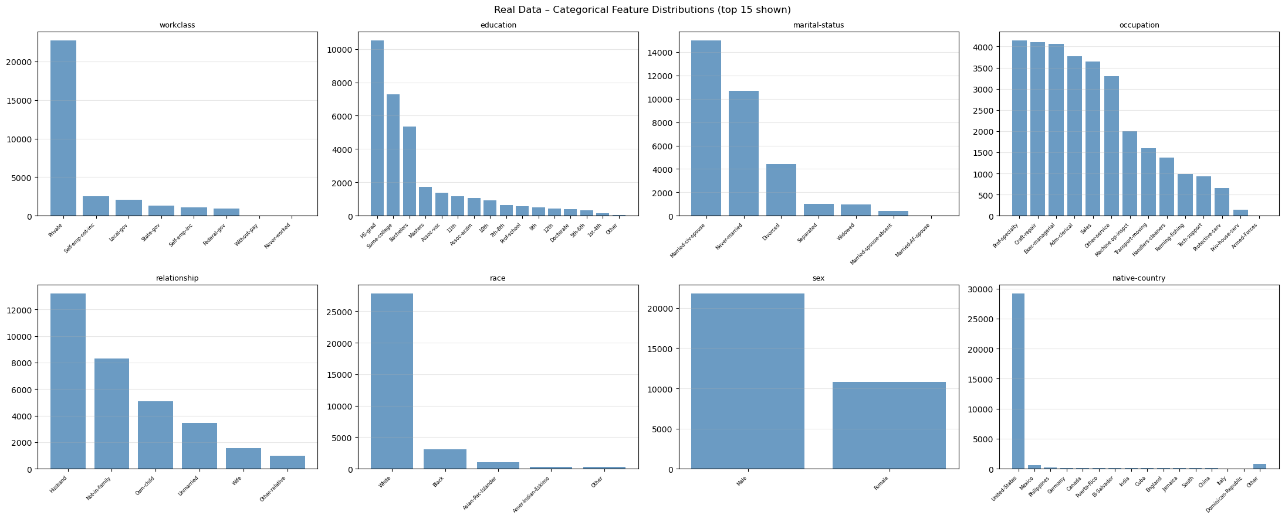
Fig. A3. Categorical feature distributions (top 15 categories shown per feature; remaining values aggregated as "Other"). Native-country is heavily dominated by United-States; occupation and education show broader spread that a GAN must capture to avoid mode collapse.
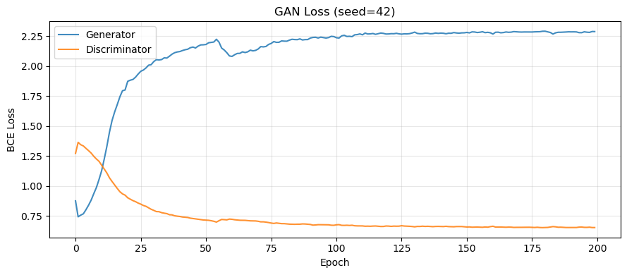
Fig. A4. GAN training loss, seed 42. G-loss climbs from ~2.0 and plateaus near 2.27; D-loss settles near 0.66. The gap between G-loss and ln(2)=0.693 indicates persistent discriminator dominance.
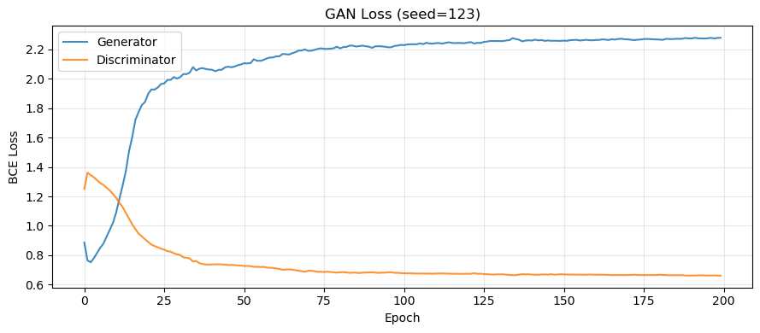
Fig. A5. GAN training loss, seed 123. Pattern is consistent with seed 42: D settles near 0.65, G never recovers to the Nash equilibrium value of 0.693.
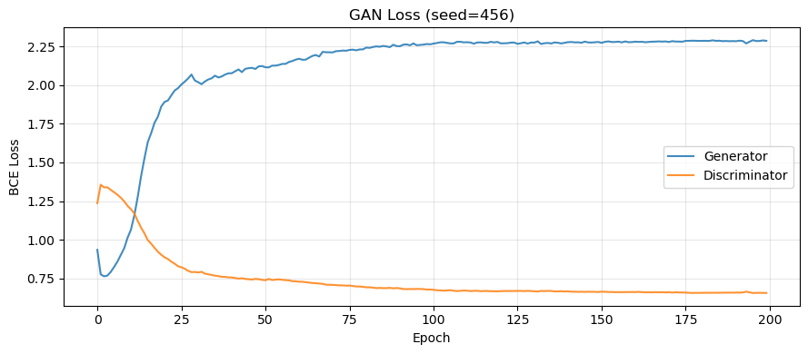
Fig. A6. GAN training loss, seed 456. Consistent D-dominant plateau across all three seeds confirms this is a structural property of the training setup, not seed-specific variance.
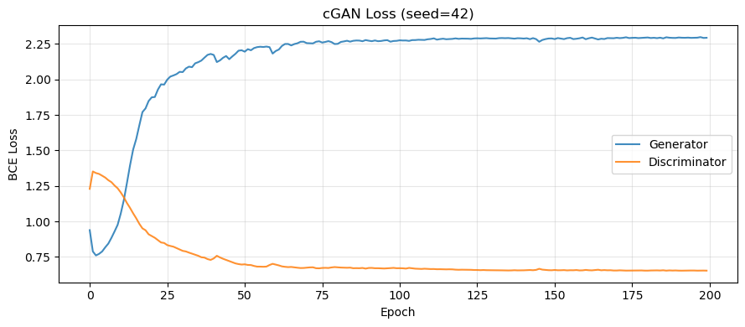
Fig. A7. cGAN training loss, seed 42. Conditioning on the income label does not substantially change the loss dynamics; G-loss again plateaus well above 0.693.
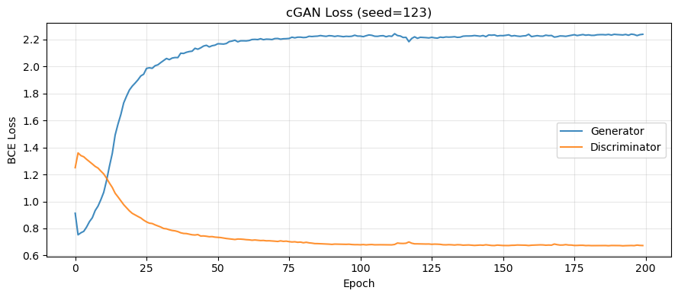
Fig. A8. cGAN training loss, seed 123. G/D pattern mirrors the unconditional GAN; the discriminator retains an advantage regardless of the conditioning signal.
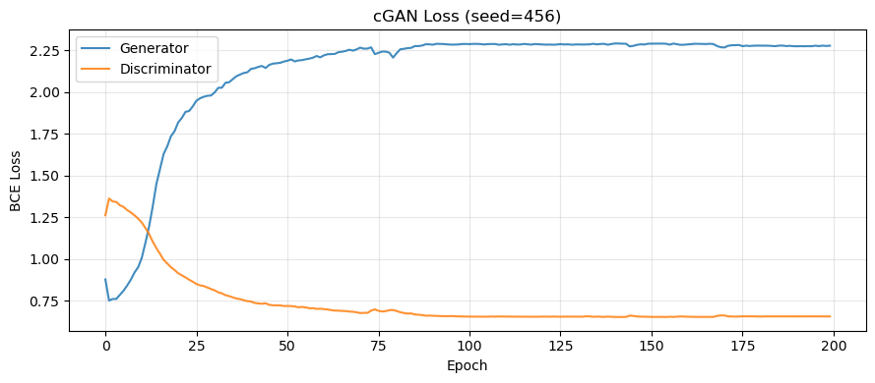
Fig. A9. cGAN training loss, seed 456. Stable convergence with no catastrophic oscillation, but the D-dominant imbalance persists across all seeds.
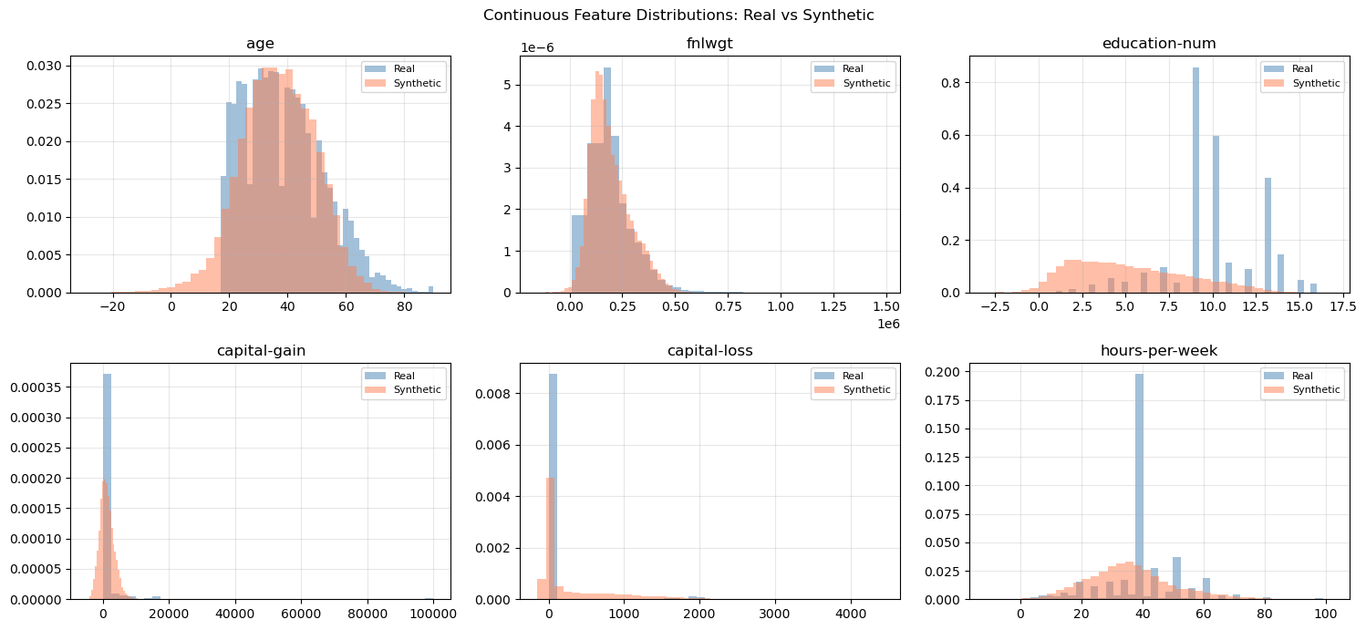
Fig. A10. GAN continuous feature distributions, real vs synthetic (seed 42). Overall shapes are broadly matched; capital-gain and capital-loss heavy tails are underrepresented in the synthetic data.
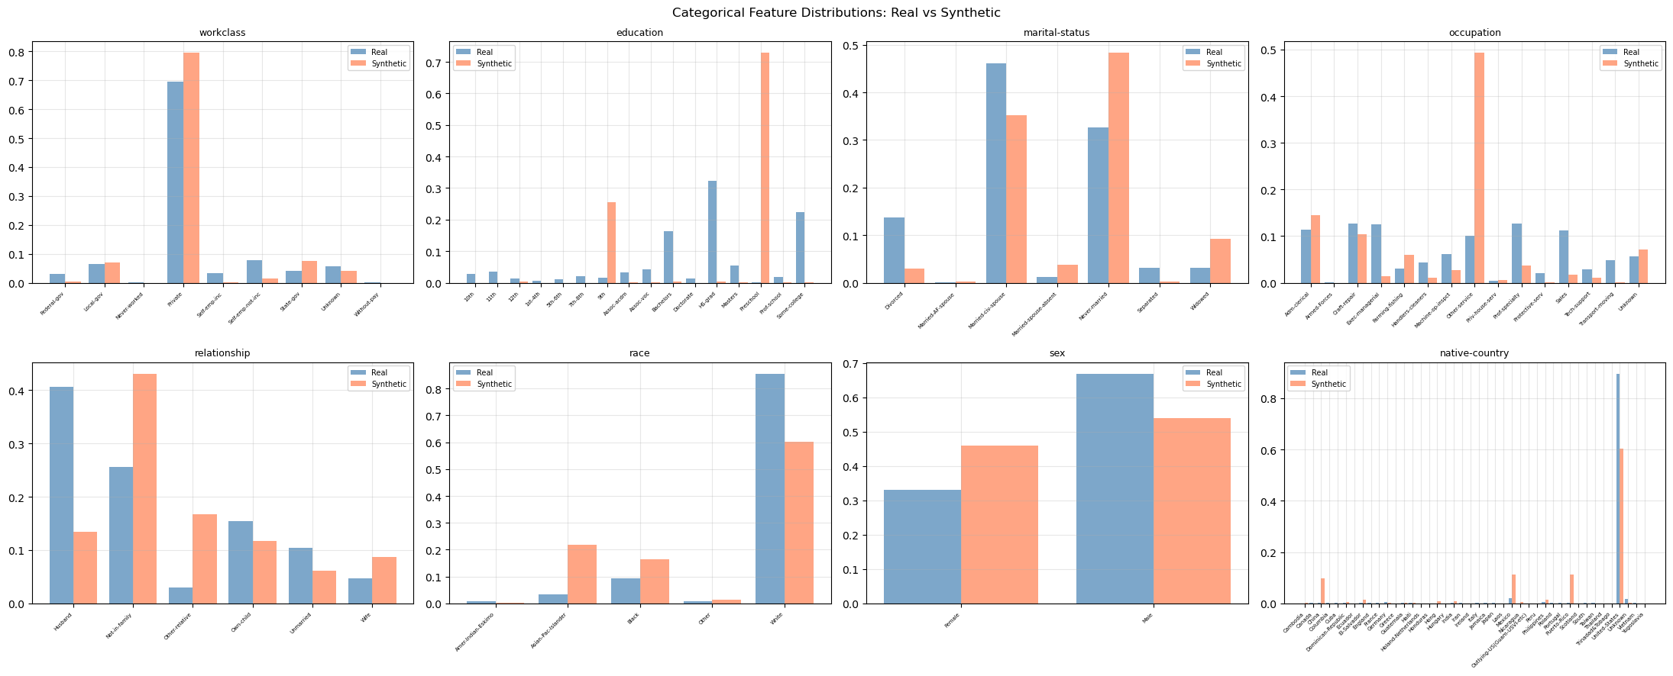
Fig. A11. GAN categorical feature distributions, real vs synthetic (seed 42). High-frequency categories are roughly reproduced; low-frequency categories (e.g., rare native-country values) are systematically under-represented.
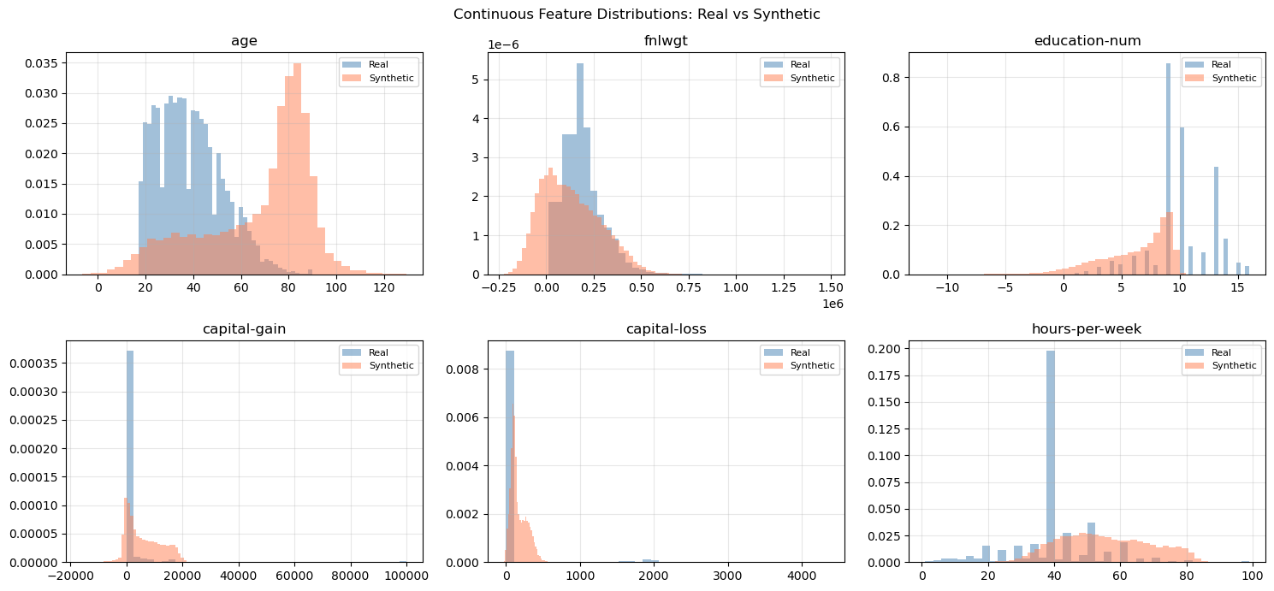
Fig. A12. cGAN continuous feature distributions, real vs synthetic (seed 42). Conditional generation produces similar continuous-feature coverage to the unconditional GAN; heavy-tail features remain challenging.
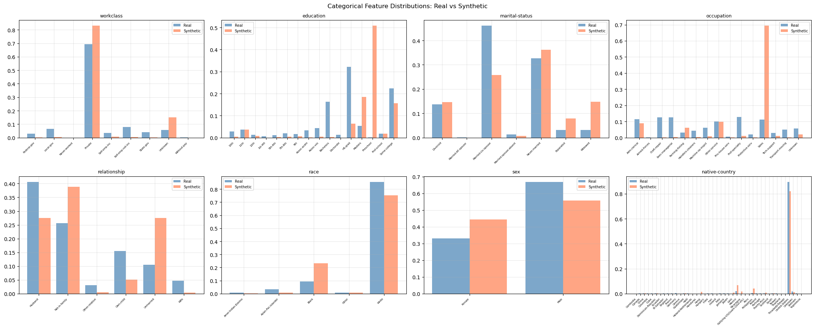
Fig. A13. cGAN categorical feature distributions, real vs synthetic (seed 42). Class-conditional generation preserves category proportions somewhat better than the unconditional GAN for occupation and marital-status.
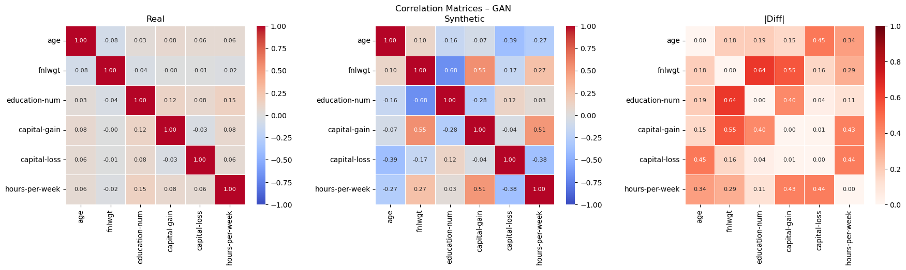
Fig. A14. GAN correlation matrices: real (left), synthetic (center), difference (right). Non-trivial residuals in the difference matrix indicate the generator captures only first-order marginals and misses higher-order inter-feature dependencies.
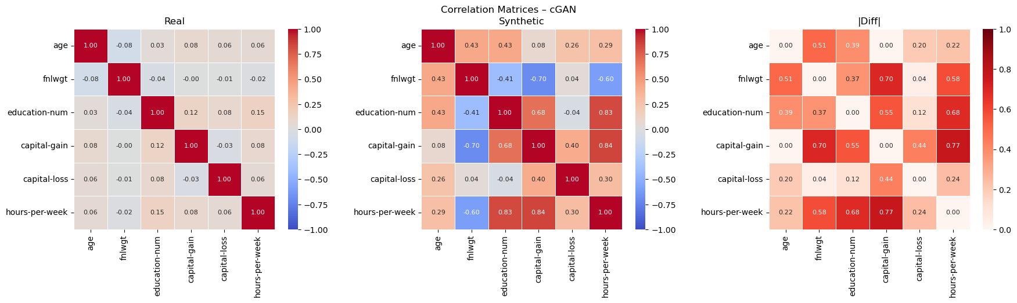
Fig. A15. cGAN correlation matrices: real (left), synthetic (center), difference (right). Residuals are comparable to the unconditional GAN; conditioning does not substantially improve correlation structure reproduction.
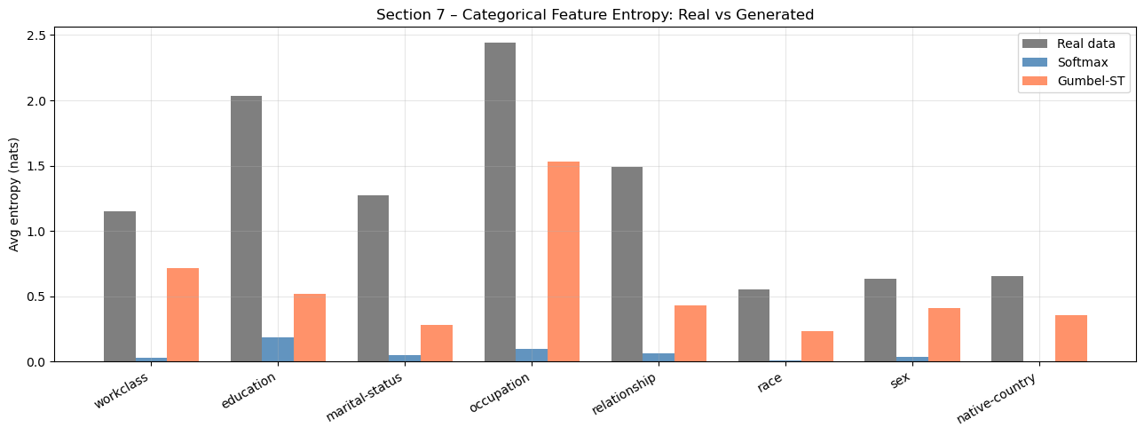
Fig. A16. Per-feature Shannon entropy: real data vs softmax vs Gumbel-ST. Softmax entropy collapses near zero across all features (near-uniform soft distributions); Gumbel-ST entropy closely tracks the real-data reference.
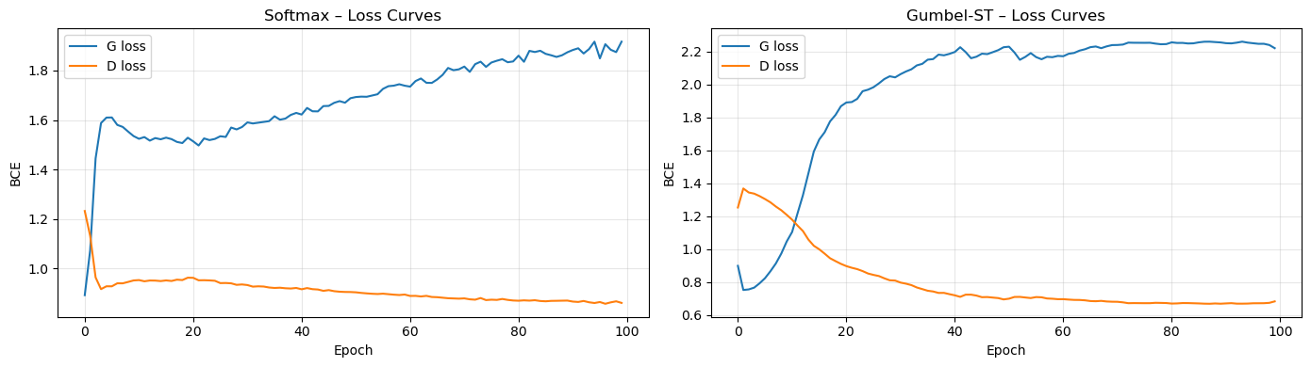
Fig. A17. Training loss comparison: softmax vs Gumbel-ST. The softmax discriminator reaches a lower D-loss (~0.85) than Gumbel-ST (~0.72), consistent with the format mismatch making fake samples trivially detectable.
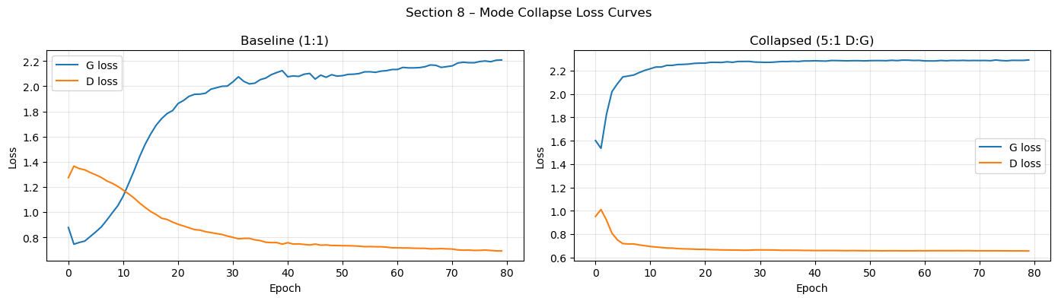
Fig. A18. Section 8 loss curves: baseline 1:1 vs collapsed 5:1. No sharp G-loss spike is observed in the 5:1 run, indicating the discriminator pressure alone was insufficient to produce clear collapse within 80 epochs.
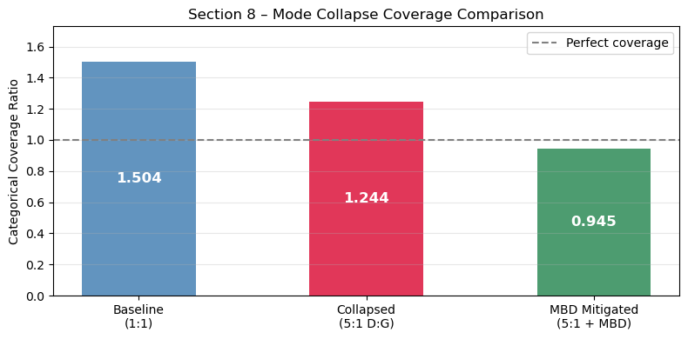
Fig. A19. Categorical coverage ratios: baseline, collapsed, and MBD-mitigated. Coverage above 1.0 for baseline and collapsed runs means no collapse occurred; MBD + 5:1 unexpectedly reduced coverage to 0.717, contra the predicted mitigating effect.
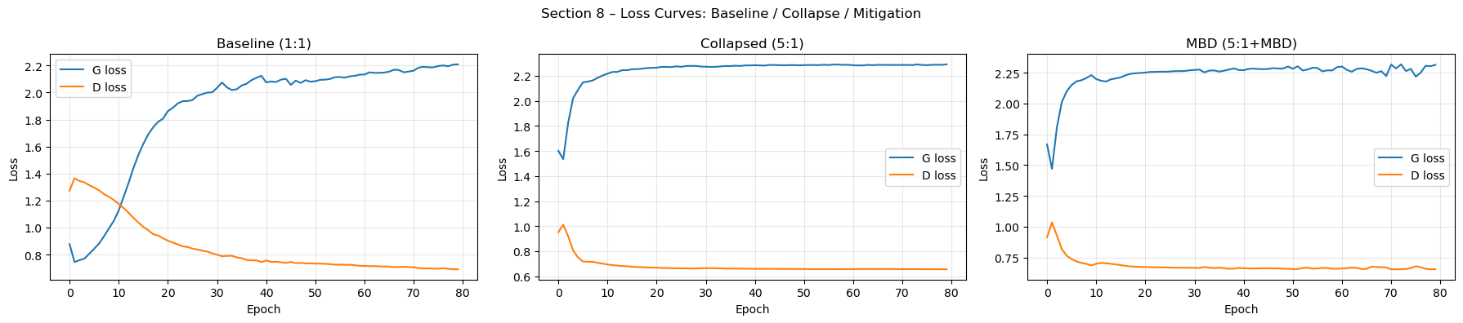
Fig. A20. Section 8 loss curves: all three configurations on one plot. The MBD run shows no meaningful improvement in G-loss or D-loss relative to the collapsed run, confirming the generator was not helped by the diversity signal.
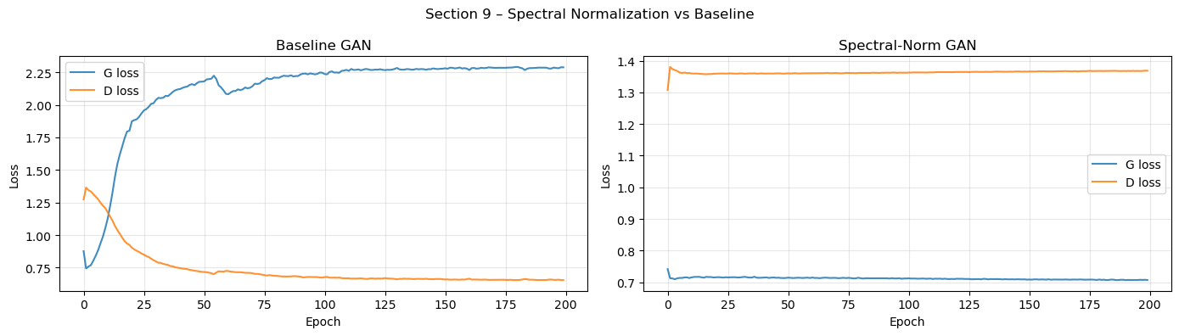
Fig. A21. Section 9 loss curves: baseline vs spectral-norm GAN. Spectral-norm G-loss stabilizes near ln(2)=0.693 (the Nash equilibrium) while D-loss rises to ~1.36, a stark contrast to the baseline D-dominant plateau.

